# [Cinentertainment] Site Plan

## Sid Skinner

## WDD 130

## Overview

### Purpose

Movie Recommendation/Summary Site

### Audience

Movie Fans

## Branding

### Website Logo



## Style Guide

### Color Palette

|  |  |  |  |
| --- | --- | --- | --- |
| **Primary** | **Secondary** | **Accent 1** | **Accent 2** |
| #000F08 | #6a7062 | #8D909B | #AAADC4 |

### Typography

#### Heading Font: [Bw Nista]

#### Paragraph Font: [Macklin]

### Navigation

Home Page2 Page3

**Content**

[put all content for the pages here, including written text and images]

Intro text for home:

Looking for your next favorite film? You’ve come to the right place.

**Cinentertainment** is your all-in-one destination for discovering movies you’ll love. Whether you’re into heart-pounding thrillers, feel-good comedies, mind-bending sci-fi, or timeless classics, we’ve got something for everyone.

Body text:

**What You’ll Find Here:**

* **Movie Summaries:** Quick, spoiler-free overviews to help you decide what to watch next.
* **Recommendations:** Personalized suggestions based on genres, mood, or what’s trending now.

Intro text for summary:

**Quick Overviews. No Spoilers. Just the Essentials.**

Looking for a quick idea of what a movie is about—without ruining the plot? You’re in the right place. Our movie summaries give you the core of the story, the vibe, and why it might be worth your time. Whether you’re revisiting a classic or checking out something new, our spoiler-free summaries help you decide what’s next on your watchlist.

Start browsing and get a feel for the films before you hit play.

Intro text for recommendations:

**Let Us Help You Find Your Next Favorite Film.**

Not sure what to watch? Our movie recommendations are here to spark inspiration. From trending blockbusters to underrated gems, we’ve put together collections based on mood, genre, and themes. Whether you're after something exciting, emotional, or just plain fun—we’ve got picks you’ll love.

Scroll through, discover something new, and get ready to press play.

Movie 1 Summary Text:

A research team in Antarctica is hunted by a shape-shifting alien that assumes the appearance of its victims.

Movie 2 Summary Text:

Marty McFly, a 17-year-old high school student, is accidentally sent 30 years into the past in a time-traveling DeLorean invented by his close friend, the maverick scientist Doc Brown.

Movie 3 Summary Text:

A mountain man who wishes to live the life of a hermit becomes the unwilling object of a long vendetta by the Crow tribe and proves to be a match for their warriors in single combat on the early frontier.

Movie 4 Summary Text:

A national manhunt is ordered for a rebellious kid and his foster uncle who go missing in the wild New Zealand bush.

Movie 1 Recommendation Text:

John Carpenter's *The Thing* is a chilling masterpiece that blends psychological horror with sci-fi thrills, keeping you on the edge of your seat from start to finish. Its atmosphere, paranoia, and groundbreaking special effects make it a must-watch for any fan of the genre.

Movie 2 Recommendation Text:

*Back to the Future* is a timeless adventure that seamlessly blends sci-fi, humor, and heart, making it a true cinematic classic. With its iconic characters, thrilling time-travel twists, and unforgettable soundtrack, it’s a film that’s as fun today as it was when it first debuted.

Movie 3 Recommendation Text:

*Jeremiah Johnson* is a rugged, introspective western that tells the story of a man seeking peace in the unforgiving wilderness. With stunning cinematography and Robert Redford's powerful performance, it's a gripping tale of survival, solitude, and self-discovery.

Movie 4 Recommendation Text:

*Hunt for the Wilderpeople* is a heartwarming and hilarious adventure that beautifully blends humor, action, and emotion. With its quirky characters and stunning New Zealand landscapes, it's an unforgettable journey of friendship and self-discovery.

Footer Text:

© Skinner 2025

Movie 1

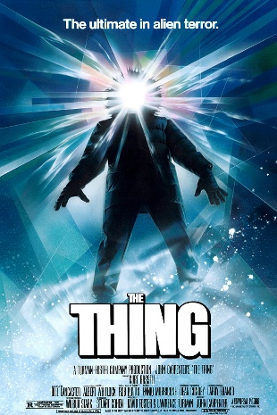

Movie 2

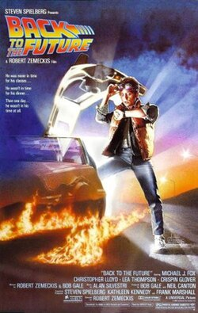

Movie 3

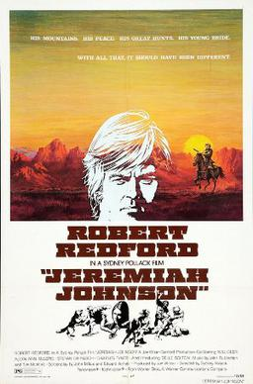

Movie 4

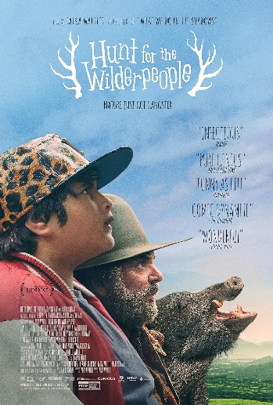

**Wireframes**

