

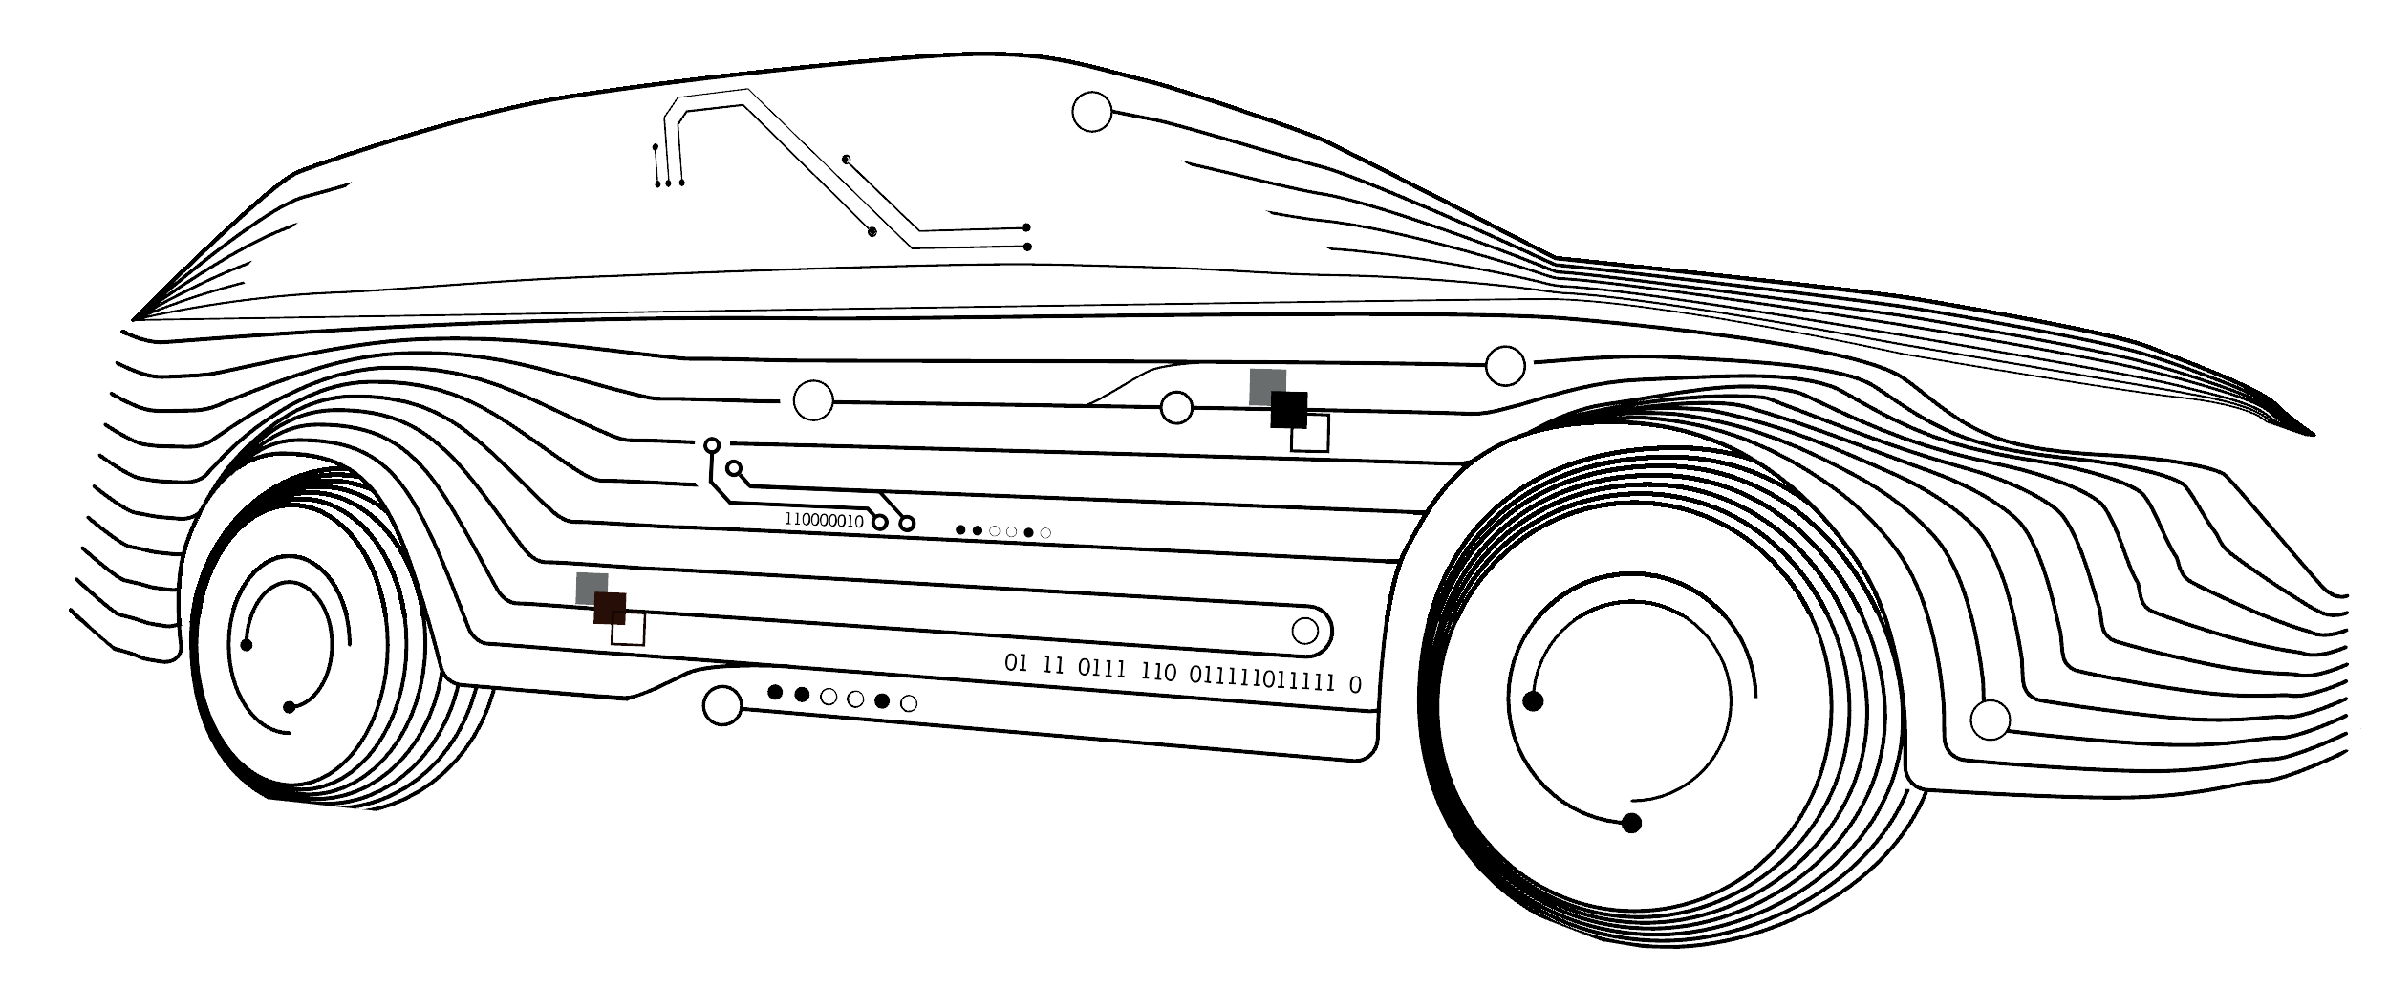
BreachLabz Academy
Advanced Automotive Security Portfolio

Building Automotive Penetration Testing Lab
Purpose:
Equipping your team with the right tools and environment to succeed.
Context:
A penetration testing team is only as effective as its environment. Many organizations struggle with knowing which hardware, software, and infrastructure they need to test ECUs in alignment with UN R155 and ISO/SAE 21434. BreachLabz supports you in building a fit-for-purpose penetration testing lab that balances cost, functionality, and scalability.
Scope of Work:
- Assess your current infrastructure and identify gaps.
- Provide a Bill of Materials (BOM) with required tools and equipment.
- Support in sourcing and purchasing equipment.
- Design lab setups for different penetration testing scopes (CAN fuzzing, firmware analysis, RF testing, fault injection).
- Deliver installation and setup guidance for hardware and software.
Deliverables:
- A customized BOM with tool options and price ranges.
- Lab setup documentation including connection diagrams and workflows.
- Step-by-step installation and configuration support.
- Best practice guidance for maintaining the lab.
Client Benefits:
- Clarity on what tools are necessary for which tasks.
- Avoid unnecessary costs by investing only in relevant equipment.
- A standardized environment for penetration testing that supports repeatability.
- Faster onboarding of new team members with a ready-to-use setup.
Remote vs Onsite:
- Remote: BOM design, configuration guidelines, tool selection consultation.
- Onsite (highly recommended): Hardware installation, physical setup, integration testing.
Phases & Timing:
- Phase 1 - Planning (1-2 week): Infrastructure review, BOM preparation.
- Phase 2 - Implementation (2-5 weeks): Setup, installation, and configuration.
- Phase 3 - Validation (1-2 week): Lab verification, operational testing.
Options / Add-Ons:
- Integration of virtualization platforms or remote access solutions.
- Additional support in preparing lab setups for regulatory audits.
- Guidance in selecting open source vs. commercial tools depending on budget and scope.

