Final Assigment – PRO192
Duration: 85’
======================================================================
Software Requirements
- Netbean 8.2 or later, JDK 8 or later, Notepad, Command Prompt, WinRAR / WinZip with Windows Explorer (File Explorer) on Windows 7 and above.
Instructions
- Step 1: Students download the given materials from LMS.
- Step 2: Students read questions and prepare answers in the given template.
- Step 3: Prepare to submit the answer:
  - For each question (e.g., question Q1, Q2, Q3,…), please create two sub-folders: run and src.
  - Copy the *.jar file into the run folder, and the entire project source code file into the src folder.
- Step 4: Submit a solution for each question:
  - Create a folder named : RollNumber_FullName_ASM0x (x : 1, 2, or 3) that contains folders (created Step 03 ) as the below figure:

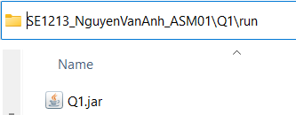

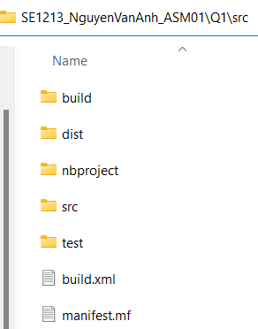

  - Use WinRAR / WinZip tool to compress the RollNumber_FullName_ASM0x folder and submit it to LMS
- Importance:
- Do not change the names of the folders specified (or required ) in the exam and the name of submit folder in Step 04 must be correct. If you change it (incorrectly), the grading software can not find the execute file (.jar) to score, thus the exam result will be 0.
======================================================================
(2 marks) Read PE instructions at the bottom of the exam paper.
Do not pay attention to the real meaning of objects, variables, and their values in the questions below.

Write a class Furniture (in the default package of the NetBean) with the following information:
Furniture | Where:  - Furniture () - default constructor  - Furniture(id:int, name:String, price:double, quantity:int) - parameterized constructor, which sets values to id, name, price and quantity  - getters & setters: write the setters and getters of the fields  - getSubTotal():double – return subTotal with subTotal = quantity * price with promotions as follows:  -If 50 <= subtotal < 100 then reduce by 10%  -If 100 <= subtotal <= 500 then reduce by 20%.  - toString(): String – return a string that contains all the information of the Furniture: id, name, price, quantity, subTotal. The price and subTotal are formatted in two decimal places.
- id: int
- name: String
- price: double
- quantity: int

+Furniture ()
+Furniture(id:int,name:String,price:double,quantity:int)
+getters & setters
+getSubTotal():double
+toString():String

Do not format the result.

The program output might look something like this:
Enter id:1  Enter name:chair  Enter price:100  Enter quantity:5  1.Test getSubTotal  2.Test toString  Enter TC(1 or 2):1  OUTPUT:  400.00 | Enter id:1  Enter name:chair  Enter price:5  Enter quantity:10  1.Test getSubTotal  2.Test toString  Enter TC(1 or 2):2  OUTPUT:  1, chair, 5.00, 10, 45.00

