The NISwGSP_line code USES documentation

0. InVisual Studio 2017, choose Release x64 as configuration and platform respectively.

1. External dependencies required by the code

1.1 dirent

1.2 opencv3.4.5

1.3 Eigen3

1.4 vlfeat-0.9.20

2 Compiling the code requires three steps (for example, header files, static libraries, and dynamic libraries)

2.1 configuration of header files

Attribute->VC++ directory->contains directories

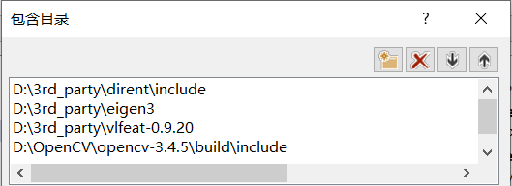

2.2 configuration of static libraries

Properties - >VC++ directory - > library directory

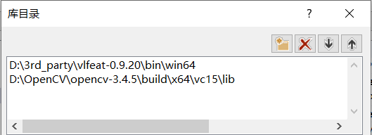

Attribute - > linker - > input - > additional dependencies

opencv_world345.lib

vl.lib

2.3 dynamic library configuration

Place the required dynamic library files under the generated Release folder

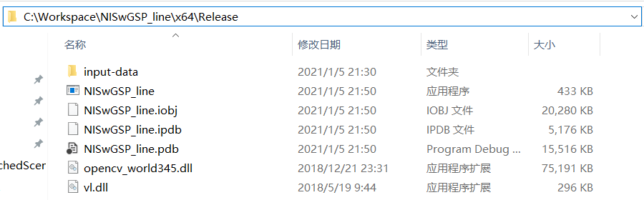

2.4 "CTRL + Shift + B" to build project.

3 run

Put the images in a folder, and put the folder in “input-data” folder.

