# 新建DAC文件

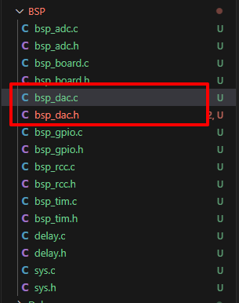

# 示例demo

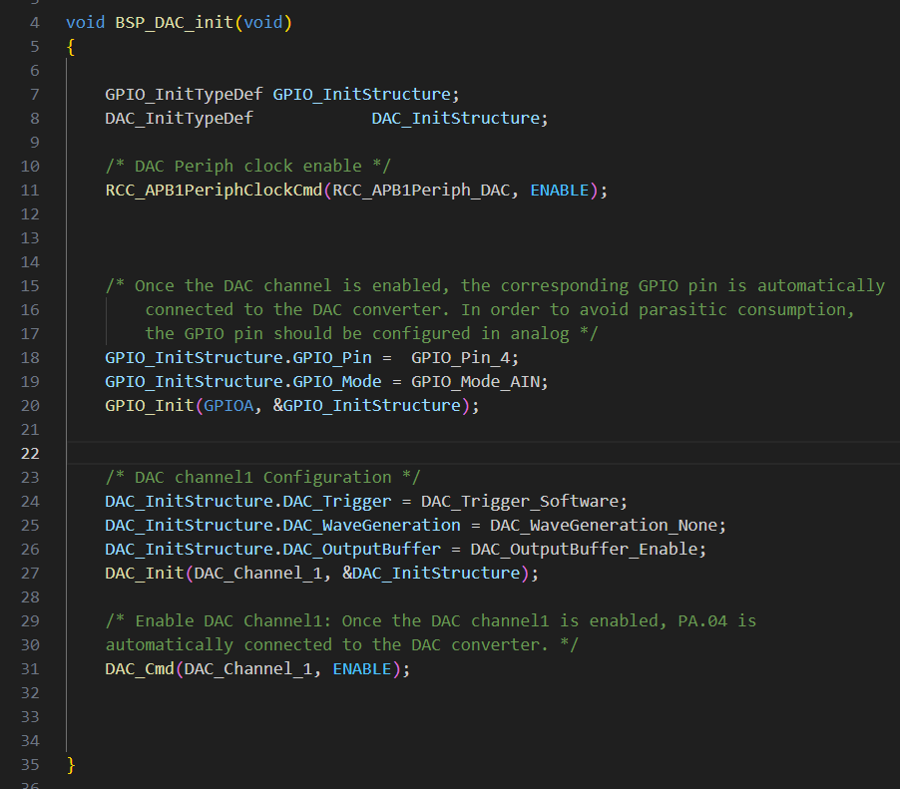

# 参考资料：

1. [STM32F4 Discovery](https://stm32f4-discovery.net/)

[Libraries and tutorials for STM32F4 series MCUs by Tilen Majerle](https://stm32f4-discovery.net/)

1. [DAC—输出正弦波](https://doc.embedfire.com/mcu/stm32/f103mini/std/zh/latest/book/DAC.html)