# 新建USART文件

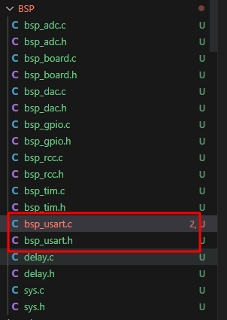

# 示例demo

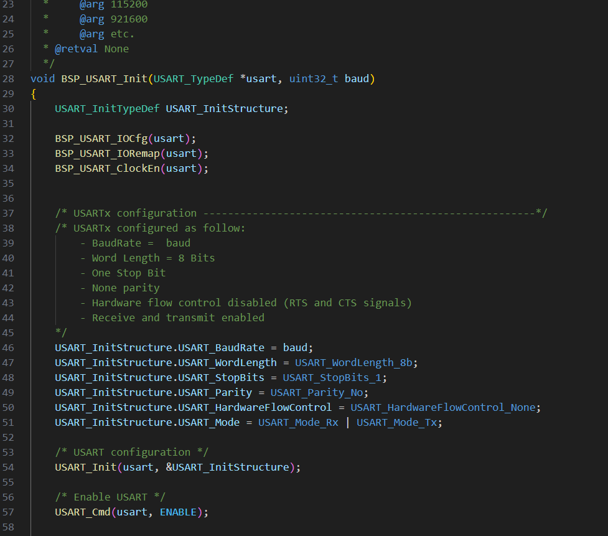

# 参考资料：

1. [STM32F4 Discovery](https://stm32f4-discovery.net/)

[Libraries and tutorials for STM32F4 series MCUs by Tilen Majerle](https://stm32f4-discovery.net/)