Implementation Assignment 3

The more thorough you are in your answers, the better your score will be. You may use this document to write your answers, or you may print and handwrite your answers. It must be legible though. If I cannot read it, I cannot grade it. Do not use ChatGPT, you may use the textbook or google. The textbook is provided to you in the About This Course.

There are two parts to this homework. The second part cannot be done before completing the first one.

Part 1:
- (30 points) Let b_{n} denote the number of different binary trees with n nodes. In this problem, you will find a formula for b_{n}, as well as an asymptotic estimate.
- Show that b₀ = 1 and that, for n >= 1,
$$b_{n}= \sum_{k=0}^{n-1}{b_{k}b_{n-1-k}}$$
Thinking through the problem. I wondered why use n-1-k. I looked it up and the reason is because if we have a tree let us pick one node as the root and examine left sub-tree and right-subtree.
Some nodes go to left subtree and rest to the right, and let us assume the left tree has k nodes, then the right subtree must have n-1-k. because 1 is the root
Total must be n
So
K+ (n-1-k)+1=n
Then why multiply bkbn-1-k. It because bk is left sub tree.
bn-1-k is for the right sub tree.
Let us solve now:
Given: bn is the number of different binary trees with n nodes.
Show :
Show that b₀ = 1 and that, for n >= 1,
$$b_{n}= \sum_{k=0}^{n-1}{b_{k}b_{n-1-k}}$$
Then find formula and an asymptotic estimate.
Step 1: our base case.
A binary tree with 0 nodes is the empty tree.
There is exactly one empty tree so
b0=1
step 2:
count trees with n>=1
take the binary tree with n nodes, pick one node as the root.
That leaves: n-1.
Nodes distributed as:
Left subtree
Right subtree.
Step 3: split into cases.
Left subtree has k node
Right subtree has n-1-k nodes
There are bk ways to build a left subtree, and
bn-1-k ways to build the right subtree
So the total split is bk*bn-1-k
Step 4:
Add all possible k
We sum over all possible left subtree sizes
K=0,1,2,…..,n-1
So
$$b_{n}= \sum_{k=0}^{n-1}{b_{k}b_{n-1-k}}$$
This is Catalan recurrence.
Now finding a closed formula:
This recurrence defines Catalan numbers, the closed form is
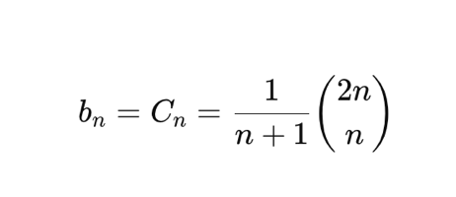
Or equivalently:
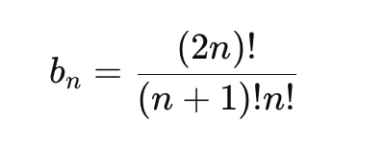
Now asymptotic estimate
We approximate the binomial coefficient using Stirling’s formula:
Known:
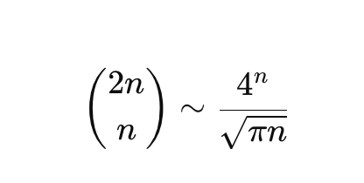
Since
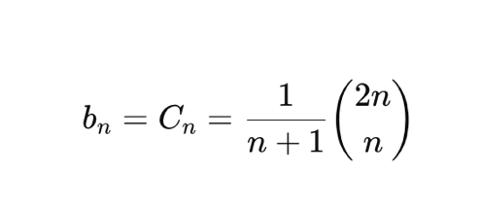
Asymptotically:
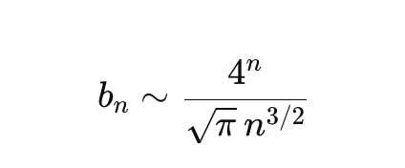

- Referring to Problem 4-4* for the definition of a generating function, let B(x) be the generating function
$B\left(x\right)= \sum_{n=0}^{∞}{b_{n}x^{n}}$
Show that $B\left(x\right)=xB{\left(x\right)}^{2} +1$, and hence one way to express B(x) in closed form is
$B\left(x\right)=\frac{1}{2x}\left(1-\sqrt{1-4x}\right)$.
The Taylor expansion of f(x) around the point x=a is given by
$f\left(x\right)=\sum_{k=0}^{∞}{\frac{f^{\left(k\right)}\left(a\right)}{k! }}{\left(x-a\right)}^{k}$,
where $f^{\left(k\right)}\left(x\right)$ is the kth derivative of f evaluated at x.

Step 1:
Show that $B\left(x\right)=xB{\left(x\right)}^{2} +1$
Since b0 =1,
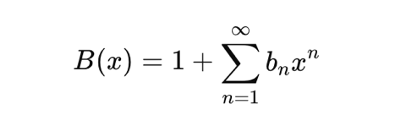
Now substitute the recurrence:
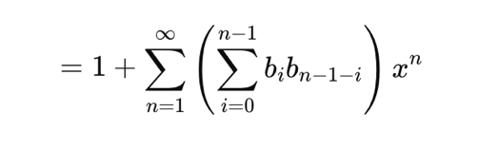
Now factor out an x:
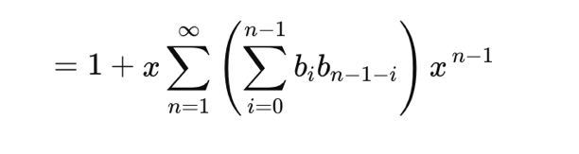

Let m = n-1:
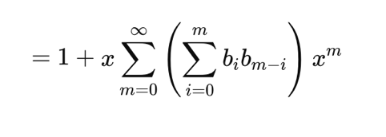
But:
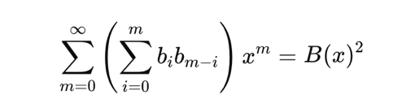
Because this is exactly the convolution formula for multiplying power series
So, we get

$$B\left(x\right)=xB{\left(x\right)}^{2} +1$$
Step 2: solve for B(x):
Rewrite the equation as:
$xB{\left(x\right)}^{2}-B(x) +1$ =0
Now choose the correct sign, As x->0, the generating function must remain finite.
The “+’ sign blow up so we take the minus sign.
Solve for B(x) by using the general quadratic formula:
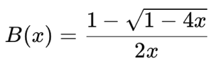
Step 3: Use Taylor expansion to extract coefficients
We expand
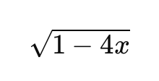
Using binomial series:
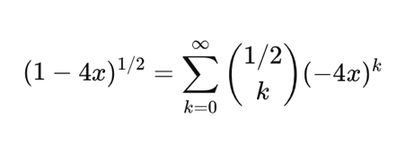
After simplifying, this gives:
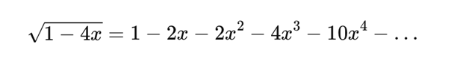
Substitute into:
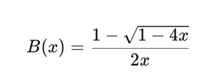
After simplifying coefficients, you obtain:
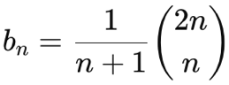
These are the Catalan numbers.

- Show that $b_{n}=\frac{1}{n+1}\left(\begin{matrix}2n \\ n\end{matrix}\right)$
(the nth Catalan number) by using the Taylor expansion of $\sqrt{1-4x}$ around x=0. (If you wish, instead of using the Taylor expansion, you may use the generalization of the binomial expansion (C 4) to nonintegral exponents n, where for any real number n and for any integer k, we interpret $\left(\begin{matrix}n \\ k\end{matrix}\right)$ to be $n\left(n-1\right)…\frac{\left(n-k+1\right)}{k!}$ If k >=0, and 0 otherwise.)
Step 1: Start from the closed form
We already have:
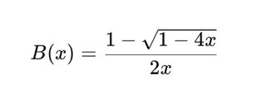
We now expand the square root using the generalized binomial theorem.
Step two expand (1-4x)^0.5
Use
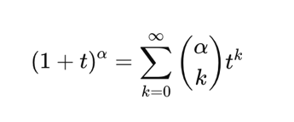
Where:
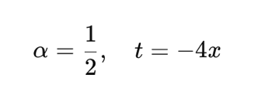
So:
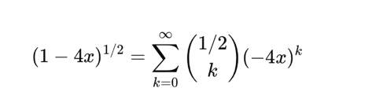
Compute the binomial coefficient
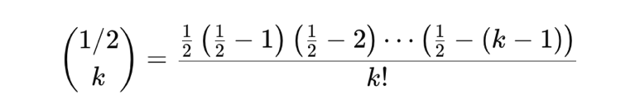
After simplifying (this is the key algebra step), I get:
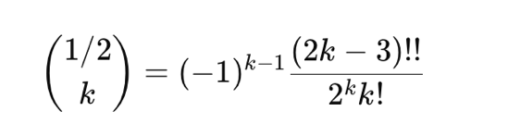
When I substitute and simplify, the series becomes:
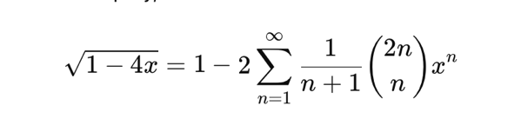
This is the crucial identity.
Step 3: Substitute into B(x)
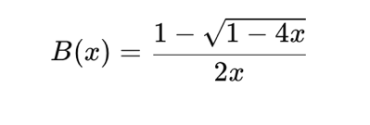
Substitute the expansion:
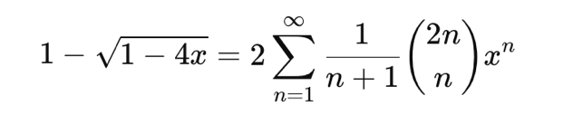
So:
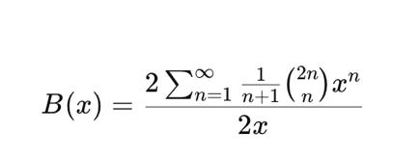
Cancel 2 then divide by x:
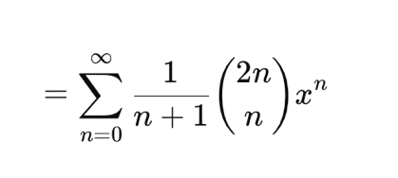
Therefore,
Since
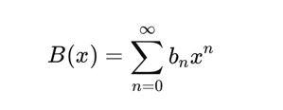
We identify coefficients:
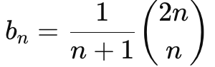

- Show that
$$b_{n}=\frac{4^{n}}{\sqrt{π}n^{\frac{3}{2}}}\left(1+O\left(\frac{1}{n}\right)\right)$$
Using Stirling’s approximation:
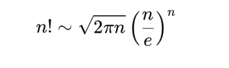
Apply to:
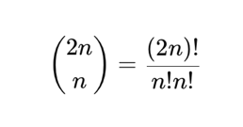
Using Stirling:
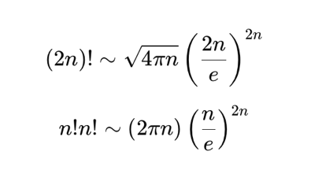
Divide:
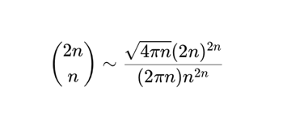
Simplify:
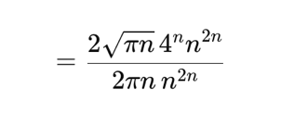
Cancel terms:
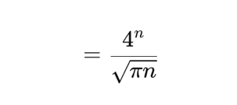
Now we need to plug into Catalan formula:
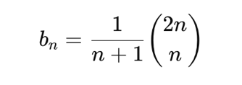
Replace binomial approximation:
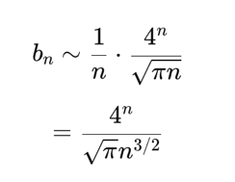
Add error term:
More precise Stirling expansion gives:
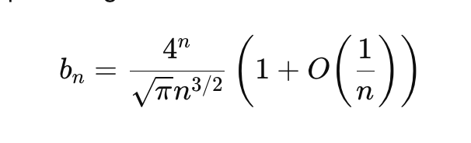

- (25 points) We can sort a given set of n numbers by first building a binary search tree containing these numbers (using TREE-INSERT repeatedly to insert the numbers one by one) and then printing the numbers by an in order tree walk.
- What are the worst- case and best-case running times for this sorting algorithm?
For this sorting algorithm:
- We build a binary search tree by inserting n numbers one by one
- Then we print the numbers using an in order traversal of the tree
The time complexity analysis:
Worst-case running time:
- In the worst case, the binary search tree becomes essentially a linked list (when numbers are inserted in sorted or reverse-sorted order)
- Each insertion takes O(h) time, where h is the height of the tree
- In the worst case, h = n (the tree is skewed)
- So inserting n elements takes O(n²) time
- The in order traversal takes O(n) time
- Overall worst-case running time: O(n²)
Best-case running time:
- In the best case, the binary search tree is balanced
- The height of a balanced binary search tree is O(log n)
- Each insertion takes O(log n) time
- Inserting n elements takes O(n log n) time
- The in order traversal takes O(n) time
- Overall best-case running time: O(n log n)
Since total running time is dominated by insertions, the overall complexity is $Θ(nh)$, which becomes $Θ(n^{2})$in the worst case and $Θ(nlog⁡n)$ in the best case.

- Prove the same result when the sums of the digits of the keys are equal.
Now suppose that the comparison between keys is done using the sum of their digits and assume that all the keys have the same digit sum.
That means whenever we insert a new key, its digit sum is equal to the digit sum of the nodes already in the tree. So, every comparison during insertion results in equality.
If the implementation sends equal keys consistently to one side (for example, always to the right), then every new node will be inserted along the same path. The tree becomes skewed, similar to a linked list.
In that situation:
- The height of the tree becomes $h=n$
- Each insertion takes $O(n)$ time
- Inserting $n$ elements take $O(n^{2})$
- The in order traversal still takes $O(n)$
So, the overall worst-case running time is:
$$O(n^{2})$$
In the best case, if the insertion order and tie-breaking rule result in a balanced tree, then the height is $O(log⁡n)$.
Each insertion takes $O(log⁡n)$, so inserting all elements takes $O(nlog⁡n)$, and traversal takes $O(n)$.
So, the overall best-case running time is:
$$O(nlog⁡n)$$
- Explain how these two cases relate
Both cases depend on the height of the binary search tree.
The total running time of the algorithm is mainly determined by how long insertions take, and insertion time depends on the height $h$ of the tree.
- If the tree is skewed, then $h=n$, and the running time becomes $O(n^{2})$.
- If the tree is balanced, then $h=O(log⁡n)$, and the running time becomes $O(nlog⁡n)$.
So in both parts, the difference between best and worst case comes from whether the tree is balanced or not.

- (5 points) Is the operation of deletion “commutative” in the sense that deleting x and then y from a binary search tree leaves the same tree as deleting y and then x? Argue why it is or give a counterexample.
Deletion in a binary search tree is not commutative.
Deleting $x$ and then $y$ does not always give the same final tree structure as deleting $y$ and then $x$.
This is because when deleting a node with two children, we usually replace it with its successor (or predecessor). That replacement changes the structure of the tree. If we delete nodes in a different order, the intermediate restructuring is different, and the final shape of the tree can also be different, even if the remaining keys are the same.
Therefore, deletion in a BST is not commutative.

Counterexample
Consider the following BST:
5
/ \
3 7
/ \
6 8

Case 1: Delete 5 first, then delete 7
Delete 5.
Since 5 has two children, we replace it with its successor (6).
The tree becomes:
6
/ \
3 7
\
8
Now delete 7.
Final tree:
6
/ \
3 8

Case 2: Delete 7 first, then delete 5
Delete 7.
Since 7 has two children, we replace it with its successor (8).
The tree becomes
5
/ \
3 8
/
6
Now delete 5.
Replace 5 with its successor (6).
Final tree:
6
/ \
3 8
The deletion process changes the structure of the tree depending on the order of deletions.
Therefore, deleting x and then y does not necessarily produce the same tree as deleting y and then x.
Deletion in a BST is not commutative.

* Problem 4-4 is on page 108 to 109 on Fibonacci Numbers

Part 2:
- (5 points) Show that the function $f\left(x\right)=2^{x}$is convex.
A convex function is a real-valued function where a line segment drawn between any two points on its graph lies on or above the graph.

A function $f(x)$ is convex if for all $x$, $y$ and for all $0≤λ≤1$, we have
$f(λx+(1-λ)y)≤λf(x)+(1-λ)f(y).$ (textbook, p. 1199)

Now apply it to $f(x)=2^{x}$
We must show:
$$2^{λx+(1-λ)y}≤λ2^{x}+(1-λ)2^{y}.$$
Notice:
$$2^{λx+(1-λ)y}=2^{λx}⋅2^{(1-λ)y}=(2^{x})^{λ}(2^{y})^{1-λ}.$$
So, the left-hand side becomes:
(2^x)^λ(2^y)^(1−λ).
Now use the inequality between weighted geometric and weighted arithmetic means:
$$a^{λ}b^{1-λ}≤λa+\left(1-λ\right)b \text{for }a,b>0.$$
Let $a=2^{x}$ and $b=2^{y}$. Since both are positive, we get:
$$(2^{x})^{λ}(2^{y})^{1-λ}≤λ2^{x}+(1-λ)2^{y}.$$
Therefore,
$$f(λx+(1-λ)y)≤λf(x)+(1-λ)f(y),$$
so $2^{x}$ is convex.
I have seen methods for solving this using the second derivative, and I learned them for future knowledge.

- (10 points) Write pseudocode for RIGHT-ROTATE for the Red-Black Tree.

The RIGHT-ROTATE operation in Red-Black Trees is a fundamental operation used to maintain the balance and properties of the tree after certain operations like insertions or deletions. It is used to restore the properties of a Red-Black Tree by reorganizing the structure of the tree while ensuring that the key ordering is preserved.

RIGHT-ROTATE(T, y)
x = y.left // Set x to y's left child
y.left = x.right // Turn x's right subtree into y's left subtree
if x.right != T.nil // If x's right subtree is not NIL
x.right.p = y // Set the parent of x's right child to y
x.p = y.p // Link y's original parent to x
if y.p == T.nil // If y was the root
T.root = x // Set x as the new root
else if y == y.p.right // If y was a right child
y.p.right = x // Set x as the right child of y's parent
else // If y was a left child
y.p.left = x // Set x as the left child of y's parent
x.right = y // Put y on x's right
y.p = x // Set x as the parent of y

- (5 points) Suggest how to implement RB-INSERT efficiently if the representation for red- black trees includes no storage for parent pointers.

If parent pointers are not stored, we can implement RB-INSERT by explicitly keeping the search path. While descending from the root to find the insertion position, store each visited node in a stack (or array). After inserting the new node as a leaf, run RB-INSERT-FIXUP using the stack to access the node’s parent and grandparent (and thus the uncle). If a rotation occurs, reconnect the rotated subtree to the ancestor from the stack; if there is no ancestor, update the tree’s root. Since the red-black tree height is $O(log⁡n)$, this method runs in $O(log⁡n)$ time and uses $O(log⁡n)$ extra space.

- (5 points) Give a dynamic-programming algorithm for the activity-selection problem, based on recurrence (16.2). Have your algorithm compute the sizes c[i,j] as defined above and also produce the maximum-size subset of mutually compatible activities. Assume that the inputs have been sorted as in equation (16.1). Compare the running time of your solution to the running time of GREEDY-ACTIVITY-SELECTOR.

Dynamic-programming algorithm (based on recurrence 16.2)
Assume activities $a_{1},…,a_{n}$ are sorted by nondecreasing finish times as in (16.1). Add two sentinels: $a_{0}$ with $f_{0}=0$ and $a_{n+1}$ with $s_{n+1}=+∞$. Let $s_{k}$ and $f_{k}$ be the start and finish times of activity $a_{k}$.
Define the set
$$S_{ij}=\{k∣i<k<j, f_{i}≤s_{k}, f_{k}≤s_{j}\}.$$
Define
$$c[i,j]=\left\{\begin{matrix}0, & \text{if }S_{ij}=∅ \\ {max⁡}_{k∈S_{ij}}\left(c[i,k]+c[k,j]+1\right), & \text{otherwise.}\end{matrix}\right.$$
Also store $\text{choice}[i,j]$, the value of $k$ that achieves the maximum, so we can reconstruct the optimal set.
Pseudocode (bottom-up DP computing $c[i,j]$ and the solution set)
Assume arrays s[0..n+1], f[0..n+1] where:
- a1..an are the real activities
- sentinel a0: f[0] = 0 (or −∞), s[0]=0 (not really used)
- sentinel a(n+1): s[n+1] = +∞ (or very large), f[n+1]=+∞
DP-ACTIVITY-SELECTOR(s, f, n):
# activities are 1..n, with sentinels 0 and n+1
# c and choice are (n+2) x (n+2) tables

for i = 0 to n+1:
for j = 0 to n+1:
c[i,j] = 0
choice[i,j] = NIL

# length is the gap between i and j in index space
for length = 2 to n+2: # smallest interval: j = i+2
for i = 0 to (n+2 - length):
j = i + length - 1
c[i,j] = 0
choice[i,j] = NIL

# try all activities k strictly between i and j
for k = i+1 to j-1:
if f[i] <= s[k] and f[k] <= s[j]: # k ∈ S_ij
val = c[i,k] + c[k,j] + 1
if val > c[i,j]:
c[i,j] = val
choice[i,j] = k

# reconstruct maximum set from interval (0, n+1)
A = RECONSTRUCT(choice, 0, n+1)
return c, A

RECONSTRUCT(choice, i, j):
k = choice[i,j]
if k == NIL:
return empty list
else:
left = RECONSTRUCT(choice, i, k)
right = RECONSTRUCT(choice, k, j)
return left + [k] + right
• c[0, n+1] is the size of an optimal solution.
• RECONSTRUCT returns the indices of activities in one optimal maximum set (in increasing finish-time order).

Running time vs GREEDY-ACTIVITY-SELECTOR

DP running time
- There are $O(n^{2})$ subproblems $\left(i , j\right)$.
- For each pair $\left(i , j\right)$, you may scan $k$ from $i+1$ to $j-1$, which is $O(n)$.
- Total: $O(n^{3})$ time.
- Space: $O(n^{2})$ for c and choice.

Greedy running time
- Given activities already sorted by finish time, greedy scans once:
  - Time: $O(n)$.
- If sorting is included: $O(nlog⁡n)$, but your prompt says assume sorted.
Comparison:
DP is much slower: $O(n^{3})$ vs greedy $O(n)$ (with sorted input). Greedy wins because this problem has the greedy-choice property; DP is correct but overkill.

$#
- (10 points) Not just any greedy approach to the activity-selection problem produces a maximum-size set of mutually compatible activities. Give an example to show that the approach of selecting the activity of least duration from among those that are compatible with previously selected activities does not work. Do the same for the approaches of always selecting the compatible activity that overlaps the fewest other remaining activities and always selecting the compatible remaining activity with the earliest start time.

Example to show that the approach of selecting the activity of least duration from among those that are compatible with previously selected activities.
Activity i | Starting time | Finishing time | duration
1 | 3 | 6 | 3
2 | 1 | 5 | 4
3 | 5 | 9 | 4

- $a1=(3,6(, d1=3$
- $a_{2}=(1,5)$, $d_{2}=4$
- $a_{3}=(5,9)$, $d_{3}=4$
Greedy (least duration): picks $a_{1}$ first (duration 3 is smallest).
After choosing $a_{1}=(3,6)$, neither $a_{2}$ nor $a_{3}$ is compatible (both overlap with it).
So greedy returns $\left\{a_{1}\right\}$ (size 1).
Optimal: choose $a_{2}=(1,5)$ and $a_{3}=(5,9)$. They are compatible since $f_{2}=5≤s_{3}=5$.
Optimal set is $\left\{a_{2} , a_{3}\right\}$ (size 2).
Therefore, selecting the compatible activity with the least duration is not optimal.

2. Example to show the approach of selecting the activity of least duration from among those that are compatible with previously selected activities.
Activity i | Starting time | Finishing time
1 | 1 | 4
2 | 3 | 5
3 | 0 | 6
4 | 5 | 7
5 | 8 | 9
Count overlaps among all activities (two activities overlap if their time intervals intersect):
- $a_{1}$ overlaps $a_{2}$ and $a_{3}$ → 2 overlaps
- $a_{2}$ overlaps $a_{1}$ and $a_{3}$ → 2 overlaps
- $a_{3}$ overlaps $a_{1},a_{2},a_{4}$ → 3 overlaps
- $a_{4}$ overlaps only $a_{3}$ → 1 overlap (fewest)
- $a_{5}$ overlaps none → 0 overlaps (also fewest, but it starts late; many versions still choose the “fewest-overlaps” early candidate first—either way the rule is not reliable)
Using the “fewest overlaps” rule, it can select $a_{4}=(5,7)$ first (it overlaps only $a_{3}$).
After picking $a_{4}$, the compatible remaining activities are $a_{5}$ only, so greedy can produce at most $\left\{a_{4} , a_{5}\right\}$ (size 2).
But the optimal solution is:
$$\left\{a_{1}=(1,4),\text{a2}=(3,5)\text{ cannot both be chosen}\right\}$$
So choose:
$$\left\{a_{1}=(1,4),\text{ a4}=(5,7),\text{ a5}=(8,9)\right\}$$
This has size 3, which is larger than 2.
Therefore, selecting the compatible activity that overlaps the fewest others does not always produce a maximum-size set.
(Note: This greedy rule depends on how “overlap count” ties are broken; the point is that overlap count is not a safe greedy choice—there exist inputs where it leads to a smaller set than optimal.)
A number of overlaps can be identified by the parallel occurrence of any other activity between starting and finishing time.
3. Example to show compatible activity selection with the earliest starting time.
Activity i | Starting time | Finishing time
1 | 1 | 5
2 | 2 | 3
3 | 4 | 5

Greedy (earliest start): picks $a_{1}$ first since it starts earliest at 1.
After choosing $a_{1}$, no other activity is compatible.
So greedy returns $\left\{a_{1}\right\}$ (size 1).
Optimal: choose $a_{2}=(2,3)$ and $a_{3}=(4,5)$. They are compatible.
Optimal set is $\left\{a_{2} , a_{3}\right\}$ (size 2).
Therefore, selecting the compatible activity with the earliest start time is not optimal.
These examples show that not every greedy rule works; the correct greedy strategy for the activity-selection problem is to repeatedly choose the compatible activity with the earliest finishing time, which is proven to yield an optimal maximum-size set.

- (5 points) Suppose that in a 0-1 knapsack problem, the order of the items when sorted by increasing weight is the same as their order when sorted by decreasing value. Give an efficient algorithm to find an optimal solution to this variant of the knapsack problem, and argue that your algorithm is correct.

Variant 0–1 Knapsack (weights increasing, values decreasing)
We are given items $I_{1},I_{2},…,I_{n}$ such that:
$$w_{1}≤w_{2}≤⋯≤w_{n} \\ v_{1}≥v_{2}≥⋯≥v_{n}$$
Assume $v_{i}≥0$ for all $i$.
Thus, for any $i<j$, item $I_{i}$ is no heavier and at least as valuable as item $I_{j}$. Hence earlier items dominate later ones.
PREFIX-KNAPSACK(w, v, n, W):
totalW = 0
S = ∅
for i = 1 to n:
if totalW + w[i] ≤ W:
S = S ∪ {i}
totalW = totalW + w[i]
else:
break
return S
Running time: $O(n)$
Extra space: $O(1)$

Correctness Proof

Claim 1:
For any feasible solution selecting $m$ items, the prefix $\left\{1,2,…,m\right\}$ is feasible and has value at least as large.
Let a feasible solution select items
$$i_{1}<i_{2}<⋯<i_{m}.$$
Since these are $m$ distinct indices, we have $i_{r}≥r$ for every $r$.
Because weights are nondecreasing:
$$w_{r}≤w_{i_{r}}∀r.$$
Summing over $r=1$ to $m$:
$$\sum_{r=1}^{m}{w_{r}}≤\sum_{r=1}^{m}{w_{i_{r}}}.$$
Thus, the prefix of length $m$ weighs no more than the chosen set, so if the chosen set is feasible (≤ W), the prefix is also feasible.
Similarly, since values are nonincreasing:
$$v_{r}≥v_{i_{r}}∀r,$$
so
$$\sum_{r=1}^{m}{v_{r}}≥\sum_{r=1}^{m}{v_{i_{r}}}.$$
Therefore, for any feasible solution with $m$ items, there exists a feasible prefix of length $m$ with at least as much value.
Hence, there exists an optimal solution that is a prefix.

Claim 2:
Among all feasible prefixes, the optimal one is the longest prefix that fits.
Let
$$V_{k}=\sum_{i=1}^{k}{v_{i}},W_{k}=\sum_{i=1}^{k}{w_{i}}.$$
Since $v_{i}≥0$, the prefix value $V_{k}$ is nondecreasing in $k$.
Since weights are nonnegative, $W_{k}$ is strictly increasing.
Therefore, among all prefixes satisfying $W_{k}≤W$, the one with the largest $k$ has maximum value.

Conclusion
From Claim 1, an optimal solution must be a prefix.
From Claim 2, the optimal prefix is the longest feasible prefix.
The algorithm returns exactly this prefix.
Thus, it produces an optimal solution in $O(n)$ time.

