PROJECT REPORT
Multi-Document RAG System
with Vector Database, Query Rewriting and RAGAS Evaluation
A Retrieval-Augmented Generation system that answers questions over PDF, DOCX, TXT, CSV, JSON, Markdown and HTML documents, cites its sources, and measures its own retrieval and generation quality.
Author: Talha Hafeez
Date: September 2026
Technology: Python 3.14 · sentence-transformers · ChromaDB · Groq / Hugging Face (OpenAI-compatible API) · RAGAS 0.4.3
Repository folder: multi_document_rag_project/

Abstract
Large Language Models (LLMs) answer fluently but know nothing about an organisation's private documents and cannot point to where an answer came from. This project builds a complete Retrieval-Augmented Generation (RAG) system that loads seven document formats (PDF, DOCX, TXT, CSV, JSON, Markdown and HTML), splits them into overlapping chunks, embeds each chunk with a local sentence-transformers model and stores the vectors in a persistent ChromaDB collection. At question time the query is rewritten — either by transparent rules whose variants are embedded and fused with Reciprocal Rank Fusion, or by an LLM using multi-query, HyDE and step-back strategies — before a cosine-similarity search retrieves the top-k chunks. A grounded prompt then makes the LLM answer only from the numbered passages, cite them as [n], or explicitly refuse.
The system is exposed through two front-ends on one pipeline: an interactive command-line application in which the provider, model, rewriting strategy and top-k can be changed mid-session, and a Streamlit web application that adds document upload, a chunk browser and an evaluation dashboard without any change to the pipeline code. Its quality is measured twice on a 12-question evaluation set with ground-truth answers: once with hand-written implementations of Faithfulness, Answer Relevance, Context Precision and Context Recall, and once with the RAGAS framework using a free Groq-hosted judge model. Manual scores averaged 1.00 / 1.00 / 0.93 / 0.93 and RAGAS 0.93 / 0.84 / 0.80 / 1.00; eleven of twelve answers were verified correct against the documents and the twelfth, an unanswerable question, was correctly refused. The disagreements between the two evaluators are analysed and traced to metric definitions and judge noise, and a diagnosis column attributes each weak score to the retrieval or the generation stage.
Keywords: Retrieval-Augmented Generation, vector database, embeddings, query rewriting, Reciprocal Rank Fusion, HyDE, RAGAS, ChromaDB, Streamlit.

Table of Contents

(If the table appears empty, right-click it and choose "Update Field", or press F9 in Microsoft Word.)

1. Introduction

1.1 Background
Modern LLMs are trained on public text and frozen at a cut-off date. When a user asks about a company's leave policy, its expense rules or a colleague's reporting line, the model has no evidence to draw on, and it will often produce a confident but invented answer. Retrieval-Augmented Generation (Lewis et al., 2020) addresses this by retrieving relevant passages from a private document collection at question time and instructing the model to answer only from those passages. RAG has become the standard architecture for enterprise question-answering because it needs no model training, keeps data local, and makes every answer traceable to a source.

1.2 Problem statement
Build a complete, measurable RAG system that can answer natural-language questions over a heterogeneous set of documents, display the source (document name, page, row or section) of every answer, and evaluate the quality of both its retrieval and its answer generation — first with manually implemented metrics and then with the RAGAS framework.

1.3 Objectives
- Load and extract text from PDF, DOCX, TXT, CSV, JSON, Markdown and HTML files through a single interface, preserving citation metadata.
- Split text into overlapping chunks with stable identifiers, embed the chunks with a sentence-transformers model and store them in a vector database.
- Retrieve the top-k most relevant chunks for a question using cosine similarity, improving recall with query rewriting — both rule-based (manual) variants matched by embeddings and LLM-generated variants — fused with Reciprocal Rank Fusion.
- Generate grounded answers with an LLM that cites passages and refuses when the evidence is missing; support several LLM providers through one client.
- Provide an interactive command-line application that exposes every pipeline setting at runtime and shares one pipeline implementation with the evaluation scripts.
- Provide a web front-end (Streamlit) on the same pipeline object — chat with citations and inspection panels, document upload and re-indexing, and the two evaluations run from the browser — while keeping the command-line application as the reference.
- Evaluate the system on a question set with ground truth using Faithfulness, Answer Relevance, Context Precision and Context Recall, implemented manually and via RAGAS, and produce CSV reports that diagnose whether a weak result stems from retrieval or generation.

1.4 Scope
The knowledge base is whatever the user places in the data/ folder; the project ships with a sample corpus for a fictional company, "Aurora Dynamics", covering HR policies, an employee directory, FAQs, meeting notes and website content. The system runs entirely on a developer laptop: embeddings and the vector database are local, and only answer generation and LLM-based judging call a hosted model (Groq's free plan or Hugging Face Inference Providers). Multi-turn conversation memory, authentication and distributed deployment are outside the scope and are listed as future work.

1.5 Structure of this report
Chapter 2 explains the concepts and algorithms used. Chapter 3 lists the requirements. Chapter 4 describes the architecture and design decisions, and Chapter 5 the implementation of each module, including the two front-ends (5.9 command line, 5.11 web). Chapter 6 covers testing and the two-stage evaluation with results and analysis. Chapter 7 records the engineering challenges, and Chapter 8 concludes with future work. The appendices give the project structure, run instructions, the evaluation questions and configuration variables.

2. Background and Key Concepts

2.1 Retrieval-Augmented Generation
RAG combines an information-retrieval component with a generative model. Instead of asking the model to remember facts, the system retrieves the passages most relevant to the question and places them in the prompt; the model reads and quotes rather than recalls. The three steps are Retrieve (find candidate passages), Augment (build a prompt containing them) and Generate (write the answer from that evidence). The quality of a RAG system is therefore bounded by its retrieval: if the right passage is not retrieved, no prompt engineering can produce a correct, grounded answer.

2.2 Text embeddings and cosine similarity
An embedding model maps a piece of text to a fixed-length vector such that semantically similar texts have geometrically close vectors. This project uses sentence-transformers/all-MiniLM-L6-v2 (Reimers & Gurevych, 2019), which produces 384-dimensional vectors, runs on a CPU in about 20 ms per chunk and needs no API key. Relevance between a question q and a chunk d is measured with cosine similarity:
cos(q, d) = (q · d) / (‖q‖ ‖d‖)
Because the vectors are L2-normalised at embedding time, the denominator equals one and cosine similarity reduces to a dot product, which is what the vector index computes. The same model must be used for documents and questions; vectors from different models live in different spaces and are not comparable.

2.3 Vector databases and approximate nearest-neighbour search
A vector database stores embeddings together with the original text and metadata and answers the query "which k stored vectors are closest to this one?". Exact search is linear in the number of vectors; production systems use approximate nearest-neighbour (ANN) indexes such as Hierarchical Navigable Small World graphs (HNSW; Malkov & Yashunin, 2018), which return the top-k in logarithmic time with very high recall. ChromaDB, used here, embeds an HNSW index in-process, persists it to disk and supports metadata filtering. It returns cosine distance (0 = identical), which the project converts to a similarity score (1 − distance) so that higher is always better.

2.4 Chunking
Embedding a whole document into one vector blurs its meaning; embedding single sentences loses context. Chunking splits documents into passages of a few hundred characters. The recursive character splitter used here tries the largest separator first (paragraph breaks), then line breaks, sentence ends, spaces and finally single characters, so that chunks end at natural boundaries whenever possible. Consecutive chunks overlap by a fixed number of characters so that a sentence cut at a boundary is still complete in one of them.

2.5 Query rewriting
Users write short, informal questions ("can i wfh fri?") while documents use formal language ("employees may work remotely up to three days per week"). This vocabulary mismatch places the question far from the relevant chunk in embedding space. Query rewriting generates alternative phrasings of the same question and searches with all of them. Two families are used:
- Manual (rule-based) rewriting: deterministic transformations — abbreviation expansion, prefixing the detected topic keyword, a formal restatement, and a keyword-only form. Each variant is embedded separately and searched; the result lists are fused (manual_rrf), or the variant embeddings are averaged into one query vector (manual_centroid).
- LLM rewriting: multi-query (the model writes several paraphrases), HyDE — Hypothetical Document Embeddings (Gao et al., 2022), where the model drafts a plausible answer passage whose embedding is searched because answers resemble documents more than questions do — and step-back prompting, where a broader question retrieves background context. A hybrid strategy combines manual and LLM variants.
All rewriters obey three rules: preserve the meaning, never answer the question, and keep the original query in the set so that a rewrite cannot lose a detail.

2.6 Reciprocal Rank Fusion
Each query variant produces its own ranked list. Reciprocal Rank Fusion (Cormack, Clarke & Büttcher, 2009) merges the lists using ranks rather than raw scores, so lists produced by different phrasings are comparable without calibration:
RRF(d) = Σ over queries q of 1 / (k + rank_q(d)), k = 60
A chunk that appears near the top of several lists accumulates the highest score. The project additionally records hit_count — the number of variants that found a chunk — and uses it as the first tie-breaker, because agreement across independently worded queries is a strong relevance signal. Duplicates are merged by chunk identifier, never by comparing text.

2.7 Grounded generation and citations
The retrieved chunks are numbered and placed in the prompt with strict instructions: answer only from the passages, cite the passage numbers as [n] after each claim, and if the evidence is missing reply with one fixed sentence. A low sampling temperature keeps the wording close to the evidence. The fixed refusal sentence lets the pipeline detect refusals programmatically, which matters for evaluation.

2.8 Evaluating RAG systems
Four metrics, each on a 0–1 scale, are widely used (Es et al., 2023). Two judge the generator and two judge the retriever, so a weak score points at the stage to fix:
Metric | Question it answers | Stage judged
Faithfulness | Is every claim in the answer supported by the retrieved context? | Generation
Answer relevance | Does the answer address the question that was asked? | Generation
Context precision | Are the relevant retrieved chunks ranked above the irrelevant ones? | Retrieval
Context recall | Was the evidence needed for the ground-truth answer retrieved at all? | Retrieval
Table 2.1 – The four RAG quality metrics
RAGAS is an open-source framework that implements these metrics with an LLM "judge" (for claim extraction and verification) and an embedding model (for relevance). Its numbers are only interpretable if one understands what each metric measures, which is why this project implements the metrics by hand first and compares the two.

3. Requirements

3.1 Functional requirements
ID | Requirement
F1 | Load PDF, DOCX, TXT, CSV, JSON, Markdown and HTML files from a data folder and extract their text with citation metadata (page, row, section, item).
F2 | Split extracted text into overlapping chunks with stable chunk identifiers.
F3 | Embed chunks and questions with the same, user-selectable embedding model.
F4 | Store vectors, text and metadata in a persistent vector database and perform top-k cosine-similarity search with optional metadata filters.
F5 | Rewrite queries with selectable strategies: none, manual_rrf, manual_centroid, llm_multi_query, llm_hyde, llm_step_back, hybrid.
F6 | Generate an answer grounded in the retrieved passages with [n] citations, or an explicit refusal.
F7 | Display retrieved sources with document name and locator, distinguishing cited from merely retrieved sources.
F8 | Support multiple LLM providers (Groq, Hugging Face) and live model lists; keys from .env or environment variables.
F9 | Provide a CLI (main.py) with an interactive loop, a one-shot mode, runtime commands to switch provider, model, strategy and top-k, chunk inspection, and an optional per-answer Evaluation block (the four metrics) as shown in the project brief.
F10 | Evaluate on a dataset of questions with ground truth using Faithfulness, Answer Relevance, Context Precision and Context Recall, manually and with RAGAS; write CSV reports with a retrieval-vs-generation diagnosis.
F11 | Provide a web application (app.py) with the same settings as the CLI, a chat view of RAGResponse (citation chips, sources, rewrites, chunks, per-answer evaluation), upload + re-index of data/, and buttons that run Stage A, the manual and the RAGAS evaluation and show both reports.
Table 3.1 – Functional requirements

3.2 Non-functional requirements
- Runs on a developer laptop (Windows, Python 3.14) without paid services; embeddings and the vector store are local.
- Every source file starts with a docstring explaining its purpose and place in the pipeline; non-obvious code is commented.
- Settings come from one configuration module backed by a .env file; API keys are never logged.
- Ingestion is idempotent (re-running upserts, never duplicates) and the vector store tolerates concurrent resets.
- The system degrades gracefully: LLM rewriting falls back to manual rewriting, rate limits are retried, and missing keys produce a clear message.

4. System Design

4.1 Architecture overview
The system consists of three pipelines that share one core object, RAGPipeline (src/rag_pipeline.py):
- Ingestion pipeline (ingest.py): Documents → Loaders → Chunker → Embedder → ChromaDB. Runs once per document set and writes two inspection files: results/chunks.json (every chunk as embedded) and results/ingest_manifest.json (per-file counts, model, timings).
- Question-answering pipeline (main.py): Question → Query rewriter → Embedding → Vector search → Top-k chunks → Prompt → LLM → Answer with citations and source list.
- Evaluation pipeline (evaluation/): Question + generated answer + retrieved contexts + ground truth → Manual metrics → RAGAS metrics → CSV reports with diagnosis.
RAGPipeline.ask() returns a single RAGResponse data object carrying everything that happened — the rewrites, every retrieved chunk with its scores, the exact context text sent to the model, the answer, the de-duplicated source list and per-stage timings. The CLI and both evaluators consume this one object, so they cannot drift apart.

4.2 Module structure
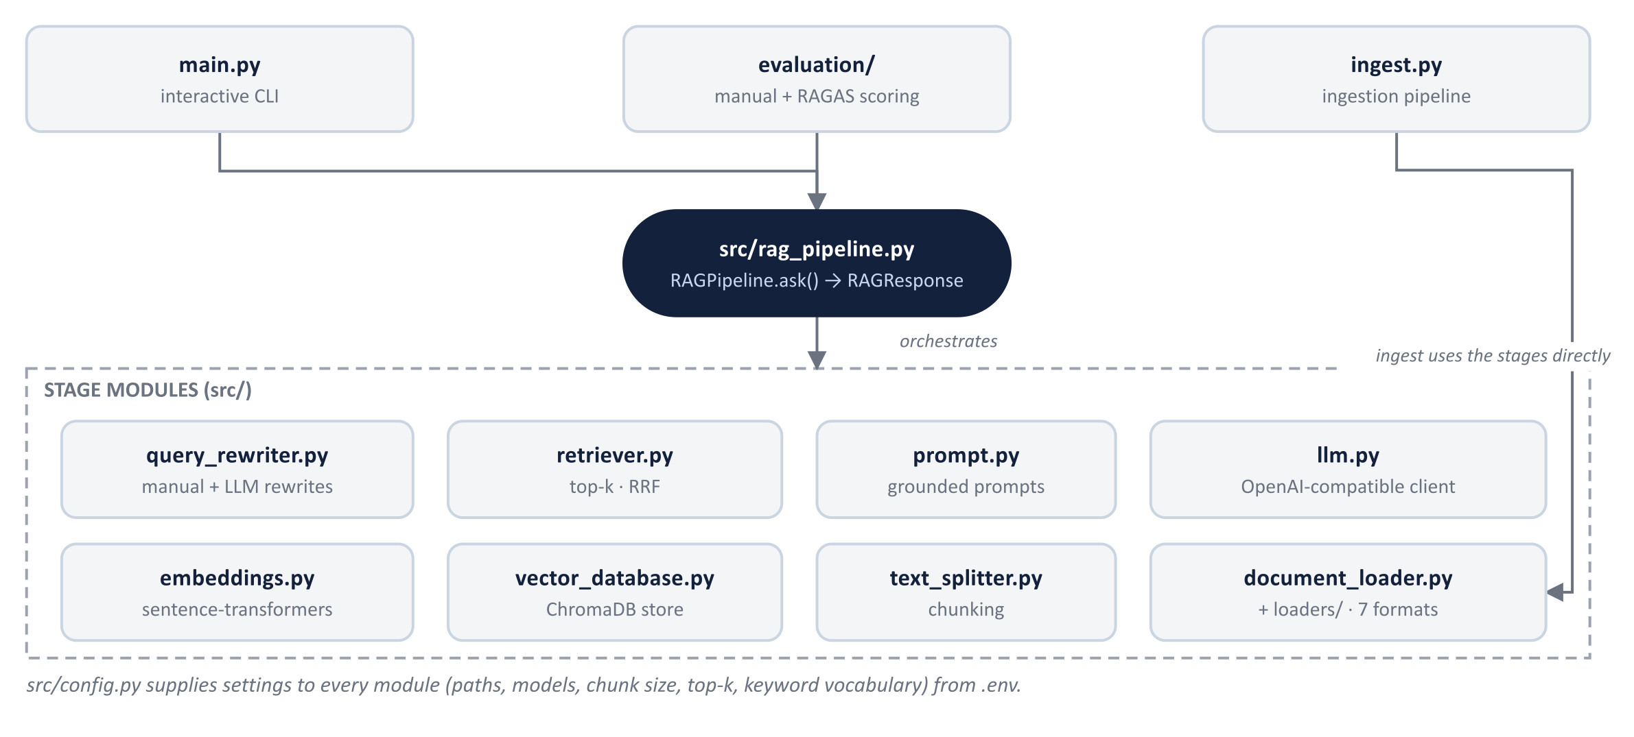
Figure 4.1 – Module structure: entry points, the orchestrator and the stage modules
Module | Responsibility
loaders/*.py | One loader per format returning LoadedDocument objects (text + metadata).
src/config.py | Single source of truth for paths, models, chunking and retrieval parameters, topic vocabulary; loads .env.
src/document_loader.py | Maps file extension → loader; load_directory() ingests a folder and summarises per-file statistics.
src/text_splitter.py | Recursive character splitter producing Chunk objects with stable chunk_ids.
src/embeddings.py | EmbeddingModel wrapper (sentence-transformers), cosine_similarity(), centroid().
src/vector_database.py | Abstract VectorStore + ChromaVectorStore (collection per embedding model, self-healing handle) + factory.
src/retriever.py | Top-k search for one vector and multi-query retrieval with Reciprocal Rank Fusion; RetrievedChunk with scores and hit_count.
src/query_rewriter.py | RewriteStrategy enum, manual rewrite rules, LLM multi-query / HyDE / step-back, hybrid; RewriteResult.
src/prompt.py | Answering prompt with numbered passages and refusal sentence; rewriting and judging prompts.
src/llm.py | ProviderSpec registry, OpenAI-compatible client factory (sync/async), model listing, reasoning-effort handling, retries.
src/rag_pipeline.py | RAGPipeline.ask() → RAGResponse: rewrites, chunks, context, answer, sources, timings; citation normalisation.
ingest.py / main.py | Ingestion CLI (writes chunks.json + manifest) and the interactive question CLI (one-shot mode, /commands, --list-models, --evaluate).
app.py + ui/ | Streamlit web front-end: sidebar settings and the Ask / Knowledge base / Evaluation tabs on the same RAGPipeline; ui/components.py renders, ui/styles.py is the CSS.
src/frontend.py | Helpers shared by both front-ends: live AnswerEvaluator, ground-truth lookup, manifest checks, provider-name aliases.
evaluation/*.py | evaluation_utils (I/O, summaries, diagnosis), manual_evaluation, ragas_evaluation; evaluation_data.json.
Table 4.1 – Modules and responsibilities

4.3 Data model
Object | Fields (abridged) | Produced by
LoadedDocument | text, metadata{source, file_type, page | row | section | item, …} | loaders/
Chunk | chunk_id, text, metadata (inherits document metadata + chunk_index) | text_splitter
SearchHit | chunk_id, text, metadata, score (cosine similarity) | vector_database
RetrievedChunk | rank, chunk_id, text, similarity, rrf_score, hit_count, matched_queries | retriever
RewriteResult | strategy, original, rewrites, notes, fallback flag; all_queries property | query_rewriter
RAGResponse | question, answer, rewrite, chunks, sources[SourceRef], context_text, timings, provider, model, refused | rag_pipeline
Table 4.2 – Core data objects

4.4 Key design decisions
- Local embeddings and an embedded vector database. Company documents never leave the machine for indexing; only the final prompt reaches the LLM provider. ChromaDB needs no server, which keeps the project self-contained.
- One OpenAI-compatible client for all LLM providers. Groq, the Hugging Face router and a local Ollama server all implement the OpenAI chat-completions protocol, so a provider is a registry entry (base URL, key variable, default models) rather than a separate integration. Ollama is marked local: it needs no key, and the CLI reports it as ready only when its server answers.
- A from-scratch text splitter and retriever. No LangChain or LlamaIndex: the algorithms (recursive splitting, RRF) are short and visible, which suits a learning project and avoids heavy dependencies.
- Collection per embedding model. The collection name is derived from the embedding model, so switching models with --embedding-model switches to a dimension-consistent index instead of silently comparing incompatible vectors.
- Fixed refusal sentence. Programmatic detection of refusals makes the UI and evaluation treat "no evidence" answers correctly.
- Front-ends render, they do not compute. Both main.py and app.py call RAGPipeline.ask() and draw the RAGResponse it returns — the CLI through src/console.py, the web app through ui/components.py. Helpers both need (the live evaluator, ground-truth lookup, manifest checks) live in src/frontend.py, so neither front-end imports the other and a pipeline change is reflected in two small renderers.
- Lazy components. The embedding model and store are created on first use and the LLM client on the first question, so retrieval-only operations work without an API key and switching provider or model mid-session (RAGPipeline.set_llm) never reloads the embedding model.

5. Implementation
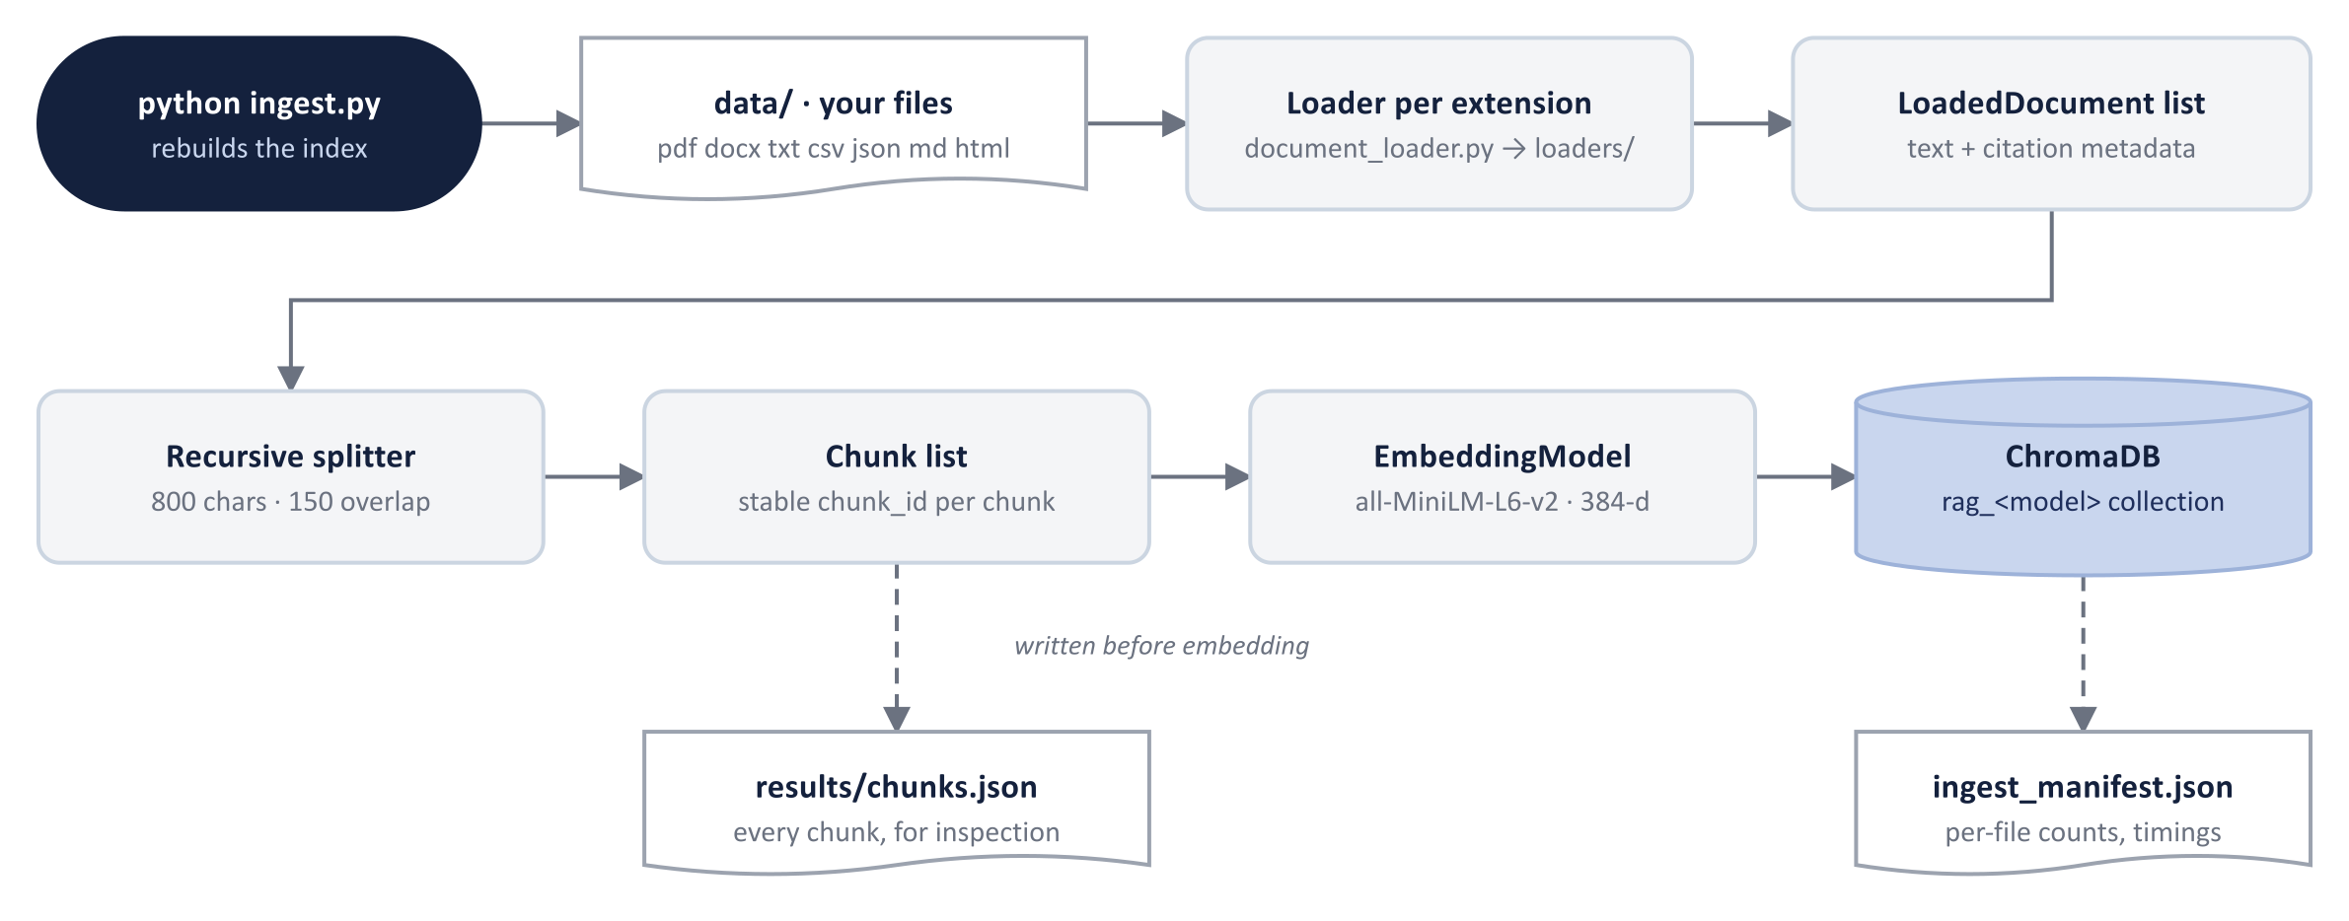
Figure 5.1 – Ingestion pipeline with its two inspection outputs

5.1 Document loading
Each loader in loaders/ implements one function returning a list of LoadedDocument objects. A PDF yields one document per page; a DOCX one per heading-delimited section; a CSV one sentence-like document per row plus a summary document with counts per column; a JSON one per item; Markdown one per heading path; HTML one per section after removing scripts, styles and navigation. src/document_loader.py selects the loader by file extension and reports per-file statistics.
File | Type | Parts | Characters | Chunks
company_policy.pdf | PDF | 3 | 5033 | 8
employee_handbook.docx | DOCX | 9 | 3658 | 10
faq.json | JSON | 15 | 3108 | 15
hr_data.csv | CSV | 26 | 5810 | 26
leave_policy.txt | TXT | 11 | 2841 | 11
notes.md | MD | 7 | 2180 | 7
website_content.html | HTML | 12 | 2164 | 12
Table 5.1 – Sample corpus after ingestion (83 parts → 89 chunks, 384-dimensional vectors, 12.17 s)

5.2 Chunking
src/text_splitter.py implements RecursiveCharacterSplitter with chunk_size = 800 characters and chunk_overlap = 150. The core algorithm:
split(text, separators):
sep = first separator in ["\n\n", "\n", ". ", " ", ""] that occurs in text
pieces = text.split(sep) # keep separator attached
for piece in pieces:
if len(piece) <= chunk_size: buffer.append(piece)
else: buffer.extend(split(piece, remaining separators)) # recurse
return merge(buffer) # pack pieces into windows <= chunk_size,
# carrying the last `overlap` characters forward

chunk_id = f"{source}__{part_index}__c{chunk_index}"
Chunk identifiers are deterministic, so re-ingesting a changed file upserts the same identifiers instead of creating duplicates.
Immediately after splitting — and deliberately before embedding, so the file exists even when the model cannot be loaded — ingest.py writes every chunk to results/chunks.json. Each entry records the order, chunk_id, source file, a human-readable locator (page 2, row 8, section: Benefits), the chunk index within its document part, the character count, the full text and the raw metadata. Because chunk_id is the identifier stored in ChromaDB and printed by the CLI (--show-chunks), a retrieved passage can be looked up in this file, and neighbouring entries make the 150-character overlap visible. Re-running ingestion with different --chunk-size / --chunk-overlap values and comparing the file is the quickest way to reason about chunking choices.
{ "order": 40, "chunk_id": "hr-data__r8__c0", "source": "hr_data.csv", "file_type": "csv",
"locator": "row 8", "chunk_index": 0, "characters": 206,
"text": "employee_id: AD-008; name: Hassan Raza; department: Engineering; ...",
"metadata": { "source": "hr_data.csv", "row": 8, "chunk_index": 0, ... } }

5.3 Embeddings
src/embeddings.py wraps sentence-transformers. embed_documents() batches chunk texts (batch size 32) with normalised output; embed_query() embeds a single question; embed_queries() embeds all rewrite variants at once. centroid() computes the weighted average of several vectors and re-normalises it (used by manual_centroid), and cosine_similarity() is used by the manual evaluation metrics. Four models are registered in src/config.py with their dimensions so that the store can refuse incompatible vectors.

5.4 Vector database
src/vector_database.py defines the abstract VectorStore (add, search, count, sources, reset) and ChromaVectorStore. The collection is created with hnsw:space = cosine; search() converts distances to similarity scores and returns SearchHit objects with metadata. Chroma only accepts scalar metadata, so a _clean_metadata() helper drops None values and stringifies anything else. Because a collection handle stores the collection UUID, the store wraps every call in a helper that re-opens the collection by name if another process has reset it — a bug discovered when rebuilding the index while another session held the collection open.

5.5 Retrieval and Reciprocal Rank Fusion
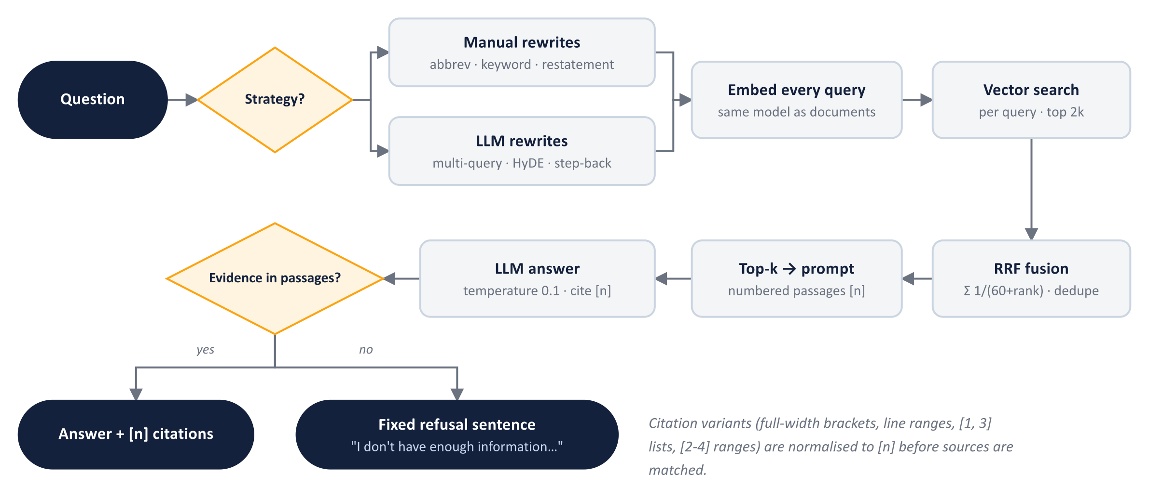
Figure 5.2 – The question path: rewriting, embedding, fused search, grounded generation
src/retriever.py provides retrieve() for a single question, retrieve_by_vector() for a pre-computed vector (used by the centroid and HyDE strategies) and retrieve_multi() for several query variants:
def retrieve_multi(queries, k):
merged = {}
for q in queries:
for rank, hit in enumerate(search(embed(q), k * 2), start=1):
entry = merged.setdefault(hit.chunk_id, RetrievedChunk(hit))
entry.rrf_score += 1.0 / (RRF_K + rank) # RRF_K = 60
entry.hit_count += 1; entry.matched_queries.append(q)
return sorted(merged.values(),
key=lambda e: (-e.rrf_score, -e.hit_count, -e.similarity))[:k]
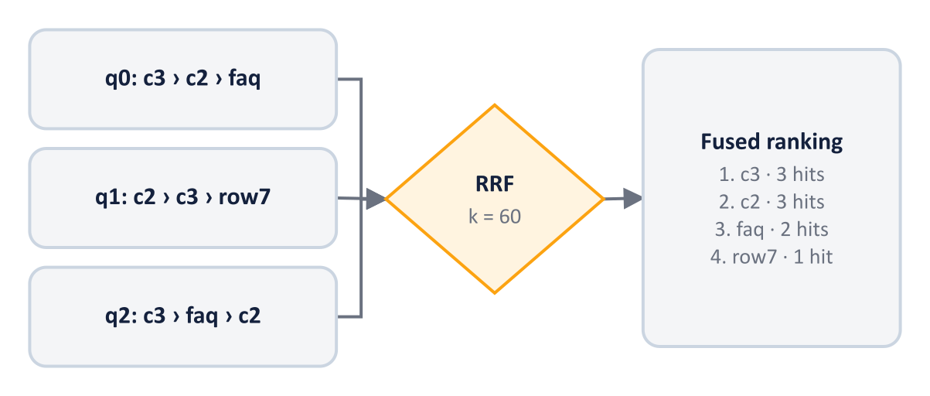
Figure 5.3 – Three ranked lists fused by RRF; agreement (hit count) breaks ties

5.6 Query rewriting
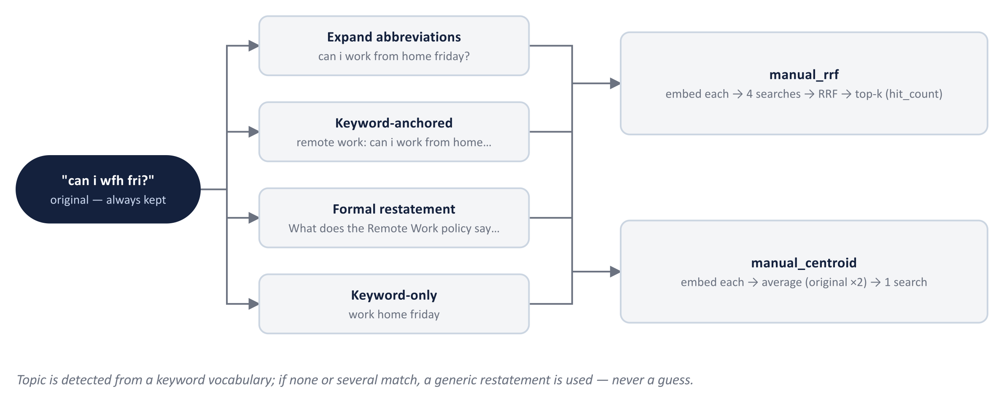
Figure 5.4 – Manual rewriting: rule-based variants embedded and searched by RRF or as a centroid
src/query_rewriter.py implements the RewriteStrategy enum (none, manual_rrf, manual_centroid, llm_multi_query, llm_hyde, llm_step_back, hybrid). The manual rewriter expands abbreviations (wfh → work from home, pto → paid time off, …), detects the topic from a keyword vocabulary in src/config.py (annual leave, sick leave, remote work, probation, expenses, payroll, benefits, training, …), and produces up to four variants: the expanded question, a keyword-anchored form ("remote work: …"), a formal restatement ("What does the Remote Work policy say about: …?") and a keyword-only form. When no topic or several topics match, it uses a generic restatement rather than guessing. The LLM rewriters use short prompts that forbid answering and require one variant per line; any failure falls back to the manual rewriter and is recorded in RewriteResult.notes so the UI can show it.

5.7 Prompting and answer generation
src/prompt.py builds the messages: a system prompt with the grounding rules, the numbered passages with their source and locator, and the question. src/rag_pipeline.py sends them with temperature 0.1, then normalises citation variants (【2】, 【2†L1-L4】, [1, 3], [2-4] → [n]), extracts the cited numbers, groups chunks into SourceRef objects per document (with locators such as "page 2" or "section: 2. ANNUAL LEAVE") and marks which sources were actually cited. The fixed refusal sentence is detected to set RAGResponse.refused.
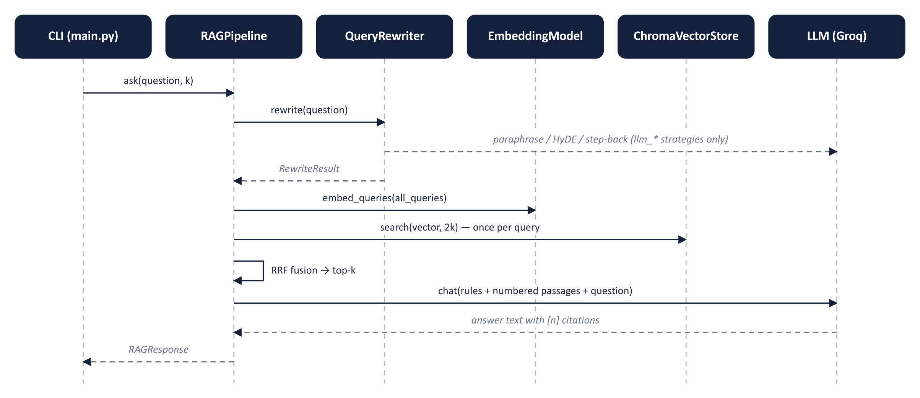
Figure 5.5 – Sequence of calls for one question (RAGPipeline.ask)

5.8 LLM providers
src/llm.py holds a PROVIDERS registry of frozen ProviderSpec dataclass instances — Groq at https://api.groq.com/openai/v1, the Hugging Face router at https://router.huggingface.co/v1 and Ollama at http://localhost:11434/v1 (a local server: no key, "ready" means the server answers GET /models). openai_client() builds a synchronous or asynchronous openai client for a provider; list_models() fetches the live model list (Groq: the free-plan models, Enterprise-only ones filtered out; Hugging Face: 140+ chat models; Ollama: whatever has been pulled) and orders a curated handful first; reasoning_kwargs() adds reasoning_effort=low / include_reasoning=false for reasoning models so their hidden "thinking" tokens do not consume the free-plan budget; chat() retries on HTTP 429 using the retry-after header. The default model is openai/gpt-oss-120b on Groq's free plan (30 requests/min, 8K tokens/min, 200K tokens/day at the time of writing).

5.9 Command-line interface
main.py is the application front-end. In one-shot mode (python main.py -q "…") it answers a single question and exits; without -q it starts an interactive loop. For every question it prints the rewrites produced by the chosen strategy, the retrieved sources with their locators (cited sources marked with *), the answer with [n] citations and the per-stage timings — the layout given in the project brief. Flags select the provider, model, embedding model, strategy and k; --list-models prints the live model catalogue of a provider; --show-chunks prints each retrieved chunk with its similarity, hit count and a text preview. With --evaluate (or /eval in the loop) every answer is followed by the Evaluation block from the brief — Faithfulness, Context Precision, Answer Relevance and Context Recall — computed with the same functions as the batch report; precision and recall are reported when the question has a ground truth in the evaluation set. Inside the loop the commands /strategy, /k, /provider, /model, /models, /chunks and /eval change settings without restarting, /strategies and /providers reprint the strategy and provider lists, /help reprints the command table and /bar hides or shows a one-line list of commands that is drawn under every prompt so the reference stays on screen; provider and model switches go through RAGPipeline.set_llm(), which rebuilds only the LLM client. /model checks the id against the provider's model list and refuses unknown ids (a provider name typed by mistake is answered with a hint to use /provider), and an API failure during a question — unknown model, exhausted rate limit, provider outage — is printed as one status line while the session continues. At start-up the CLI reports each provider's readiness (key present, or for Ollama the local server running), the index size and the chunk size and overlap it was built with, and warns when .env or the data/ folder differ from the manifest. All output is framed by src/console.py, which follows the terminal width (re-measured whenever a section opens, capped at 140 columns, RAG_WIDTH overrides), wraps and truncates on visible characters so that ANSI colour codes never break a line, and falls back to plain ASCII and no colour when output is piped or NO_COLOR / RAG_ASCII are set.

5.10 The data/ folder and the sample documents
As the brief specifies, data/ is simply the folder in which the user places the documents to be indexed; ingest.py reads every supported file in it, sub-folders included, records each file's size and modification time in the manifest, and rebuilds the index so that it always mirrors the folder (--append keeps existing chunks). main.py compares the folder against the manifest at start-up and warns when files were added, removed or edited after the last ingestion. The folder ships with seven sample documents for the fictional company Aurora Dynamics: a company policy PDF (remote work, expenses, code of conduct), an employee handbook DOCX (probation, leave at a glance, benefits, learning budget), a leave policy TXT, an HR directory CSV of 25 employees with departments, roles and managers, a FAQ JSON, Markdown meeting notes and an HTML "about us" page. The sample documents deliberately share facts (the 20-day annual leave entitlement appears in three files) so that multi-document retrieval can be exercised; they can be deleted or replaced at any time. Because evaluation/evaluation_data.json was written for these files, the evaluation scripts check that the question set's expected sources exist in the index and otherwise ask for a matching --dataset.

5.11 Web front-end (app.py)
The web application was added as a second front-end after the command-line version was complete, under four constraints: the CLI keeps every feature and remains the reference output; nothing inside src/ or evaluation/ changes; every CLI setting appears once in the sidebar and an answer scored in the browser scores the same in the terminal; and the heavy objects are loaded once per server process and shared by every browser session.
Preparation. The helpers the CLI had accumulated that the web page also needs — AnswerEvaluator (the live Evaluation block), find_ground_truth, relevance_label, index_settings, data_changes and resolve_provider — were moved from main.py into src/frontend.py (156 lines, no printing, no widgets). main.py imports the same names it used to define and shrank by 118 lines; its --evaluate output was re-run and is unchanged. app.py cannot import main.py (which reconfigures stdout and owns the argparse loop), so a shared module was the only way to avoid a second copy.
Structure. app.py (502 lines) has a sidebar and three tabs. The sidebar mirrors the CLI flags: provider radio with a readiness light (a key present, or for Ollama the local server answering), model select (curated models first, then the provider's live list), rewriting strategy with the same descriptions as the CLI, the k slider, and toggles for the rewrite panel, the chunk panel and per-answer evaluation, followed by the index summary and the same two warnings the CLI prints at start-up (.env differs from the index; data/ changed since ingestion). The Ask tab keeps a chat history in st.session_state; each answer is drawn by ui/components.py (198 lines, 11 pure rendering functions): the answer with [n] rendered as chips whose tooltip names the source and locator, a sources table with a star for cited files, expanders for the rewrites and the retrieved chunks (rank, chunk id, score, similarity, hit count, per-phrasing rank, text) and the four-metric Evaluation block. The Knowledge base tab shows the manifest and the files in data/, accepts uploads into data/ and removes files from it (the index follows on the next rebuild), and rebuilds or appends the index through the same ingest() function as ingest.py, passing a progress callback the function already accepted; it also offers a searchable view of results/chunks.json. The Evaluation tab runs Stage A (run_pipeline_on_dataset), the manual evaluation (manual_evaluation.evaluate_rows) and RAGAS (ragas_evaluation.evaluate_rows) with progress, writes the same files as the scripts, and reads the two CSVs back into a grouped bar chart, a per-question table with diagnosis and notes, and download buttons.
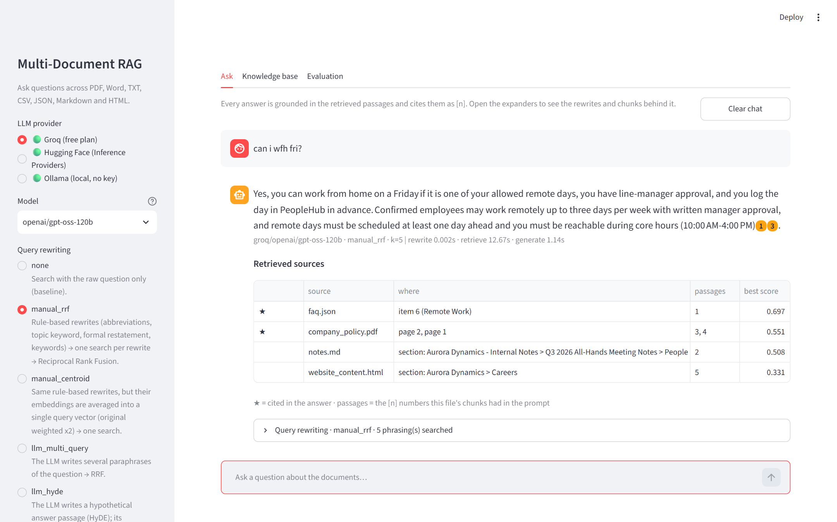
Figure 5.6 – The Ask tab: sidebar settings, an answer with citation chips, the sources table and the rewriting expander
Caching. Streamlit re-runs the script on every interaction, so the pipeline (embedding model + vector store) is an st.cache_resource keyed on the embedding model; provider and model changes go through RAGPipeline.set_llm(), which rebuilds only the small LLM client. The live evaluator is a second cached resource; provider_status() (which probes the Ollama port) and list_models() are st.cache_data with 60 s and 5 min lifetimes. After an ingest from the browser both resource caches are cleared so counts and manifest refresh. Measured on the development laptop: the first question costs about 15 s (model load and index open); each question after that spends the same time as the CLI (rewrite 0.002 s, retrieve 0.01 s, generate about 0.75 s on Groq).
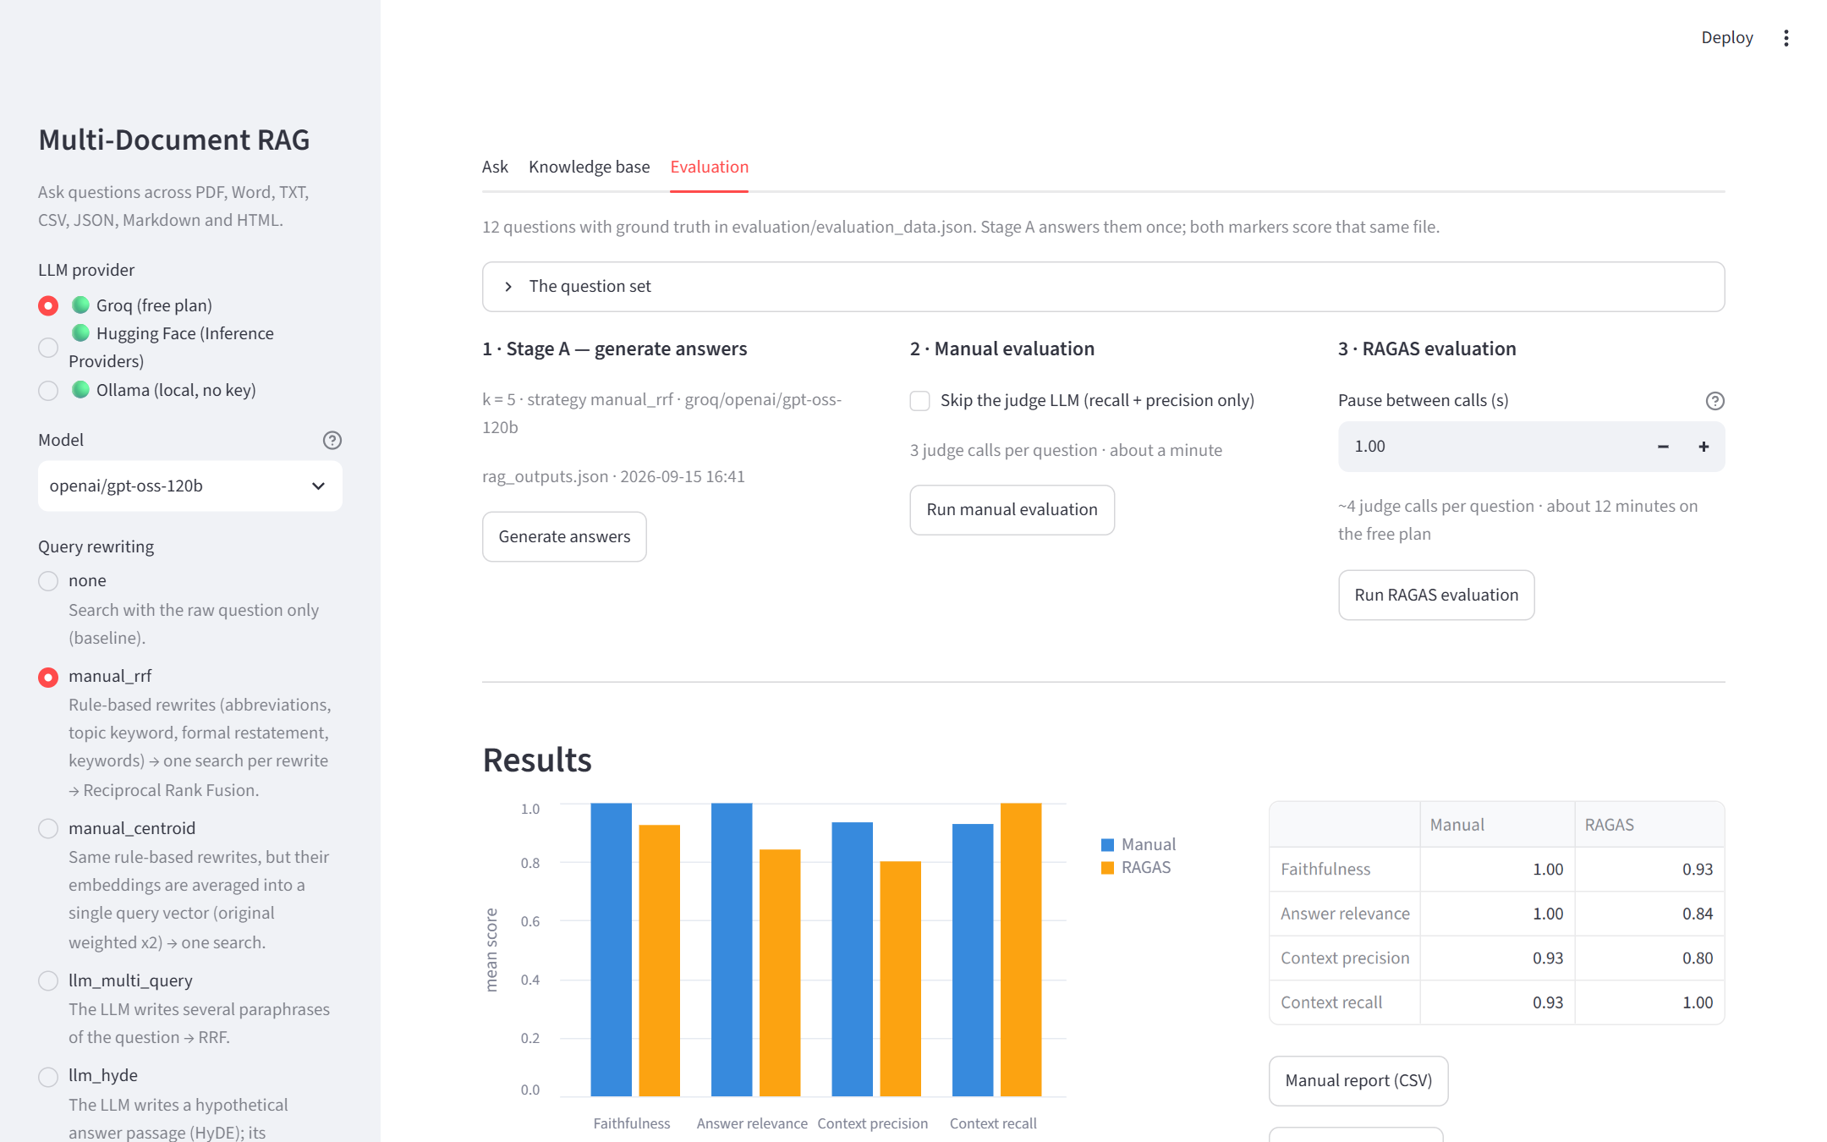
Figure 5.7 – The Evaluation tab after Stage A and both markers: grouped means, the summary table and CSV downloads
Size of the change: 902 lines added (app.py 502, ui/components.py 198, ui/styles.py 46, src/frontend.py 156), 118 lines removed from main.py, zero lines changed in src/ or evaluation/ apart from the new module, one optional dependency (streamlit). Both front-ends can run at the same time against the same index; the self-healing ChromaDB handle (Chapter 7) covers one of them rebuilding while the other answers.

6. Testing and Evaluation
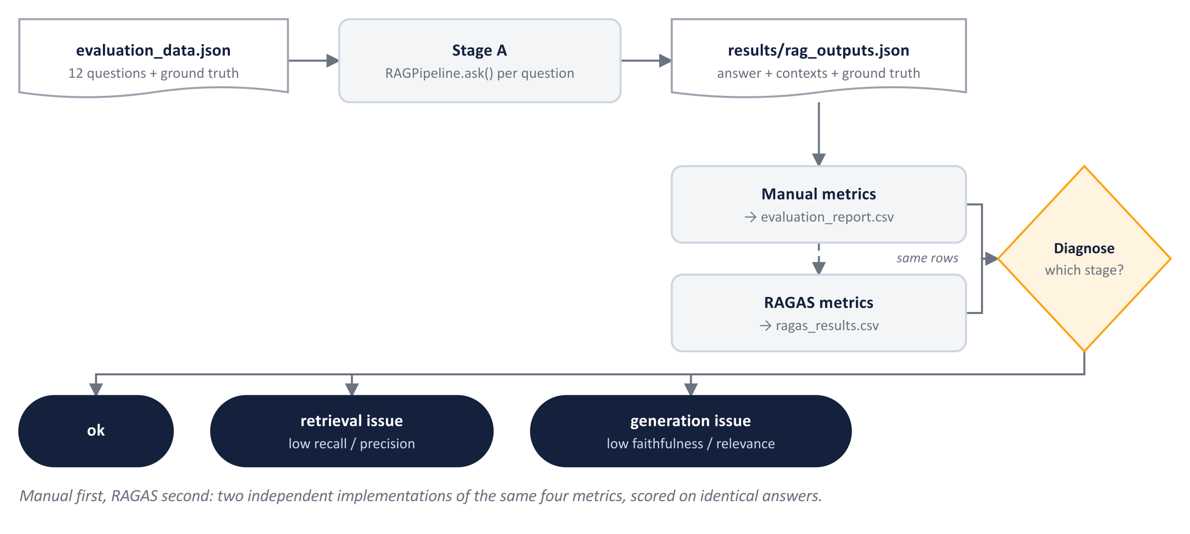
Figure 6.1 – Evaluation pipeline: one set of answers, two scorers, one diagnosis

6.1 Functional testing
Each requirement was exercised end-to-end through the CLI with the Groq provider. Representative cases:
Test | Input | Observed result
Demo question from the brief | How many annual leave days are allowed? (manual_rrf) | Sources: employee_handbook.docx, leave_policy.txt (cited), faq.json. Answer: "Employees are entitled to 20 paid annual leave days per calendar year [2][3]."
Informal query | can i wfh fri? (llm_multi_query) | Three paraphrases generated; answer cites the remote-work policy (up to three days per week, manager approval, core hours).
HyDE | How many unused leave days can I carry over? (llm_hyde) | Hypothetical passage generated; answer "up to 5 unused annual leave days" with citations.
Structured data | Who is Fatima Noor's manager? (llm_step_back) | Step-back question generated; answer "Hira Siddiqui" from hr_data.csv.
Aggregate | How many employees work in the Data Engineering department? (hybrid) | Seven queries fused; answer "4" from the CSV summary chunk.
Out of scope | What is Aurora Dynamics' current stock price? | Explicit refusal sentence; refused flag set; no hallucination.
Ingestion | python ingest.py | 83 parts → 89 chunks in 12.17 s; results/chunks.json (89 entries) and the manifest written.
Changed documents | add a file to data/, start main.py | Start-up warns: "data/ changed since the index was built (1 added: …) — run python ingest.py".
Empty folder | python ingest.py --data-dir <empty> | Clear message: the folder is empty; put PDF/DOCX/TXT/CSV/JSON/MD/HTML files there.
Concurrent rebuild | ingest.py while another session holds the collection | Store re-opens the collection; no crash (after fix, see Chapter 7).
Runtime commands | /model openai/gpt-oss-20b, /strategy llm_multi_query, /k 4, /chunks, /provider huggingface, /strategies, /providers, /help, /bar | Prompt reflects each change; next answer uses the new settings; chunk view shows similarity and hit counts; the lists reprint; the command bar toggles.
Model validation | /model Hugging Face on Groq; /model does-not-exist; /model Qwen/Qwen3-32B on Hugging Face | First two refused with a hint ("is a provider — use /provider huggingface"; "not in the model list — see /models"); third accepted.
Web app — Ask | streamlit run app.py; "can i wfh fri?" then a dataset question with all toggles on, in light and dark themes | Cited answer with chips, sources table, rewrites and chunk panels, Evaluation block with four scores and diagnosis; identical numbers to the CLI for the same question.
Web app — Knowledge base | Ingest now (700/150) from the browser | Progress bar, "83 parts → 93 chunks in 1.86 s", manifest and sidebar counts refreshed after the cache reset.
Web app — Evaluation | Generate answers, then Run manual evaluation, from the browser | 12 answers saved; manual means 1.00 / 1.00 / 0.91 / 0.94 (report: 1.00 / 1.00 / 0.93 / 0.93); chart and per-question table rendered; CSV downloads work.
Ollama provider | /provider ollama with no server; then against an OpenAI-compatible server on port 11434 | Banner shows "not running" with the start command; a question prints one connection-error line and the session continues. With a server: "ready", live model list (embedding models hidden), /model, a cited answer, /provider groq back.
Per-answer evaluation | main.py -q "How many annual leave days are allowed?" --evaluate | Evaluation block: Faithfulness 1.00, Context Precision 1.00, Answer Relevance High (1.00), Context Recall 1.00, Diagnosis ok. For a question outside the set, precision/recall show n/a.
Table 6.1 – Functional test cases

6.2 Evaluation dataset
evaluation/evaluation_data.json contains 12 questions, each with a ground-truth answer and the files expected to contain the evidence. Categories: multi-document (7), single-document (2), structured-data (1), aggregate (1), out-of-scope (1). The full list is given in Appendix C.

6.3 Manual evaluation
evaluation/manual_evaluation.py first runs the pipeline over the dataset (k = 5, strategy manual_rrf) and stores the outputs in results/rag_outputs.json, then scores each row:
- Faithfulness: the judge LLM extracts the factual claims from the answer, then verifies each claim against the numbered contexts in JSON mode; score = supported ÷ total. A refusal has no claims and scores 1.0.
- Answer relevance: the judge rates how well the answer addresses the question on a 1–5 scale, scaled to 0–1; the cosine similarity between the question and answer embeddings is reported alongside as a judge-free signal.
- Context precision: a retrieved chunk is deemed relevant when its cosine similarity to the ground-truth answer is at least 0.45; the average-precision formula over ranks yields 1.0 when all relevant chunks are ranked first. No LLM required.
- Context recall: the fraction of the ground truth's content words and numbers that occur anywhere in the retrieved contexts; expected-source recall additionally checks that the expected files were hit. No LLM required.
The script writes results/evaluation_report.csv and prints a summary table with a diagnosis column: low precision/recall → "retrieval issue"; low faithfulness/relevance → "generation issue".

6.4 RAGAS evaluation
evaluation/ragas_evaluation.py scores the same rag_outputs.json with RAGAS 0.4.3 metric classes (Faithfulness, AnswerRelevancy, ContextPrecisionWithReference, ContextRecall). The judge is Groq's openai/gpt-oss-120b, connected through ragas.llms.llm_factory with an AsyncOpenAI client; embeddings are the local sentence-transformers model through ragas.embeddings.HuggingFaceEmbeddings. Calls are paced with a configurable pause to respect the free plan, and any metric error is recorded in a ragas_errors column instead of aborting the run. Results are written to results/ragas_results.csv together with a side-by-side comparison against the manual report.

6.5 Results
Metric | Manual | RAGAS | Difference
Faithfulness | 1.00 | 0.93 | -0.07
Answer relevance | 1.00 | 0.84 | -0.16
Context precision | 0.93 | 0.80 | -0.13
Context recall | 0.93 | 1.00 | +0.07
Table 6.2 – Mean scores over the 12 questions (k = 5, manual_rrf, judge openai/gpt-oss-120b)
# | Question | Faith. | Relev. | Prec. | Recall | Diagnosis
1 | How many annual leave days are allowed? | 1.00 | 1.00 | 1.00 | 1.00 | ok
2 | How long is the probation period and can it be extended? | 1.00 | 1.00 | 1.00 | 1.00 | ok
3 | How many days per week can confirmed employees work remot… | 1.00 | 1.00 | 1.00 | 1.00 | ok
4 | Within how many days must an expense claim be submitted, … | 1.00 | 1.00 | 1.00 | 1.00 | ok
5 | In which cities does Aurora Dynamics have offices, and wh… | 1.00 | 1.00 | 0.95 | 0.88 | ok
6 | Who is the manager of Fatima Noor and what is her role? | 1.00 | 1.00 | 1.00 | 0.92 | ok
7 | On which day of the month is salary paid? | 1.00 | 1.00 | 1.00 | 1.00 | ok
8 | What is the annual learning budget and who is eligible fo… | 1.00 | 1.00 | 1.00 | 1.00 | ok
9 | How many unused annual leave days can be carried over to … | 1.00 | 1.00 | 1.00 | 1.00 | ok
10 | Does the company health insurance cover dental treatment? | 1.00 | 1.00 | 0.83 | 1.00 | ok
11 | How many employees work in the Data Engineering department? | 1.00 | 1.00 | 0.50 | 0.43 | retrieval issue
12 | What is Aurora Dynamics' current stock price? | 1.00 | 1.00 | n/a | n/a | ok
Table 6.3 – Manual evaluation per question (results/evaluation_report.csv)
# | Question | Faith. | Relev. | Prec. | Recall | Diagnosis
1 | How many annual leave days are allowed? | 1.00 | 0.81 | 0.58 | 1.00 | ok
2 | How long is the probation period and can it be extended? | 1.00 | 0.81 | 1.00 | 1.00 | ok
3 | How many days per week can confirmed employees work remot… | 1.00 | 0.93 | 0.95 | 1.00 | ok
4 | Within how many days must an expense claim be submitted, … | 1.00 | 0.91 | 1.00 | 1.00 | ok
5 | In which cities does Aurora Dynamics have offices, and wh… | 1.00 | 0.95 | 0.70 | 1.00 | ok
6 | Who is the manager of Fatima Noor and what is her role? | 0.50 | 0.96 | 0.50 | 1.00 | generation issue
7 | On which day of the month is salary paid? | 1.00 | 0.88 | 1.00 | 1.00 | ok
8 | What is the annual learning budget and who is eligible fo… | 1.00 | 0.91 | 0.75 | 1.00 | ok
9 | How many unused annual leave days can be carried over to … | 1.00 | 0.95 | 0.83 | 1.00 | ok
10 | Does the company health insurance cover dental treatment? | 0.75 | 1.00 | 1.00 | 1.00 | ok
11 | How many employees work in the Data Engineering department? | 1.00 | 1.00 | 0.50 | 1.00 | ok
12 | What is Aurora Dynamics' current stock price? | 0.86 | 0.00 | n/a | n/a | generation issue
Table 6.4 – RAGAS evaluation per question (results/ragas_results.csv)

6.6 Analysis
Both evaluators agree that the system is faithful to its evidence and retrieves the needed context; RAGAS is stricter on answer relevance and context precision. Eleven of the twelve generated answers were checked by hand against the source documents and found correct; the twelfth question is deliberately unanswerable and was refused. Three rows explain most of the difference between the two evaluators:
- Q12 (out of scope, "stock price"). The refusal is the correct behaviour. The manual metric scores it as fully relevant (1.00) because an honest refusal addresses the question; RAGAS AnswerRelevancy returns 0.00 by design, treating non-committal answers as irrelevant. Same answer, opposite verdicts — a metric must be read with its definition.
- Q6 (CSV row lookup). The answer — Fatima Noor's manager is Hira Siddiqui and her role is Senior Data Engineer — matches the HR row exactly, yet RAGAS faithfulness came out at 0.50: the judge split the sentence into two claims and rejected one. The manual metric scored 1.00. LLM judges are noisy; running two independent implementations exposes such cases.
- Q11 (aggregate count). The count (4) is correct and came from the CSV summary chunk, but manual context recall is 0.43 because not all four employee rows named in the ground truth were among the five retrieved chunks. The diagnosis column correctly labels this a retrieval issue; raising k or adding a department-oriented rewrite would resolve it.
RAGAS context precision is also lower on several single-document questions (for example Q1 at 0.58) because the corpus repeats facts across files: the retriever returns several passages that all support the answer, and RAGAS's per-chunk judge marks the redundant ones as not needed. This is a property of the sample data rather than a retrieval failure.

6.7 Performance
On the development laptop (CPU only) ingestion of the sample corpus takes about 12.17 seconds including embedding-model load. At question time a typical request spends roughly 0.1 s in retrieval (multi-query with four variants against 89 chunks; the first call of a session adds the embedding-model load) and 0.4–1.5 s in generation on Groq. The full RAGAS run over 12 questions takes about 12 minutes because of the free plan's 8K-tokens-per-minute limit; the manual evaluation, which needs the judge for only two of its four metrics, is faster.

7. Challenges and Solutions
Challenge | Cause | Solution
RAGAS would not install on Python 3.14 | Its dependency scikit-network has no 3.14 wheel and fails to compile; langchain-community 0.4 removed a module RAGAS imports. | Install RAGAS with --no-deps, pin langchain-community < 0.4 and list every needed dependency explicitly in requirements.txt (scikit-network is only used by test-set generation, which the project does not use).
Stale ChromaDB collection handle | Rebuilding the index with ingest.py while another process held the collection left that process with the UUID of a deleted collection. | ChromaVectorStore routes every call through a helper that catches NotFoundError, re-opens the collection by name and retries.
Console crashes on Windows | The default cp1252 code page cannot print curly quotes and non-breaking hyphens emitted by the model. | All CLI entry points reconfigure stdout to UTF-8; citation variants are normalised.
RAGAS metrics failed with "Cannot use agenerate() with a synchronous client" | RAGAS metric classes call the judge asynchronously. | openai_client() gained an async_client option; the judge is built with AsyncOpenAI.
Free-plan rate limits (HTTP 429) | Groq's free plan allows 8K tokens per minute per model; a RAGAS run makes many calls. | Retries honour the retry-after header (8 attempts), reasoning_effort=low reduces token use, and a configurable pause between calls paces the run.
Model line-up changed during the project | Groq moved the Llama 3.x models to an Enterprise tier. | Defaults switched to openai/gpt-oss-120b; the model list is fetched live and free-plan models are pinned first.
Coloured table rows wrapped although the frame had room | The console wrapped lines with textwrap, which counts invisible ANSI colour codes as text (about nine characters per coloured cell); truncation had the mirror problem. | src/console.py wraps and truncates on visible length, passes colour codes through and closes an open style at a line break; the frame also follows the terminal width. The bug was invisible in piped (colour-less) test runs — a reminder to test the styled path.
Web app: edits to ui/ not picked up | Streamlit hot-reloads app.py but not the modules it imports; an AttributeError named a function that existed. | Restart the server after editing ui/ or src/; documented in the README troubleshooting table.
Web app: results chart stacked the two markers | st.bar_chart stacks series and sorts categories alphabetically. | Altair grouped bar chart in the brief's metric order with a 0–1 axis; theme-neutral colours after the navy bars vanished on the dark theme.
Model emitted unexpected citation formats | gpt-oss writes 【2】, 【2†L1-L4】 (a line-range form) or [1, 3]. | normalize_citations() in rag_pipeline.py maps every variant to [n].
Table 7.1 – Challenges and their solutions

8. Conclusion and Future Work

8.1 Conclusion
The project delivers what the brief asked for: a complete RAG system over seven document formats with source display, plus a two-stage evaluation. Beyond the brief it adds two families of query rewriting (rule-based variants matched by embeddings, and LLM strategies including HyDE and step-back) fused with Reciprocal Rank Fusion, a pluggable LLM provider layer, and a command-line application that makes every stage of the pipeline inspectable and every setting switchable at runtime. On the evaluation set the system is faithful (manual 1.00, RAGAS 0.93), retrieves the needed evidence (context recall 0.93 / 1.00) and refuses correctly when the documents do not contain an answer. Implementing the metrics by hand before running RAGAS proved valuable: it made the metric definitions concrete and revealed that two of the largest disagreements were properties of the metric definition and judge noise rather than system defects.

8.2 Future work
The web front-end that the first version of this report listed as future work has since been built (Section 5.11); the remaining items are:
- Hybrid search: add BM25 keyword retrieval and fuse it with the vector results through the existing RRF code to capture exact identifiers and rare terms.
- Re-ranking: re-score the fused top-20 with a cross-encoder before prompting to raise context precision.
- More vector stores: FAISS and Qdrant implementations of the VectorStore interface, selectable with a --vector-db flag.
- Conversation memory: rewrite follow-up questions using chat history so that elliptical questions ("and for interns?") resolve correctly.
- Larger evaluation set: use RAGAS test-set generation to grow the dataset, and run per-strategy comparisons to quantify the effect of each rewriting method.
- Hardening the web front-end: streaming answers (a streaming path in src/llm.py with citations resolved after the stream), background execution of the long evaluation runs, authentication and per-team document permissions before any deployment beyond a laptop.

References
- Lewis, P. et al. (2020). Retrieval-Augmented Generation for Knowledge-Intensive NLP Tasks. Advances in Neural Information Processing Systems 33.
- Reimers, N. & Gurevych, I. (2019). Sentence-BERT: Sentence Embeddings using Siamese BERT-Networks. EMNLP 2019.
- Malkov, Y. A. & Yashunin, D. A. (2018). Efficient and Robust Approximate Nearest Neighbor Search Using Hierarchical Navigable Small World Graphs. IEEE TPAMI.
- Cormack, G. V., Clarke, C. L. A. & Büttcher, S. (2009). Reciprocal Rank Fusion Outperforms Condorcet and Individual Rank Learning Methods. SIGIR 2009.
- Gao, L., Ma, X., Lin, J. & Callan, J. (2022). Precise Zero-Shot Dense Retrieval without Relevance Labels (HyDE). arXiv:2212.10496.
- Zheng, H. S. et al. (2023). Take a Step Back: Evoking Reasoning via Abstraction in Large Language Models. arXiv:2310.06117.
- Es, S., James, J., Espinosa-Anke, L. & Schockaert, S. (2023). RAGAS: Automated Evaluation of Retrieval Augmented Generation. arXiv:2309.15217.
- ChromaDB documentation, https://docs.trychroma.com
- Groq documentation: Supported Models and Rate Limits, https://console.groq.com/docs
- sentence-transformers documentation, https://www.sbert.net

Appendix A – Project structure
multi_document_rag_project/
|-- data/ company_policy.pdf employee_handbook.docx leave_policy.txt
| hr_data.csv faq.json notes.md website_content.html
|-- loaders/ base.py pdf_loader.py docx_loader.py txt_loader.py csv_loader.py
| json_loader.py markdown_loader.py html_loader.py
|-- src/ config.py document_loader.py text_splitter.py embeddings.py
| vector_database.py retriever.py query_rewriter.py prompt.py
| llm.py rag_pipeline.py
|-- evaluation/ evaluation_data.json evaluation_utils.py
| manual_evaluation.py ragas_evaluation.py
|-- results/ chunks.json ingest_manifest.json rag_outputs.json
| evaluation_report.csv ragas_results.csv
|-- ui/ components.py styles.py (web-app rendering)
|-- docs/ presentations, screenshots and this report
|-- main.py app.py ingest.py requirements.txt .env.example .gitignore README.md
`-- chroma_db/ created at ingest time (git-ignored)

Appendix B – Installation and run instructions
python -m venv .venv
.venv\Scripts\activate # Windows
pip install -r requirements.txt
pip install ragas==0.4.3 --no-deps # see README for why
copy .env.example .env # add GROQ_API_KEY (free plan)

# put your documents in data/ (the sample set is already there)
python ingest.py # load -> chunk -> embed -> ChromaDB (full rebuild)
python main.py # interactive CLI
streamlit run app.py # web front-end (same pipeline)
python main.py --list-models # models per provider (--provider huggingface | ollama)
python main.py --evaluate # Evaluation: block under each answer

python evaluation/manual_evaluation.py --generate
python evaluation/ragas_evaluation.py --sleep 1.5

Appendix C – Evaluation questions
# | Category | Question | Ground truth (abridged) | Expected sources
1 | multi-document | How many annual leave days are allowed? | Employees receive 20 paid annual leave days per calendar year. | employee_handbook.docx, leave_policy.txt
2 | multi-document | How long is the probation period and can it be extended? | The probation period is 3 months. It can be extended once by up to 3 additional months; it cannot be extend… | company_policy.pdf, employee_handbook.docx, faq.json
3 | multi-document | How many days per week can confirmed employees work remotely? | Confirmed employees may work remotely up to 3 days per week with written approval from their line manager. … | company_policy.pdf, faq.json, notes.md
4 | multi-document | Within how many days must an expense claim be submitted, and when are receipts required? | Expense claims must be submitted within 30 days of the expense being incurred. Receipts are mandatory for e… | company_policy.pdf, faq.json
5 | single-document | In which cities does Aurora Dynamics have offices, and which one is the headquarters? | Aurora Dynamics has offices in Lahore, Karachi and Dubai. The Lahore office is the headquarters. | website_content.html
6 | structured-data | Who is the manager of Fatima Noor and what is her role? | Fatima Noor is a Senior Data Engineer in the Data Engineering department, based in Karachi, and her manager… | hr_data.csv
7 | single-document | On which day of the month is salary paid? | Payroll is processed on the 25th of every month. If the 25th falls on a weekend or public holiday, salary i… | faq.json
8 | multi-document | What is the annual learning budget and who is eligible for it? | Every confirmed employee has a learning budget of USD 1,000 per year for courses, certifications and confer… | notes.md, employee_handbook.docx, faq.json
9 | multi-document | How many unused annual leave days can be carried over to the next year, and by when must they be used? | A maximum of 5 unused annual leave days can be carried over into the next calendar year, and they must be u… | leave_policy.txt, faq.json, employee_handbook.docx
10 | multi-document | Does the company health insurance cover dental treatment? | No. Dental and optical treatment are not covered. The plan covers inpatient care in full and outpatient car… | employee_handbook.docx, faq.json
11 | aggregate | How many employees work in the Data Engineering department? | Four employees work in the Data Engineering department: Hira Siddiqui, Fatima Noor, Usman Tariq and Laiba S… | hr_data.csv
12 | out-of-scope | What is Aurora Dynamics' current stock price? | The documents do not contain any information about a stock price. The system should say it does not have en…
Table C.1 – The evaluation dataset (evaluation/evaluation_data.json)

Appendix D – Configuration variables (.env)
Variable | Purpose | Default
LLM_PROVIDER | Default provider (groq | huggingface | ollama) | groq
GROQ_API_KEY / GROQ_MODEL | Groq key and model | openai/gpt-oss-120b
HF_TOKEN / HF_MODEL | Hugging Face token and model | meta-llama/Llama-3.3-70B-Instruct
OLLAMA_BASE_URL / OLLAMA_MODEL | Local Ollama server (no key) and model | http://localhost:11434/v1 / llama3.2
EMBEDDING_MODEL | sentence-transformers model | sentence-transformers/all-MiniLM-L6-v2
VECTOR_DB / CHROMA_DIR | Store backend and folder | chroma / chroma_db
CHUNK_SIZE / CHUNK_OVERLAP | Chunking parameters (characters) | 800 / 150
TOP_K / RRF_K | Chunks retrieved / RRF constant | 5 / 60
QUERY_REWRITE_STRATEGY | Default rewriting strategy | manual_rrf
LLM_TEMPERATURE / LLM_MAX_TOKENS | Generation settings | 0.1 / 1024
RAGAS_JUDGE_PROVIDER / RAGAS_JUDGE_MODEL | Judge used by RAGAS and manual metrics | groq / openai/gpt-oss-120b
Table D.1 – Configuration variables

