
4. Web Server Administration
Miquel Àngel París i Peñaranda
Web Application Deployment
2nd C-VET Web Application Development

Index
SSH exercises 3

SSH exercises

Practice 1: SSH
At the end of this practice, you must submit a script that explains and demonstrates the process and steps followed to complete each of the following tasks:
- Start the SSH server on your machine and verify that you can access it with any user from any device.
- Configure the SSH service so that:
  - Logging in as root is not allowed.
  - Then, allow logging in as root.
  - Create two new users: user2 and user3, and a group named ssh_users. Add these users to the group and ensure that only the members of this group can access the SSH service.
- The SSH service, by default, listens on port 22. Modify it to start on port 10022 (or another port), and figure out the command required to access the server on this port. (Hint: Use man ssh)
- By default, when authenticating successfully on the SSH server, it shows the date and time of the last connection. Find the option responsible for this behavior and modify it.
- Configure the SSH server to enable X11 redirection, allowing the execution of graphical applications remotely. Test and verify its functionality.
- Test connecting from a Windows SSH client (e.g., PuTTY) to a GNU/Linux SSH server and verify the connection.

Practice 1:
Exercise 1:Start the SSH server on your machine and verify that you can access it with any user from any device.
Server’s machine: $ systemctl start ssh && systemctl status ssh
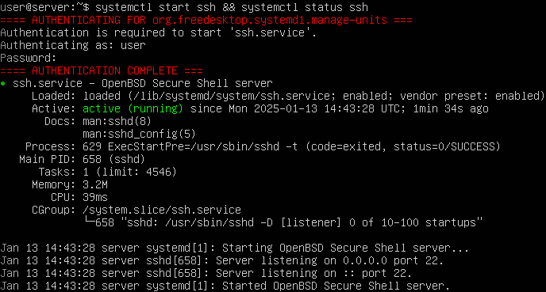
Server’s machine: $ ssh user@192.168.18.251
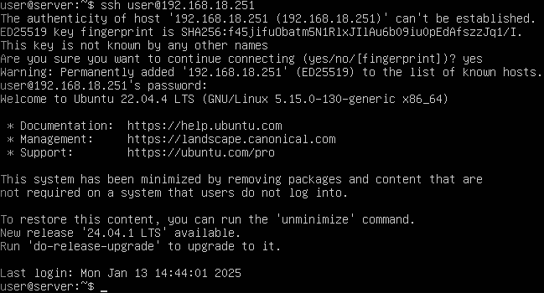
Client’s machine: $ssh user@192.168.18.251
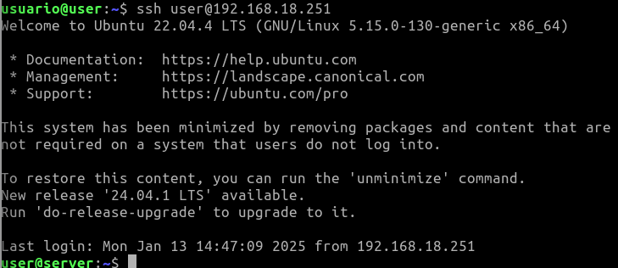
Exercise 2: Configure the SSH service so that:
Exercise 2.1: Logging in as root is not allowed.
Server’s machine(folder:’/etc/ssh/’): $ sudo nano sshd_config
In this file, we must descomment the line ‘PermitRootLogin’ and change the value for ‘no’
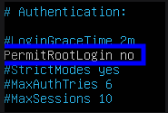

Server’s machine: $ sudo nano systemctl restart ssh && sudo systemctl status ssh
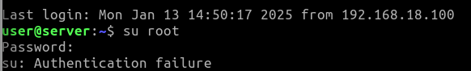
Client’s machine:(After we connected to the server):$su root

Exercise 2.1: Then, allow logging in as root
Server’s machine(folder:’/etc/ssh/’): $ sudo nano sshd_config
In this file, we must descomment the line ‘PermitRootLogin’ and change the value for ‘yes’
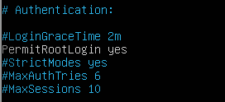

Also, for activate the user root, we need to set new password: $sudo passwd root

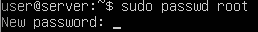
Client’s machine:(After we connected to the server):$su root
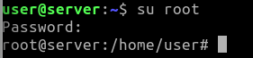

Exercise 2.2:Create two new users: user2 and user3, and a group named ssh_users. Add these users to the group and ensure that only the members of this group can access the SSH service
Server’s machine: $sudo groupadd ssh_users
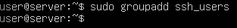

Server’s machine: $useradd -m(with this parameter, when the server create the user, also create the personal folder for the user called /home/<name_of_user>) user2 && sudo passwd user2
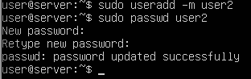
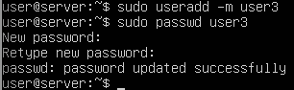

Server’s machine: $usermod -aG ssh_users user2 && usermod -aG ssh_users user3
Server’s machine(folder:’/etc/ssh/’): $ sudo nano sshd_config
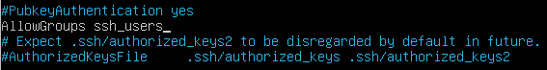

Server’s machine: $ sudo nano systemctl restart ssh && sudo systemctl status ssh

Client’s machine: $ssh user2@192.168.18.251
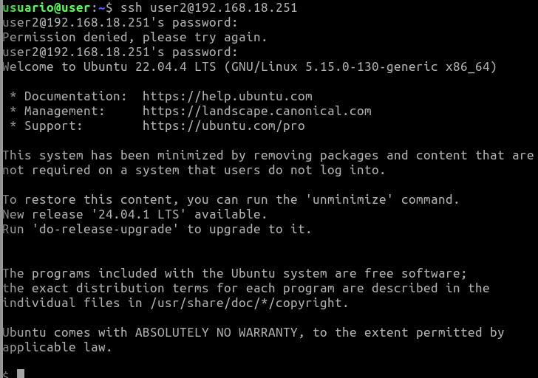

Exercise 3: The SSH service, by default, listens on port 22. Modify it to start on port 10022 (or another port), and figure out the command required to access the server on this port.
Server’s machine(folder:’/etc/ssh/’): $ sudo nano sshd_config
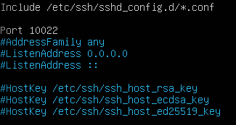

Server’s machine: $ sudo nano systemctl restart ssh && sudo systemctl status ssh

To comprobate that the SSH service is listening for port 10022 we will execute in the server’s machine: $grep -i port /etc/ssh/sshd_config
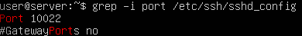

Client’s machine: $ssh -p 10022 user2@192.168.18.251
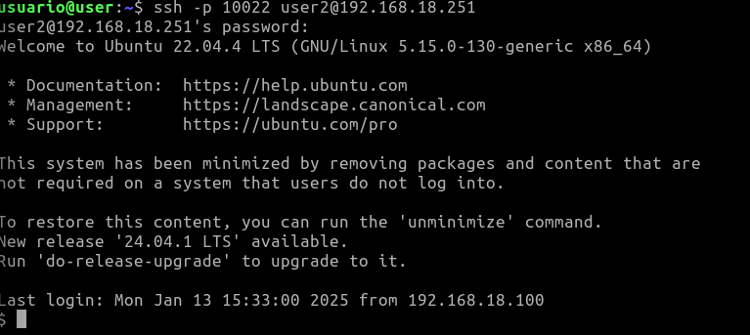

Exercise 4: By default, when authenticating successfully on the SSH server, it shows the date and time of the last connection. Find the option responsible for this behavior and modify it.
Server’s machine(folder:’/etc/ssh/’): $ sudo nano sshd_config
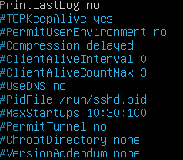
We must descomment the line ‘PrintLastLog’ and assign value for ‘no’

To check this: Client’s machine: $ssh -p 10022 user2@192.168.18.251
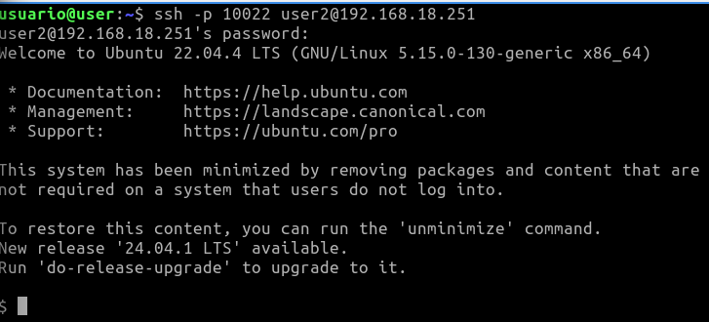
Before, we appeared the datetime of the last conection, but now, how we changed the configuration, now it’s not visible

Exercise 5: Configure the SSH server to enable X11 redirection, allowing the execution of graphical applications remotely. Test and verify its functionality.
Server’s machine(folder:’/etc/ssh/’): $ sudo nano sshd_config
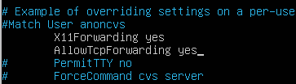

Server’s machine: $ sudo nano systemctl restart ssh && sudo systemctl status ssh

To check this: Client’s machine: $ssh -x -p 10022 user2@192.168.18.251
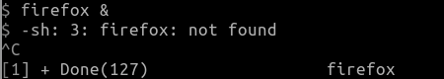

In this case, the server has not firefox app because it don’t have any graphical enviroment, but the process will execute

Exercise 6: Test connecting from a Windows SSH client (e.g., PuTTY) to a GNU/Linux SSH server and verify the connection.
Client’s W10 machine: Oppen the puTTY program on Windows and select SSH with the port and the IP of the server:
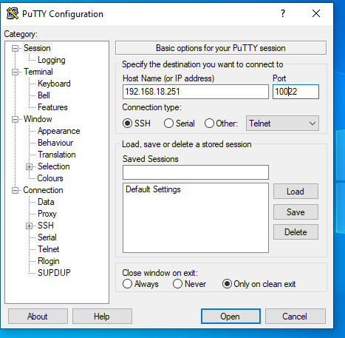

Click over Open and a window of CMD will be open and introduce the information from the user of the group ssh_users:
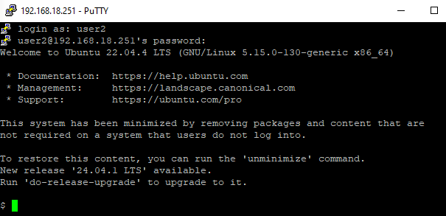

Practice 2: SSH
At the end of this practice, you must submit a script that explains and demonstrates the process and steps followed to complete each of the following tasks:
Perform client authentication from machine A to machine B using SSH with the following methods:
- Password-based authentication.
- Public key authentication with a null passphrase, where the users on both machines are identical. Copy the public key using scp and append it (without overwriting) to the authorized_keys file.
- Public key authentication with a non-null passphrase, where the users on each machine are identical.

Practice 2:
Exercise 1:Perform client authentication from machine A to machine B using SSH with the following methods:
Exercise 1.1:Password-based authentication.
Server’s machine(folder:’/etc/ssh/’): $ sudo nano sshd_config
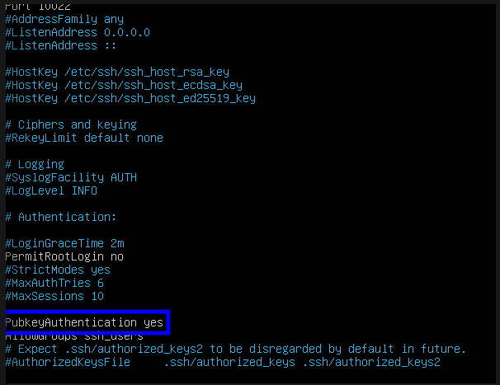
Server’s machine: $ sudo nano systemctl restart ssh && sudo systemctl status ssh

To check this: Client’s machine: $ssh -p 10022 user2@192.168.18.251
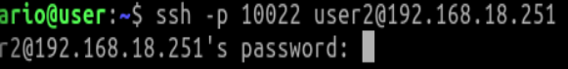
Exercise 1.2: Public key authentication with a null passphrase, where the users on both machines are identical. Copy the public key using scp and append it (without overwriting) to the authorized_keys file.
Client’s machine: $ sudo ssh-keygen -t rsa -b 2048
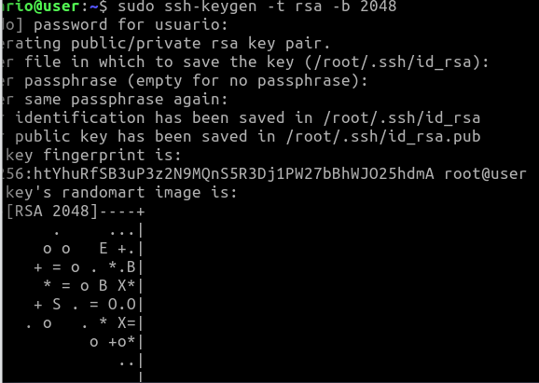
Now we must transfer this key to the server. Do it this:
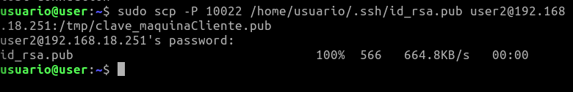
Client’s machine: $ scp ~/.ssh/id_rsa.pub usuario@192.168.18.251:/tmp/clave_maquina_A.pub

Now, we must agregate the key of the client to the folders of authorized_keys, then we will log in and give the permissions:
Server’s machine: $ ssh user@192.168.18.251
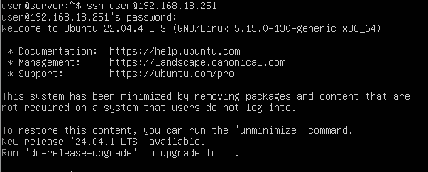
Server’s machine: #mkdir -p ~/.ssh && chmod 700 ~/.ssh
Now we must copy the key of the client that we saved in TMP folder to the correct folder(authorized_keys) and give it the correct permissions
Server’s machine: #cat /tmp/clave_maquina_A.pub >> ~/.ssh/authorized_keys && chmod 600 ~/.ssh/authorized_keys
You should remember to delete the file in /tmp to avoid a security issue.
Server’s machine: #rm /tmp/clave_maquinaCliente.pub
Finally, we will say to the server that takes this file.
Server’s machine(folder:’/etc/ssh/’): $ sudo nano sshd_config
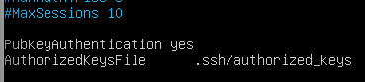
Server’s machine: $ sudo nano systemctl restart ssh && sudo systemctl status ssh

To check the results, go to the client and connect to the server:
Client’s machine: $ssh usuario@192.168.18.251
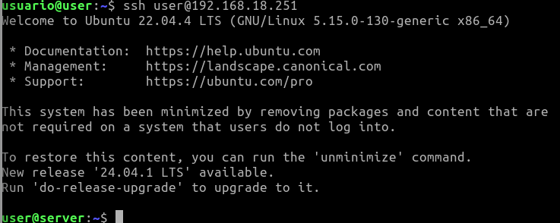

Practice 3: SSH
At the end of this practice, you must submit a script that explains and demonstrates the process and steps followed to complete each of the following tasks:
In this practice, you will use the scp command to copy files and directories between the client and server.
- In your HOME directory, create a folder named dir1. Inside it:
  - Create another folder called dir2.
  - Create two text files named f1.txt and f2.txt.
  - Inside dir2, create a file named f3.txt.
- Copy f1.txt and f2.txt to the server.
- Copy the entire dir2 folder to the server.
- Modify f1.txt on the server and then copy it back to the client.

Practice 3:
Exercise 1:In your HOME directory, create a folder named dir1. Inside it:
Client’s machine: $sudo mkdir dir1:
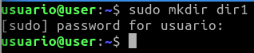

Exercise 1.1:Create another folder called dir2.
Client’s machine:$sudo mkdir dir2
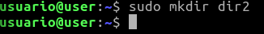

Exercise 1.2:Create two text files named f1.txt and f2.txt.

Exercise 1.3: Inside dir2, create a file named f3.txt.
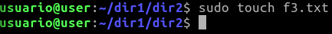

Exercise 2: Copy f1.txt and f2.txt to the server.
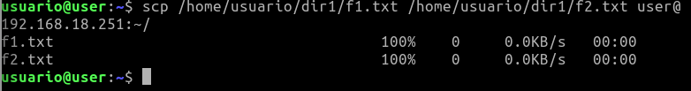
Exercise 3: Copy the entire dir2 folder to the server.
Exercise 4: Modify f1.txt on the server and then copy it back to the client.
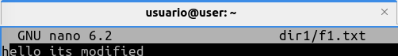

Practice 4: SSH
At the end of this practice, you must submit a script that explains and demonstrates the process and steps followed to complete each of the following tasks:
In this practice, you will configure port forwarding using SSH so that DNS queries (port 53) over the TCP protocol are securely transmitted through the port forwarding.
You can use your own DNS server or the classroom's DNS server (ask your instructor for access).
To test the port forwarding, ensure the DNS query commands specify TCP usage with:
- dig -tcp target_system
- host -T target_system

Practice 4:
Exercise 1:In this practice, you will configure port forwarding using SSH so that DNS queries (port 53) over the TCP protocol are securely transmitted through the port forwarding. You can use your own DNS server or the classroom's DNS server (ask your instructor for access).
Client’s machine: $sudo ssh -L 53:192.168.18.251:53 user@192.168.18.251
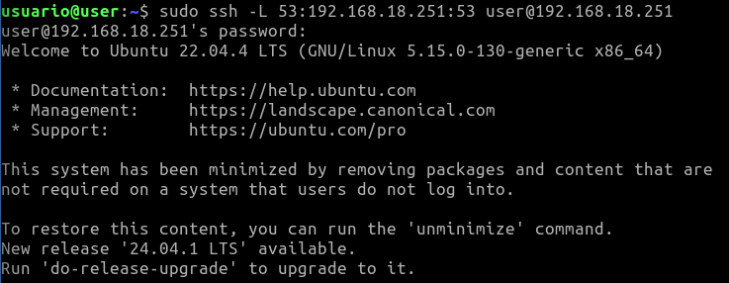
Client’s machine: $ dig -p 53 @localhost google.com +tcp
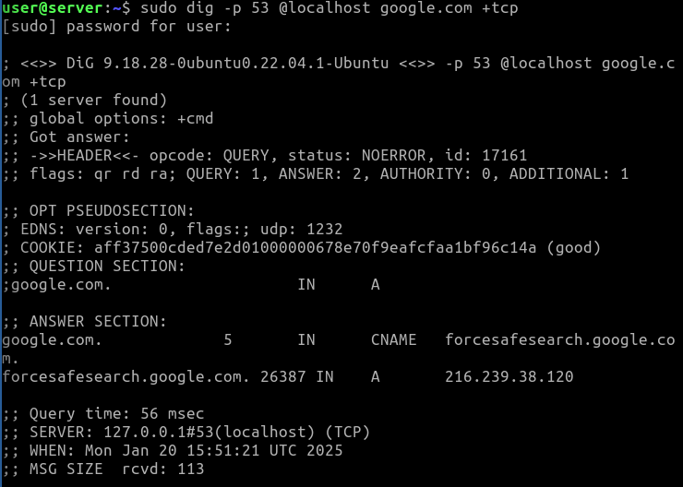
Client’s machine: $host -T google.com localhost
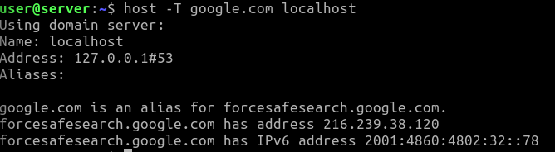

Practice 5: SSH
At the end of this practice, you must submit a script that explains and demonstrates the process and steps followed to complete each of the following tasks:
In this practice, you will create a tunnel to establish a secure connection between systems. As discussed, the information transmitted through the tunnel's associated IPs will be encrypted using the SSH connection.
- The tunnel will connect your SSH server and a system acting as a client.
- Network configuration for the tunnel:
  - Network: 10.1.1.0 / 30 (subnet mask 255.255.255.252). This configuration allows only two IPs: one for the server and one for the client.
- To test the tunnel’s functionality:
  - On the server, execute: ping 10.1.1.2.
  - On the client, execute: ping 10.1.1.1.
- Access the web server running on the SSH server using the URL:
http://10.1.1.1

Practice 5:
Exercise 1:The tunnel will connect your SSH server and a system acting as a client.
Server’s machine(folder:’/etc/ssh/’): $ sudo nano sshd_config
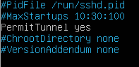

Client’s machine: $ssh -f -w 0:0 user@192.168.18.251 -N
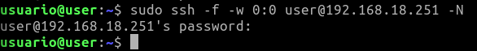
Client’s machine: $

