
4. Web Server Administration
Miquel Àngel París i Peñaranda
Web Application Deployment
2nd C-VET Web Application Development

Index
SSH exercises 3

SSH exercises

Practice 1: SSH
At the end of this practice, you must submit a script that explains and demonstrates the process and steps followed to complete each of the following tasks:
- Start the SSH server on your machine and verify that you can access it with any user from any device.
- Server machine:

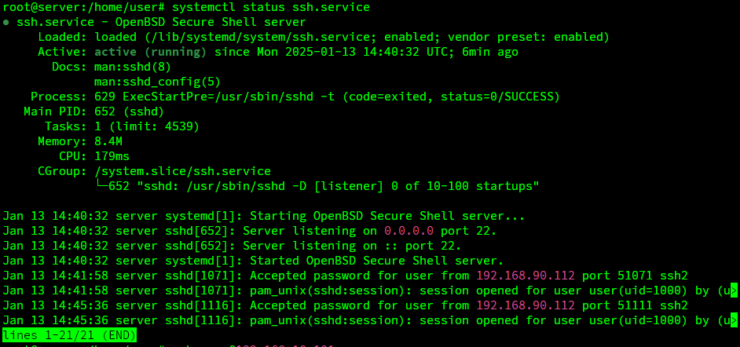
- Client
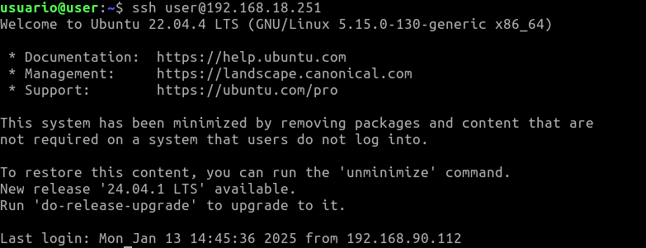

- Configure the SSH service so that:
  - Logging in as root is not allowed.

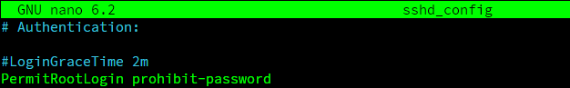

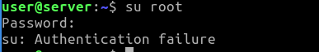

  - Then, allow logging in as root.
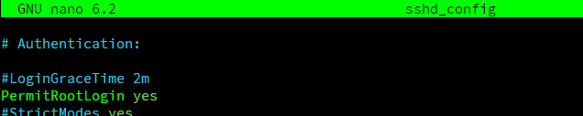
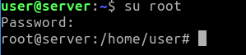
  - Create two new users: user2 and user3, and a group named ssh_users. Add these users to the group and ensure that only the members of this group can access the SSH service.
  - Create the ssh_users group:

  - Create users user2 and user3:
    - -m (create home directory)
      - This parameter tells the system to create a home directory for the new user.
    - -s (specify shell)
      - This parameter defines which shell to assign to the user.

  - Set passwords for these users:

  - Add users to the group ssh_users:
The -aG parameter in the usermod command has the following functions:
    - -a (append)
      - This parameter ensures that the user is added to the additional group(s) without removing the user from existing groups.
    - -G (groups)
      - Este parámetro permite especificar uno o varios grupos adicionales a los que se desea agregar al usuario.

  - Restrict access to the SSH service
    - Edit the SSH configuration file: /etc/ssh/sshd_config
    - Add the following line so that only members of the ssh_users group have access:

  - Chek:

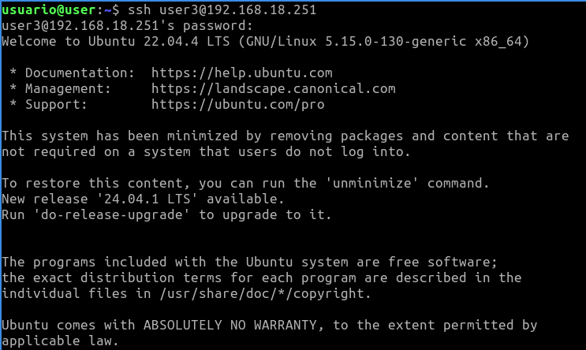

- The SSH service, by default, listens on port 22. Modify it to start on port 10022 (or another port), and figure out the command required to access the server on this port. (Hint: Use man ssh)
- edit the file: /etc/ssh/sshd_config

- execute this command in order to activate the port:

- check:

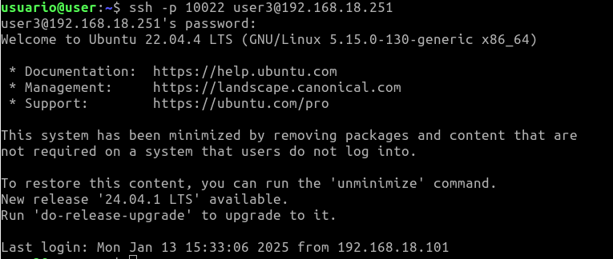

- By default, when authenticating successfully on the SSH server, it shows the date and time of the last connection. Find the option responsible for this behavior and modify it.
- uncomment the line and enter no
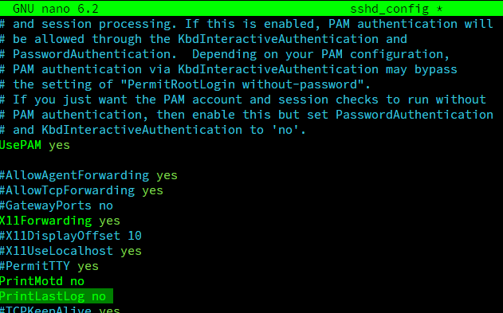
- Check:

- Configure the SSH server to enable X11 redirection, allowing the execution of graphical applications remotely. Test and verify its functionality.
- uncomment these two lines and mark them as ‘yes’
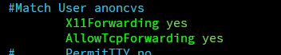

- check:
#as the server does not have a graphical environment, the process is executed but the programme does not start.

- Test connecting from a Windows SSH client (e.g., PuTTY) to a GNU/Linux SSH server and verify the connection.

Practice 2: SSH
At the end of this practice, you must submit a script that explains and demonstrates the process and steps followed to complete each of the following tasks:
Perform client authentication from machine A to machine B using SSH with the following methods:
- Password-based authentication.
- Public key authentication with a null passphrase, where the users on both machines are identical. Copy the public key using scp and append it (without overwriting) to the authorized_keys file.
- Public key authentication with a non-null passphrase, where the users on each machine are identical.

Practice 3: SSH
At the end of this practice, you must submit a script that explains and demonstrates the process and steps followed to complete each of the following tasks:
In this practice, you will use the scp command to copy files and directories between the client and server.
- In your HOME directory, create a folder named dir1. Inside it:
  - Create another folder called dir2.
  - Create two text files named f1.txt and f2.txt.
  - Inside dir2, create a file named f3.txt.
- Copy f1.txt and f2.txt to the server.
- Copy the entire dir2 folder to the server.
- Modify f1.txt on the server and then copy it back to the client.

Practice 4: SSH
At the end of this practice, you must submit a script that explains and demonstrates the process and steps followed to complete each of the following tasks:
In this practice, you will configure port forwarding using SSH so that DNS queries (port 53) over the TCP protocol are securely transmitted through the port forwarding.
You can use your own DNS server or the classroom's DNS server (ask your instructor for access).
To test the port forwarding, ensure the DNS query commands specify TCP usage with:
- dig -tcp target_system
- host -T target_system

Practice 5: SSH
At the end of this practice, you must submit a script that explains and demonstrates the process and steps followed to complete each of the following tasks:
In this practice, you will create a tunnel to establish a secure connection between systems. As discussed, the information transmitted through the tunnel's associated IPs will be encrypted using the SSH connection.
- The tunnel will connect your SSH server and a system acting as a client.

- Network configuration for the tunnel:
  - Network: 10.1.1.0 / 30 (subnet mask 255.255.255.252). This configuration allows only two IPs: one for the server and one for the client.
- To test the tunnel’s functionality:
  - On the server, execute: ping 10.1.1.2.
  - On the client, execute: ping 10.1.1.1.
- Access the web server running on the SSH server using the URL:
http://10.1.1.1

