
3. Network Services Involved in the Deployment of a Web Application
Miquel Àngel París i Peñaranda
Web Application Deployment
2nd C-VET Web Application Development

Index
DHCP Service Activity 3

DHCP Service Activity
Preliminary considerations:
For the development of this activity you need the two previously created virtual machines.
You have to foresee that if the environment where the activity takes place has some other equipment (such as a router) with DHCP server functions, it can interfere with the DHCP server that you will configure and so you have to take this into account.
Environment to be simulated:
It is intended to implement a dynamic network configuration assignment service within a public library. The network where the equipment will be located will be 192.168.18.0/24 and it should be taken into account that the router has 192.168.18.1/24 as its IP address and the DHCP server to be implemented is 192.168.18.252/24.
The DNS server addresses will be provided as 192.168.18.252 and 8.8.8.8
A. Installation planning
A.1. With the DÍA software or similar, you make a physical and logical diagram of the network where the different computers and devices are shown, as well as their IPs. Insert the physical/logical schematic of the network.
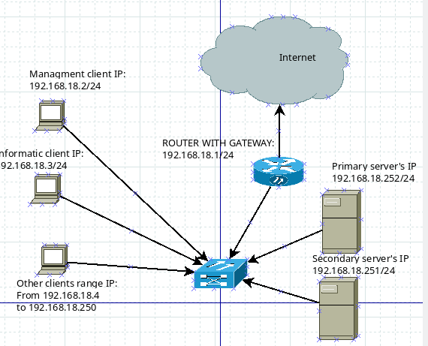
A.2. Define what the range of available addresses will be, if you want the DHCP server to handle as many addresses as possible. Indicates the range of available addresses.
The range of available IP’s will consist of 192.168.18.4 to 192.168.18.250 since the client with a static IP, which is the IT department, consists of 192.168.18.3, the maintenance department consists of 192.168.18.2, the link is 192.168.18.1 and 192.168.18.0 is the network address. In the other part of the segment, we end at 192.168.18.250 because the secondary server consists of 192.168.18.251 and the primary server must use 192.168.18.252
A.3. Propose a lease time appropriate to the scenario. Justify your answer. Indicate the lease time in seconds. Justify your choice.
The default lease time of DHCP configuration its 6000 seconds. In this case, this quantity of time its enough for all the clients that will connect it.
A.4. With the lsb_release -a command you get the distribution and version of the server. Insert screenshot.
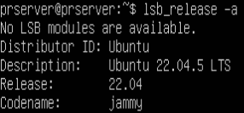

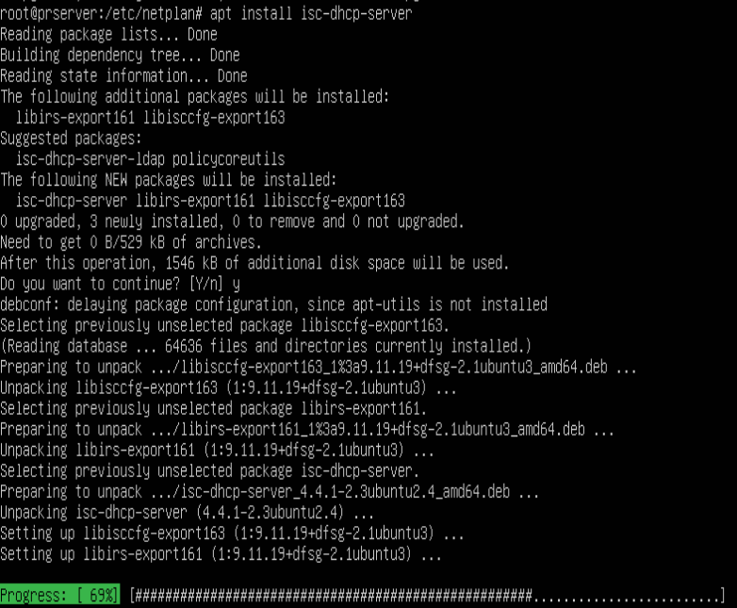
A.5. Install the isc-dhcp-server, nmap and wireshark packages that you will use during the development of the activity. Insert screenshot.

B. DHCP Server Configuration
If you experience errors during the configuration of the service or the service does not start up correctly, go to section D.7.
B.1. Assign a static network configuration to the server. Insert screenshot.
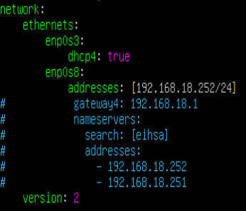

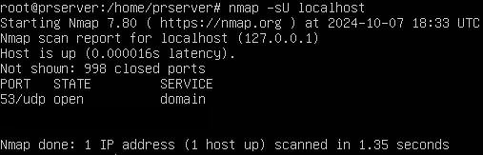
B.2. Check with the help of the nmap -sU localhost command if the DHCP server is listening on any port. If yes, indicate the port through which the DHCP server listens. Insert screenshot.

B.3. Access the DHCP server configuration file /etc/dhcp/dhcpd.conf. Configure it (creating a new subnet) taking into account the previous requirements. Insert screenshot.
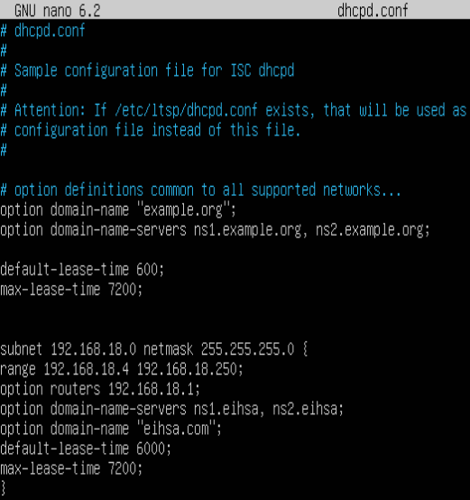

B.4. Remember that when a configuration file is modified, in order for the changes to take effect, the service has to be started/restarted. Start the DHCP server with the command: sudo systemctl start isc-dhcp-server Insert screenshot.
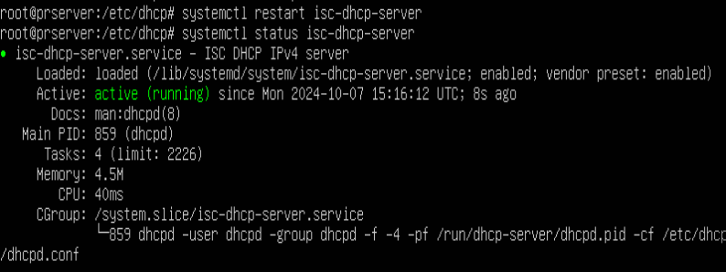
B.5. Double-check, with the help of the nmap -sU command, if the DHCP server is listening on any port. If yes, indicate the port through which the DHCP server listens. Insert screenshot.
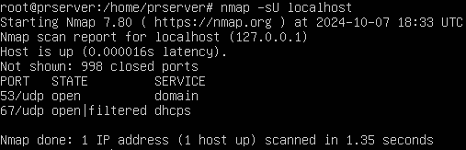
B.6. Why did the DHCP server not appear listening to question B2 on any port and question B5 already appears listening? What is the relationship between the subnet of the configuration file and the NIC of the server? Insert a screenshot and answer, if applicable, the question.
The reason was because in question B2 the server was not configured so it did not receive requests and was not active, with the current configuration it is already active.
It is related to the fact that depending on the IP that is assigned to the network card, it will make requests for it.

C. DHCP Client Configuration
C.1. Assign a dynamic network configuration to the client. Remember that you have to edit the configuration file /etc/netplan/xx-network-manager-all.yaml. Insert screenshot.
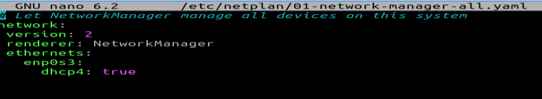
C.2. If not IP address is allocated you can start the dynamic allocation process using the sudo dhclient [interface] command. Insert screenshot of network interface IP address.

C.3. Why didn't I have to install the DHCP client package? You can use the command dpkg -L package or dpkg -l | grep search-string to get the packages installed on the system. Insert a screenshot and answer the question.
C.4. In the client's /var/lib/dhcp/ folder you can check the granting times and the renews of these loans. Insert a screenshot showing this data and indicate the file consulted.
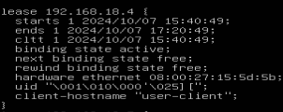

C.5. Using the ifconfig command you display the client's network configuration. Insert screenshot.
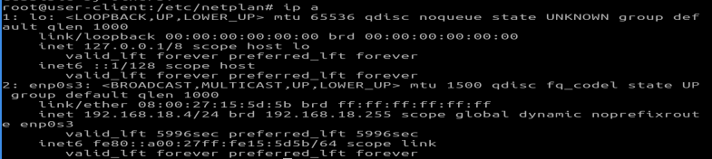
D. Advanced management
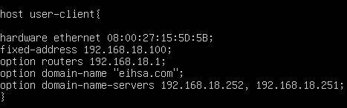
D.1. Suppose that your client computer is the computer used by the librarian and therefore we want to always have it identified with the same IP address. Configure the server (file /etc/dhcp/dhcpd.conf) so that this client has the address 192.168.18.100 reserved. Insert a screenshot showing the client's MAC address. Insert a screenshot showing the configuration made on the server.

D.2. Make a request from the client and verify that the IP address assigned is the 192.168.18.100. Insert screenshot.
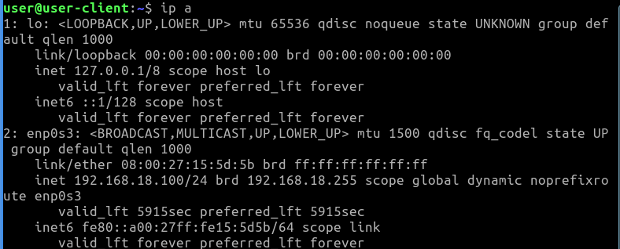

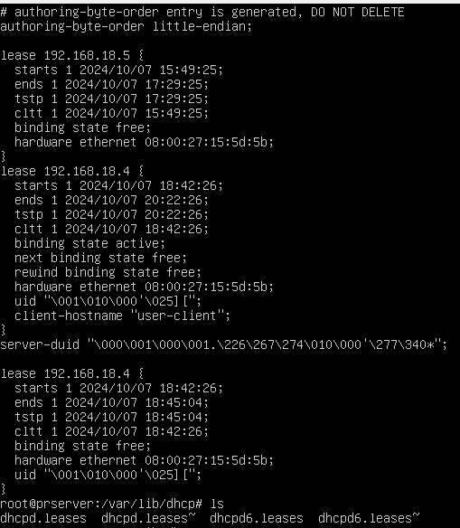
D.3. Check the server's concessions database (/var/lib/dhcp/dhcpd file). What can you find in this file? Relate the content of the file to the practice you are developing. Insert a screenshot and answer the question.

In this file you cand find the concessions of the IP’s assigned to the clients were connected to the server

D.4. Go to the /var/lib/dhcp folder. Can you find the file for question C.4.? Why do you think this file is not on the server? Insert a screenshot and answer the question.
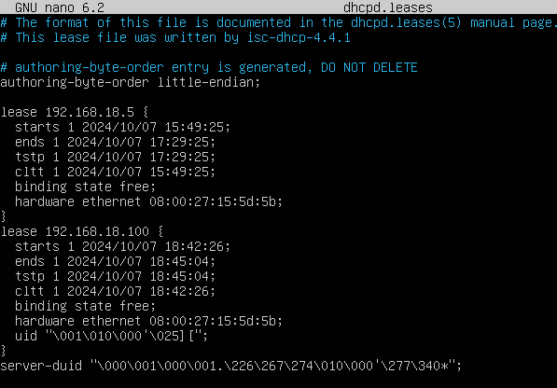
This client was the first to connect to our server so it received 192.168.18.4. The change made is that from its MAC address we have determined that the private host receives 192.168.18.100 and that is why 192.168.18.4 does not appear in the concessions file but now 192.168.18.100 appears.

D.5. The log of actions/errors is monitored to the /var/log/syslog file. This file is usually very large since it monitors a large number of system services/actions, so you can look for incidents related to the sudo cat /var/log/syslog | grep dhcp command. Can you identify any issues related to a configuration error? If so, how did you solve it? Insert a screenshot and answer the question.
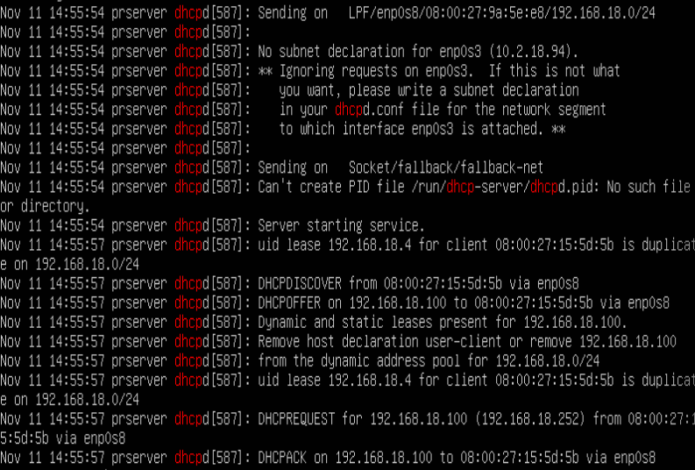
Actually, the syslog file its deprecated, but using journalctl | “dhcp” you can find all the changes applied in the server

Note: Screenshots must incorporate a timestamp (i.e. in a corner you must put a small console and execute the date command, so that the user is seen in the screenshot as well as the day and time of its completion).
E. Extension
E.1. With the help of the Wireshark software (which you will have to run with administrator privileges) analyze the operation of the DHCP service. Run this software, monitor the network card that the DHCP server is listening on, and filter by the BOOTP protocol (predecessor to dhcp). With the results, analyze the operation of the DHCP (type of messages that are sent and addresses) relating it to the protocol studied in class. Insert screenshot and analyze the protocol.
First we will have to install the tshark package, which is the wireshark prepared for CLI:
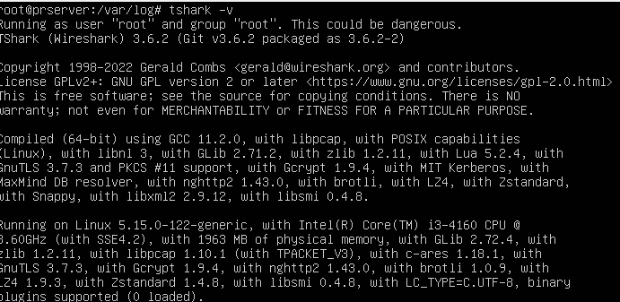
To capture the operation of DHCP with thsark we must execute tshark -i enp0s8 (name of the interface through which DHCP listens for requests) -f “udp port 67 or udp port 68” (ports where DHCP listens) -w capture.pcap( where you will save the information):
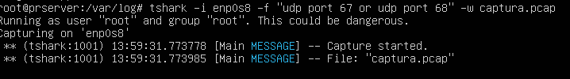
Finally, to check adding the “bootp” filter, we will execute thsark -r capture.pcap -Y “bootp”:
The first request is the same since the MAC has value 0000000 and the second request is the configured service where the server IP is 192.168.18.252 and the client is the private host declared previously with the IP 192.168.18.100 and the MAC is the same

