DNS PRACTICE – DAW2

Environment we will simulate:

The businessman Equipamientos Industriales Homero S.A. (EIHSA) has acquired a .com domain and has commissioned you to install and configure the primary and secondary servers of the domain authority.

For the simulation, use the following relationship between machine names and IPs:

Name | IP | Description
router | 192.168.x.1 | Gateway
NS1 | NS1 virtual Machine IP | Name Server 1 (Primary DNS Server)
NS2 | NS2 virtual Machine IP | Name Server 2 (Secondary DNS Server)
www | 192.168.x.252 | Web server
FTP | 192.168.x.252 | FTP server (located on the same www machine) alias
mail | 192.168.x.251 | Mail Server
management | 192.168.x.2 | Management computer
Inf | 192.168.x.3 | Computer IT department

A. Installation planning

A.1. With the DÍA or similar software, you make a physical and logical diagram of the network where the different equipment and devices are shown, as well as their IPs and DNS names.
Insert physical/logical schematic of the network.
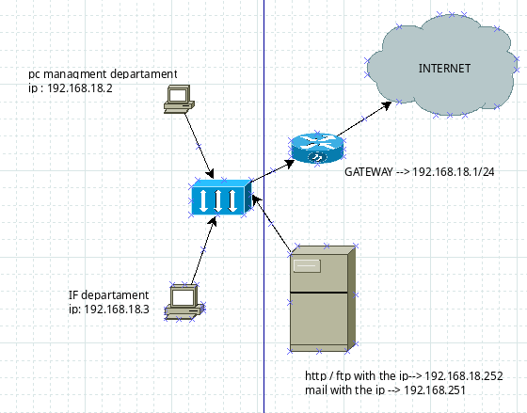

A.2. Indicate which registers will be required to configure the direct resolution zone and the values of the configuration parameters for each register.
Indicate the required registers and the value of the different configuration parameters

@ IN NS ns1.eihsa.
@ IN NS ns2.eihsa.
ns1 IN A 192.168.18.254
ns2 IN A 192.168.18.253
www IN A 192.168.18.252
ftp IN A 192.168.18.252
mail IN MX 10 mail.eihsa.com.
management IN A 192.168.18.2
inf IN A 192.168.18.3

A.3. Indicate which registers will be required to configure the reverse resolution zone and the values of the configuration parameters for each register.
Indicate the required registers and the value of the different configuration parameters

@ IN NS ns1.eihsa.
@ IN NS ns2.eihsa.
254 IN PTR ns1.eihsa.
253 IN PTR ns2.eihsa.
252 IN PTR www.eihsa.
252 IN PTR ftp.eihsa.
251 IN PTR mail.eihsa.
2 IN PTR management.eihsa.
3 IN PTR inf.eihsa.

B. DNS Server Installation and Forwarder Operation
From this section, the virtual machine network must be configured as a bridge adapter.

B.1. Assign a static network configuration to the NS1 server according to the IP that corresponds to your virtual machine
Insert screenshot

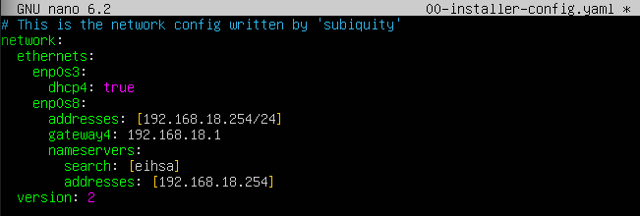
B.2. Install the bind9 DNS server software.
Insert screenshot and answer, if applicable, the question

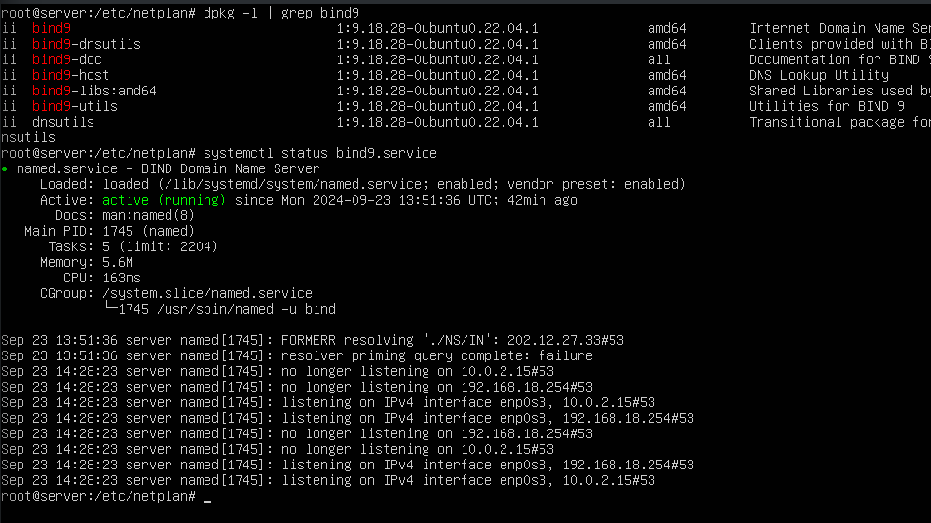

B.3. You show the contents of the configuration file /etc/bind/named.conf. What is the use of the include directive? What files are included?
Insert screenshot and answer the questions

the directive “Include” means that when the “named.conf” file is executed, it will sequentially execute the files that have been specified.

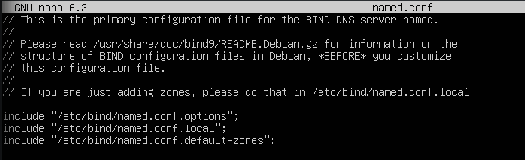

B.4. You look for which file, within the configuration directory /etc/bind/ you find the IP addresses of the root servers and show their content.
Insert screenshot

In the file... all the information about the root IP's is indicated
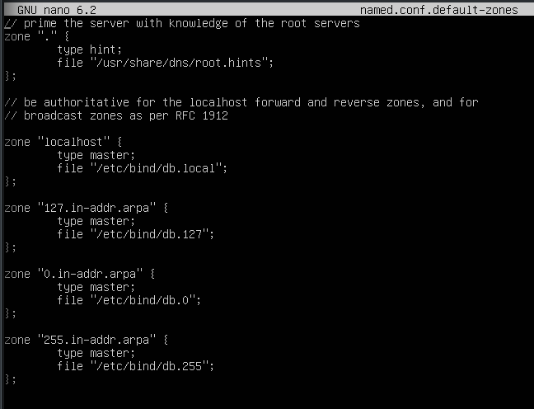

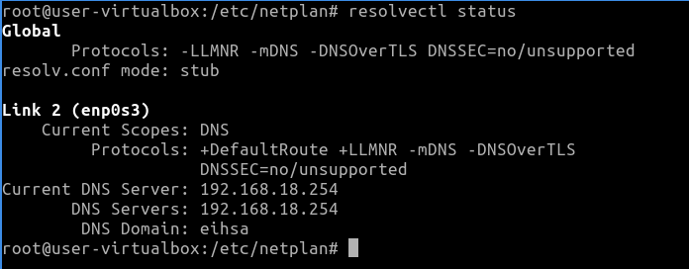

B.5. You configure forwarders to the named.conf.options file.
Insert screenshot
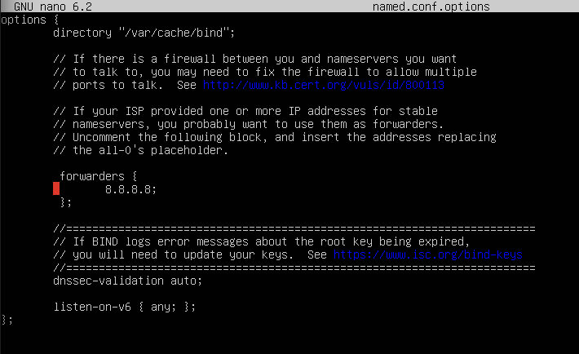

B.6. You configure your server and a client so that they have the DNS server you are configuring. You check the result of the resolve status command to check the configuration of the Name Resolution System (DNS).

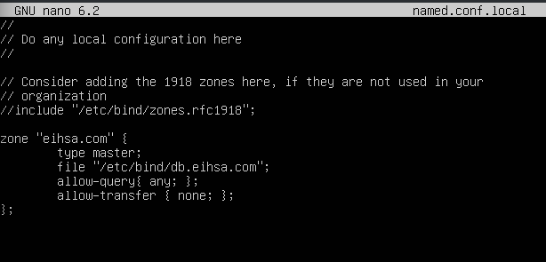
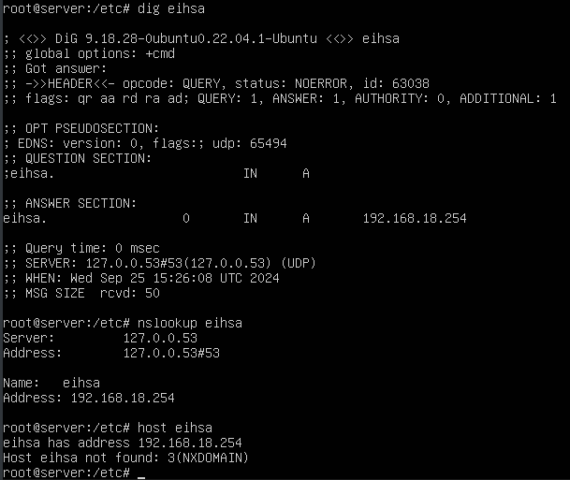
B.7. Install the dnsutils package and check that your server performs the catching correctly by testing dig, nslookup and host requests

C. Direct Zone Configuration
C.1. Create a new direct zone for the domain eimsa.com to the /etc/bind/named.conf.local file. The file where the database of the zone will be saved will be the /etc/bind/db.eihsa.com
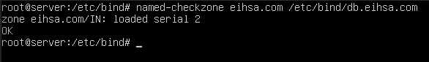
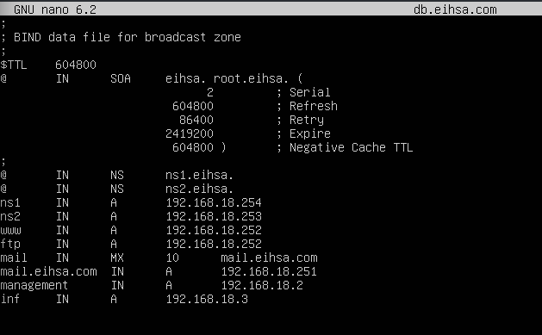
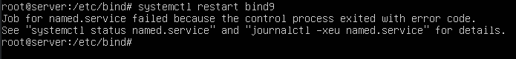

C.2. Create a new file called /etc/bind/db.eihsa.com and configure it taking into account the requirements of the statement for the direct zone.

C.3. Restart the service with the sudo systemctl restart bind9.service command for the changes to take effect

C.4. Check, using the named-checkzone command, that the syntax of the /etc/bind/db.eihsa.com file is correct. You can use the man named-checkzone command to check how the order works. If you have any syntax errors, correct them until the zone is correctly configured. Don't forget to restart the service and update the serial of the SOA record. Insert screenshot

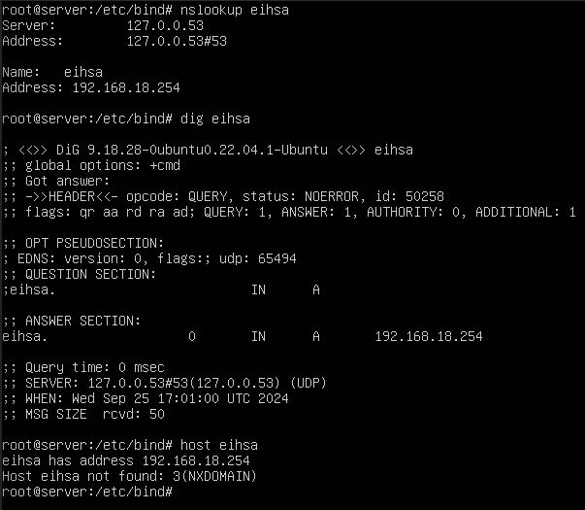

C.5. Using the nslookup, dig and host commands, verify that your DNS server has the direct zone correctly configured.
Insert screenshot

D. Reverse Zone Configuration
D.1. Create a new reverse zone for the domain eihsa.com to the /etc/bind/named.conf.local file. The file where the database of the zone will be saved will be the /etc/bind/db.x.168.192.in-addr.arpa.
Insert screenshot

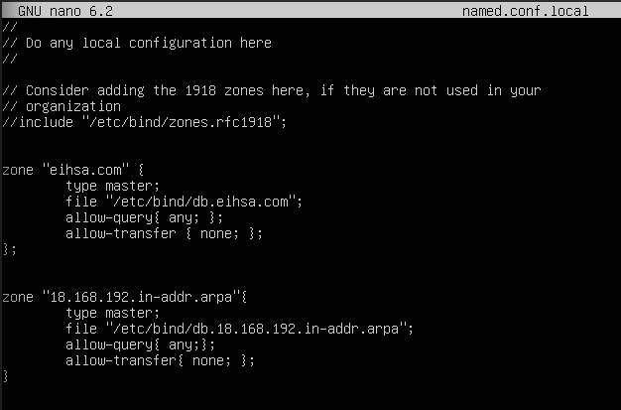
D.2. Create a new file called /etc/bind/db.x.168.192.in-addr.arpa. Set it up with the requirements of the statement for the inverse zone in mind.
Insert screenshot

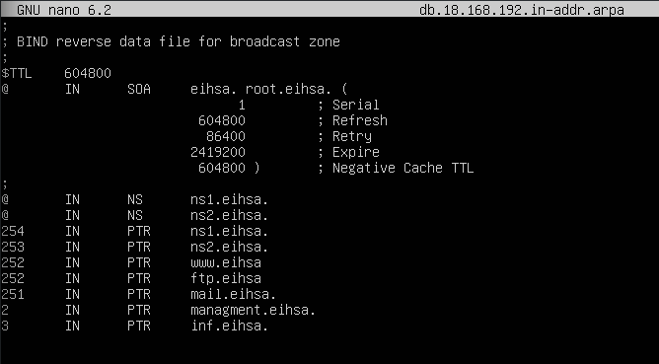
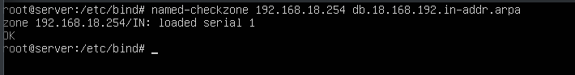
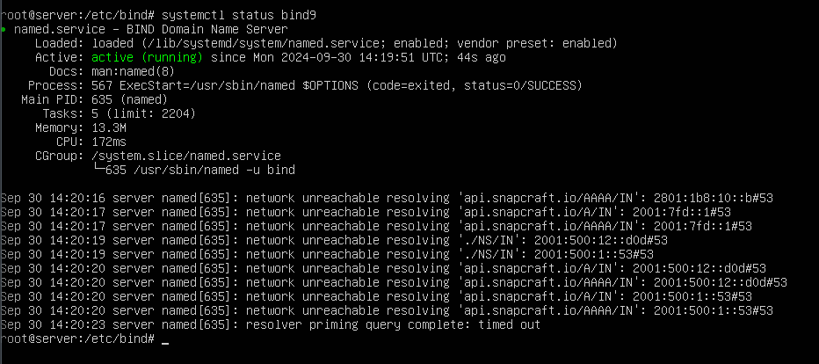

D.3. Restart the service with the sudo systemctl restart bind9 command for the changes to take effect. Insert screenshot

D.4. Check, using the named-checkzone command, that the syntax of the /etc/bind/db.x.168.192.in-addr.arpa file is correct. You can use the man named-checkzone command to check how the order works. If you have any syntax errors, correct them until the zone is correctly configured. Don't forget to restart the service and update the serial of the SOA record. Insert screenshot

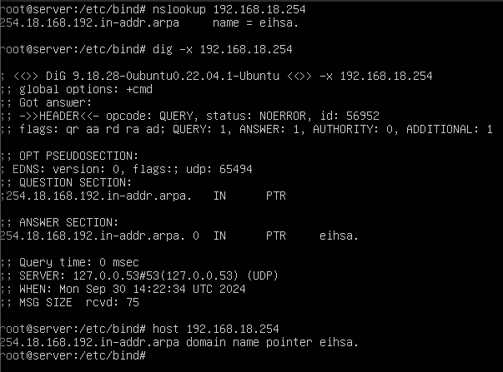
D.5. Using the nslookup, dig and host commands, verify that your DNS server has the reverse zone correctly configured. Insert screenshot

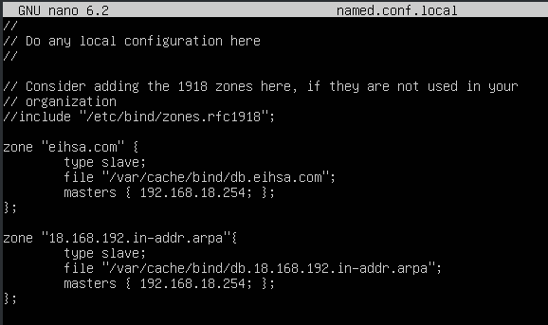
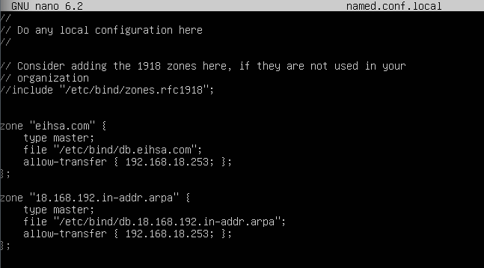
E. Secondary Server Configuration

E.1. Allow the primary server to transfer the zone to the secondary server. Add the corresponding configuration options to the /etc/bind/named.conf.local file on the primary server. Don't forget to restart the service for the changes to take effect. Insert screenshot

E.2. Configure the /etc/bind/named.conf.local file of the secondary server to connect to the primary server and perform the corresponding zone transfer. You need to edit the /etc/bind/named.conf.local file. Don't forget to restart the service for the changes to take effect.

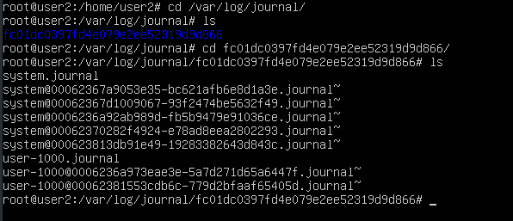
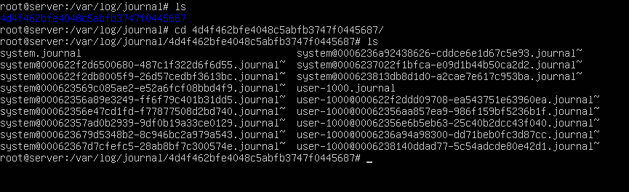
E.3. Check the /var/log/syslog file, both on the primary and secondary servers, that the transfer has been carried out correctly.
Insert screenshots
PRIMARY:

SECONDARY:

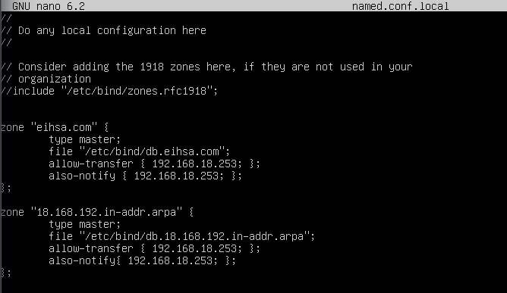

E.4. A zone transfer is performed only if the serial number of the primary server is larger than the serial number of the secondary server. Add the also-notify directive to the /etc/bind/named.conf.local configuration file on the primary server to notify the secondary server of the changes made. Insert screenshot

E.5. Access the files contained in the /var/cache/bind folder of the secondary server. What content is saved to this folder? Insert screenshot and answer the question

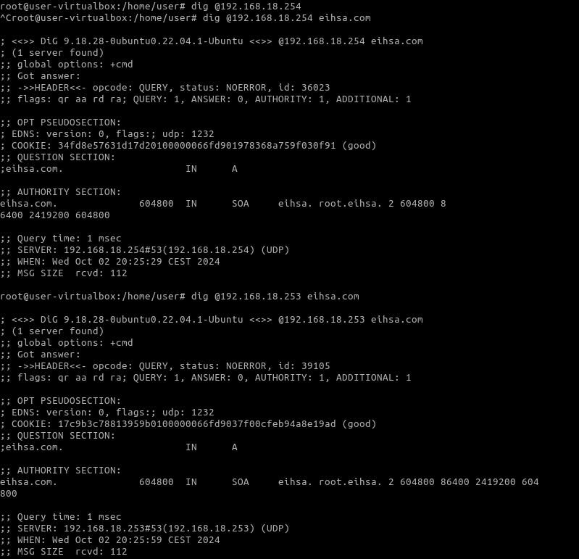

E.6. Configure a DNS client to connect to the secondary DNS server. Using the nslookup, dig and host commands, verify that your DNS server is correctly configured. Based on the results obtained, indicate whether the responses obtained from the secondary DNS server are authoritative or non-authoritative.
Insert screenshot and answer the question

