
4. Web Server Administration
Miquel Àngel París i Peñaranda
Web Application Deployment
2nd C-VET Web Application Development

Index
Apache exercises 3

Apache exercises
Step 1: Install the Apache2 Server
Verify that Apache2 is installed and running by opening a browser and navigating to http://localhost. Attach screenshots.

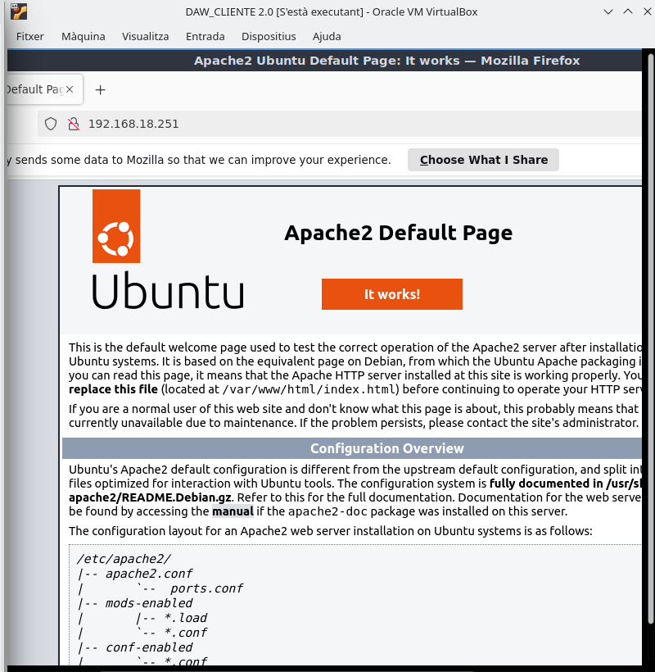
Step 2: Check the Version
Use the command apache2 -v to check the installed version. Attach a screenshot.
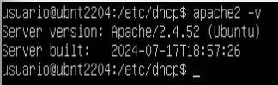

Step 3: Create a Welcome Page
Replace the default welcome page with a custom one:
- Navigate to /var/www/html/.
- Rename the existing index.html file.
- Create a new index.html file with the following content:
<center>
<h1>Welcome to the Apache 2 Server of [Your Name]</h1>
<h2>Web Application Deployment</h2>
</center>
Replace [Your Name] with your own name. Refresh the browser, and the new page should appear. Attach screenshots.
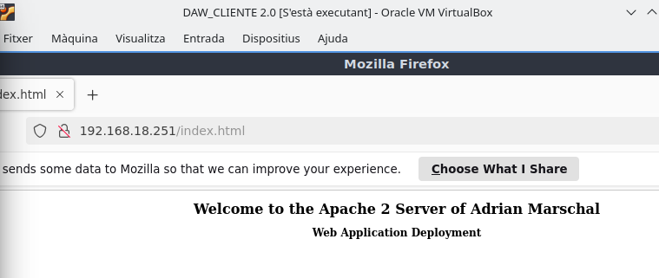
Step 4: Update Apache2 Configuration File
- Make a backup of /etc/apache2/apache2.conf.
- Add the following lines to the configuration file:
# Basic Configuration File (/etc/apache2/apache2.conf)
ServerRoot "/etc/apache2"
DocumentRoot "/var/www/html"
PidFile /var/run/apache2/apache2.pid
User www-data
Group www-data
ErrorLog /var/log/apache2/error.log
IncludeOptional mods-enabled/*.load
IncludeOptional mods-enabled/*.conf
Include ports.conf
IncludeOptional sites-enabled/*.conf
Restart Apache2 and verify its functionality. Attach screenshots.
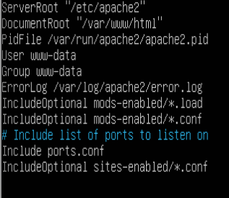

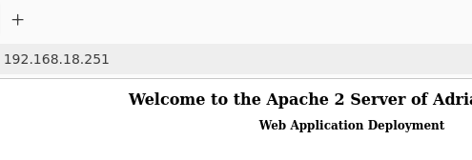

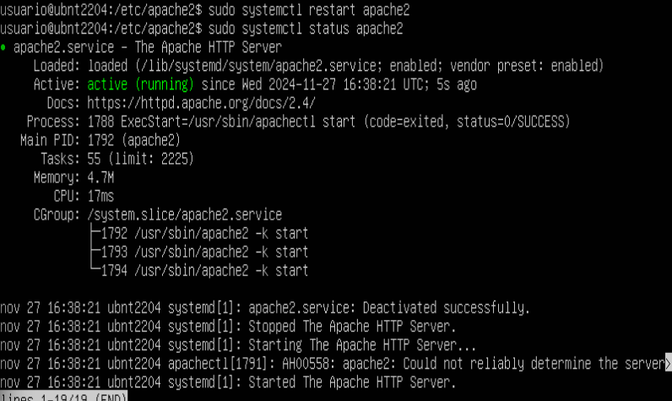

Step 5: Change the Server's Access Name
Change the access name of the server to www.eihsa.es using either DNS configuration or by editing the /etc/hosts file. Test that the server responds to the new name. Attach screenshots.
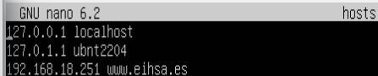



Step 6: Enable User Web Spaces
Enable Apache’s module that allows users to host their web pages in personal directories:
- Run: $ sudo a2enmod userdir
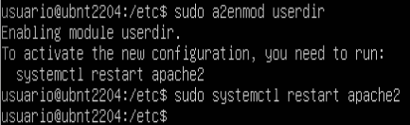

- Each user can create a public_html folder in their home directory (e.g., /home/username/public_html). Set appropriate permissions:
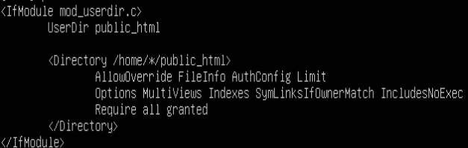
- Directory: chmod 755
- Files: chmod 644

Users can access their pages via URLs like http://server_address/~username. Restart Apache2 and test. Attach screenshots.
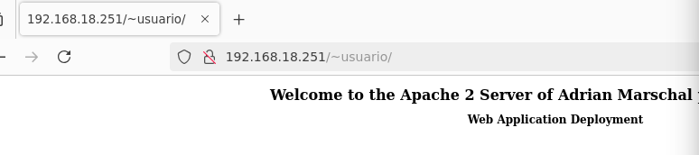
Step 7: Define Virtual Hosts by Name
- Create a new configuration file in /etc/apache2/sites-available/ for the new host.cd
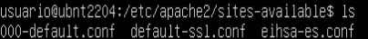

- Set up the directory and create a web page for the host.
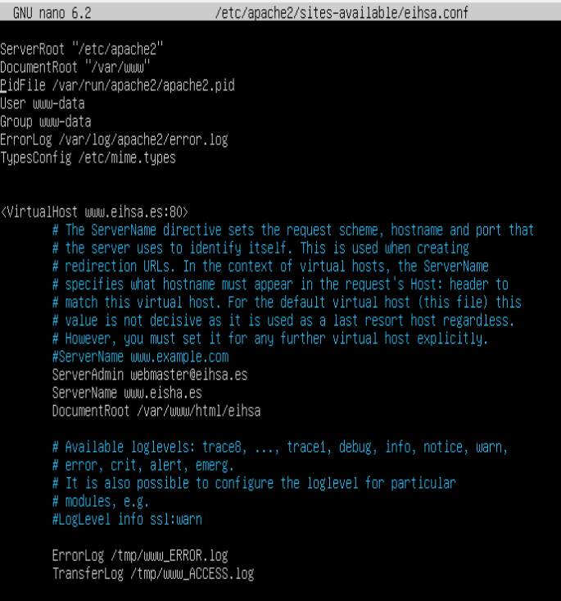
- Enable the site using sudo a2ensite.
- Restart Apache2 and verify functionality. Attach screenshots.
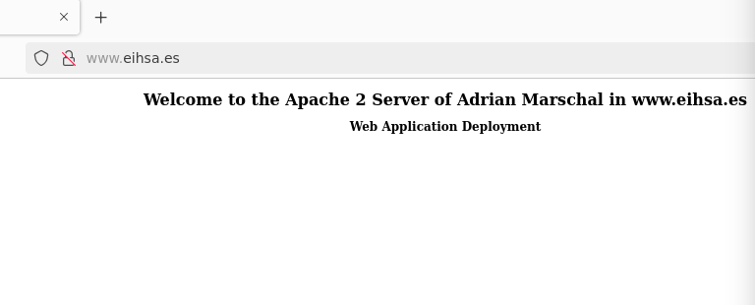
Step 8: Define Virtual Hosts by IP
Configure a virtual host accessible via IP address. Test and attach screenshots.
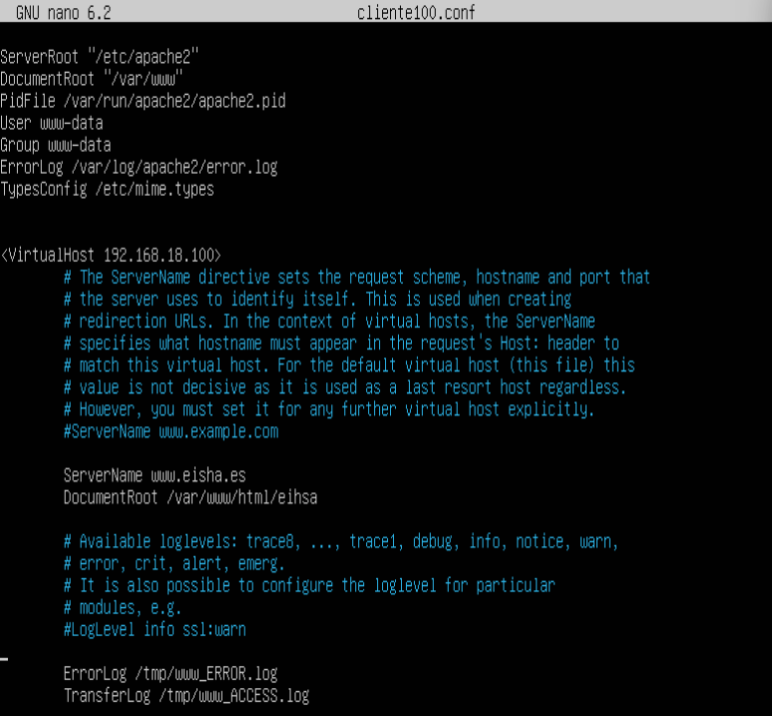

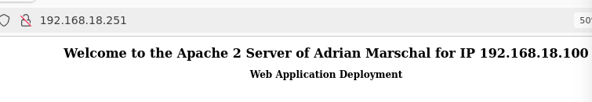
Step 9: Define Virtual Hosts by IP and Port
Set up a virtual host accessible via a specific IP and port. Test and attach screenshots.
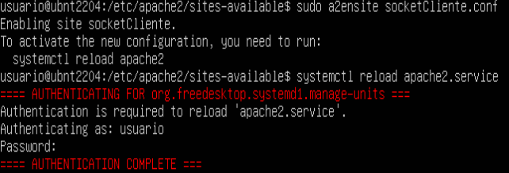
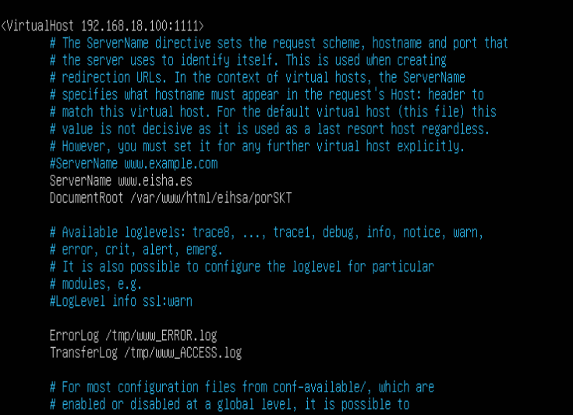
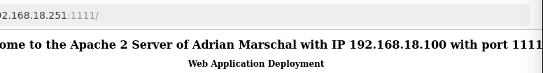

Step 10: Basic HTTP Authentication and Protected Directories
Add authentication to a directory on the virtual server using mod_auth_basic.
Steps to Implement:
- Create a User
Use the htpasswd command to create a .htpasswd file:
sudo su
htpasswd -c /etc/apache2/passwd/.htpasswd username
Set permissions on .htpasswd to chmod 644.
- Restrict Access to a Private Directory
Create the directory /var/www/html/virtual/private_directory and add an index.html file. Add the following configuration to the relevant site file:
<Directory "/var/www/html/virtual/private_directory">
AuthType Basic
AuthName "Private Directory"
AuthUserFile /etc/apache2/passwd/.htpasswd
Require valid-user
</Directory>
Restart Apache2 and test access via a browser.
- Using .htaccess for Authentication
Create a .htaccess file in the directory:
AuthType Basic
AuthName "Private Directory"
AuthUserFile /etc/apache2/passwd/.htpasswd
Require user username
Enable .htaccess in the site configuration by adding:
<Directory "/var/www/html/virtual/private_directory">
AllowOverride AuthConfig
</Directory>
Test functionality without restarting Apache2.
- Digest Authentication
Enable the mod_auth_digest module for encrypted authentication. Configure using the htdigest tool to add users and allow access to the protected directory.

Step 11: Create a Secure Virtual Server with OpenSSL
Set up a secure virtual server using OpenSSL. Test and attach screenshots.

