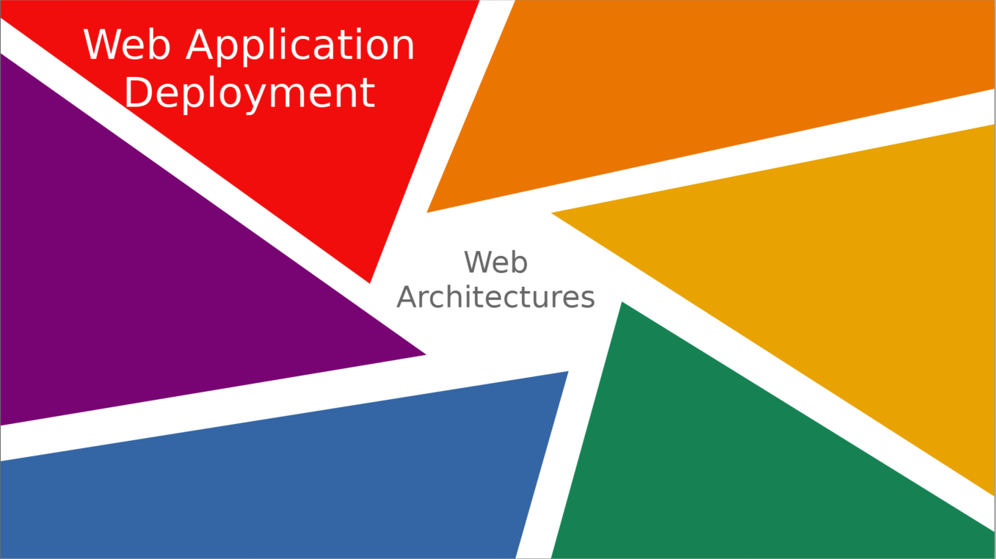
Deployment of Web Architectures
Application architecture in web environments differs significantly from desktop applications, where a program runs on one of the seen modes (interpreted, directly executed on a platform, or executed with a virtual machine) directly on the machine used by the user.
The basic architecture model underlying all web applications is called the client-server model, involving multiple machines or platforms, each with a differentiated role in the application's execution. Depending on the application’s needs and complexity, this basic architecture model can be adapted to improve task distribution, performance, reliability, processing capacity, etc.
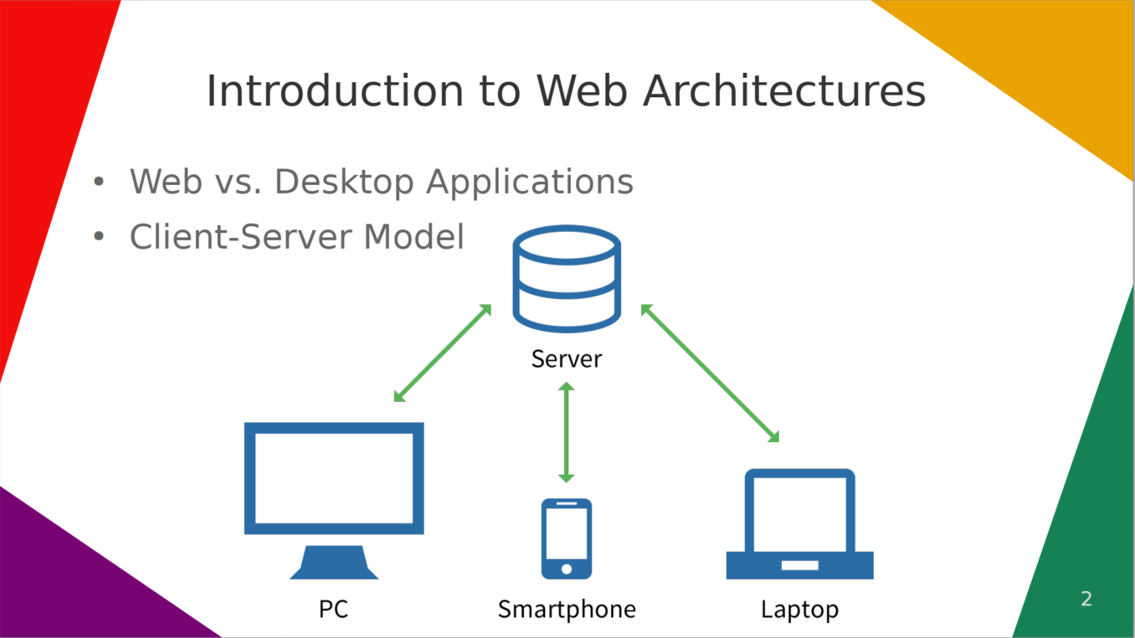
Web Architectures: Models
A distributed application consists of a collection of autonomous computers linked by a network and supported by software that makes the collection act as an integrated service.

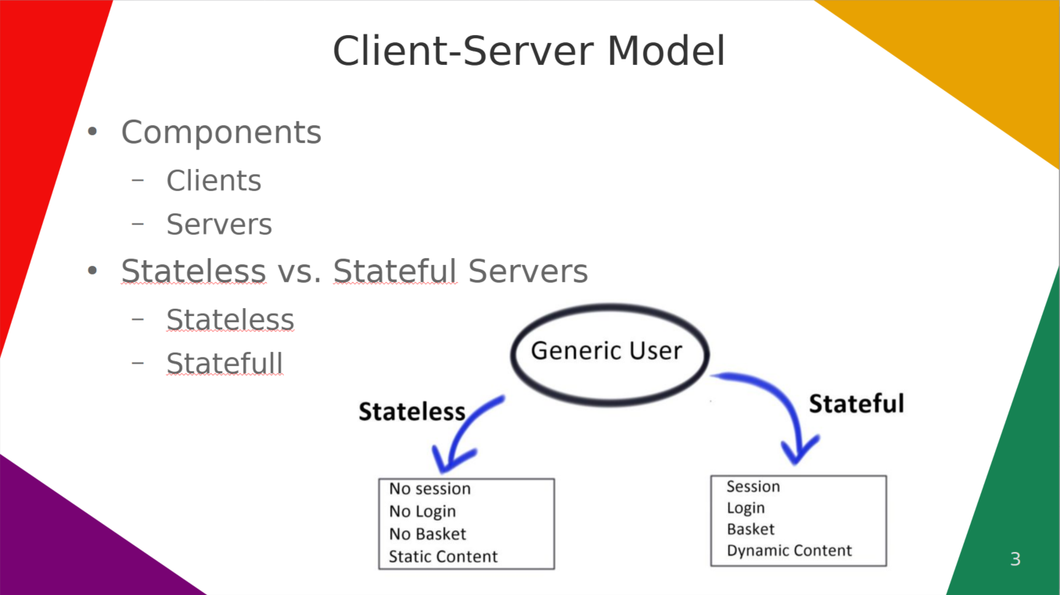
The Client-Server Model
The client-server model is an application architecture where computers are mainly assigned two roles: clients and servers, as indicated by the model’s name (see Figure 1).
Client-Server Structure
In the client-server model, there are two types of components:
- Clients: Request services. Typically, clients initiate communication with the server.
- Servers: Provide services. Servers usually wait to receive requests, resolve them, and return the results to the client.
Servers can be stateless or stateful. A stateless server does not maintain any information between requests, while a stateful server can retain information between requests. For example, a server with static web pages would be stateless, whereas a server with dynamic content would be stateful.
The basic client-server model shown above is suitable for small, simple web applications with light workloads, i.e., a small number of clients connected simultaneously.
A server can also act as a client to other servers. For instance, web servers and other internet services are clients of the Domain Name System (DNS) service.
In real environments, these characteristics are often not met, necessitating a more complex architecture based on the client-server model, with modifications or extensions to ensure good performance, reliability, and the capacity to handle a high number of simultaneous client requests in medium to large web applications with medium/high complexity.
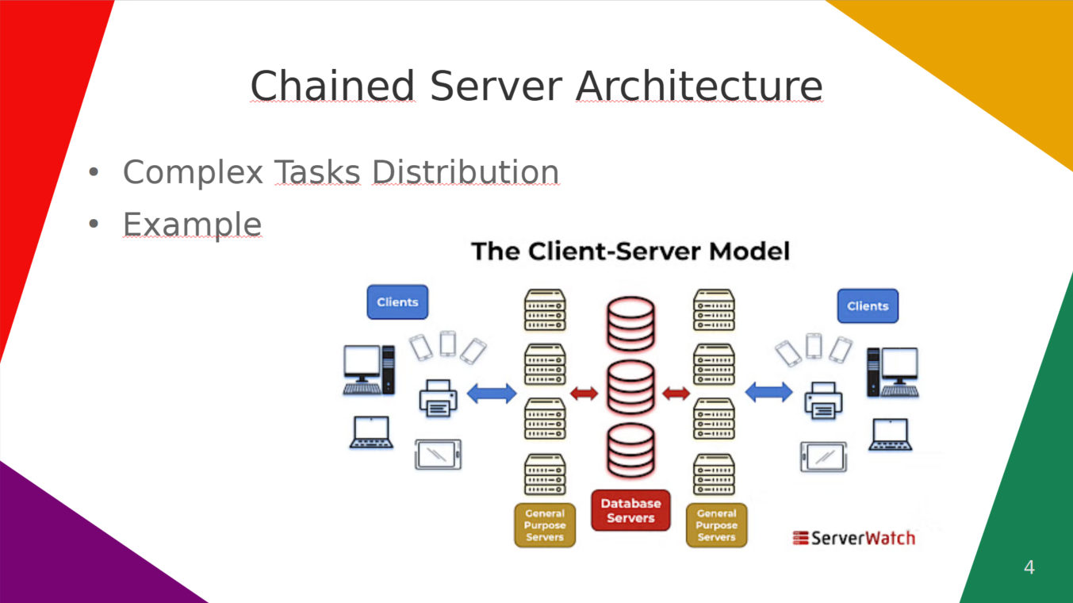
Chained Server Model
When an application’s server has to perform complex or costly processing tasks, these tasks can be distributed across multiple servers. A server can act as a client to another server to delegate specific responsibilities.
For example, when a client of a bank accesses the bank’s online services through a web browser (client), the client initiates a request to the bank’s web server. The client’s login credentials are stored in a database, and the web server acts as a client to access the database server. An application server interprets the returned data, applying the bank’s business logic and providing output to the web server. Finally, the web server returns the result to the client’s web browser for display.
Web-Based Applications
A particular case of client-server applications is those that run using web architecture. These applications rely on processing power located on a web server (or set of servers) accessed from a web browser.
When a user clicks a link on a web page in their browser, it generates a request to the server containing the information. Once the server receives the request, it returns the content. The communication between client and server is conducted via the HTTP protocol.
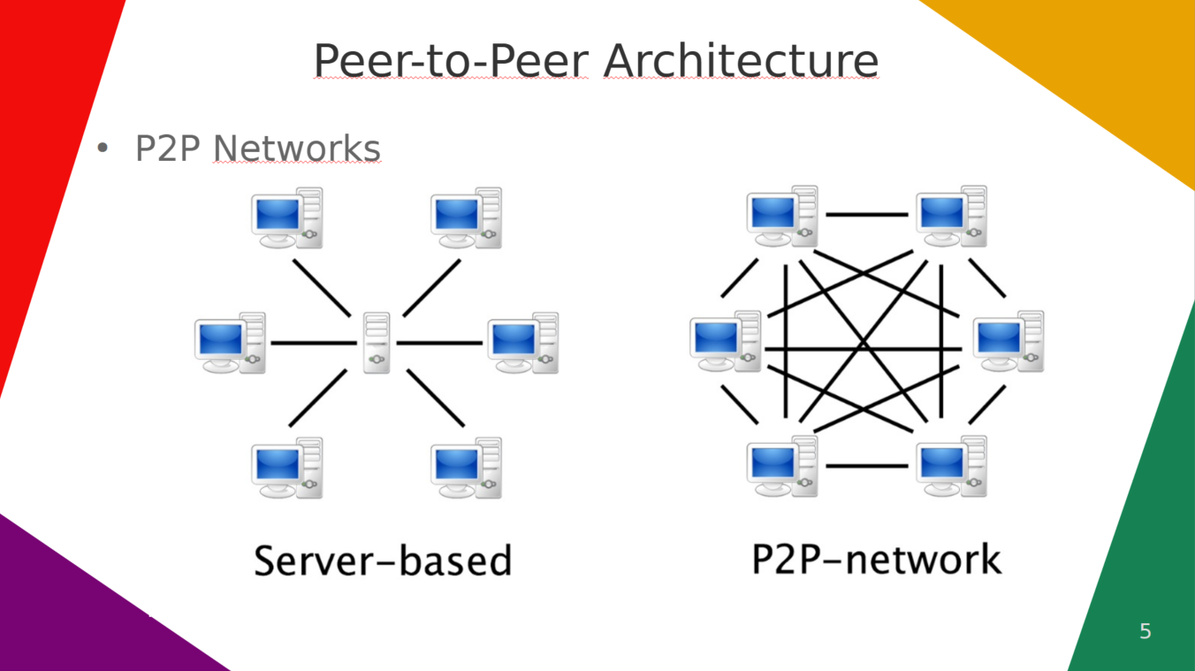
Peer-to-Peer Model
There is an architecture type where all computers behave as both clients and servers simultaneously. These types of networks are known as peer-to-peer.
Peer-to-Peer
A peer-to-peer system is a distributed system where all nodes have the same capabilities and responsibilities, acting as both clients and servers simultaneously, resulting in symmetric communication.
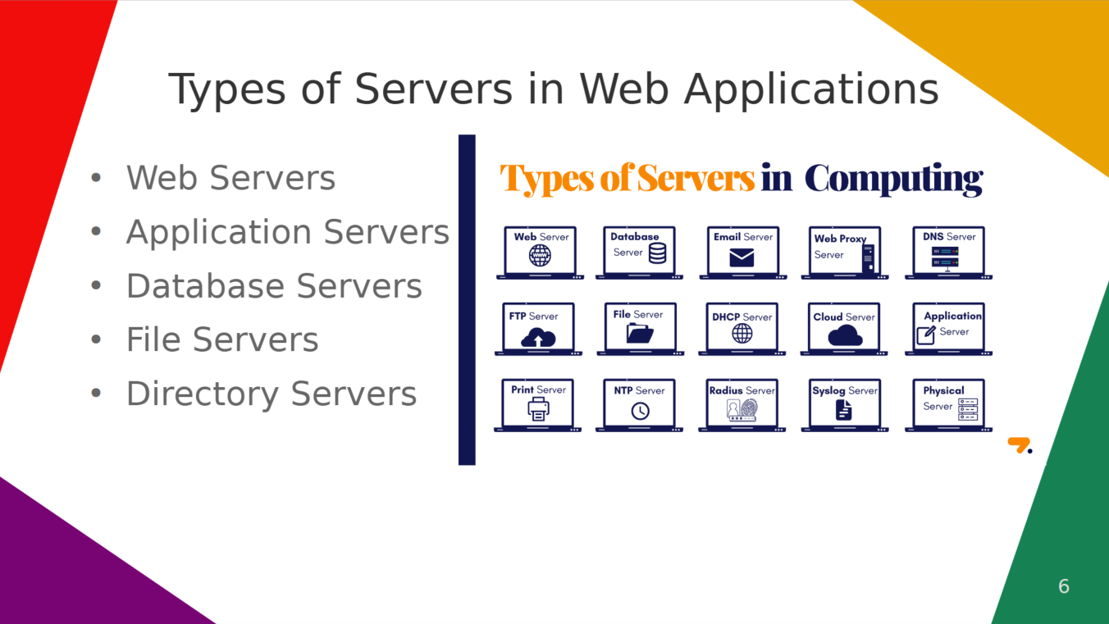
Web and Application Servers: Installation and Basic Configuration
During the development, deployment, and maintenance phases of a web application, various types of servers may be involved, each carrying out specific tasks within the overall functionality.
Web Servers
A web server is a server that allows access to resources via the HTTP protocol.
Originally, the concept of an HTTP server referred to servers capable of providing access and managing a set of static resources in response to client requests. In practice, most web servers now support the installation of modules that generate dynamic content by executing programs written in languages such as PHP, JavaScript, Python, Perl, etc., although this is typically a feature of application servers.
Examples of web servers include Apache HTTP Server (Linux) and Microsoft Internet Information Server (Windows).
Application Servers
An application server provides execution services to clients. In web applications, an application server is software that controls program execution. Clients access a web interface from where they run the application using a browser (via HTTP). Application servers are commonly used in complex web applications.
Examples of application servers include GlassFish (Java EE, Oracle) and Microsoft Internet Information Server (.NET).
Database Servers
A database server stores, retrieves, and manages data. It handles data updates, allows simultaneous access by multiple servers or users, and ensures data security and integrity.
Examples of database servers include Oracle Database, MySQL, Microsoft SQL Server, PostgreSQL, MongoDB, and Firebase.
File Servers
A file server manages file upload, download, update, and deletion over a network. In web applications, file servers are primarily used to deploy applications on production servers.
Common protocols for file transfer during application deployment include FTP and its security variants FTPS and SFTP.
Examples of file transfer servers include ProFTPD and vsftpd (Linux) and Microsoft Internet Information Server (Windows).
Directory Servers
A directory server manages administrative information, such as authorized users and their roles or permissions, in a web application environment.
Examples of directory servers include OpenLDAP (Linux) and Active Directory (Windows).
Web Application Structure and Resources
Web applications, besides having a client-server architecture, are usually structured with numerous files and resources. Clear guidelines must be set for organizing these components and their interrelation during development and deployment.
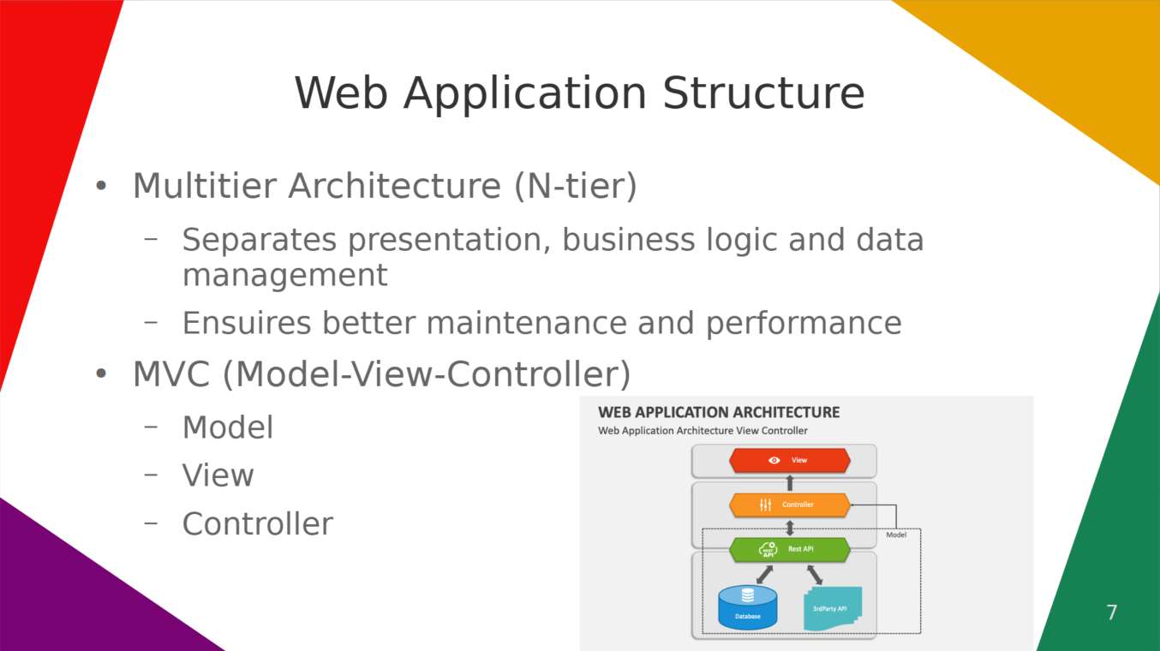
Multitier Architecture
Multitier architecture (or N-tier architecture) separates application components by function, typically into presentation, application logic, and data management layers.
Model-View-Controller (MVC) Architecture
MVC separates data, application logic, and user interaction into three components: Model (data and business logic), View (visible representation), and Controller (handles user interaction).
Advanced development platforms often dictate a minimal directory structure and configuration descriptors for application components to manage and update these efficiently without altering source code.
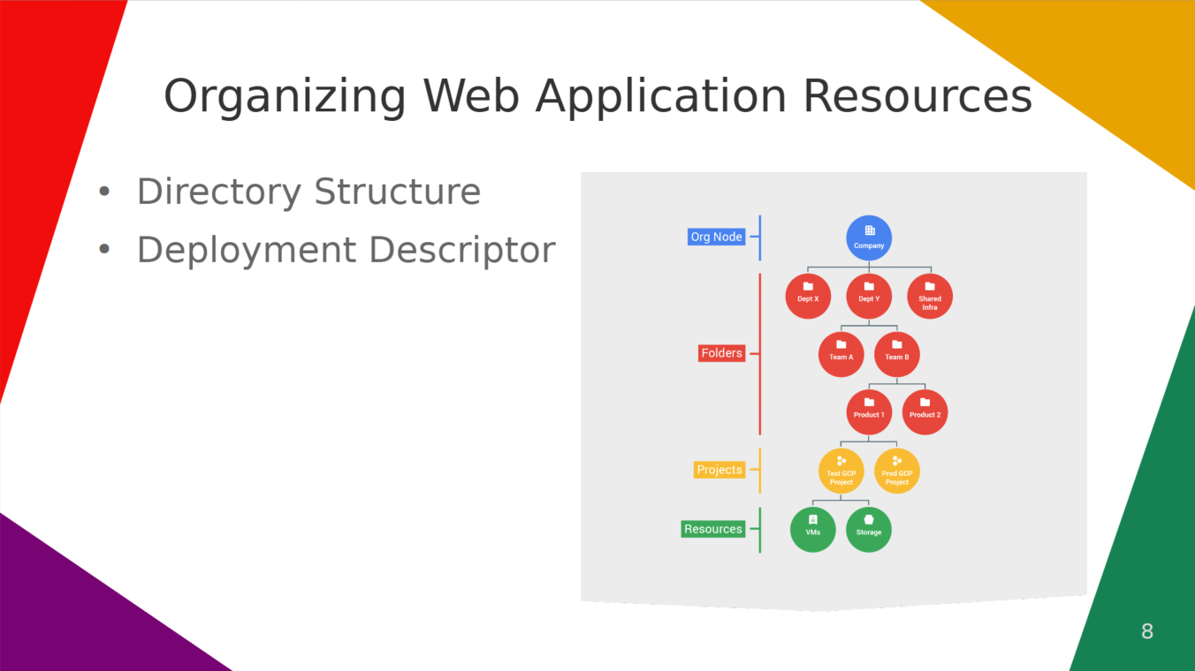
Organizing Web Application Resources
- Directory Structure: Defined by development platforms; organizes components systematically.
- Deployment Descriptor: Configuration file centralizes information on components' location, settings, and deployment instructions.

