
4. Web Server Administration
Miquel Àngel París i Peñaranda
Web Application Deployment
2nd C-VET Web Application Development

Index
COMBINED PRACTICE DNS and APACHE2 3

COMBINED PRACTICE DNS and APACHE2
We have been asked to manage two websites, www.daw.iesjc and www.dam.iesjc. The pages will be hosted on separate virtual servers in Apache2. The server has the IP 192.168.18.254.
You must:
- Configure a DNS service to handle the websites, defining the necessary zones in a Bind9 server and its database files with the information of names and IPs.
- Configure the two virtual servers in Apache2.
- Test the functionality of the setup by accessing the websites through their URLs.
Insert screenshots that prove the funcionality. Also upload all configuration files zipped.

Create zones
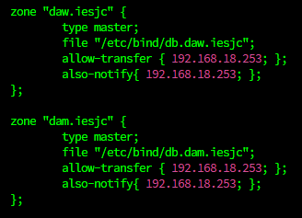

Create data base zones
File →db.daw.iesjc:
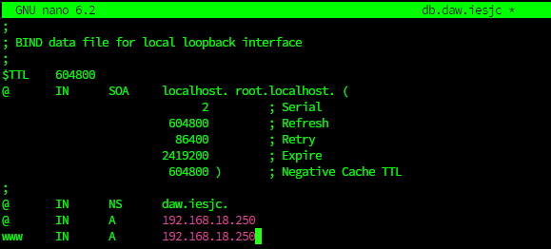

File →db.dam.iesjc:
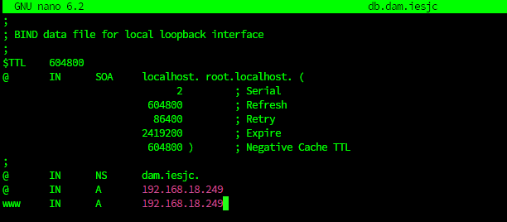
Create configuration files

Create index.html
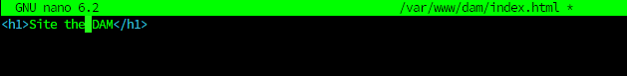

Enable settings:
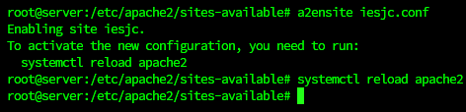

Comprobate status of site



