

Breanna Hansen

CIT230: 07

WeatherView

Site Plan

## Site Purpose

The pu­­­rpose of the Weather View website is to provide up-to-date and projected weather forecasts and road conditions for the areas of Franklin, Springfield, and Greenville. A Storm Center page will also provide them with critical weather information and a gallery of weather from the participating areas. The information provided will help individuals assess needs to prepare for various weather types and what to expect when they are outside in the participating areas.

## Target Audience

Our target audience is any individuals or groups of both genders located in the target areas who live in or will be visiting in the upcoming future.

* Individuals
  + Individual visitors come from all economic and educational levels in life. The range starts with elementary students who read to adults. Generally, individuals are attempting to plan clothing, outwear, and activities either for the day or in the near future.
* Families
  + Families range from small to large and include very active families wanting to participate in outdoor recreation activities to special needs families that may need to avoid an area due to the weather.
* Business or Leisure Travelers
  + Travelers will often be searching to see how the weather differs from where they live so they can plan clothing needs appropriately. This is helpful in instances where a weather forecast will determine if a traveler may need to purchase a different type of clothing item than they currently own.
* School or Tour Groups and Sports Teams
  + The weather forecast for these groups will help determine if they need to continue, move, or cancel an event. It also gives coordinators the ability to notify attendees to dress for a certain type of weather.

## Site Map

### 

## Color Scheme

Color Palette

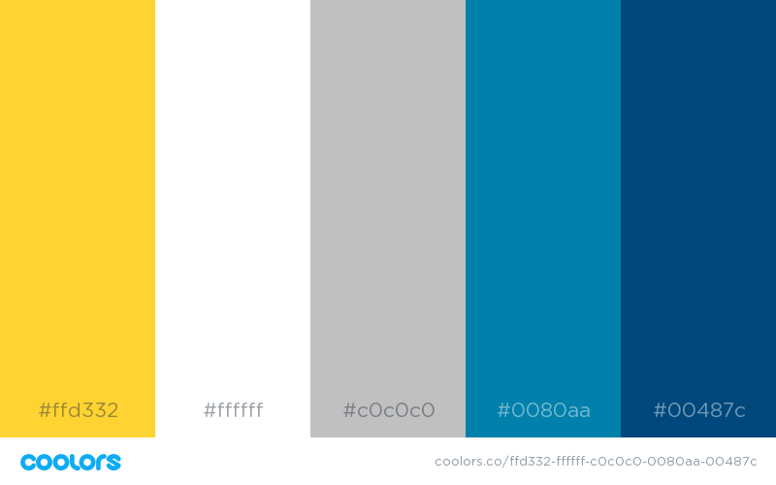

|  |  |  |
| --- | --- | --- |
| **Element** | **Background Hex #** | **Background Sample** |
| Header | #00478a |  |
| Nav | #00487a |  |
| Main | #ffffff |  |
| Footer | #c0c0c0 |  |
| Button | #ffd332 |  |

|  |  |  |  |
| --- | --- | --- | --- |
| **Primary** | **Secondary** | **Accent** | **Accent** |
| #01487c | #c0c0c0 | #0080aa | #ffd332 |

### Website Logo

|  |
| --- |
| Primary Color |
| #ffd332 |



## Typography

|  |  |  |  |  |  |
| --- | --- | --- | --- | --- | --- |
| Element | Font | Size | Font Hex # | Background Hex # | Sample |
| Site Header | Arvo | 2em/32px | #ffffff | #00478c | Sample |
| Primary Navigation | Open Sans | 1em/16px | #ffffff | #00478c | Sample |
| Footer Navigation | Open Sans | 0.750em/12px | #00487c | #0000000c0 | Sample |
| Heading (h1) | Arvo | 2em/32px | #00487c | #ffffff | Sample |
| Heading (h2) | Arvo | 1.5em/24px | #00487c | #ffffff | Sample |
| Heading (h3) | Arvo | 1.250em/20px | #00487c | #ffffff | Sample |
| Paragraph text (p) | Open Sans | 0.875em/14px | #000000 | #ffffff | Sample |

|  |  |  |
| --- | --- | --- |
| Primary Navigation | | |
| a:link | #ffffff | Sample |
| a:visited | #ffffff | Sample |
| a:hover | #c0c0c0 | Sample |
| a:active | # ffd332 | Sample |

|  |  |  |
| --- | --- | --- |
| Links | | |
| a:link | #00487c | Sample |
| a:visited | #00487c | Sample |
| a:hover | #0080aa | Sample |
| a:active | #0080aa | Sample |

## Wireframes

### Large View

### Medium View

### Small View