

Breanna Hansen

CIT230: 07

**Mountain Spoke**

**Site Plan**

## Site Purpose

The pu­­­rpose of the Mountain Spoke website is to provide sales, tour, event, service, and contact information to customers. The home page goal is to display different types of services our business offers and to display any current sales information or recent news.

The sales page two goals are to allow customers to quickly find the type of bike they are searching for and provide enough detail for products to help customer’s feel confident in purchasing. To make this as expeditious as possible, bicycles will be sorted into categories of mountain, fitness & multi-use, road, electric, and children/youth bikes. All categories will have a listing of brands, makes, and models available. Each bicycle listing will offer an image and specification details to aid in the goal of raising customer confidence.

The goals of the tour page are to increase customer participation in tours and build brand loyalty for the store from customer references. The page will provide information about length, skill level required, cost, rentals available, and location of each daily tour. There will also be a small section featuring our Instagram account and how customers can tag photos of their tours. A second option they have is to share tour photos from our Facebook page with friends and family.

Our purposes for the events page are to gain new customers from the Cycle the Continental Divide annual event and build store brand loyalty with previous customers and event participants. Detailed information about the event will be provided to answers usual participant questions. An online registration form will allow customers to easily register which will return a higher rate of participants. Adding these two items together will alleviate time employees spend asking questions and registering participants. By having this information available on the site, we will also increase the range of participants who can find information for the event.

The goal of the service page is to provide a list of common repairs and services performed and cost to aid customer satisfaction. This will save employees time in answering questions. Customers will be able to determine if our store offers the services they need, what they need done, and prices. This will help them feel more confident in our services.

The objective of the contact page is to allow customers to easily find the store address and directions, contact information, and hours. A secondary objective is to give them the ability to ask questions via the contact form or email.

## Target Audience

Our target audience is a vast array individuals or groups of both genders that participate in cycling in the Bozeman area or who will be visiting in the upcoming future. These individuals have extra income at their disposal to spend on extracurricular activities.

* Individuals
  + Our target is those individuals, families, or groups who are interested in road cycling and mountain biking adventures. Ages range from high school teens and up. The goal for individuals is often shopping for a bicycle and for service and repairs. Generally, members of this group are more avid cyclists then the regular public and focus on either mountain biking or road cycling. This target audience is a focus for store brand loyalty, so they will continue to use our store for future service and repairs.
* Families
  + Families range from small to large and include active families wanting to participate in cycling activities. This includes families with children whose objective is to purchase bicycles and accessories for growing youth and new bicycles for parents as old ones may have been handed down. This group often enjoys rides as a family while on vacation or around town. There are a small percentage of families who will also mountain bike together. This group focuses more on the hybrid and mountain bikes as well as service and repairs.
* Leisure Travelers
  + The leisure travelers target audience includes those that like to do cycling activities and tours while on vacation. This may include those that will need to rent a bicycle to participate in tours and events. This can be a group of individuals traveling together, families, or individuals. These individuals focus more on participation and rentals than sales.
* Cycling Teams and Organizations
  + This group will have a high range of participants and often will qualify for a group discount on some purchases and events. Their goal is to purchase a wide range of tools and consumable accessories to maintain their cycling adventures. They generally also participate in events. The youngest age in this group is generally middle and high school students participating on a local race team. Other adult groups included store sponsored weekly cycling groups, local cycling clubs, circuit race teams, and semi and professional race teams. Building store loyalty with local teams and clubs is key to boosting individual and family store brand loyalty.

## Site Map

### 

## Color Scheme

Color Palette

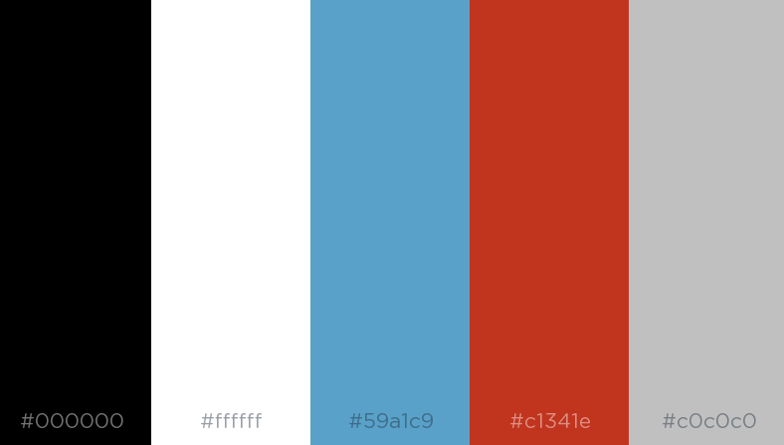

|  |  |  |
| --- | --- | --- |
| **Element Background** | **Hex #** | **Fill** |
| Header | #262721 |  |
| Nav | #262721 |  |
| Main | #ffffff |  |
| Footer | #262721 |  |
| Button | #C1341E |  |

|  |  |  |  |
| --- | --- | --- | --- |
| **Primary** | **Secondary** | **Accent** |  |
| #262721 | #C1341E | #59A1C9 | #c0c0c0 |

### Website Logo



## Typography

|  |  |  |  |  |
| --- | --- | --- | --- | --- |
| Element | Font | Size | Hex # | Sample |
| Site Header | Anton | 2em/32px | #ffffff | Sample |
| Primary Navigation | Source Sans Pro | 1em/16px | #ffffff | Sample |
| Footer Navigation | Source Sans Pro | 0.750em/12px | #ffffffffff | Sample |
| Heading (h1) | Anton | 2em/32px | #c1341e | Sample |
| Heading (h2) | Anton | 1.5em/24px | #c1341e | Sample |
| Heading (h3) | Anton | 1.250em/20px | #c1341e | Sample |
| Paragraph text (p) | Source Sans Pro | 1em/16px | #000000 | Sample |

|  |  |  |
| --- | --- | --- |
| Primary Navigation | | |
| a:link | #ffffff | Sample |
| a:visited | #c0c0c0 | Sample |
| a:hover | #59a1c9 | Sample |
| a:active | #c1341e | Sample |

|  |  |  |
| --- | --- | --- |
| Links | | |
| a:link | #c1341e | Sample |
| a:visited | #c0c0c0 | Sample |
| a:hover | #59a1c9 | Sample |
| a:active | #c1341e | Sample |

## Wireframes

### Large

### 

### Medium

### Small