**MILESTONE FOUR: DATABASES**

BREANNA C SMITH

SOUTHERN NEW HAMPSHIRE UNIVISERTY

COMPUTER SCIENCE CAPSTONE

PROFESSOR MARYANN KRUPA

OCTOBER 4, 2024

The SHOP HEALTHY! app is designed to help users manage their dietary preferences and make informed decisions while grocery shopping by scanning product barcodes. This project builds on the work I completed in CS-319 UI/UX Design and CS-360 Mobile Architecture and Development. In CS-360, I developed an inventory management application using SQLite, and I have chosen to continue using SQLite for this project due to its simplicity and efficiency as relational database that operates directly on the user’s device. The system effectively handles key tasks such as user account creation, login, and ingredient retrieval. The core functionality of the app allows users to save their dietary preferences, such as vegan or gluten-free, and scan product barcodes to display information.

First while designing this code, I knew that this app needed two databases. One will be the *UserDB* which manages user accounts, stores details such as usernames, passwords, and dietary preferences. The second database manages ingredients associated with product barcodes which is *Ingredient DB*.

For the database name: *userDB*

For the Table: *users*

* *id*: A unique identifier for each user.
* *usernam*e: A text field for storing the users chosen username.
* *password*: A text field for storing the user’s password.
* *DietaryPreference*: A text field to store the users dietary preference such as vegan and gluten-free.

This will allow the app to store multiple users, with each user having their own login credentials and dietary preference.

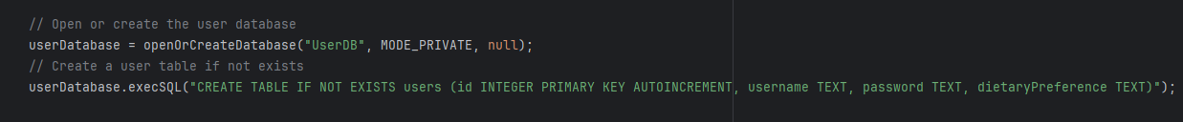

For the Ingredient Database that will allow the application to store ingredient data for different products that can be retrieved using the barcode are:

For the database name: *IngredientDB*

For the Table: *ingredients*

* *id:* A unique identifier for each entry.
* *Barcode:* The barcode of product used for identifying products.
* *ingredientData:* A text field that stores ingredient information associated with the product barcode.

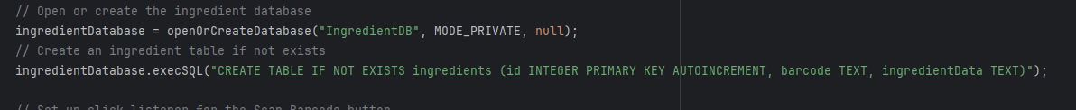

For login functionality, this app allows you to log in using username and password. When the user logs in to the app, the *users* table to see if the credentials match.



When the user enters a barcode and clicks “Scan Barcode”, the app will query the *ingredients* table in the *IngredientDB* to match the ingredient data based on the barcode:

The transformation from the original to the updated code has significantly enhanced the functionality of the SHOP HEALTHY! App. One of the key challenges of this app heavily relied on barcode scanning and quick ingredient lookup. Ensuring the fast and efficient retrieval from the SQLite database was critical. Unlike inventory management, the app needed to handle multiple data types and optimize queries for performance.