The DALY Calculator

A graphical user interface for stochastic DALY calculation in **R**

— Manual version 1.5.0 —

**Brecht** **Devleesschauwer • Scott McDonald • Juanita** **Haagsma • Nicolas** **Praet • Arie** **Havelaar • Niko** **Speybroeck**

**Maintainer:**

**Brecht Devleesschauwer, Dept Public Health and Surveillance, Scientific Institute of Public Health (WIV-ISP), Brussels, Belgium;** [brechtdv@gmail.com](mailto:brechtdv@gmail.com)

**Online:**

<http://daly.cbra.be> (DALY Calculator homepage)

<http://cran.r-project.org/package=DALY> (current version & archive)

<https://github.com/brechtdv/DALY/> (development version & bug reports)

**To cite the DALY Calculator in publications, please use:**

Brecht Devleesschauwer, Scott McDonald, Juanita Haagsma, Nicolas Praet, Arie Havelaar and Niko Speybroeck (2016). DALY: The DALY Calculator - A GUI for stochastic DALY calculation in R. R package version 1.5.0. http://cran.r-project.org/package=DALY

# ABSTRACT

The disability-adjusted life year or DALY is an increasingly used measure of population health. The DALY package, accessible in the **R** statistical programming environment, provides a Graphical User Interface (GUI) for calculating DALYs and performing uncertainty and sensitivity analyses. The uncertainty propagation is based on Monte Carlo simulations, which are used to compute DALY credibility intervals from the uncertainty in the various input parameters. Based on these simulations, probabilistic global sensitivity analysis can be carried out to identify those input parameters that have the highest contribution to the overall uncertainty.

The GUI of the *DALY Calculator* allows for ease and flexibility, while the **R** environment enables more advanced computations and graphical functions. The underlying calculation methods are designed to promote consistency in the uncertainty analysis of DALYs. These methods are demonstrated through the inclusion of two examples from the foodborne disease burden literature (i.e., the burden of neurocysticercosis in West-Cameroon and the burden of congenital toxoplasmosis in the Netherlands). We believe that the *DALY Calculator* can become a useful tool for students, scientists and health officials involved in the quantification of public health problems.

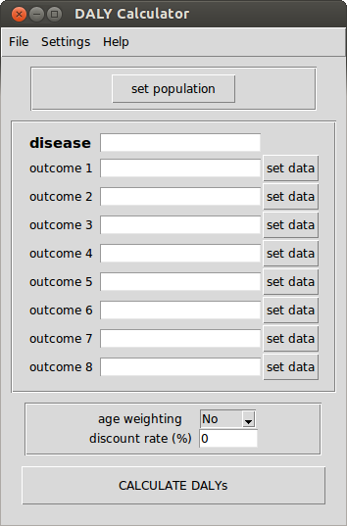

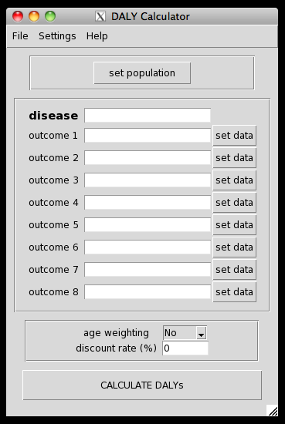

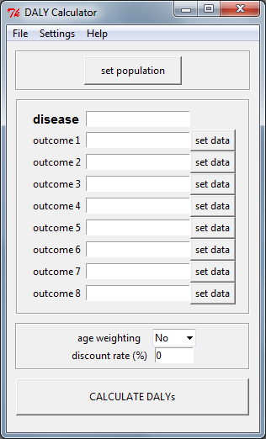

Figure 1. DALY Calculator main window in Ubuntu Linux, Mac OS X 10.6, and Windows 7

# 1. Introduction

The ***disability-adjusted life year* or DALY** is a summary measure of population health widely used in disease burden assessment studies and cost-utility analyses (Murray and Lopez, 1996; Lopez et al., 2006). DALYs represent the number of healthy life years lost due to a disease or disability, and do so by incorporating non-fatal and fatal health outcomes, calculated as the years of life lived with disability (YLD) and the years of life lost due to premature death (YLL), respectively. In order to make a direct comparison of YLDs and YLLs possible, disability weights are assigned to various degrees of disability, ranging from zero (full health) to one (worst possible health state). In addition to these disability weights, the DALY calculation requires the choice of two other social values, i.e., age weighting and time discounting. The former gives a higher weight to the healthy life years lived between the age of 9 and 54, as this period of life is considered to be socially more important than the younger and older life spans (Murray, 1994). The latter discounts the years of healthy life lived in the future, at a rate of (usually) 3%. The incorporation of a time discount rate reflects similar practices in economic assessments, and would prevent policy makers from saving resources for a possible future eradication program, instead of investing in currently available, but less effective, intervention measures (the so-called "disease eradication and research paradox"; Murray, 1994).

The formulas for calculating the YLLs and YLDs are presented in Murray (1994) and Murray and Acharya (1997), and can easily be incorporated in a spreadsheet, such as the "**DALY calculation template**"[[1]](#footnote-1) prepared by the World Health Organization for its Global Burden of Disease (GBD) project (Mathers et al., 2001). This template allows the computation of YLLs and YLDs for both sexes and various age groups, which are then summarized into a single deterministic DALY measure.

The reliability of the final DALY result depends heavily on the quality of the epidemiological data, which are commonly derived from routine data collection systems, scientific literature, and expert elicitation. The estimates provided by these data sources include an inherent level of uncertainty, mainly due to sampling error, diagnostic uncertainty, and population heterogeneity. To reflect this stochastic nature, epidemiological parameters are often accompanied by a confidence or credibility interval, or represented as a probability distribution, rather than being represented by a single point estimate. **Monte Carlo simulations** have been suggested as the appropriate technique to incorporate this uncertainty in the final DALY result (de Vocht et al., 2010), which can then be presented as a point estimate with a credibility interval. This interval allows the assessment of the level of uncertainty in the total DALYs, and facilitates a more reliable comparison of the health impact of different diseases.

To our knowledge, however, there are **no standardized tools** available for stochastic DALY calculation. Therefore, we designed a Graphical User Interface (GUI) for calculating DALYs that allows for the incorporation of input uncertainty and the computation of a DALY credibility interval through Monte Carlo simulations. This program, the *DALY* *Calculator*, is designed to be used by a variety of users, with different levels of statistical skills, to allow maximum flexibility, and to promote consistency in the DALY uncertainty analysis.

The remainder of this manual is structured as follows. A description of how to obtain and install the *DALY Calculator* is given in Chapter 2. The five basic steps to calculate DALYs with the *DALY Calculator* are presented in Chapter 3. Using the table widgets of the *DALY Calculator* is described in Chapter 4. Manipulating the *DALY Calculator* output in the **R** environment is presented in Chapter 5. Sensitivity analysis features are presented in Chapter 6, scenario analysis features in Chapter 7. The two built-in examples are introduced in Chapter 8. The features to save and load input data are described in Chapter 9. Current limitations and envisioned future improvements are listed in Chapter 10. Finally, an overview of the different versions of the DALY Calculator is given in Chapter 11.

The computational details of the uncertainty analysis performed by the *DALY Calculator* are outlined in Annex 1.

# 2. Installing and running the *DALY Calculator*

The *DALY Calculator* is developed in **R**, an open-source environment for statistical programming and graphics (R Core Team, 2014). The use of the *DALY Calculator* requires the prior installation of **R**, which can be freely downloaded from the Comprehensive R Archive Network (CRAN): <http://cran.r-project.org/>

The installation procedure under Mac OS X is more complicated. Two additional tools need to be installed:

* The **X Window System (X11)**: if this is properly installed, the file X11.app should appear in the Utilities folder under Applications in the Finder. If not, you can install it from your Mac OS X installation disc.
* **Tcl/Tk for X Windows**: this can be installed by downloading and installing tcltk-8.5.5-x11.dmg from <http://cran.r-project.org/bin/macosx/tools/>

Linux users may need to download and install the **Tktable** toolkit, which can be found through <http://packages.ubuntu.com/search?keywords=tk-table>. Ubuntu/Debian users may download and install the toolkit directly by issuing any of the following command from Terminal:

sudo apt-get install tk-table

sudo apt-get install libtktable2.10

The DALY package is available on the CRAN repository, and can be installed directly from the **R** console, by calling:

install.packages("DALY")

Finally, every time the *DALY Calculator* has to be used, the DALY package has to be loaded in the **R** environment, by typing the following command in the **R** console (Figure 2):

library(DALY)

This call will load and attach the DALY package, and initiate the main window of the *DALY Calculator* (Figure 1, 3-5). To re-initiate this window, call the following function in the **R** console:

DALYcalculator()

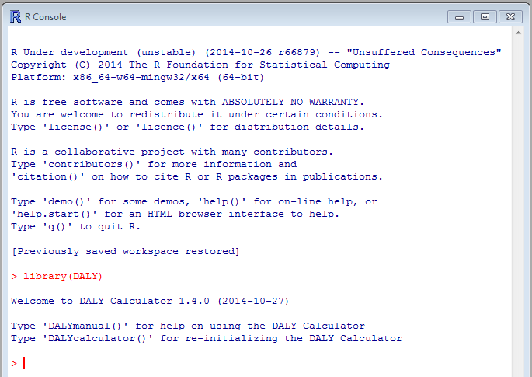

Figure 2. Initializing the DALY Calculator

|  |  |
| --- | --- |
| C:\Users\UGent\Desktop\doctoraat\- Art 01. DALY Package\- DALY_1.1.0\manuals\main-file.png  Figure 3. DALY Calculator 'File' menu | C:\Users\UGent\Desktop\doctoraat\- Art 01. DALY Package\- DALY_1.1.0\manuals\main-settings.png  Figure 4. DALY Calculator 'Settings' menu |

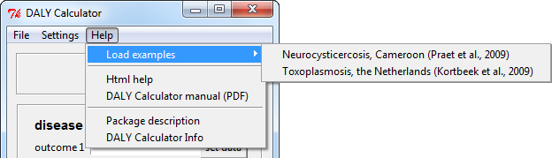

Figure 5. DALY Calculator 'Help' menu

# 3. Getting started with the *DALY Calculator*

The *DALY Calculator* is designed to be used in an **outcome-based** as well as an **agent-based** approach. Depending on the approach, YLDs, YLLs, DALYs and incident cases and deaths can be computed for a combination of up to eight different disease categories of one outcome, or of up to eight different outcomes of one agent.

According to the GBD studies, the **incidence-based** approach was favored over the prevalence-based approach. The current version of the *DALY Calculator* is able to calculate DALYs for a basic incidence-based disease model with well-defined incidence and/or mortality rates per disease category or outcome.

The default age groups used by the *DALY Calculator* are the **five age groups** used by the GBD 1990 study: 0-4; 5-14; 15-44; 45-59; 60+ (Lopez and Murray, 1996). At least one combination of sex and age group has to be set in order to proceed with the DALY calculation.

To compute YLDs, YLLs, DALYs, incident cases and deaths, **five steps** have to be followed (as illustrated in Figure 6). These steps will be explained using one of the two built-in examples (The burden of *Taenia solium* cysticercosis in Cameroon; Praet et al., 2009). Users can load this example by selecting:

Help > Load examples > Neurocysticercosis, Cameroon (Praet et al., 2009)

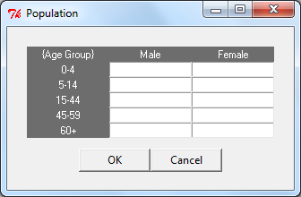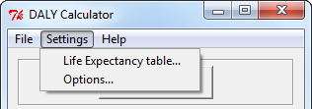

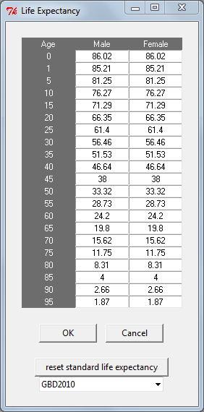

Figure 6. DALY calculation with the DALY Calculator

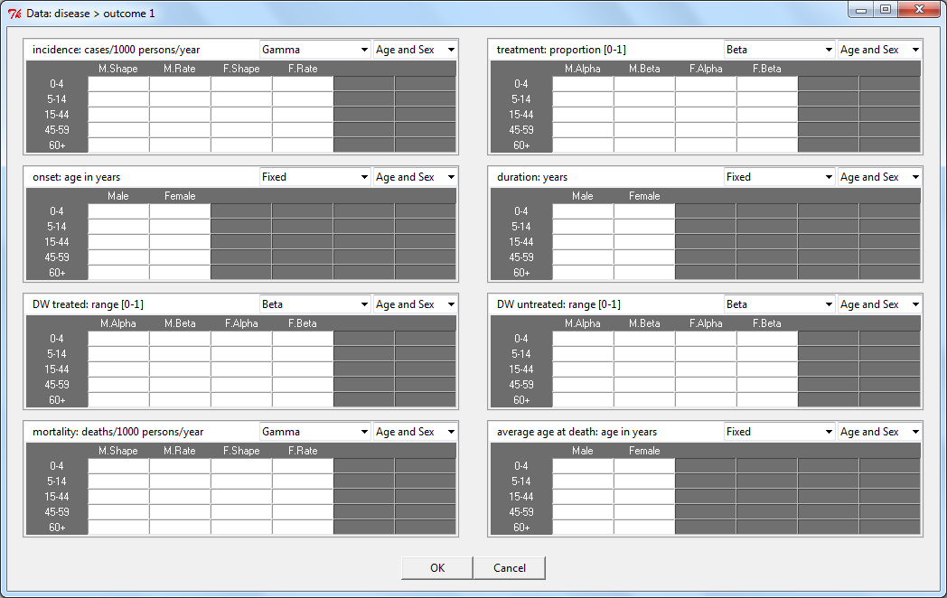

Select distribution

Select level of stratification

Enter data



Figure 6. DALY calculation with the DALY Calculator (continued; M = Male, F = Female)

**① Set the population table**

Clicking the "set population" button opens the population window, where the number of males and females, per age group, can be entered. At least one combination of sex and age group has to be set.

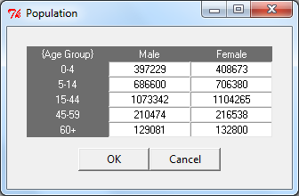

Figure 7. Population of West-Cameroon, stratified by sex and age

**② Set the life expectancy table**

The *DALY Calculator* provides the three standard life expectancy tables proposed so far:

1. **GBD1990**: the Coale and Demeny model life-table West, level 26 and 25, which has a life expectancy at birth of 80 for males and 82.5 for females (Murray, 1994);
2. **GBD2010 (default)**: the synthetic standard life expectancy introduced for the GBD 2010 study, with a life expectancy at birth of 86 for both males and females;
3. **WHO/GHE**: the projected frontier life expectancy for the year 2050, used for the WHO Global Health Estimates, with a life expectancy at birth of 92 for both males and females.

The user can select a different standard life expectancy table or define their own life expectancy table, by accessing the 'Life Expectancy' window through the 'Settings' menu:

Settings > Life Expectancy

*Praet et al. (2009) applied the GBD1990 standard life expectancy table. We therefore need to change the life expectancy table by selecting "GBD1990" and clicking "reset life expectancy table".*

**③ Set the input parameters, per disease category or outcome**

After entering the disease and outcome names, the epidemiological data and disability weights can be entered by clicking the "set data" button. For every parameter, the user can specify the **distribution** by selecting one of following:

**Beta-Pert** (mode; min; max)

**Beta** (alpha; beta)

**Gamma** (shape; rate)

**Normal** (mu; sigma)

**Lognormal-geometric** (logmean; logsigma)

**Lognormal-arithmetic** (mean; sigma)

**Uniform** (min; max)

**Fixed**

Next, the user has to select the specific **level of stratification** for every parameter. The following four stratification levels are available:

**Age and Sex** (i.e., full stratification)

**Age** (i.e., data is stratified by age group, but not by sex)

**Sex** (i.e., data is stratified by sex, but not by age group)

**None** (i.e., no stratification, data applies to total population)

For calculating the **YLDs and incident cases**, the following tables have to be completed:

**Incidence**: number of new cases per 1,000 persons per year

**Treatment**: proportion of patients receiving proper treatment; range [0-1]

**Onset of the disease**: age of onset in years

**Duration of the disease**: duration in years

**Disability Weight for treated cases**: range [0-1]

**Disability Weight for non-treated cases**: range [0-1]

For calculating the **YLLs and deaths**, the following tables have to be completed:

**Mortality**: number of deaths per 1,000 persons per year

**Average age at death**: age at death in years; based on these values, the *DALY Calculator* will compute the corresponding life expectancies according to the Life Expectancy table.

By default, the distributions of incidence and mortality will be set to "Gamma", those of the proportion treated and the disability weights to "Beta", and those of onset, duration and average age at death to "Fixed"; the level of stratification for all parameters is set to full stratification (i.e., "Age and Sex").

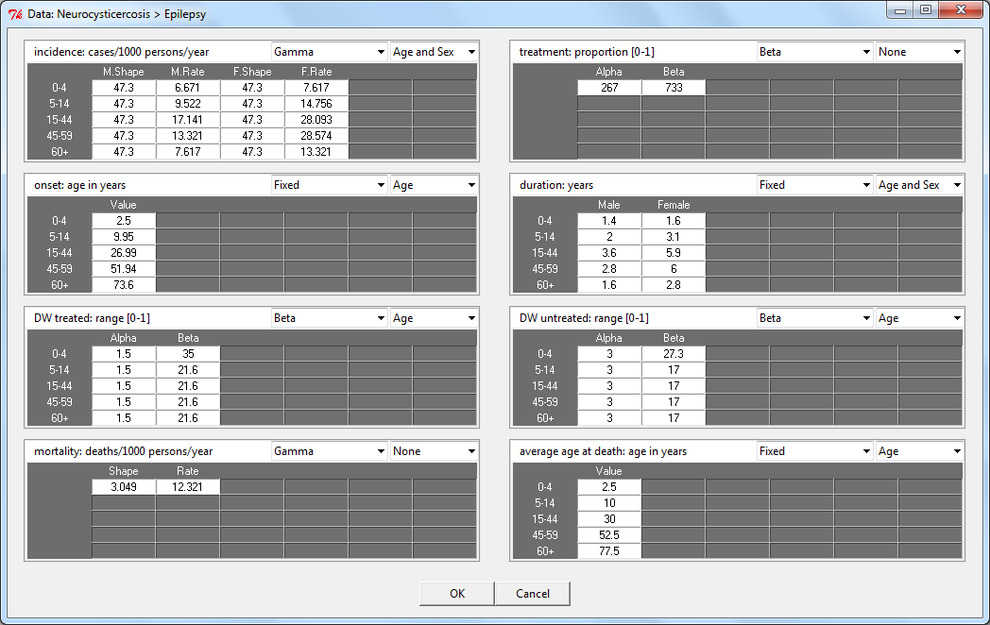

Figure 8. Epidemiological parameters for the DALY calculation of Neurocysticercosis in Cameroon, based on Praet et al. (2009)

**④ Set the social values:**

**Age weighting** yes or no

**Discount rate (%)** …

The default social weighting values applied by the *DALY calculator* are uniform age weights (i.e., no age weighting) and a zero discount rate. However, the user is given the possibility to define the required set of social values, and to alter these values to assess their influence on the final result.

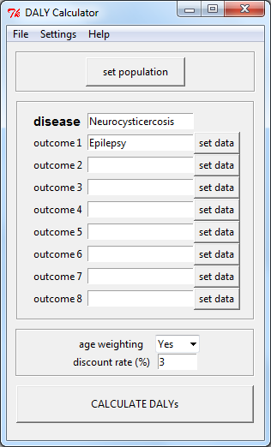

Figure 9. DALY Calculator main window, with social values set to full age-weighting and a 3% discount rate, as applied by Praet et al. (2009)

**⑤ CALCULATE DALYs**

Clicking the "CALCULATE DALYs" button will read the data and compute the YLDs, YLLs, DALYs and incident cases and deaths per disease category/outcome. Standard, the overall mean, median and a 95% credibility interval of these results will be printed to the **R** Console, and a histogram of total DALYs, with corresponding credibility interval, will be displayed (Figure 10).

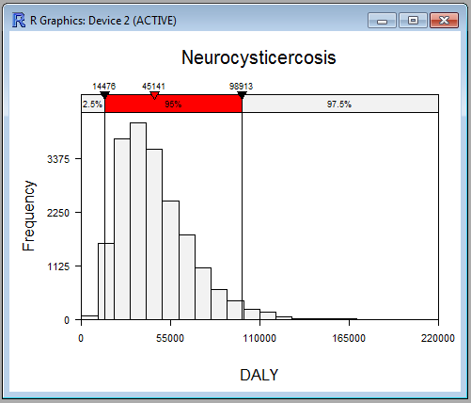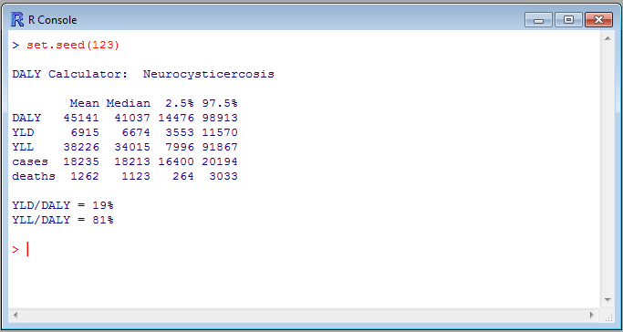

Figure 10. Standard output of the DALY calculation for *Taenia solium* Neurocysticercosis in Cameroon (based on Praet et al., 2009)

A more detailed output of the DALY calculation can be obtained by changing the output settings in the 'Options' window (Figure 11):

Settings > Options

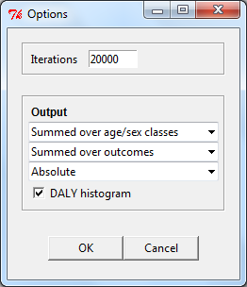

Figure 11. Options window

The following settings are possible:

* Age/Sex classes
  + Results summed over different age/sex classes (default)
  + Results shown per age/sex class
* Outcomes
  + Results summed over different outcomes (default)
  + Results shown per outcome
* Absolute/Relative
  + Absolute values (default)
  + Relative values, i.e., per 1000 population

More advanced output, both numerically as graphically, can be obtained by saving the *DALY Calculator* output to an **R** object, and manipulating this object in the **R** environment (see Chapter 5 for more details and examples).

# 4. Using the *DALY Calculator* table widgets

All tables of the *DALY Calculator* are built using the **Tktable** toolkit. The navigation and editing properties of this tabulator toolkit differ from those of common spreadsheet documents, which may cause confusion. Some clues are therefore useful to get started:

* Keyboard navigation is only possible through the arrow keys; pressing the RETURN (ENTER) key will not change focus to the underlying cell, but will append blank space to the currently active cell.
* To select all values of a column (row), you can click the column (row) header. Selecting all values in the table is possible by clicking the header in the top-left corner of the table. Figure 12 gives some examples.
* Removing the value of one or more cells can be done by selecting the corresponding cells and pressing CTRL+X (also on Mac).
* Pasting values into a table (eg, after copying them from a spreadsheet document), can be done by selecting the top-left cell of the desired range, and pressing CTRL+V (also on Mac).

C:\Users\UGent\Desktop\arrow.gif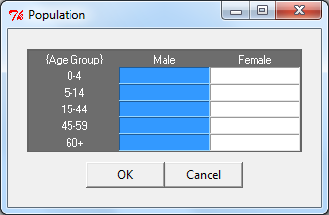

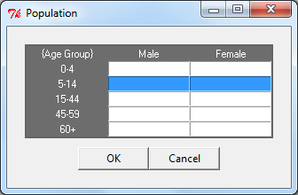

Figure 12. Selecting columns/rows in *DALY Calculator* table widgets.

# 5. Handling *DALY Calculator* output in the R environment

Instead of clicking the "CALCULATE DALYs" button in the *DALY Calculator* main window, the DALY calculation process may also be invoked by calling the getDALY() function from the **R** console. This function initiates the Monte Carlo simulation process, and returns the simulated DALYs, YLDs, YLLs and incident cases and deaths. Of course, this will only take place if the data have been entered, as outlined before.

The getDALY() function takes two arguments, aw and dr, that specify the age weighting constant and time discount rate, respectively. If these values are not specified, they will be taken from the GUI (see Figure 9).

The results of the DALY calculation process can be stored in an object, say x, as follows:

x <- getDALY()

Since aw and dr were not specified, these values were taken from the GUI. If one wishes to specify the social weighting values directly from the command-line, the values from the GUI will be over-ruled. For instance, one could specify to use *no age weighting* and a *3% time discount rate* as follows:

x <- getDALY(aw = FALSE, dr = 0.03)

## 5.1. Structure of the object returned by getDALY()

The getDALY() function returns an object of class 'DALY', which inherits from class 'list'. The returned object is a list containing the following elements:

*i* For each outcome *i*, an unnamed list containing simulated DALYs, YLDs, YLLs and incident cases and deaths, per age/sex class;

pop A matrix containing the population data;

name The name of the disease.

Each list of simulated results for a certain outcome *i* contains the following six elements:

DALY 3-dimensional array of simulated DALYs;

YLD 3-dimensional array of simulated YLDs;

YLL 3-dimensional array of simulated YLLs;

cases 3-dimensional array of simulated incident cases;

deaths 3-dimensional array of simulated deaths;

name The name of the outcome;

input A list containing the simulated samples (arranged in 3-dimensional arrays) from all input distributions.

The three dimensions of DALY, YLD, YLL, cases, deaths and the input elements, are, respectively, *iteration*, *age group*, and *sex*.

The input element is a list of eight arrays, named as follows:

inc incidence rate;

trt proportion treated;

ons age at disease onset;

dur disease duration;

DWt disability weight for treated cases;

DWn disability weight for non-treated cases;

mrt mortality rate;

dth age at death.

To view the structure of the returned object, one may call the following command:

str(x)

## 5.2. Methods for objects of class 'DALY'

Six methods have been made available for the objects of class 'DALY':

print() print results, summed over age/sex classes;

summary() print results, per age/sex class;

aggregate() aggregate simulations by outcome, age/sex, or both;

hist() histogram of total DALYs, YLDs, YLLs, cases or deaths;

plot() plot a stacked barplot of YLLs/YLDs with a DALY error bar;

scatterplot() generate a scatterplot of population versus patient level burden.

In both the print() and summary() methods, the user can specify whether or not to print the results per outcome (argument outcome), and whether or not to print the results relative to the population (i.e., per 1000 population; argument relative). By default, outcome and relative are set to FALSE.

The argument digits of both the print() and summary() methods controls the number of decimal digits to be printed. By default, digits equals zero. The argument prob of the print() method sets the range of the printed credibility interval. By default, prob = 0.95.

For example, if one wishes to see the results of the Neurocysticercosis example expressed relative to the population size, and with 90% credibility intervals, one would call:

> print(x, relative = TRUE, prob = 0.90, digits = 2)

DALY Calculator: Neurocysticercosis

Total population: 5065382

Mean Median 5% 95%

DALY 8.91 8.10 3.39 17.23

YLD 1.37 1.32 0.78 2.11

YLL 7.55 6.72 2.09 15.82

cases 3.60 3.60 3.29 3.92

deaths 0.25 0.22 0.07 0.52

YLD/DALY = 19%

YLL/DALY = 81%

The hist() method plots a standardized histogram of simulated results. By default, argument xval is set to "DALY", argument prob to 0.95, and argument central to "mean". The histogram shown in Figure 10 is a result of these default settings.

If one wishes to see a histogram of, say, the number of deaths in the Neurocysticercosis example, with an indication of the median and a 90% credibility interval, one would call:

hist(x, xval = "deaths", prob = 0.90, central = "median")

*For more info on the available methods for class* 'DALY'*, please visit the* ***R*** *help pages for the corresponding methods. To access the* ***R*** *help page for, say,* print.DALY()*, call* ?print.DALY*.*

## 5.3. Handling objects of class 'DALY'

The strength of the implementation of the *DALY Calculator* is that its results can be directly manipulated from within the **R** environment. This allows users to obtain virtually any possible numerical or graphical output they desire. Of course, this also requires a more advanced knowledge of the **R** programming language. Some examples might therefore be useful.

Each of the elements from x may be extracted using the [[ operator. Named elements may also be extracted using the $ operator. For example, we can view the population matrix of the Neurocysticercosis example as follows:

> x[["pop"]] # equivalent to 'x$pop'

[,1] [,2]

[1,] 397229 408673

[2,] 686600 706380

[3,] 1073342 1104265

[4,] 210474 216538

[5,] 129081 132800

Likewise, the simulated DALYs due to epilepsy (i.e., outcome 1 of the Neurocysticercosis example), may be extracted as follows (note the double indexing):

x[[1]][["DALY"]]

The aggregate() method is a utility function used to sum up simulated results by outcome, age/sex, or both (controlled by argument by). This method returns a list of aggregated DALYs, YLDs, YLLs, incident cases and deaths, as well as the population matrix and disease name.

aggregate(x, by = "outcome") # aggregate by outcome, sum over age/sex class

aggregate(x, by = "class") # aggregate by age/sex class, sum over outcomes

aggregate(x, by = "total") # sum over outcomes and age/sex classes

For more information on the aggregate() method, please visit its **R** help page:

?aggregate.DALY

As an example, suppose one would like to have a boxplot of total YLDs, YLLs and DALYs from the Neurocysticercosis example:

y <- aggregate(x, by = "total")

boxplot(y$YLD, y$YLL, y$DALY)

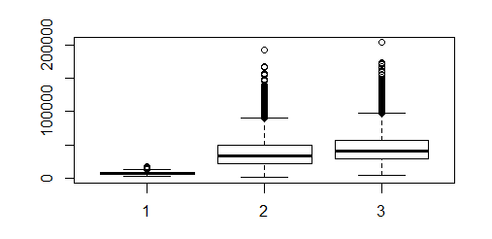

# 6. Sensitivity analysis

Sensitivity analysis studies how the uncertainty in the overall DALY estimate can be apportioned to the different sources of uncertainty in the input parameters (Vose, 2008). These results can therefore help to identify those input parameters that cause significant uncertainty in the overall DALY estimate and that therefore may be the focus of further research if one wishes to reduce the uncertainty in the overall estimate.

The sensitivity() function implements a probabilistic global sensitivity analysis of the overall DALY estimate, in which the analysis is conducted over the full range of plausible input values (hence *global*), determined by the specified uncertainty distributions (hence *probabilistic*). Two general methods are available, i.e., based on (standardized) regression coefficients (method = "src") or on partial correlation coefficients (method = "pcc"). The sensitivity() function is defined as follows:

sensitivity(x, method = c("src", "pcc"), rank = FALSE, mapped = TRUE)

Specifying method = "src" will perform a linear regression-based sensitivity analysis. Here, the simulated overall DALY estimates will be regressed against the simulated values for the stochastic input parameters (using lm()). To facilitate comparison, the independent terms are standardized such that they are normally distributed with mean zero and standard deviation one (using scale()). The resulting regression coefficients are therefore referred to as *standardized* regression coefficients.

Argument rank specifies whether the regression should be performed on the actual values (rank = FALSE; default) or on the ranked values (rank = TRUE). Rank-based regression may be preferred when the relation between output and inputs is non-linear. R^2 values smaller than 0.60 may be indicative of a poor fit of the default linear regression model.

If mapped = TRUE, the dependent term is not standardized, such that the resulting *mapped* regression coefficients correspond to the change in overall DALY given one standard deviation change in the corresponding input parameter. If mapped = FALSE, the dependent term is standardized, such that the resulting *standardized* regression coefficients correspond to the number of standard deviations change in overall DALY given one standard deviation change in the corresponding input parameter.

Specifying method = "pcc" will calculate partial correlation coefficients for each of the input variables. Partial correlation coefficients represent the correlation between two variables when adjusting for other variables. In the presence of important interactions between input variables, partial correlation coefficients may be preferred over standardized regression coefficients.

Argument rank specifies whether the correlation should be calculated between the actual values (rank = FALSE; default) or between the ranked values (rank = TRUE).

The sensitivity() function returns an object of class 'DALY\_sensitivity'. Both a print() and plot() method are available for this class, the latter generating a tornado plot of the regression or partial correlation coefficients.

For example, a sensitivity analysis of the Neurocysticercosis model, based on mapped regression coefficients, could be performed as follows:

set.seed(123)

x <- getDALY(aw = TRUE, dr = 0.03)

sa <- sensitivity(x, method = "src", mapped = TRUE)

## show results of sensitivity analysis

print(sa)

Mapped standardized regression coefficients:

Estimate Std. Error t value Pr(>|t|)

mrt1 21897.942 1.505 14549.977 0 \*\*\*

DWn1.3 1725.126 1.505 1146.392 0 \*\*\*

DWn1.2 901.396 1.505 598.937 0 \*\*\*

DWt1.3 410.693 1.505 272.862 0 \*\*\*

inc1.M.3 284.638 1.505 189.112 0 \*\*\*

inc1.F.3 280.846 1.505 186.619 0 \*\*\*

DWn1.4 237.095 1.505 157.515 0 \*\*\*

DWt1.2 213.054 1.505 141.567 0 \*\*\*

inc1.F.2 149.741 1.505 99.507 0 \*\*\*

DWn1.1 146.834 1.505 97.586 0 \*\*\*

inc1.M.2 143.994 1.505 95.687 0 \*\*\*

DWn1.5 90.457 1.505 60.115 0 \*\*\*

trt1 -61.807 1.505 -41.077 0 \*\*\*

DWt1.4 54.818 1.505 36.429 2.24e-281 \*\*\*

inc1.M.4 41.145 1.505 27.338 1.4e-161 \*\*\*

inc1.F.4 37.730 1.505 25.069 1.38e-136 \*\*\*

DWt1.1 31.732 1.505 21.087 1.22e-97 \*\*\*

inc1.F.1 25.253 1.505 16.781 8.98e-63 \*\*\*

DWt1.5 23.401 1.505 15.548 3.43e-54 \*\*\*

inc1.M.1 20.817 1.505 13.833 2.54e-43 \*\*\*

inc1.M.5 14.897 1.505 9.899 4.77e-23 \*\*\*

inc1.F.5 13.275 1.505 8.822 1.21e-18 \*\*\*

---

Signif. codes: 0 ‘\*\*\*’ 0.001 ‘\*\*’ 0.01 ‘\*’ 0.05 ‘.’ 0.1 ‘ ’ 1

Adjusted R-squared: 0.997

## plot tornado graph

plot(sa)

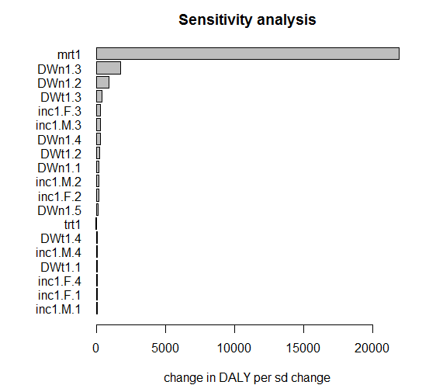

From the above results, we learn that the uncertainty in mortality rate has the highest influence on the overall uncertainty. Indeed, one standard deviation change in mortality rate would lead to a difference of more than 20,000 DALYs in the overall DALY estimate.

Further note that the names of the different input parameters are constructed as a combination of the input element (see 5.1), the sex (in case of sex stratification), and the age group (in case of age stratification).

# 7. Scenario analysis

To assess the impact of methodological choices, such as the application of age weighting or the choice of the discount rate, different scenarios can be run and the results compared. Likewise, scenario analyses can be performed to assess model uncertainty.

The DALY\_list() function combines multiple 'DALY' objects into an object of class 'DALY\_list'. Methods exist to print the different scenario results and for producing comparative stacked barplots and scatterplots.

As an example, we will calculate DALYs for the neurocysticercosis example based on three different social weighting scenarios, i.e., no age weighting or time discounting (DALY[0,0]), no age weighting but 3% time discounting (DALY[0,0.03]), and age weighting and 3% time discounting (DALY[1,0.03]).

## load NCC example

setDALYexample(1)

## calculate DALYs under different scenarios

ncc\_00 <- getDALY(aw = FALSE, dr = 0)

ncc\_03 <- getDALY(aw = FALSE, dr = 0.03)

ncc\_13 <- getDALY(aw = TRUE, dr = 0.03)

## save results as 'DALY\_list'

ncc <- DALY\_list(ncc\_00, ncc\_03, ncc\_13)

## barplot of different scenarios

plot(ncc, names = c("DALY[0,0]", "DALY[0,0.03]", "DALY[1,0.03]"))

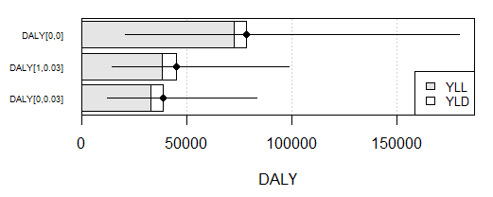

# 8. Built-in examples

To demonstrate the calculation process of the *DALY Calculator*, two DALY calculation examples are derived from the foodborne disease literature, and are built-in to the *DALY Calculator*:

* "The burden of *Taenia solium* cysticercosis in Cameroon" (Praet et al., 2009); and
* "Congenital toxoplasmosis and DALYs in the Netherlands" (Kortbeek et al., 2009).

These examples can be loaded by accessing the 'Help' menu, selecting 'Load examples', and selecting the required examples (Figure 2.3):

Help > Load examples > Neurocysticercosis, Cameroon (Praet et al., 2009)

Help > Load examples > Toxoplasmosis, the Netherlands (Kortbeek et al., 2009)

## 8.1. The burden of *Taenia solium* cysticercosis in Cameroon

Praet and colleagues (2009) estimated the health impact of *T. solium* by calculating the DALYs due to neurocysticercosis (NCC)-associated epilepsy, as this is the main health outcome of NCC. Non-uniform age weights and a 3% discount rate were selected as DALY parameters, and YLLs were calculated based on the GBD1990 standard life expectancy. The authors presented the following results:

Mean 2.5% 97.5% % of total DALYs

**DALY** 45838 14108 103469 100

**YLD** 6821 2765 12878 15

**YLL** 39017 8196 95513 85

The authors did not directly provide probability distributions for the incidence and mortality of NCC-associated epilepsy, but estimated these values through the following formulas:

|  |  |
| --- | --- |
| $$I=P*N/D$$ | (1) |
| $$M=P*N*C$$ | (2) |

Where,

|  |  |
| --- | --- |
| I = Incidence of NCC-associated epilepsy; |  |
| P = Prevalence of epilepsy; P $\sim$ Beta(67, 1791); |  |
| N = Proportion NCC-associated epilepsy cases; N $\sim$ Uniform(0.236, 0.315); |  |
| D = Duration of epilepsy; D $\sim$ Fixed, differs by sex and age group; |  |
| M = Mortality due to NCC-associated epilepsy; |  |
| C = Case-fatality ratio of epilepsy; C $\sim$ Beta(3.2, 124.8). |  |

Since both incidence and mortality are examples of count data, an underlying gamma distribution was presumed. Monte Carlo simulations were used to generate a compiled distribution of incidence and mortality, based on equations (1) and (2). These compiled distributions were then used to estimate the parameters of the gamma distributions, based on maximum likelihood. This was done using the fitdistr() function, available in the MASS package (Venables and Ripley, 2002). The results of this process are presented in Figure 8.

As the mortality rate presented by Praet et al. (2009) applied to the entire study population, the stratification level was set accordingly (i.e., "None"). Likewise, the "Age" stratification level was selected for the disability weights, as they were only stratified by age category (Figure 8).

After entering all required data in the *DALY Calculator*, the following results were obtained (taken from Figure 10):

Mean 2.5% 97.5% % of total DALYs

**DALY** 45141 14476 98913 100

**YLD** 6915 3553 11570 19

**YLL** 38226 7996 91867 81

These results and their corresponding credibility intervals resemble the values obtained by Praet and colleagues (2009). The difference in percentage of DALYs attributed to YLDs versus YLLs, is due to the fact that the *DALY Calculator* presents the means of the proportions, whereas the authors presented the proportion of the means:

6915 / 45133 = 0.15

38218 / 45133 = 0.85

## 8.2. Congenital toxoplasmosis and DALYs in the Netherlands

The second built-in example computes the burden of congenital toxoplasmosis in the Netherlands, as presented by Kortbeek et al. (2009). These authors applied uniform age weighting and no time discounting, and used the Dutch life expectancy table, which has an average life expectancy at birth of 79. DALYs were calculated for the seven most important health outcomes of congenital toxoplasmosis:

* Fetal loss (≥ 24 weeks)
* Clinical symptoms in first year of life:
  + Chorioretinitis
  + Intracranial calcification
  + Hydrocephalus
  + Central nerve system abnormalities
  + Neonatal death
* Asymptomatic at birth:
  + Chorioretinitis later in life

Kortbeek et al. (2009) estimated the most likely burden of congenital toxoplasmosis to be 2,303 DALYs. By adding up the minimum and maximum estimates of the different outcomes, a lower bound of 818 and an upper bound of 6,713 DALYs was obtained. This range represents the possible extremes of the DALYs due to congenital toxoplasmosis, but should not be interpreted as a credibility interval.

The only sources of uncertainty included in the authors' calculation model were the incidence and mortality rates of the various outcomes, for which most likely, low and high estimates were presented. In our example, we used a Beta-Pert distribution to represent this uncertainty, and interpreted the "most likely" values as the mean values of the Beta-Pert:

$\overline{x}="\text{most likely"}$

$m=(6\overline{x}-max-min)/4$

$$s=\frac{max-min}{6}$$

$$α=\left(\frac{\overline{x}-min}{max-min}\right)*\left\{\frac{\left(\overline{x}-min\right)*\left(max-\overline{x}\right)}{s^{2}}-1\right\}$$

$$β=\left(\frac{max-\overline{x}}{\overline{x}-min}\right)*α$$

$Beta˗Pert\left(m,min,max\right)=Beta\left(α,β\right)*\left(max-min\right)+min$

Where,

$\overline{x}$ = mean of the Beta-Pert distribution

m = mode of the Beta-Pert distribution

s = standard deviation of the Beta-Pert distribution

α= shape 1 of the Beta distribution

β= shape 2 of the Beta distribution

The authors did not present different estimates for male and females, therefore the "Age" stratification level was selected for all parameters.

After loading the toxoplasmosis example in the *DALY Calculator*, the life expectancy table will be adapted by changing the values for age 0 to 79, for both males and females. The social values will be set automatically to those applied by Kortbeek and colleagues (2009).

The following results were generated by the *DALY Calculator* (after setting the seed to 123):

Mean 2.5% 97.5% % of total DALYs

**DALY** 2355 1548 3505 100

**YLD** 1294 787 2081 55

**YLL** 1061 565 2036 45

Again, the results are similar to those presented by the authors. In addition, the *DALY Calculator* provides a genuine 95% credibility interval, which is, of course, narrower than the range of extremes presented by the authors. Through the **R** environment, it is possible to obtain the extremes of the vector of DALYs generated by the *DALY Calculator*. This can be done by applying the min() and max() functions to the aggregated 'DALY' object (see Chapter 5):

set.seed(123) # sets the seed to '123', for reproducibility reasons

x <- getDALY() # assign *DALY Calculator* output to object 'x'

y <- aggregate(x, by = "total") # sums results over outcomes and age/sex

min(y$DALY) # get minimum DALY

[1] 1134.689

max(y$DALY) # get maximum DALY

[1] 4643.737

Of course, these results will depend on the number of iterations applied. The higher the number of iterations, the more extreme the minimum and maximum values will be, until the absolute minimum and maximum is reached.

# 9. Saving and loading input data

An additional feature of the *DALY Calculator* is the possibility to save the entered values for the epidemiological parameters to an RData image file. This function is available through:

File > Save DALY data to file…

Thus created (and edited) RData files can be loaded into the *DALY Calculator* by accessing:

File > Load DALY data from file…

Alternatively, saving and loading RData files can be done directly from the **R** console:

saveDALYdata() # save data to .RData file

readDALYdata() # load data from .RData file

# 10. Current limitations and future work

The current version of the *DALY Calculator* allows basic DALY calculation and uncertainty analysis, which could be useful for a variety of users. However, this first release has some restrictions, which might limit a more advanced performance:

* The current version of the *DALY Calculator* is designed to calculate a **basic incidence-based disease model**, with well-defined incidence and mortality rates per disease category or outcome. The incorporation of conditional probabilities or the calculation of complex disease models is currently not possible;
* The *DALY Calculator* only allows the simultaneous assessment of **up to eight disease categories or outcomes**. This is sufficient for most diseases or agents, but could be limiting for certain more complex models;
* Until now, the *DALY Calculator* only allows the simultaneous use of a **maximum of five age groups**;
* Currently, **only two DALY calculation examples** are built-in.

Efforts are being made to clear these limitations, and solutions should be provided in the next major releases of the *DALY Calculator*. User suggestions will be substantially taken into account during the further development of the *DALY Calculator*.

# 11. Version history

DALY 1.5.0 – Release date 25/11/2016

Performance improvements

* The GBD2010 and WHO/GHE standard life expectancy tables have been added;
* The GBD2010 standard life expectancy table is now the default option.

Bug fixes

* Fixed imports declarations in NAMESPACE;
* converted round() to fround() in DALY.cpp;
* sensitivity() methods resulted in errors due to loss of dimensions (@thanhleviet).

DALY 1.4.0 – Release date 27/10/2014

Bug fixes

* Fixed NAMESPACE issues with imported packages;
* Removed Poisson distribution on number of cases and deaths;
* Fixed bug with scientific notation in Tk tables.

DALY 1.3.0 – Release date 10/05/2014

New features

* Introduction of a DALY\_list() function to combine different 'DALY' objects;
* Introduction of a plot() method for objects of class 'DALY' and 'DALY\_list';
* Introduction of a scatterplot() method for objects of class 'DALY' and 'DALY\_list';
* Introduction of a print() and plot() method for objects of class 'DALY\_sensitivity'.

Performance improvements

* Function sensitivity() has been updated to allow calculating (standardized) regression coefficients and partial correlation coefficients, either on the original or the ranked input values.

Bug fixes

* Fixed mismatch between Authors@R and Author fields in DESCRIPTION file;
* The use of extern "C" {} in the DALY.cpp file has been revised to fix issues with clang.

DALY 1.2.0 – Release date 06/07/2013

New features

* Introduction of a sensitivity() function;
* Function getDALY() gains arguments aw and dr.

Performance improvements

* The *DALY Calculator* now also includes the simulated values from the input distributions;
* Several functions have been updated to make proper use of the match.arg() functionality;
* The 'DALY' database on the search path is replaced by a '.DALYenv' environment in the DALY package.

Bug fixes

* The readDALYdata() now correctly reads .RData files when specified through the file argument;
* All instances of INC and MRT have now consistently been renamed to cases and deaths, respectively;
* The *DALY Calculator* manual has been rebuilt to fix issues with pdffonts.

DALY 1.1.0 – Release date 27/08/2012

New features

* Introduction of an aggregate() method for objects of class 'DALY'.

Performance improvements

* Each window has a "save or cancel" policy;
* The basic *DALY Calculator* output consists of simulated DALYs, YLLs, YLDs, incident cases and deaths per outcome and per age/sex class;
* print(), summary() and hist() methods have been updated;
* Saving and loading data is implemented through .RData files instead of .txt files.

Deprecated and defunct

* Text files with input data can no longer be read by the *DALY Calculator*;
* As a result, the *DALY Calculator* Excel template is defunct.

Installation

* DALY 1.1.0 can be installed and run under Mac OS X, Linux and Windows operating systems. The *DALY Calculator* is only launched after attaching the package in an interactive session, which means that the package can be installed without having the required tools installed. Loading the package under Mac OS X and Linux requires the prior installation of the X Window System (X11) and the Tcl/Tk toolkit.

Bug fixes

* Global variables removed; all variables needed by the *DALY Calculator* are stored in a separate 'DALY' database;
* Welcome messages implemented through packageStartupMessage();
* Problems with installation of BWidget resolved by replacing tkwidget(parent, type = "ComboBox", ...) by ttkcombobox();
* set.seed() can be used to select the seed used for the random number generation processes within the *DALY Calculator*;
* A same window can be opened only once; calling a window opening function while the corresponding window is already opened will return focus to the existing window;
* Evaluation of input data improved by using regular expressions;
* Empty cells in the 'Life Expectancy' window produce an error message, while they are still allowed in other windows;
* 'Iterations' can only be set to a strictly positive integer value;
* On closing the *DALY Calculator* main window, all other *DALY Calculator* windows will close as well;
* Checkboxes may also be set by clicking the corresponding text.

DALY 1.0.0 – Release date 23/03/2011

Features

* Calculate DALYs, YLDs, YLLs and Deaths for a simple incidence-based disease model;
* Able to include up to eight outcomes;
* Five age-groups included, i.e., 0-4; 5-14; 15-44; 45-59; 60+;
* Life expectancy table can be defined by user; standard table is the Coale and Demeny model life-table West, level 26 and 25;
* Two examples included, i.e., Neurocysticercosis in Cameroon and Toxoplasmosis in the Netherlands;
* Saving/loading data through .txt file;
* The basic *DALY Calculator* output consists of simulated DALYs, YLLs, YLDs and deaths per outcome, aggregated over age/sex classes;
* print(), summary() and hist() methods for objects returned by the *DALY Calculator*.

DALY 0.0.0

A first version of the *DALY Calculator* was developed in November 2010, but was never released. This version consisted of a single 'data' window, and was only able to reproduce the Neurocysticercosis example.

# ANNEX 1. DALY calculation and uncertainty analysis

Traditionally, three types of uncertainty are distinguished (Bilcke et al., 2011):

* Methodological uncertainty: which normative modeling approach should be used?
* Structural uncertainty: what structural aspects should be incorporated to capture the relevant characteristics of the phenomenon being investigated?
* Parameter uncertainty: what is the true value of each model parameter?

The *DALY Calculator* mainly deals with parameter uncertainty. Other types can be dealt with by running multiple simulations (i.e., performing scenario analyses):

* Methodological uncertainty: different normative views exist regarding the application of **age weighting** and **time discounting** in DALY calculations. The *DALY Calculator* easily allows to calculate results based on different scenarios of age weighting and time discounting (see Chapter 3, Step 4).
* Structural uncertainty: the definition of a **disease model** is one of the most important steps preceding the actual DALY calculation. In case of uncertainty or controversy regarding the disease model, different scenarios can be run and their results compared.

The *DALY Calculator* allows for the incorporation of parameter uncertainty at two different levels, i.e., **parameter uncertainty *sensu stricto***, and **stratification uncertainty**.

Evidence for parameters is often only available through population samples, leading to sampling error in the reported parameters. The evidence of available parameter values may furthermore be of questionable quality, due to imperfect test characteristics, or worse, low-quality study designs. Sometimes, parameter values are even completely lacking. In these cases, parameter values should be represented by appropriate probability distributions reflecting their uncertainty, rather than by mere point estimates. The *DALY Calculator* allows the user to specify for each parameter one of the following probability distributions:

**Beta-Pert** (mode; min; max)

**Beta** (alpha; beta)

**Gamma** (shape; rate)

**Normal** (mu; sigma)

**Lognormal-geometric** (logmean; logsigma)

**Lognormal-arithmetic** (mean; sigma)

**Uniform** (min; max)

**Fixed**

As the available parameter values are often not available per combination of age group and sex, the total uncertainty would be underestimated if the exact level of data stratification would not be taken in account. This can be demonstrated by a simple example:

Suppose parameter X is sampled from a distribution with variance σ². We need this parameter for males and females, but the distribution we derived from literature makes no distinction between sexes, and is thus not stratified by sex (for the sake of the example, we will forget about age group stratification). If we do not take in account stratification uncertainty, we will simulate two times from the same distribution, thereby obtaining a sequence of random values for Xm and Xf. As for regular DALY calculations, our end result will be the sum of both parameters (see Annex 1). The variance of our end result will then be:

Var(Xm + Xf) = Var(Xm) + Var(Xf) + 2 \* Cov(Xm, Xf) = 2σ²

Since Xm and Xf were independent simulations from a same distribution, their covariance is zero.

The correct approach, however, would be to draw one sequence of simulations from the distribution, and then multiply it by two. The variance of the end result will then be:

Var(2 \* X) = 4σ²

Not accounting for stratification uncertainty would thus underestimate the overall uncertainty by a factor of two. Likewise, not accounting for stratification uncertainty due to *n* strata, would lead to an *n*-fold underestimation of overall uncertainty.

The *DALY Calculator* enables users to specify the level of stratification of the input parameters, and incorporates this information in the DALY calculation process. Four possibilities are provided:

**Age and Sex** (i.e., full stratification)

**Age** (i.e., data is stratified by age group, but not by sex)

**Sex** (i.e., data is stratified by sex, but not by age group)

**None** (i.e., no stratification, data applies to total population)

For the case where the data applies to the total population (i.e., no stratification), a single random value is generated per iteration and applied to each age and sex class. If the data is only stratified by age (sex), a random value is generated during each iteration per age (sex) class, and applied to all sex (age) classes. Finally, in case of full stratification, during each iteration, a random value will be generated for each combination of age group and sex, reflecting the maximum level of detail of the respective input parameter.

The DALY uncertainty analysis implemented by the *DALY Calculator* is performed through Monte Carlo simulations. This method iteratively simulates random values for each of the epidemiological parameters and disability weights, according to their user-defined distributions. During each iteration, these random values are incorporated in a calculation of incident cases and deaths, and YLDs and YLLs, which can be summed up to DALYs. The calculation of incident cases, deaths, YLDs and YLLs is given by:

|  |  |
| --- | --- |
| ${Cases}_{ijkl}=rpois\left({pop}_{ij}*{inc}_{ijkl}\right)$ | (1) |
| ${Deaths}_{ijkl}=rpois\left({pop}_{ij}*{mrt}_{ijkl}\right)$ | (2) |
| ${YLD}_{ijkl}={Cases}_{ijkl}*\left({trt}_{ijkl}*{DWt}_{ijkl}+\left\{1-{trt}_{ijkl}\right\}*{DWn}_{ijkl}\right)$ $*Formula\left({ons}_{ijkl}, {dur}_{ijkl}\right)$ | (3) |
| ${YLL}_{ijkl}={Deaths}_{ijkl}*1*Formula({aad}_{ijkl}, {lxp}_{ijkl})$ | (4) |

Where,

i = sex;

*j* = age group;

*k* = outcome;

*l* = iteration (l = 1, …, n);

Casesijkl = simulated incident cases for sex i, age group j and outcome k;

Deathsijkl = simulated incident deaths for sex i, age group j and outcome k;

YLDijkl = simulated YLDs for sex i, age group j and outcome k;

YLLijkl = simulated YLLs for sex i, age group j and outcome k;

rpois(λ) = **R** function which generates a random value based on a

Poisson distribution with mean λ;

popij = population belonging to sex i and age group j;

incijkl = randomly generated incidences for sex i, age group j and outcome k;

trtijkl = randomly generated treatment rates for sex i, age group j and outcome k;

DWtijkl = randomly generated Disability Weights–treated for sex i, age group j and outcome k;

DWnijkl = randomly generated Disability Weights–untreated for sex i, age group j and outcome k;

onsijkl = randomly generated ages at disease onset for sex i, age group j and outcome k;

durijkl = randomly generated disease durations for sex i, age group j and outcome k;

mrtijkl = randomly generated mortalities for sex i, age group j and outcome k;

aadijkl = randomly generated ages at death for sex i, age group j and outcome k;

lxpijkl = calculated life expectancies for sex i, age group j and outcome k.

The **Formula(a,L)** function used in equations (3) and (4) is the solution of the integral used to calculate the years of life lived with disability or the years of life lost due to premature mortality for one individual. The integral for calculating age-weighted and time-discounted YLLs or YLDs is given by Murray (1994):

|  |  |
| --- | --- |
| $$\int_{x=a}^{x=a+L}{Cxe^{-βx}e^{-r(x-a)}dx}$$ | (5) |

Where,

a = age of onset *or* age at death;

L = disease duration *or* life expectancy at age *a*;

C = age-weighting correction constant (C = 0.1658);

$β$ = parameter from age-weighting function ( $β$ = 0.04);

r= discount rate.

In order to allow the calculation of uniformly age-weighted DALYs, an **age weighting modulation factor** (K ) is introduced, which can be either one (non-uniform age weights) or zero (uniform age weights, i.e., no age-weighting) (Murray and Acharya, 1997):

|  |  |
| --- | --- |
| $$\int_{x=a}^{x=a+L}{KCxe^{-βx}e^{-r(x-a)}dx}$$ | (6) |

The solution of integral (6) gives us the general form of the YLD and YLL formula:

|  |  |
| --- | --- |
| $$\frac{KCe^{ra}}{{\left(r+β\right)}^{2}}\left[e^{-\left(r+β\right)\left(L+a\right)}\left\{-\left(r+β\right)\left(L+a\right)-1\right\}-e^{-\left(r+β\right)a}\left\{-\left(r+β\right)a-1\right\}\right]+\frac{1-K}{r}(1-e^{-rL})$$ | (7) |

When r approaches zero (i.e., no time-discounting), the limit of equation (7) becomes:

|  |  |
| --- | --- |
| $$\frac{KCe^{-βa}}{β²}\left[e^{-βL}\left\{-β\left(L+a\right)-1\right\}-(-βa-1)\right]+\left(1-K\right)L$$ | (8) |

For the case where both r and K are zero (i.e., no time-discounting and no age-weighting), equation (8) equals L, the disease duration (for the calculation of YLDs) or the life expectancy at age a (for the calculation of YLLs).

This process of simulating YLD and YLL values is iteratively repeated for each combination of sex and age group (i,j) within each outcome k. By summing these values, a DALY matrix is obtained per age/sex class (i,j) and outcome *k*:

|  |  |
| --- | --- |
| $${DALY}_{ijkl}={YLD}_{ijkl}+{YLL}_{ijkl}$$ | (9) |

Based upon these vectors, posterior summary statistics can be calculated for incident cases and deaths, and YLDs, YLLs and DALYs, per outcome and age/sex class. Summing these vectors over age group i, sex j, and/or outcome k, will lead to aggregated results, as returned by the aggregate() method. For example, summary statistics of total DALYs, such as those given by the default print() method, can be obtained by summing up the simulated results over all outcomes and age/sex classes:

|  |  |
| --- | --- |
| $${DALY}_{l}=\sum_{i}{\sum_{j}{\sum_{k}{{DALY}_{ijkl}}}}$$ | (10) |

The implementation of the above-mentioned features is primarily written in the R programming language, with additional support from **Tcl/Tk** (using the tcltk package; R Core Team, 2013), to design the GUI. In order to speed up the computation process, the *DALY Calculator* interacts with the **C++** programming language, which is used to randomly generate the epidemiological input values (through R random number generation functions), and to calculate the YLDs, YLLs and incident cases and deaths, based on equations (1) to (4). These results are then sent back to the R environment, where they are summed up to obtain DALYs and processed into their corresponding list elements. Finally, the output of the results and their graphical representation is handled by R, which is optimized towards these tasks.

# REFERENCES

Bilcke J, Beutels P, Brisson M, Jit M (2011). Accounting for methodological, structural, and parameter uncertainty in decision-analytic models: a practical guide. *Medical Decision Making* ***31****(4)*, 675-692.

de Vocht F, Higgerson J, Oliver K, Verma A (2010). Incorporating uncertainty in aggregate burden of disease measures: an example of DALYs-averted by a smoking cessation campaign in the UK. *Journal of Epidemiology and Community Health* ***65****(9)*, 751-756.

Kortbeek LM, Hofhuis A, Nijhuis CDM, Havelaar AH (2009). Congenital toxoplasmosis and DALYs in the Netherlands. *Memórias de Instituto Oswaldo Cruz* ***104****(2)*, 370-373.

Lopez AD, Mathers CD, Ezzati M, Jamison DT, Murray CJL (2006). *Global burden of disease and risk factors*. Oxford University Press, New York, USA, pp. 475.

Mathers CD, Vos T, Lopez AD, Salomon J, Ezzati M (2001). *National Burden of Disease Studies: a Practical Guide.* Edition 2.0. Global Program on Evidence for Health Policy. World Health Organization, Geneva, Switzerland.

Murray CJL (1994). Quantifying the burden of disease: the technical basis for disability-adjusted life years. *Bulletin of the World Health Organization* ***72****(3)*, 429-445.

Murray CJL, Lopez AD (1996). The Global Burden of Disease: a comprehensive assessment of mortality and disability from diseases, injuries and risk factors in 1990 and projected to 2020. Harvard University Press, Cambridge, UK, pp. 990.

Murray CJL, Acharya AK (1997). Understanding DALYs. *Journal of Health Economics* ***16****(6)*, 703-730.

Praet N, Speybroeck N, Manzanedo R, Berkvens D, Nforninwe DN, Zoli A, Quet F, Preux P-M, Carabin H, Geerts S (2009). The disease burden of *Taenia solium* cysticercosis in Cameroon. *PLoS Neglected Tropical Diseases* ***3****(3)*, e406.

R Core Team (2014). *R: A language and environment for statistical computing*. R Foundation for Statistical Computing, Vienna, Austria. URL <http://www.R-project.org/>.

Venables WN, Ripley BD (2002). *Modern Applied Statistics with S*. Fourth Edition. Springer, New York, USA. ISBN 0-387-95457-0.

Vose D (2008). *Risk Analysis: a quantitative guide*. Third Edition. John Wiley & Sons, Chichester, UK. ISBN 978-0-470-51284-5.

1. http://www.who.int/entity/healthinfo/bodreferencedalycalculationtemplate.xls [↑](#footnote-ref-1)