CS 317 Final Project Proposal

# Brosu! Phase 2

Branden Guevara and Garrett Eledui

### Concept:

* What is this game about?: Our ambition is to produce an advanced and appealing game that stimulates the senses while presenting a worthwhile challenge. We seek to employ techniques learned from the curriculum taught over the semester such as graphics object shape manipulation, which will give various responses to the user upon interaction with the game. Additionally, we are using timing from music for the user to recognize in order to play the game properly and with full enjoyment.
* Genre
  + Rhythm Game
* Design (Add screenshots)
  + 2D Graphics
  + Flat Design/Minimalist
* Target audience
  + All ages
  + Music Enthusiasts
  + People who enjoy Rhythm Games
* Key Features
  + Touch screen interaction
  + Shape-shifting graphics
  + Beat heavy music
* References
  + Tap Tap Revenge
  + Geometry Dash
  + Osu

### Game Mechanics:

* Game play screens

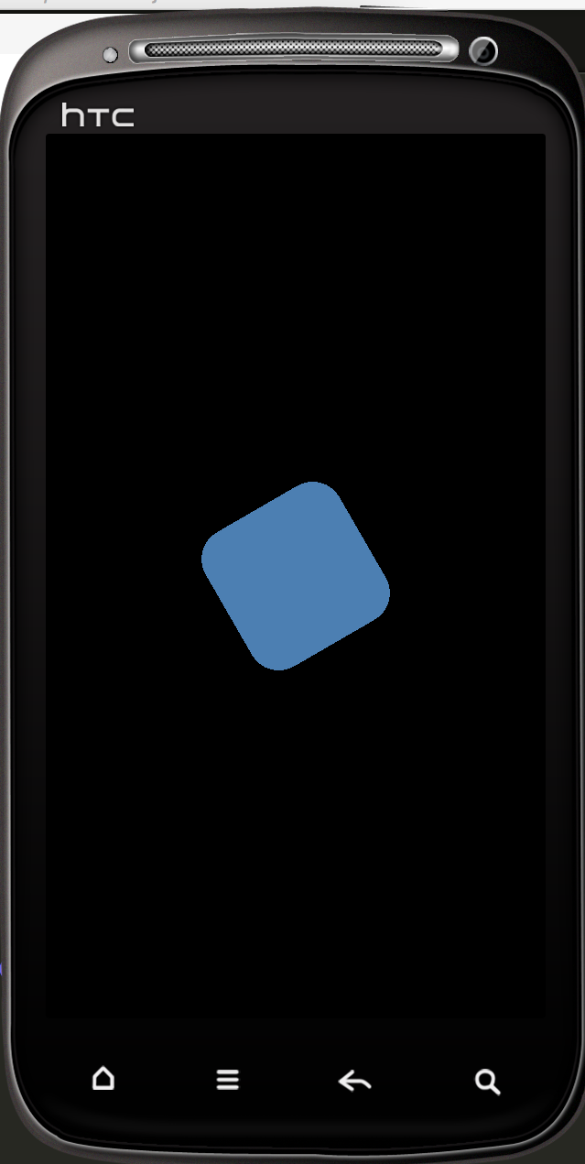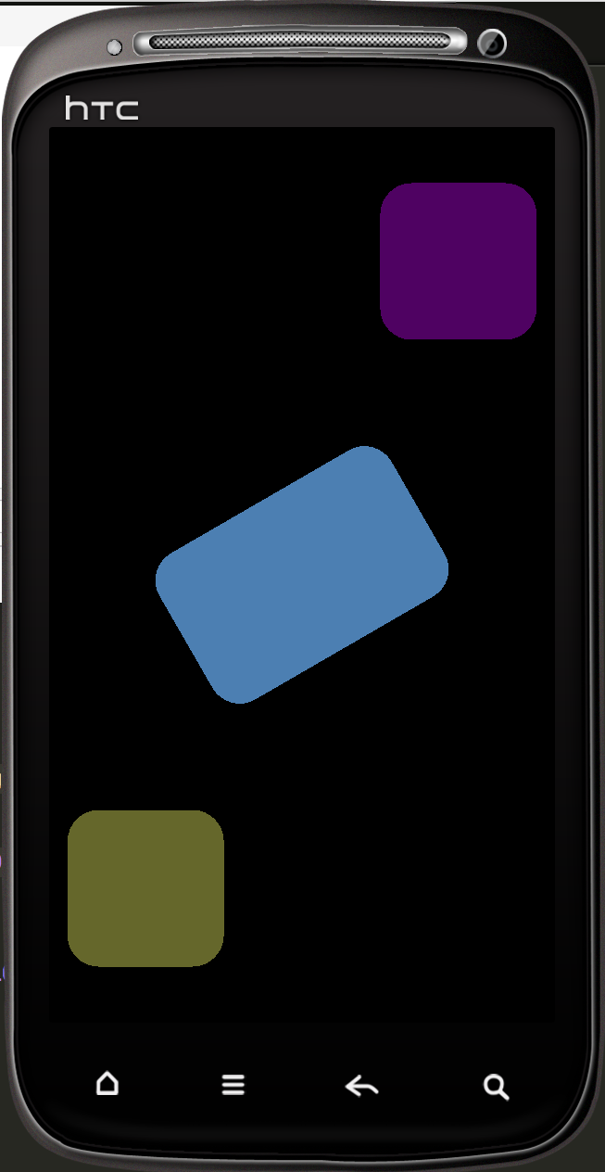

* Control scheme interface:
  + Our dark background accentuates the graphics that the user will interact with. This gives a pleasant environment for the user to focus on the gameplay.

screenFlow.png

Fig. 1: Screen Flow Diagram

* Scoring system and achievements:
  + Scoring is based on whether or not the user touched the graphic within the specified time window.
  + If the user gets 10 taps with accuracy, the game play will go into bonus mode in which the user will receive double points for every correct tap.
* Game Flow:
* Gameplay: After the user has selected a song, the scene will change to the game where the user will see a rounded rectangle in the middle of the screen as well as an indicator bar at the top of the screen where purple circles or beats will pass from right to left. As the song begins to play, whenever a purple circle passes through the green circle, it signals to the user when it is time to tap the box in the middle in time with the beat of the song. As the user continues tapping on the box, different screen effects will be triggered. A score board at the bottom of the screen will keep up with how many of the total beats the user successfully hit as well as the amount of times the user incorrectly tapped.
* The graphics throughout the game will continue to grow more and more elaborate as the user taps at the correct time. If the user taps at the incorrect time, the graphics will become less elaborate. The game will continue until the end of the song regardless of the number of correct taps the user has gotten.



Fig. 2: Game Flow Diagram

### Tech:

* Platform
  + iPhone 6s Plus
    - Resolution: 1920-by-1080
    - Display Size: 5.5 inch (diagonal)
    - Audio Playback: AAC(8 to 320 Kbps), MP3(8 to 320 Kbps), WAV
  + iPhone 7 Plus
    - Resolution: 1920-by-1080
    - Display Size: 5.5 inch (diagonal)
    - Audio Playback: AAC(8 to 320 Kbps), MP3(8 to 320 Kbps), WAV
  + Kindle Fire
    - Resolution: 1024-by-600
    - Display Size: 7-inch (diagonal)
    - Audio Playback: PCM/WAVE, MP3, AAC
* Graphics
  + Resolution: depends on device
  + Planning on utilizing Lua’s API for graphics
* Camera
  + N/A
* Control Interface
  + Touchscreen
* Game Assets
  + Songs of our choosing
  + Backgrounds for level selection and main menu
* Development Resources
  + Corona SDK
* Work Division
  + Branden Guevara
    - Implementation of game mechanics
  + Developed the indicator bar
  + Implemented handling of songs and beats
    - Developed screen/game flow
  + Garrett Eledui
    - Developed graphics during gameplay
  + Worked with particle effects
  + Worked with object transition effects
    - Tested design
* Implementation note:
  + Corona Libraries:
  + Composer
  + Physics
  + Widget