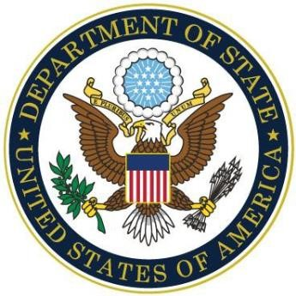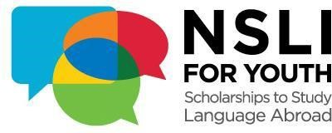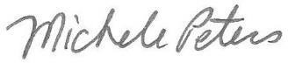

United

States

Department

of

State

This

Certificate

is

Awarded

to

Briannah Greene

in recognition of your successful completion of the
Virtual

National

Security

Language

Initiative

for

Youth

NSLI
(
-
Y)

Korean Fall 2022 Program

Michele

Peters

Youth

Programs

Branch

Chief

Bureau

of

Educational

and

Cultural

Affairs
United States Department of State

