Feedback sesssion 10/30/18
Aaron Young
Something to explain the rules of cricket to a user who might not be familiar.
Add link to cricket basic rules.
What's the focus of the visualization? Teams or players?
Focus on teams, people mainly follow their state team more than players.
Maybe add an arrow or dial to show time progression in the custom visualization.
Redesign the custom visualization (Fig 1.)
How will you interact with data? Just options? or would there be anything more advanced? (brushing can be implemented in the over time data)
Implement brushing for line graphs so the user can view subsets of games.
What views will be linked?
Season timeline will link to the map and all game data. The table will be linked to the custom visualization, and the custom visualization will be linked to the comparison view and season view.
Can you show a performance over time plot?
This will be accomplished by the season view, which will show performance over time for the team of interest game by game.
Maybe you should do visualization only by a single time scale (season, team, ect). It seems difficult to do all these different things.
We can change to focus mainly on season data, which will have a time scale based off of games.
Make the dynamic drawing a must have.
Dynamic drawing is easy to implement, can be used to draw the line charts.
Kevin Le
The custom visualiztion doesn't make it clear that time is something that it is sorted by. Maybe a vertical linear arrangement would be better. It should be rearranged to show the progression of the season better.
Redesign the custom visualization (Fig 1.)
Abhialash Tiruveedhula
Why not rank teams with a stacked bar chart instead of side by side bars? it shows differences better.
Stacked bar charts would be a better way of showing team by team differences. Numbers can be overlaid atop the bars to show exact numbers.
Make a line chart showing season ranking over time.
This can be a stretch goal, it may clutter the view, so its position should be considered carefully.
Addressing feedback
The feedback that we received was especially helpful in narrowing down the scope of our project, focusing on one particular aspect of the data (teams or players), along with what time intervals would be of interest (season data, all time data, or game by game data). The peer feedback session also made us realize that the custom season game visualization also needs some rethinking to better show the progression of time over a season. The clock-like setting doesn’t make the chronology very clear, but a timeline would make the game order very clear.
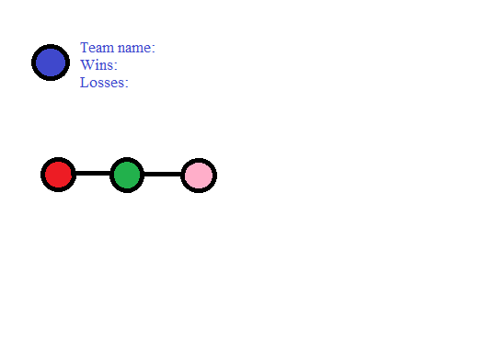
Fig 1. Timeline design, which shows clear linear progression between games, which are represented by the connected and colored circles.

