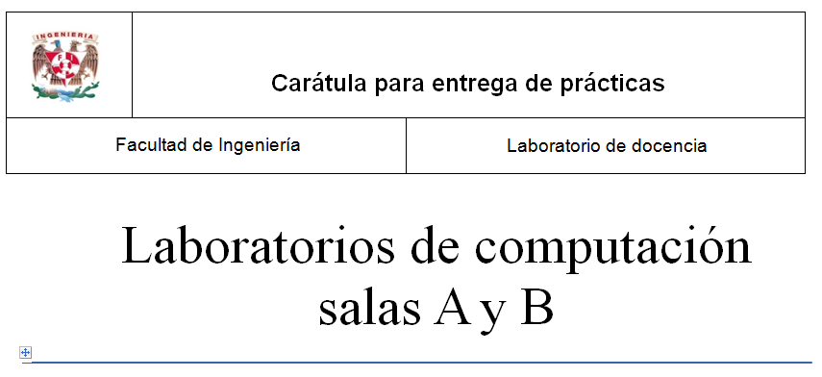

*Profesor: Cruz Carlón Juan Alfredo*

*Asignatura: Fundamentos de Programación*

*Grupo: 1107*

*No de práctica(s): 12*

*Integrante(s): Juárez Pérez Brenda Jacqueline*

*Semestre: Primero*

*Fecha de entrega: 28/noviembre/2017*

*Observaciones:*

*CALIFICACIÓN:*

Funciones: “todo programa es un función pero no toda función es programa”

¿por qué no toda función es un programa?

Porque un programa es la resolución de un problema complejo y a veces largo el cual su resolución se divide en pequeños bloques o funciones correlacionadas que calculan una parte del resultado final en el cual se ven involucradas las variables comunes, mientras que un función es simplemente un bloque compuesto con cabecera y variables parciales que nos proporcionan solo una parte del resultado final deseado.

#include <cache.h>

#undef DEBUG_85

#ifdef DEBUG_85

#define say(a) fprintf(stderr, a)

#define say1(a,b) fprintf(stderr, a, b)

#define say2(a,b,c) fprintf(stderr, a, b, c)

#else

#define say(a) do { /* nothing */ } while (0)

#define say1(a,b) do { /* nothing */ } while (0)

#define say2(a,b,c) do { /* nothing */ } while (0)

#endif

static const char en85[] = {

'0', '1', '2', '3', '4', '5', '6', '7', '8', '9',

'A', 'B', 'C', 'D', 'E', 'F', 'G', 'H', 'I', 'J',

'K', 'L', 'M', 'N', 'O', 'P', 'Q', 'R', 'S', 'T',

'U', 'V', 'W', 'X', 'Y', 'Z',

'a', 'b', 'c', 'd', 'e', 'f', 'g', 'h', 'i', 'j',

'k', 'l', 'm', 'n', 'o', 'p', 'q', 'r', 's', 't',

'u', 'v', 'w', 'x', 'y', 'z',

'!', '#', '$', '%', '&', '(', ')', '*', '+', '-',

';', '<', '=', '>', '?', '@', '^', '_', '`', '{',

'|', '}', '~'

};

static char de85[256];

static void prep_base85(void)

{

int i;

if (de85['Z'])

return;

for (i = 0; i < ARRAY_SIZE(en85); i++) {

int ch = en85[i];

de85[ch] = i + 1;

}

}

int decode_85(char *dst, const char *buffer, int len)

{

prep_base85();

say2("decode 85 <%.*s>", len / 4 * 5, buffer);

while (len) {

unsigned acc = 0;

int de, cnt = 4;

unsigned char ch;

do {

ch = *buffer++;

de = de85[ch];

if (--de < 0)

return error("invalid base85 alphabet %c", ch);

acc = acc * 85 + de;

} while (--cnt);

ch = *buffer++;

de = de85[ch];

if (--de < 0)

return error("invalid base85 alphabet %c", ch);

/* Detect overflow. */

if (0xffffffff / 85 < acc ||

0xffffffff - de < (acc *= 85))

return error("invalid base85 sequence %.5s", buffer-5);

acc += de;

say1(" %08x", acc);

cnt = (len < 4) ? len : 4;

len -= cnt;

do {

acc = (acc << 8) | (acc >> 24);

*dst++ = acc;

} while (--cnt);

}

say("\n");

return 0;

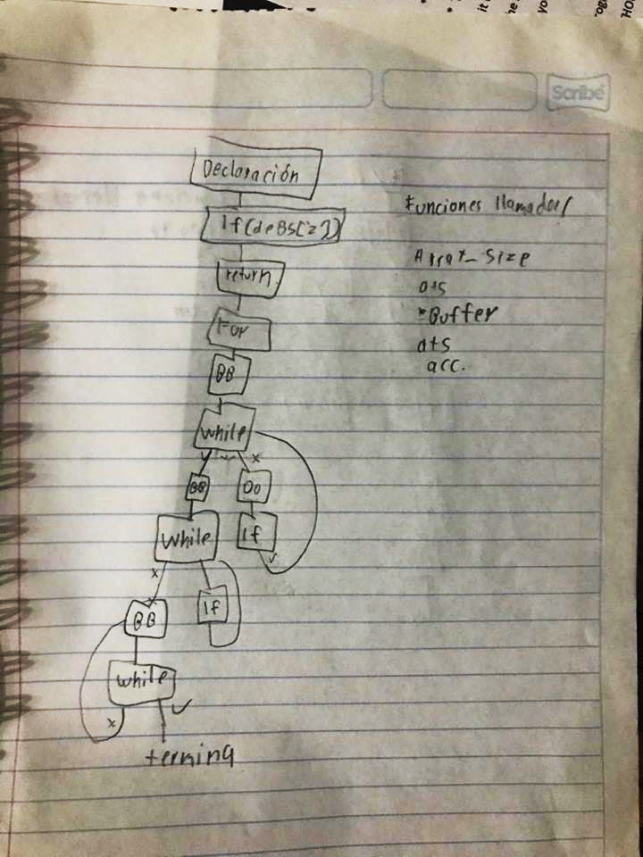

}

void encode_85(char *buf, const unsigned char *data, int bytes)

{

say("encode 85");

while (bytes) {

unsigned acc = 0;

int cnt;

for (cnt = 24; cnt >= 0; cnt -= 8) {

unsigned ch = *data++;

acc |= ch << cnt;

if (--bytes == 0)

break;

}

say1(" %08x", acc);

for (cnt = 4; cnt >= 0; cnt--) {

int val = acc % 85;

acc /= 85;

buf[cnt] = en85[val];

}

buf += 5;

}

say("\n");

*buf = 0;

}

#ifdef DEBUG_85

int main(int ac, char **av)

{

char buf[1024];

if (!strcmp(av[1], "-e")) {

int len = strlen(av[2]);

encode_85(buf, av[2], len);

if (len <= 26) len = len + 'A' - 1;

else len = len + 'a' - 26 - 1;

printf("encoded: %c%s\n", len, buf);

return 0;

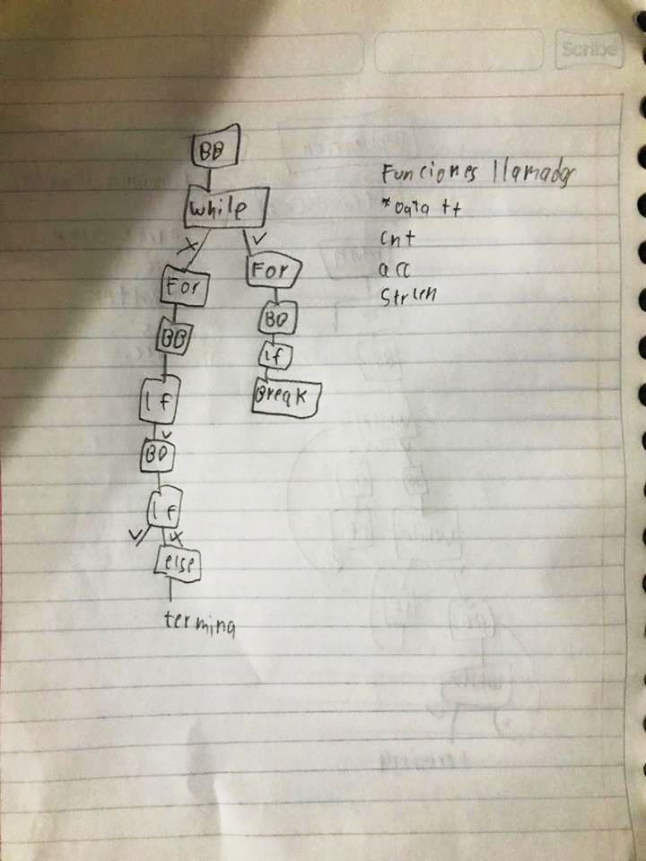

}

if (!strcmp(av[1], "-d")) {

int len = *av[2];

if ('A' <= len && len <= 'Z') len = len - 'A' + 1;

else len = len - 'a' + 26 + 1;

decode_85(buf, av[2]+1, len);

printf("decoded: %.*s\n", len, buf);

return 0;

}

if (!strcmp(av[1], "-t")) {

char t[4] = { -1,-1,-1,-1 };

encode_85(buf, t, 4);

printf("encoded: D%s\n", buf);

return 0;

}

}

#endif

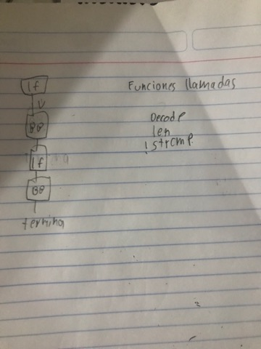

/*

*

* Bluetooth support for Broadcom devices

*

* Copyright (C) 2015 Intel Corporation

*

*

* This program is free software; you can redistribute it and/or modify

* it under the terms of the GNU General Public License as published by

* the Free Software Foundation; either version 2 of the License, or

* (at your option) any later version.

*

* This program is distributed in the hope that it will be useful,

* but WITHOUT ANY WARRANTY; without even the implied warranty of

* MERCHANTABILITY or FITNESS FOR A PARTICULAR PURPOSE. See the

* GNU General Public License for more details.

*

* You should have received a copy of the GNU General Public License

* along with this program; if not, write to the Free Software

* Foundation, Inc., 59 Temple Place, Suite 330, Boston, MA 02111-1307 USA

*

*/

#include <linux/module.h>

#include <linux/firmware.h>

#include <asm/unaligned.h>

#include <net/bluetooth/bluetooth.h>

#include <net/bluetooth/hci_core.h>

#include "btbcm.h"

#define VERSION "0.1"

#define BDADDR_BCM20702A0 (&(bdaddr_t) {{0x00, 0xa0, 0x02, 0x70, 0x20, 0x00}})

#define BDADDR_BCM4324B3 (&(bdaddr_t) {{0x00, 0x00, 0x00, 0xb3, 0x24, 0x43}})

#define BDADDR_BCM4330B1 (&(bdaddr_t) {{0x00, 0x00, 0x00, 0xb1, 0x30, 0x43}})

int btbcm_check_bdaddr(struct hci_dev *hdev)

{

struct hci_rp_read_bd_addr *bda;

struct sk_buff *skb;

skb = __hci_cmd_sync(hdev, HCI_OP_READ_BD_ADDR, 0, NULL,

HCI_INIT_TIMEOUT);

if (IS_ERR(skb)) {

int err = PTR_ERR(skb);

bt_dev_err(hdev, "BCM: Reading device address failed (%d)", err);

return err;

}

if (skb->len != sizeof(*bda)) {

bt_dev_err(hdev, "BCM: Device address length mismatch");

kfree_skb(skb);

return -EIO;

}

bda = (struct hci_rp_read_bd_addr *)skb->data;

/* Check if the address indicates a controller with either an

* invalid or default address. In both cases the device needs

* to be marked as not having a valid address.

*

* The address 00:20:70:02:A0:00 indicates a BCM20702A0 controller

* with no configured address.

*

* The address 43:24:B3:00:00:00 indicates a BCM4324B3 controller

* with waiting for configuration state.

*

* The address 43:30:B1:00:00:00 indicates a BCM4330B1 controller

* with waiting for configuration state.

*/

if (!bacmp(&bda->bdaddr, BDADDR_BCM20702A0) ||

!bacmp(&bda->bdaddr, BDADDR_BCM4324B3) ||

!bacmp(&bda->bdaddr, BDADDR_BCM4330B1)) {

bt_dev_info(hdev, "BCM: Using default device address (%pMR)",

&bda->bdaddr);

set_bit(HCI_QUIRK_INVALID_BDADDR, &hdev->quirks);

}

kfree_skb(skb);

return 0;

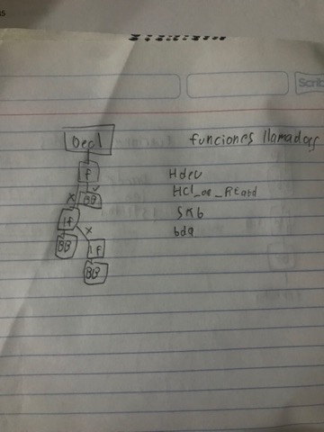

}

EXPORT_SYMBOL_GPL(btbcm_check_bdaddr);

int btbcm_set_bdaddr(struct hci_dev *hdev, const bdaddr_t *bdaddr)

{

struct sk_buff *skb;

int err;

skb = __hci_cmd_sync(hdev, 0xfc01, 6, bdaddr, HCI_INIT_TIMEOUT);

if (IS_ERR(skb)) {

err = PTR_ERR(skb);

bt_dev_err(hdev, "BCM: Change address command failed (%d)", err);

return err;

}

kfree_skb(skb);

return 0;

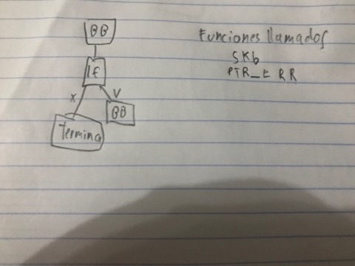

}

EXPORT_SYMBOL_GPL(btbcm_set_bdaddr);

int btbcm_patchram(struct hci_dev *hdev, const struct firmware *fw)

{

const struct hci_command_hdr *cmd;

const u8 *fw_ptr;

size_t fw_size;

struct sk_buff *skb;

u16 opcode;

int err = 0;

/* Start Download */

skb = __hci_cmd_sync(hdev, 0xfc2e, 0, NULL, HCI_INIT_TIMEOUT);

if (IS_ERR(skb)) {

err = PTR_ERR(skb);

bt_dev_err(hdev, "BCM: Download Minidrv command failed (%d)",

err);

goto done;

}

kfree_skb(skb);

/* 50 msec delay after Download Minidrv completes */

msleep(50);

fw_ptr = fw->data;

fw_size = fw->size;

while (fw_size >= sizeof(*cmd)) {

const u8 *cmd_param;

cmd = (struct hci_command_hdr *)fw_ptr;

fw_ptr += sizeof(*cmd);

fw_size -= sizeof(*cmd);

if (fw_size < cmd->plen) {

bt_dev_err(hdev, "BCM: Patch is corrupted");

err = -EINVAL;

goto done;

}

cmd_param = fw_ptr;

fw_ptr += cmd->plen;

fw_size -= cmd->plen;

opcode = le16_to_cpu(cmd->opcode);

skb = __hci_cmd_sync(hdev, opcode, cmd->plen, cmd_param,

HCI_INIT_TIMEOUT);

if (IS_ERR(skb)) {

err = PTR_ERR(skb);

bt_dev_err(hdev, "BCM: Patch command %04x failed (%d)",

opcode, err);

goto done;

}

kfree_skb(skb);

}

/* 250 msec delay after Launch Ram completes */

msleep(250);

done:

return err;

}

EXPORT_SYMBOL(btbcm_patchram);

static int btbcm_reset(struct hci_dev *hdev)

{

struct sk_buff *skb;

skb = __hci_cmd_sync(hdev, HCI_OP_RESET, 0, NULL, HCI_INIT_TIMEOUT);

if (IS_ERR(skb)) {

int err = PTR_ERR(skb);

bt_dev_err(hdev, "BCM: Reset failed (%d)", err);

return err;

}

kfree_skb(skb);

/* 100 msec delay for module to complete reset process */

msleep(100);

return 0;

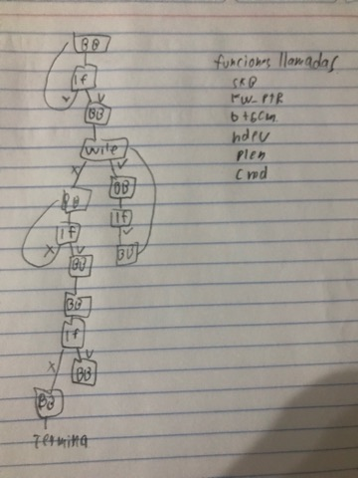

}

static struct sk_buff *btbcm_read_local_name(struct hci_dev *hdev)

{

struct sk_buff *skb;

skb = __hci_cmd_sync(hdev, HCI_OP_READ_LOCAL_NAME, 0, NULL,

HCI_INIT_TIMEOUT);

if (IS_ERR(skb)) {

bt_dev_err(hdev, "BCM: Reading local name failed (%ld)",

PTR_ERR(skb));

return skb;

}

if (skb->len != sizeof(struct hci_rp_read_local_name)) {

bt_dev_err(hdev, "BCM: Local name length mismatch");

kfree_skb(skb);

return ERR_PTR(-EIO);

}

return skb;

}

static struct sk_buff *btbcm_read_local_version(struct hci_dev *hdev)

{

struct sk_buff *skb;

skb = __hci_cmd_sync(hdev, HCI_OP_READ_LOCAL_VERSION, 0, NULL,

HCI_INIT_TIMEOUT);

if (IS_ERR(skb)) {

bt_dev_err(hdev, "BCM: Reading local version info failed (%ld)",

PTR_ERR(skb));

return skb;

}

if (skb->len != sizeof(struct hci_rp_read_local_version)) {

bt_dev_err(hdev, "BCM: Local version length mismatch");

kfree_skb(skb);

return ERR_PTR(-EIO);

}

return skb;

}

static struct sk_buff *btbcm_read_verbose_config(struct hci_dev *hdev)

{

struct sk_buff *skb;

skb = __hci_cmd_sync(hdev, 0xfc79, 0, NULL, HCI_INIT_TIMEOUT);

if (IS_ERR(skb)) {

bt_dev_err(hdev, "BCM: Read verbose config info failed (%ld)",

PTR_ERR(skb));

return skb;

}

if (skb->len != 7) {

bt_dev_err(hdev, "BCM: Verbose config length mismatch");

kfree_skb(skb);

return ERR_PTR(-EIO);

}

return skb;

}

static struct sk_buff *btbcm_read_controller_features(struct hci_dev *hdev)

{

struct sk_buff *skb;

skb = __hci_cmd_sync(hdev, 0xfc6e, 0, NULL, HCI_INIT_TIMEOUT);

if (IS_ERR(skb)) {

bt_dev_err(hdev, "BCM: Read controller features failed (%ld)",

PTR_ERR(skb));

return skb;

}

if (skb->len != 9) {

bt_dev_err(hdev, "BCM: Controller features length mismatch");

kfree_skb(skb);

return ERR_PTR(-EIO);

}

return skb;

}

static struct sk_buff *btbcm_read_usb_product(struct hci_dev *hdev)

{

struct sk_buff *skb;

skb = __hci_cmd_sync(hdev, 0xfc5a, 0, NULL, HCI_INIT_TIMEOUT);

if (IS_ERR(skb)) {

bt_dev_err(hdev, "BCM: Read USB product info failed (%ld)",

PTR_ERR(skb));

return skb;

}

if (skb->len != 5) {

bt_dev_err(hdev, "BCM: USB product length mismatch");

kfree_skb(skb);

return ERR_PTR(-EIO);

}

return skb;

}

static int btbcm_read_info(struct hci_dev *hdev)

{

struct sk_buff *skb;

/* Read Verbose Config Version Info */

skb = btbcm_read_verbose_config(hdev);

if (IS_ERR(skb))

return PTR_ERR(skb);

bt_dev_info(hdev, "BCM: chip id %u", skb->data[1]);

kfree_skb(skb);

/* Read Controller Features */

skb = btbcm_read_controller_features(hdev);

if (IS_ERR(skb))

return PTR_ERR(skb);

bt_dev_info(hdev, "BCM: features 0x%2.2x", skb->data[1]);

kfree_skb(skb);

/* Read Local Name */

skb = btbcm_read_local_name(hdev);

if (IS_ERR(skb))

return PTR_ERR(skb);

bt_dev_info(hdev, "%s", (char *)(skb->data + 1));

kfree_skb(skb);

return 0;

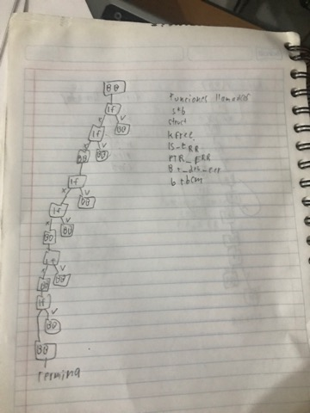

}

static const struct {

u16 subver;

const char *name;

} bcm_uart_subver_table[] = {

{ 0x4103, "BCM4330B1" }, /* 002.001.003 */

{ 0x410e, "BCM43341B0" }, /* 002.001.014 */

{ 0x4406, "BCM4324B3" }, /* 002.004.006 */

{ 0x610c, "BCM4354" }, /* 003.001.012 */

{ 0x2209, "BCM43430A1" }, /* 001.002.009 */

{ 0x6119, "BCM4345C0" }, /* 003.001.025 */

{ 0x230f, "BCM4356A2" }, /* 001.003.015 */

{ }

};

int btbcm_initialize(struct hci_dev *hdev, char *fw_name, size_t len)

{

u16 subver, rev;

const char *hw_name = NULL;

struct sk_buff *skb;

struct hci_rp_read_local_version *ver;

int i, err;

/* Reset */

err = btbcm_reset(hdev);

if (err)

return err;

/* Read Local Version Info */

skb = btbcm_read_local_version(hdev);

if (IS_ERR(skb))

return PTR_ERR(skb);

ver = (struct hci_rp_read_local_version *)skb->data;

rev = le16_to_cpu(ver->hci_rev);

subver = le16_to_cpu(ver->lmp_subver);

kfree_skb(skb);

/* Read controller information */

err = btbcm_read_info(hdev);

if (err)

return err;

switch ((rev & 0xf000) >> 12) {

case 0:

case 1:

case 2:

case 3:

for (i = 0; bcm_uart_subver_table[i].name; i++) {

if (subver == bcm_uart_subver_table[i].subver) {

hw_name = bcm_uart_subver_table[i].name;

break;

}

}

snprintf(fw_name, len, "brcm/%s.hcd", hw_name ? : "BCM");

break;

default:

return 0;

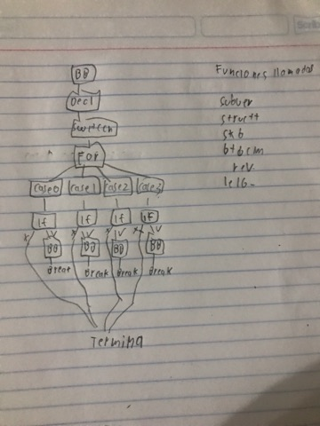

}

bt_dev_info(hdev, "%s (%3.3u.%3.3u.%3.3u) build %4.4u",

hw_name ? : "BCM", (subver & 0xe000) >> 13,

(subver & 0x1f00) >> 8, (subver & 0x00ff), rev & 0x0fff);

return 0;

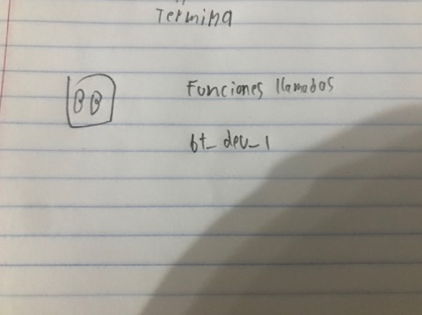

}

EXPORT_SYMBOL_GPL(btbcm_initialize);

int btbcm_finalize(struct hci_dev *hdev)

{

struct sk_buff *skb;

struct hci_rp_read_local_version *ver;

u16 subver, rev;

int err;

/* Reset */

err = btbcm_reset(hdev);

if (err)

return err;

/* Read Local Version Info */

skb = btbcm_read_local_version(hdev);

if (IS_ERR(skb))

return PTR_ERR(skb);

ver = (struct hci_rp_read_local_version *)skb->data;

rev = le16_to_cpu(ver->hci_rev);

subver = le16_to_cpu(ver->lmp_subver);

kfree_skb(skb);

bt_dev_info(hdev, "BCM (%3.3u.%3.3u.%3.3u) build %4.4u",

(subver & 0xe000) >> 13, (subver & 0x1f00) >> 8,

(subver & 0x00ff), rev & 0x0fff);

btbcm_check_bdaddr(hdev);

set_bit(HCI_QUIRK_STRICT_DUPLICATE_FILTER, &hdev->quirks);

return 0;

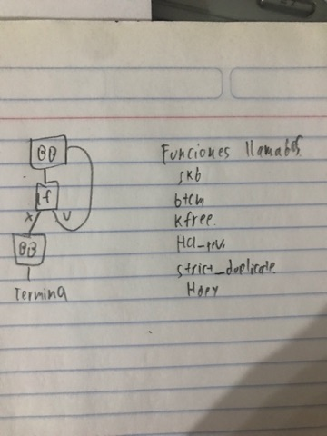

}

EXPORT_SYMBOL_GPL(btbcm_finalize);

static const struct {

u16 subver;

const char *name;

} bcm_usb_subver_table[] = {

{ 0x210b, "BCM43142A0" }, /* 001.001.011 */

{ 0x2112, "BCM4314A0" }, /* 001.001.018 */

{ 0x2118, "BCM20702A0" }, /* 001.001.024 */

{ 0x2126, "BCM4335A0" }, /* 001.001.038 */

{ 0x220e, "BCM20702A1" }, /* 001.002.014 */

{ 0x230f, "BCM4354A2" }, /* 001.003.015 */

{ 0x4106, "BCM4335B0" }, /* 002.001.006 */

{ 0x410e, "BCM20702B0" }, /* 002.001.014 */

{ 0x6109, "BCM4335C0" }, /* 003.001.009 */

{ 0x610c, "BCM4354" }, /* 003.001.012 */

{ }

};

int btbcm_setup_patchram(struct hci_dev *hdev)

{

char fw_name[64];

const struct firmware *fw;

u16 subver, rev, pid, vid;

const char *hw_name = NULL;

struct sk_buff *skb;

struct hci_rp_read_local_version *ver;

int i, err;

/* Reset */

err = btbcm_reset(hdev);

if (err)

return err;

/* Read Local Version Info */

skb = btbcm_read_local_version(hdev);

if (IS_ERR(skb))

return PTR_ERR(skb);

ver = (struct hci_rp_read_local_version *)skb->data;

rev = le16_to_cpu(ver->hci_rev);

subver = le16_to_cpu(ver->lmp_subver);

kfree_skb(skb);

/* Read controller information */

err = btbcm_read_info(hdev);

if (err)

return err;

switch ((rev & 0xf000) >> 12) {

case 0:

case 3:

for (i = 0; bcm_uart_subver_table[i].name; i++) {

if (subver == bcm_uart_subver_table[i].subver) {

hw_name = bcm_uart_subver_table[i].name;

break;

}

}

snprintf(fw_name, sizeof(fw_name), "brcm/%s.hcd",

hw_name ? : "BCM");

break;

case 1:

case 2:

/* Read USB Product Info */

skb = btbcm_read_usb_product(hdev);

if (IS_ERR(skb))

return PTR_ERR(skb);

vid = get_unaligned_le16(skb->data + 1);

pid = get_unaligned_le16(skb->data + 3);

kfree_skb(skb);

for (i = 0; bcm_usb_subver_table[i].name; i++) {

if (subver == bcm_usb_subver_table[i].subver) {

hw_name = bcm_usb_subver_table[i].name;

break;

}

}

snprintf(fw_name, sizeof(fw_name), "brcm/%s-%4.4x-%4.4x.hcd",

hw_name ? : "BCM", vid, pid);

break;

default:

return 0;

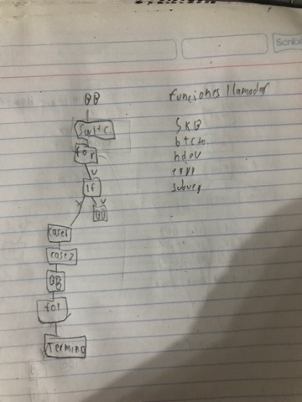

}

bt_dev_info(hdev, "%s (%3.3u.%3.3u.%3.3u) build %4.4u",

hw_name ? : "BCM", (subver & 0xe000) >> 13,

(subver & 0x1f00) >> 8, (subver & 0x00ff), rev & 0x0fff);

err = request_firmware(&fw, fw_name, &hdev->dev);

if (err < 0) {

bt_dev_info(hdev, "BCM: Patch %s not found", fw_name);

goto done;

}

btbcm_patchram(hdev, fw);

release_firmware(fw);

/* Reset */

err = btbcm_reset(hdev);

if (err)

return err;

/* Read Local Version Info */

skb = btbcm_read_local_version(hdev);

if (IS_ERR(skb))

return PTR_ERR(skb);

ver = (struct hci_rp_read_local_version *)skb->data;

rev = le16_to_cpu(ver->hci_rev);

subver = le16_to_cpu(ver->lmp_subver);

kfree_skb(skb);

bt_dev_info(hdev, "%s (%3.3u.%3.3u.%3.3u) build %4.4u",

hw_name ? : "BCM", (subver & 0xe000) >> 13,

(subver & 0x1f00) >> 8, (subver & 0x00ff), rev & 0x0fff);

/* Read Local Name */

skb = btbcm_read_local_name(hdev);

if (IS_ERR(skb))

return PTR_ERR(skb);

bt_dev_info(hdev, "%s", (char *)(skb->data + 1));

kfree_skb(skb);

done:

btbcm_check_bdaddr(hdev);

set_bit(HCI_QUIRK_STRICT_DUPLICATE_FILTER, &hdev->quirks);

return 0;

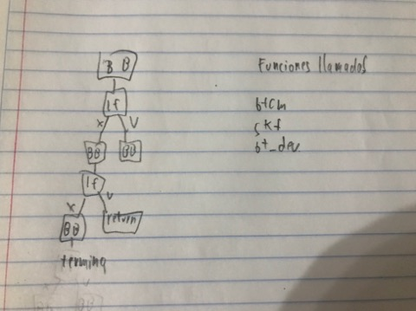

}

EXPORT_SYMBOL_GPL(btbcm_setup_patchram);

int btbcm_setup_apple(struct hci_dev *hdev)

{

struct sk_buff *skb;

int err;

/* Reset */

err = btbcm_reset(hdev);

if (err)

return err;

/* Read Verbose Config Version Info */

skb = btbcm_read_verbose_config(hdev);

if (!IS_ERR(skb)) {

bt_dev_info(hdev, "BCM: chip id %u build %4.4u",

skb->data[1], get_unaligned_le16(skb->data + 5));

kfree_skb(skb);

}

/* Read USB Product Info */

skb = btbcm_read_usb_product(hdev);

if (!IS_ERR(skb)) {

bt_dev_info(hdev, "BCM: product %4.4x:%4.4x",

get_unaligned_le16(skb->data + 1),

get_unaligned_le16(skb->data + 3));

kfree_skb(skb);

}

/* Read Controller Features */

skb = btbcm_read_controller_features(hdev);

if (!IS_ERR(skb)) {

bt_dev_info(hdev, "BCM: features 0x%2.2x", skb->data[1]);

kfree_skb(skb);

}

/* Read Local Name */

skb = btbcm_read_local_name(hdev);

if (!IS_ERR(skb)) {

bt_dev_info(hdev, "%s", (char *)(skb->data + 1));

kfree_skb(skb);

}

set_bit(HCI_QUIRK_STRICT_DUPLICATE_FILTER, &hdev->quirks);

return 0;

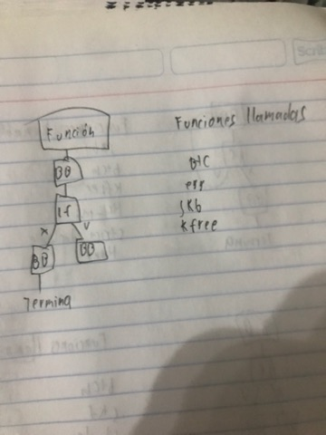

}

EXPORT_SYMBOL_GPL(btbcm_setup_apple);

MODULE_AUTHOR("Marcel Holtmann <marcel@holtmann.org>");

MODULE_DESCRIPTION("Bluetooth support for Broadcom devices ver " VERSION);

MODULE_VERSION(VERSION);

MODULE_LICENSE("GPL");