**TwigaPlan – Comprehensive Frontend Project Report**

**1. Project Title**

**TwigaPlan – Group Saving & Planning Web App**

**2. Student Information**

* **Name:** UFITINEMA Junior Charte
* **Class/Level:** Level 6 Y1 GA
* **Institution:** RP NGOMA COLLEGE
* **Date of Submission:** 4th May 2025

**3. Problem Statement**

Many informal community groups in Rwanda such as youth cooperatives, church teams, and women’s associations rely on notebooks, WhatsApp, or memory to manage group savings and tasks. These manual methods often lead to poor transparency, missed contributions, forgotten meetings, and unproductive group coordination.

**4. Project Objective**

To design and develop a web application (frontend only) that allows small savings groups to:

* Set and track shared financial goals
* Log and view member contributions
* Plan and monitor group activities and meetings
* Keep members updated through a digital dashboard

**5. Tools and Technologies Used**

* **Design Tool:** Adobe XD (for UI/UX prototyping)
* **Frontend Technologies:**
  + HTML5
  + CSS3 (Flexbox, Grid)
  + JavaScript (DOM manipulation, Fetch API)
* **Fonts:** Google Fonts (Poppins, Nunito)
* **Icons:** Font Awesome
* **API Simulation:** Mock JSON data
* **Deployment:** Vercel ([Live Site Link](https://twiga-plan.vercel.app/))

**6. Adobe XD Prototype Screens**

Screens designed in Adobe XD:

* Landing Page (Home)
* Dashboard View
* Savings Entry & Tracker
* Social Feed Concept (showing posts visually)

The prototype allowed for user flow design, early layout testing, and component planning before coding.

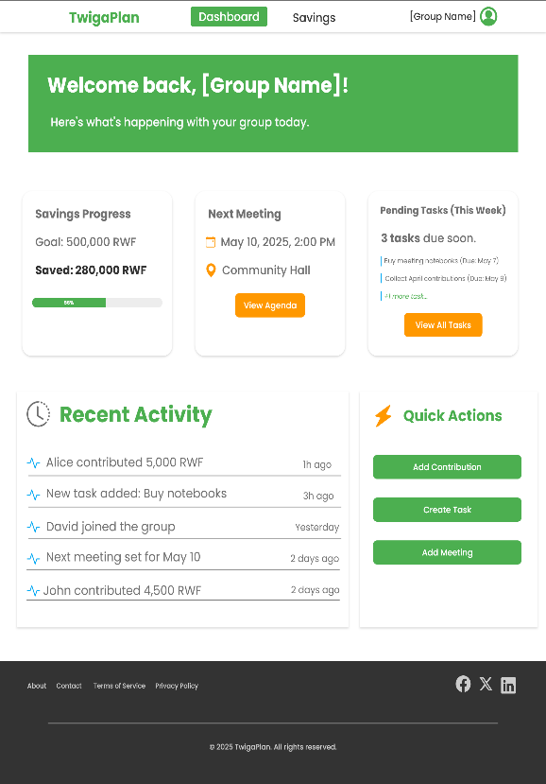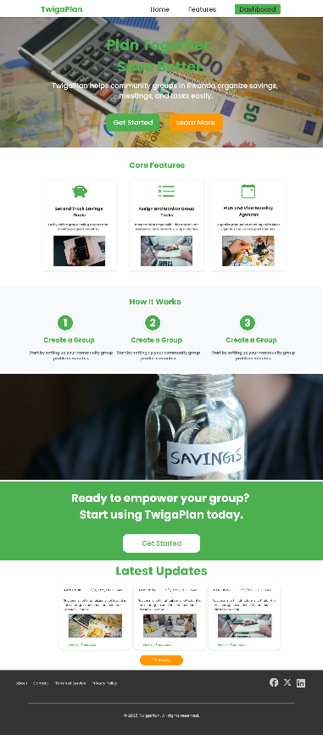

**7. Pages Developed and Their Functionality**

**🔸 1. Index (Home Page)**

* Hero banner introducing the platform
* Core features (Goals, Tasks, Meetings)
* “How It Works” walkthrough
* CTA section encouraging group signup
* Social feed section (simulated posts via posts.json)

**🔸 2. Dashboard Page**

* Group overview: Savings status, next meeting, task summary
* Cards display visual metrics
* Structured, mobile-responsive layout

**🔸 3. Savings Page**

* Form to log member contributions
* Live goal progress tracker (progress bar)
* History table displaying who contributed and how much

**8. Social Feed Integration**

To simulate real-world interaction, a dynamic “Social Feed” section was implemented using JavaScript and a local JSON file:

* Mock posts from Facebook and Twitter
* Posts are loaded via Fetch API
* This gives a realistic example of how social content could enrich the platform

**9. Challenges Encountered**

* Frontend-only projects can’t securely use real social media APIs without server-side logic
* JSON-based API mocking was used instead for demonstration
* Making the design fully responsive took careful layout testing across breakpoints

**10. Deployment**

The site was deployed on **Vercel**, a frontend deployment platform.

* **Live Demo:** [https://twiga-plan.vercel.app](https://twiga-plan.vercel.app/)

**11. Conclusion**

TwigaPlan demonstrates how web technologies can be applied to address real-world problems in community finance and collaboration. By using Adobe XD for planning and web tools for implementation, the project shows how even a student-level frontend solution can have real impact if scaled.

**12. Recommendations for Future Development**

* Add backend (e.g., Firebase or FastAPI) for data storage
* Enable user registration/login
* Use real Facebook Graph API or integrate WhatsApp notifications
* Add multi-language support (Kinyarwanda, English)