This is the closed-note and closed-script part of the exam. That is, students are not allowed to reference their course notes or any previously developed R script while completing this part of the exam. However, students are permitted to use R Help Pages or any internet search engine (like Google). Failure to comply with these rules will result in a score of zero on the exam and being reported to the program for an Honor Code Violation.

* Show ALL work! Partial credit will be given.
* Your submission file must be uploaded to your Sakai Drop Box no later than 1:15 pm in order to be considered for grading.
  + Name your submission file using the following format:
    - LastName_FirstName_Midterm.R (.docx)
* By giving your name on your submission file, you are agreeing to abide by the Duke Honor Code.

______________________________________________________________________________

1. Write a function that will find the sum of all positive elements in a numeric data object. If there are no positive elements in the data object, the function should return the character string ‘No positive elements in the data object’. Call the function POS_SUM. Test the function on the data objects shown below. Please provide the R code in your submission file. (20 points)
   1. The R script file YourNameHere_Midterm.R contains R commands to create the objects shown below. Please download this file from the course Sakai site to complete the exam.

> x1

[1] 1 2 3 4 5

> x2

[1] -2 -1 0 1 2

> x3

[1] -100 -90 -80 -70 -60 -50 -40 -30 -20 -10

> x4

[,1] [,2] [,3] [,4] [,5]

[1,] -5 -4 -3 -2 -1

[2,] 1 2 3 4 5

> x5

[,1] [,2] [,3]

[1,] -1 0 0

[2,] 0 -1 0

[3,] 0 0 -1

1. Consider the data files shown below:

**Data1.txt**

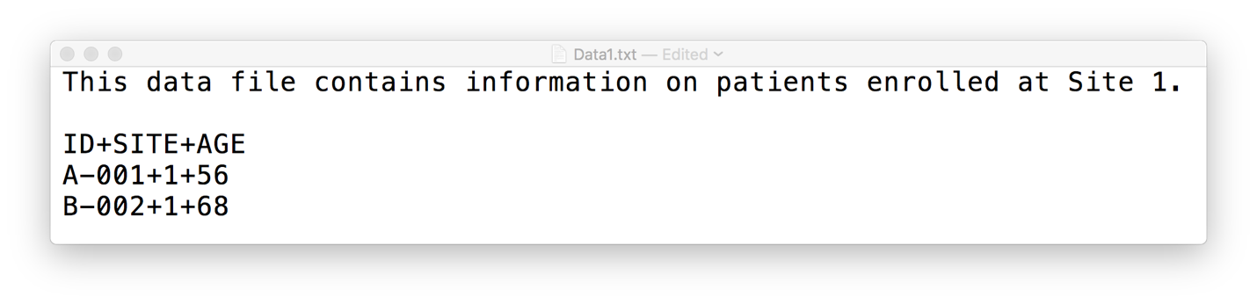

**Data2.txt**

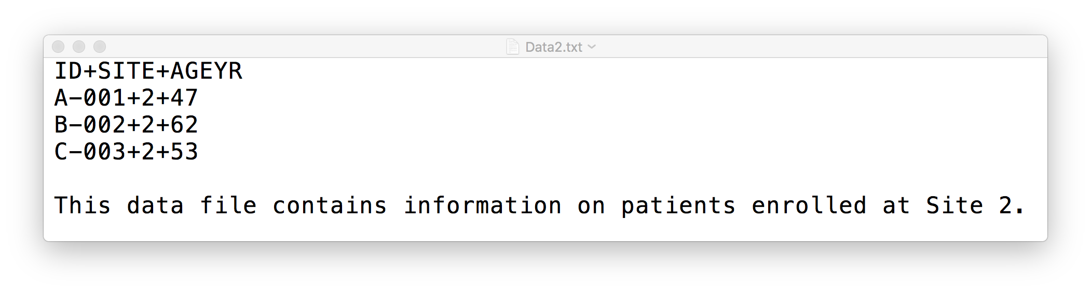

**Data3.txt**

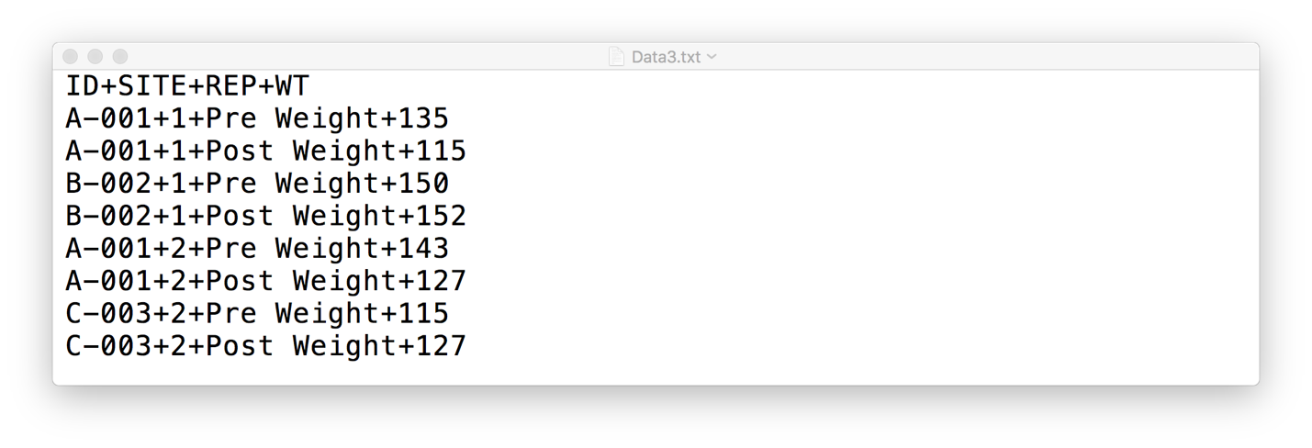

1. Download the data files. Import the data files Data1.txt, Data2.txt, and Data3.txt into R to create the data objects D1, D2, and D3, respectively. Make sure that all non-numeric data values are stored in character mode. Make sure to import all data values and variables names into R from the data file and do not to type them in by hand. Please provide the R code in your submission file. (15 points)
   1. Note: All data files are stored in the zipped file: BIOS721_Midterm_Fall2016_DataFiles.zip.

1. Using the data object D1, D2, and D3, create the data object shown. Please provide the R code in your submission file. (15 points)

> WORK

ID SITE AGE REP WT

1 A-001 1 56 Pre Weight 135

2 A-001 1 56 Post Weight 115

3 A-001 2 47 Pre Weight 143

4 A-001 2 47 Post Weight 127

5 B-002 1 68 Pre Weight 150

6 B-002 1 68 Post Weight 152

7 C-003 2 53 Pre Weight 115

8 C-003 2 53 Post Weight 127

1. The function call runif(1,a,b) will generate a single random value from a uniform distribution with the limits a and b. Under a uniform distribution, all values between a and b are equally likely to occur. Write a loop that generates random values from a uniform distribution with the limits 0 and 1 until 20 values greater than 0.9 have been observed. Store these values in an object called BigUs. Make sure that your code is reproducible. How many random values did you have to generate to get 20 values that met this criterion? Please provide the R code in your submission file. (20 points)