Simulation Study Summary Report
Background| Performed a simulation study to compare the performance of three estimators (mean, trimmed mean, and median) of the population mean by comparing their BIAS and MSE.
Results| See figure below for BIAS and MSE results.
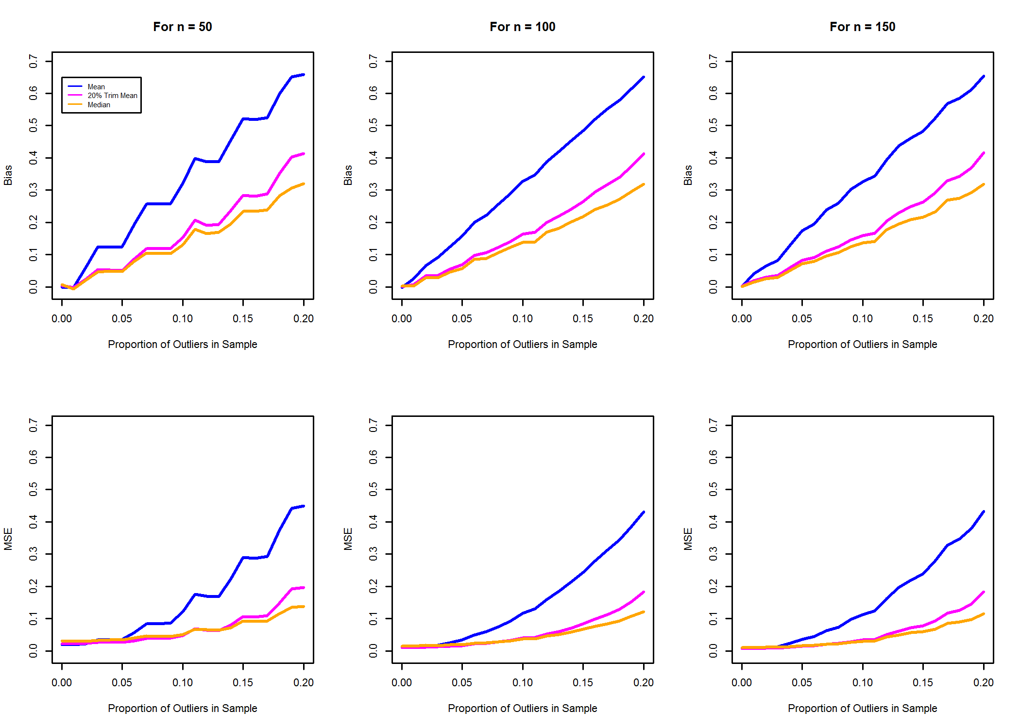
Conclusions| Mean is superior when proportion of outliers is low (< 5%), but the median becomes superior as the proportion increases. However, for higher proportions the performance of all three estimators suffers.

