1. retrieving each individual table from the database and printing
2. Database

Script: show tables;

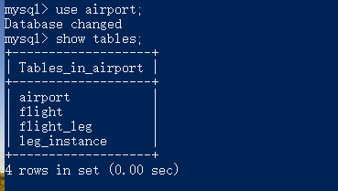

1. Tables
   1. airport
      1. Structure

Script: desc airport;

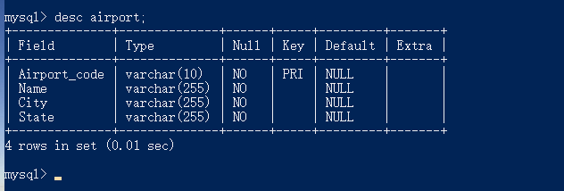

* + 1. Data

Script: select * from airport;

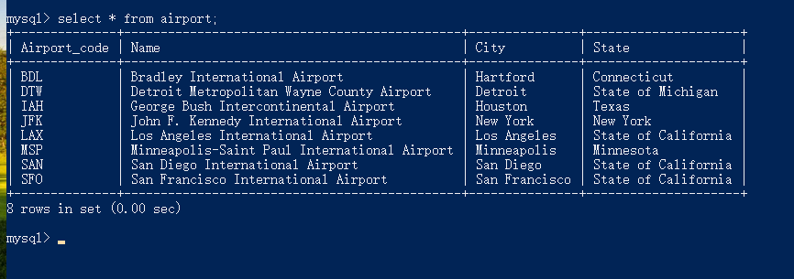

* 1. flight
     1. Structure

Script: desc flight;

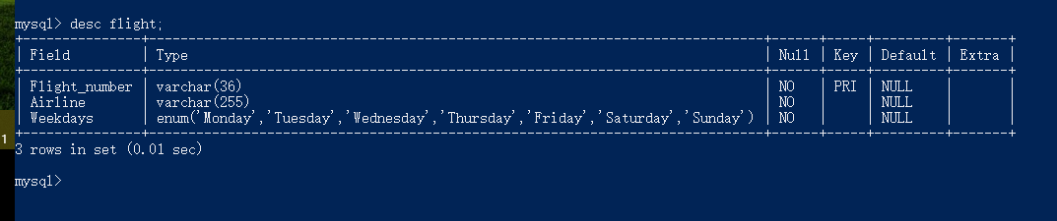

* + 1. Data

Script: select * from flight;

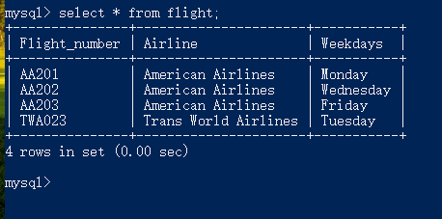

* 1. flight_leg
     1. Structure

Script: desc flight_leg;

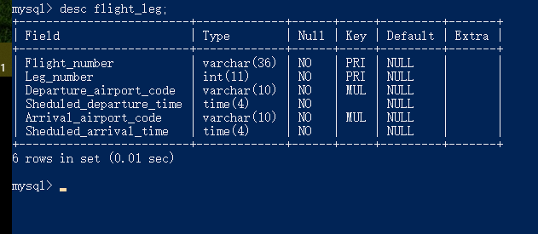

* + 1. Data

Script: select * from flight_leg;

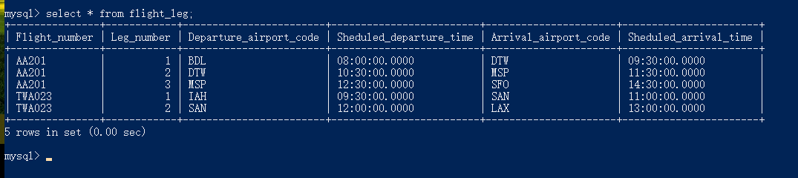

* 1. leg_instance
     1. Structure

Script: desc leg_instance;

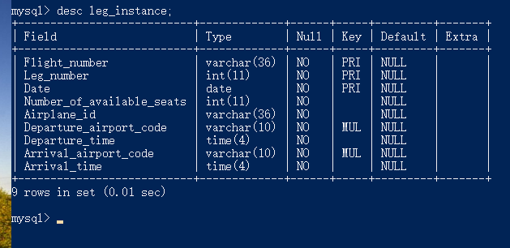

* + 1. Data

Script: select * from leg_instance;

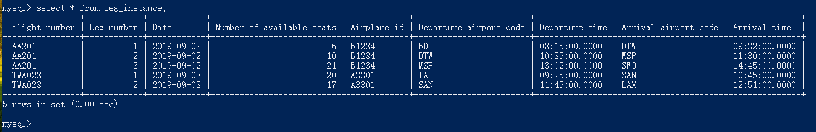

1. showing appropriate section of the system catalog
2. information_schema.KEY_COLUMN_USAGE

Script: select CONSTRAINT_SCHEMA, CONSTRAINT_NAME, TABLE_NAME, COLUMN_NAME, ORDINAL_POSITION, POSITION_IN_UNIQUE_CONSTRAINT, REFERENCED_TABLE_SCHEMA, REFERENCED_TABLE_NAME, REFERENCED_COLUMN_NAME from INFORMATION_SCHEMA.KEY_COLUMN_USAGE where `TABLE_SCHEMA` = 'airport';

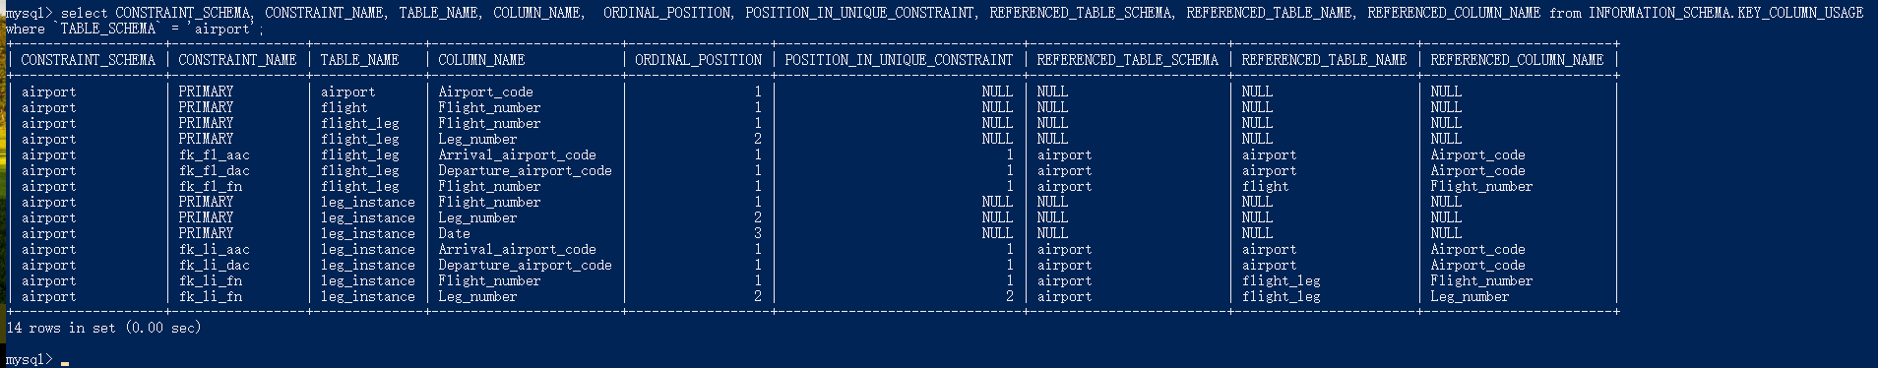

1. information_schema.TABLE_CONSTRAINTS

Script: select * from information_schema.TABLE_CONSTRAINTS where table_schema='airport';

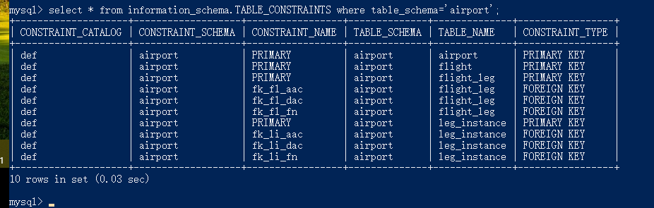

1. problems
2. Check constraints

Since MySQL does not implement the check constraint function, I use enum and trigger to replace it. I used enum to limit the values of the weekdays column in the table “flight” to 'Monday', 'Tuesday', 'Wednesday', 'Thursday', 'Friday', 'Saturday', or 'Sunday'.

I used triggers to check for “Sheduled_departure_time” and “Sheduled_arrival_time” in table “flight_leg”, and “Departure_time” and “Arrival_time” in table “leg_instance”, and restricted the former to be smaller than the latter, otherwise exceptions are thrown.

 Appendix I SQL Script to create database and tables and insert data

-- create database

DROP DATABASE IF EXISTS `airport`;

CREATE DATABASE `airport`;

USE `airport`;

-- create tables

DROP TABLE IF EXISTS `airport`;

CREATE TABLE `airport` (

`Airport_code` varchar(10) NOT NULL,

`Name` varchar(255) NOT NULL,

`City` varchar(255) NOT NULL,

`State` varchar(255) NOT NULL,

PRIMARY KEY (`Airport_code`)

);

DROP TABLE IF EXISTS `flight`;

CREATE TABLE `flight` (

`Flight_number` varchar(36) NOT NULL,

`Airline` varchar(255) NOT NULL,

`Weekdays` enum('Monday', 'Tuesday', 'Wednesday', 'Thursday', 'Friday', 'Saturday', 'Sunday') NOT NULL,

PRIMARY KEY (`Flight_number`)

);

DROP TABLE IF EXISTS `flight_leg`;

CREATE TABLE `flight_leg` (

`Flight_number` varchar(36) NOT NULL,

`Leg_number` int(11) NOT NULL,

`Departure_airport_code` varchar(10) NOT NULL,

`Sheduled_departure_time` time(4) NOT NULL,

`Arrival_airport_code` varchar(10) NOT NULL,

`Sheduled_arrival_time` time(4) NOT NULL,

PRIMARY KEY (`Flight_number`, `Leg_number`),

CONSTRAINT `fk_fl_aac` FOREIGN KEY (`Arrival_airport_code`) REFERENCES `airport` (`Airport_code`) ON DELETE CASCADE ON UPDATE CASCADE,

CONSTRAINT `fk_fl_dac` FOREIGN KEY (`Departure_airport_code`) REFERENCES `airport` (`Airport_code`) ON DELETE CASCADE ON UPDATE CASCADE,

CONSTRAINT `fk_fl_fn` FOREIGN KEY (`Flight_number`) REFERENCES `flight` (`Flight_number`) ON DELETE CASCADE ON UPDATE CASCADE,

CONSTRAINT `ck_fl_sdsa` CHECK(Sheduled_departure_time <= Sheduled_arrival_time)

);

DROP TABLE IF EXISTS `leg_instance`;

CREATE TABLE `leg_instance` (

`Flight_number` varchar(36) NOT NULL,

`Leg_number` int(11) NOT NULL,

`Date` date NOT NULL,

`Number_of_available_seats` int(11) NOT NULL,

`Airplane_id` varchar(36) NOT NULL,

`Departure_airport_code` varchar(10) NOT NULL,

`Departure_time` time(4) NOT NULL,

`Arrival_airport_code` varchar(10) NOT NULL,

`Arrival_time` time(4) NOT NULL,

PRIMARY KEY (`Flight_number`, `Leg_number`, `Date`),

CONSTRAINT `fk_li_aac` FOREIGN KEY (`Arrival_airport_code`) REFERENCES `airport` (`Airport_code`) ON DELETE CASCADE ON UPDATE CASCADE,

CONSTRAINT `fk_li_dac` FOREIGN KEY (`Departure_airport_code`) REFERENCES `airport` (`Airport_code`) ON DELETE CASCADE ON UPDATE CASCADE,

CONSTRAINT `fk_li_fn` FOREIGN KEY (`Flight_number`, `Leg_number`) REFERENCES `flight_leg` (`Flight_number`, `Leg_number`) ON DELETE CASCADE ON UPDATE CASCADE,

CONSTRAINT `ck_li_da` CHECK(Departure_time <= Arrival_time)

);

-- Use triggers instead of check constraints

DROP TRIGGER IF EXISTS `tri_fl_before_insert_time`;

CREATE TRIGGER `tri_fl_before_insert_time` BEFORE INSERT ON flight_leg FOR EACH ROW

BEGIN

DECLARE msg VARCHAR(200);

IF new.Sheduled_departure_time > new.Sheduled_arrival_time

THEN

SET msg = CONCAT('Invalid Time: ', NEW.Sheduled_departure_time, '>', NEW.Sheduled_arrival_time);

SIGNAL SQLSTATE 'HY000' SET MESSAGE_TEXT = msg;

END IF;

END;

DROP TRIGGER IF EXISTS `tri_fl_before_update_time`;

CREATE TRIGGER `tri_fl_before_update_time` BEFORE UPDATE ON flight_leg FOR EACH ROW

BEGIN

DECLARE msg VARCHAR(200);

IF new.Sheduled_departure_time > new.Sheduled_arrival_time

THEN

SET msg = CONCAT('Invalid Time: ', NEW.Sheduled_departure_time, '>', NEW.Sheduled_arrival_time);

SIGNAL SQLSTATE 'HY000' SET MESSAGE_TEXT = msg;

END IF;

END;

DROP TRIGGER IF EXISTS `tri_li_before_insert_time`;

CREATE TRIGGER `tri_li_before_insert_time` BEFORE INSERT ON leg_instance FOR EACH ROW

BEGIN

DECLARE msg VARCHAR(200);

IF new.Departure_time > new.Arrival_time

THEN

SET msg = CONCAT('Invalid Time: ', NEW.Departure_time, '>', NEW.Arrival_time);

SIGNAL SQLSTATE 'HY000' SET MESSAGE_TEXT = msg;

END IF;

END;

DROP TRIGGER IF EXISTS `tri_li_before_update_time`;

CREATE TRIGGER `tri_li_before_update_time` BEFORE UPDATE ON leg_instance FOR EACH ROW

BEGIN

DECLARE msg VARCHAR(200);

IF new.Departure_time > new.Arrival_time

THEN

SET msg = CONCAT('Invalid Time: ', NEW.Departure_time, '>', NEW.Arrival_time);

SIGNAL SQLSTATE 'HY000' SET MESSAGE_TEXT = msg;

END IF;

END;

-- insert data

INSERT INTO `airport` VALUES ('BDL', 'Bradley International Airport', 'Hartford', 'Connecticut');

INSERT INTO `airport` VALUES ('IAH', 'George Bush Intercontinental Airport', 'Houston', 'Texas');

INSERT INTO `airport` VALUES ('JFK', 'John F. Kennedy International Airport', 'New York', 'New York');

INSERT INTO `airport` VALUES ('DTW', 'Detroit Metropolitan Wayne County Airport', 'Detroit', 'State of Michigan');

INSERT INTO `airport` VALUES ('MSP', 'Minneapolis-Saint Paul International Airport', 'Minneapolis', 'Minnesota');

INSERT INTO `airport` VALUES ('SFO', 'San Francisco International Airport', 'San Francisco', 'State of California');

INSERT INTO `airport` VALUES ('SAN', 'San Diego International Airport', 'San Diego', 'State of California');

INSERT INTO `airport` VALUES ('LAX', 'Los Angeles International Airport', 'Los Angeles', 'State of California');

INSERT INTO `flight` VALUES ('AA201', 'American Airlines', 'Monday');

INSERT INTO `flight` VALUES ('AA202', 'American Airlines', 'Wednesday');

INSERT INTO `flight` VALUES ('AA203', 'American Airlines', 'Friday');

INSERT INTO `flight` VALUES ('TWA023', 'Trans World Airlines', 'Tuesday');

INSERT INTO `flight_leg` VALUES ('AA201', 1, 'BDL', '08:00', 'DTW', '09:30');

INSERT INTO `flight_leg` VALUES ('AA201', 2, 'DTW', '10:30', 'MSP', '11:30');

INSERT INTO `flight_leg` VALUES ('AA201', 3, 'MSP', '12:30', 'SFO', '14:30');

INSERT INTO `flight_leg` VALUES ('TWA023', 1, 'IAH', '09:30', 'SAN', '11:00');

INSERT INTO `flight_leg` VALUES ('TWA023', 2, 'SAN', '12:00', 'LAX', '13:00');

INSERT INTO `leg_instance` VALUES ('AA201', 1, '2019-09-02', 6, 'B1234', 'BDL', '08:15', 'DTW', '09:32');

INSERT INTO `leg_instance` VALUES ('AA201', 2, '2019-09-02', 10, 'B1234', 'DTW', '10:35', 'MSP', '11:30');

INSERT INTO `leg_instance` VALUES ('AA201', 3, '2019-09-02', 21, 'B1234', 'MSP', '13:02', 'SFO', '14:45');

INSERT INTO `leg_instance` VALUES ('TWA023', 1, '2019-09-03', 20, 'A3301', 'IAH', '09:25', 'SAN', '10:45');

INSERT INTO `leg_instance` VALUES ('TWA023', 2, '2019-09-03', 17, 'A3301', 'SAN', '11:45', 'LAX', '12:51');