DELETE FROM `airport`;

DELETE FROM `flight`;

DELETE FROM `flight_leg`;

DELETE FROM `leg_instance`;

SELECT * FROM `airport`;

SELECT * FROM `flight`;

SELECT * FROM `flight_leg`;

SELECT * FROM `leg_instance`;



-- AIRPORT

INSERT INTO airport VALUES('BDL', 'Bradley International Airport', 'Hartford', 'Connecticut');

INSERT INTO airport VALUES('JFK', 'John F. Kennedy International Airport', 'New York', 'New York');

INSERT INTO airport VALUES('DTW', 'Detroit Metropolitan Wayne County Airport', 'Detroit', 'Michigan');

INSERT INTO airport VALUES('MSP', 'Minneapolis-Saint Paul International Airport', 'St. Paul', 'Minnesota');

INSERT INTO airport VALUES('SFO', 'San Francisco International Airport', 'San Francisco', 'California');

INSERT INTO airport VALUES('SAN', 'San Diego International Airport', 'San Diego', 'California');

INSERT INTO airport VALUES('LAX', 'Los Angeles International Airport', 'Los Angeles', 'California');

INSERT INTO airport VALUES('SJU', 'Luis Munoz Marin International Airport', 'Carolina', 'Puerto Rico');

INSERT INTO airport VALUES('MCO', 'Orlando International Airport', 'Orlando', 'Florida');

INSERT INTO airport VALUES('IAH', 'George Bush Intercontinental Airport', 'Houston', 'Texas');

INSERT INTO airport VALUES('HOU', 'William P. Hobby Airport', 'Houston', 'Texas');

INSERT INTO airport VALUES('PHX', 'Phoenix Sky Harbor International Airport', 'Phoenix', 'Arizona');

-- FLIGHT

INSERT INTO flight VALUES('AA201', 'American Airlines', 'Monday');

INSERT INTO flight VALUES('AA202', 'American Airlines', 'Wednesday');

INSERT INTO flight VALUES('AA203', 'American Airlines', 'Friday');

INSERT INTO flight VALUES('TWA021', 'Trans World Airlines', 'Tuesday');

INSERT INTO flight VALUES('TWA022', 'Trans World Airlines', 'Wednesday');

INSERT INTO flight VALUES('TWA023', 'Trans World Airlines', 'Thursday');

INSERT INTO flight VALUES('SW1385', 'South West Airline', 'Thursday');

INSERT INTO flight VALUES('SW1386', 'South West Airline', 'Sunday');

INSERT INTO flight VALUES('SW1387', 'South West Airline', 'Monday');

-- FLIGHT_LEG

INSERT INTO flight_leg VALUES('AA201', 1, 'BDL', '08:00', 'DTW', '09:30');

INSERT INTO flight_leg VALUES('AA201', 2, 'DTW', '10:30', 'MSP', '11:30');

INSERT INTO flight_leg VALUES('AA201', 3, 'MSP', '12:30', 'SFO', '14:30');

INSERT INTO flight_leg VALUES('AA202', 1, 'DTW', '08:00', 'BDL', '09:30');

INSERT INTO flight_leg VALUES('AA203', 1, 'SFO', '10:00', 'LAX', '10:45');

INSERT INTO flight_leg VALUES('AA203', 2, 'LAX', '14:00', 'BDL', '23:00');

INSERT INTO flight_leg VALUES('TWA023', 1, 'IAH', '09:30', 'SAN', '11:00');

INSERT INTO flight_leg VALUES('TWA023', 2, 'SAN', '12:00', 'LAX', '13:00');

INSERT INTO flight_leg VALUES('SW1385', 1, 'HOU', '09:30', 'LAX', '10:30');

INSERT INTO flight_leg VALUES('SW1386', 1, 'BDL', '07:00', 'MCO', '10:00');

INSERT INTO flight_leg VALUES('SW1386', 2, 'MCO', '12:30', 'SJU', '15:30');

INSERT INTO flight_leg VALUES('SW1387', 1, 'BDL', '09:30', 'IAH', '12:30');

INSERT INTO flight_leg VALUES('SW1387', 2, 'IAH', '13:30', 'PHX', '14:30');

INSERT INTO flight_leg VALUES('SW1387', 3, 'PHX', '15:30', 'LAX', '16:30');

-- LEG_INSTANCE

INSERT INTO leg_instance VALUES('TWA023', 1, '2019-08-29', 5, 'A3301', 'IAH', '09:35', 'SAN', '11:00');

INSERT INTO leg_instance VALUES('TWA023', 2, '2019-08-29', 7, 'A3301', 'SAN', '12:05', 'LAX', '12:50');

INSERT INTO leg_instance VALUES('SW1386', 1, '2019-09-01', 8, 'A3305', 'BDL', '07:25', 'MCO', '10:05');

INSERT INTO leg_instance VALUES('SW1386', 2, '2019-09-01', 3, 'A3305', 'MCO', '12:35', 'SJU', '15:30');

INSERT INTO leg_instance VALUES('AA201', 1, '2019-09-02', 6, 'B1234', 'BDL', '08:15', 'DTW', '09:32');

INSERT INTO leg_instance VALUES('AA201', 2, '2019-09-02', 10, 'B1234', 'DTW', '10:35', 'MSP', '11:30');

INSERT INTO leg_instance VALUES('AA201', 3, '2019-09-02', 11, 'B1234', 'MSP', '13:02', 'SFO', '14:45');

INSERT INTO leg_instance VALUES('AA202', 1, '2019-09-04', 12, 'B1235', 'DTW', '08:01', 'BDL', '09:25');

INSERT INTO leg_instance VALUES('SW1385', 1, '2019-09-05', 2, 'A3309', 'HOU', '09:30', 'LAX', '10:25');

INSERT INTO leg_instance VALUES('TWA023', 1, '2019-09-05', 5, 'A3301', 'IAH', '09:25', 'SAN', '10:45');

INSERT INTO leg_instance VALUES('TWA023', 2, '2019-09-05', 1, 'A3301', 'SAN', '11:45', 'LAX', '12:51');

INSERT INTO leg_instance VALUES('AA203', 1, '2019-09-06', 7, 'B1236', 'MSP', '13:02', 'SFO', '14:45');

INSERT INTO leg_instance VALUES('AA203', 2, '2019-09-06', 9, 'B1236', 'MSP', '13:02', 'SFO', '14:45');

INSERT INTO leg_instance VALUES('SW1386', 1, '2019-09-08', 10, 'A3311', 'BDL', '07:05', 'MCO', '09:50');

INSERT INTO leg_instance VALUES('SW1386', 2, '2019-09-08', 17, 'A3311', 'MCO', '12:30', 'SJU', '15:15');

1. SELECT Flight_number FROM flight WHERE Airline = 'American Airlines';

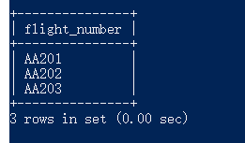

1. SELECT COUNT(DISTINCT Flight_number) FROM flight WHERE Airline = 'American Airlines' AND Weekdays = 'Monday';

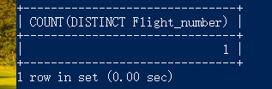

1. SELECT f.Flight_number flight_number, f.Weekdays weekdays FROM flight as f WHERE f.Flight_number IN (SELECT fl.Flight_number FROM flight_leg as fl, (SELECT fld.Flight_number, fld.Leg_number FROM flight_leg fld WHERE fld.Departure_airport_code IN (SELECT Airport_code FROM airport WHERE `Name`='George Bush Intercontinental Airport')) as t1, (SELECT fla.Flight_number, fla.Leg_number FROM flight_leg fla WHERE fla.Arrival_airport_code IN (SELECT Airport_code FROM airport WHERE `Name`='Los Angeles International Airport')) as t2 WHERE t1.Flight_number = t2.Flight_number AND t1.Leg_number <= t2.Leg_number AND fl.Flight_number = t1.Flight_number);

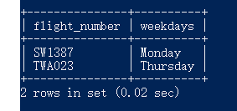

1. SELECT t1.Flight_number flight_number, t1.Departure_airport_code DAC, DATE_FORMAT(t1.Sheduled_departure_time,"%H%i") SDT, t2.Arrival_airport_code AAC, DATE_FORMAT(t2.Sheduled_arrival_time,"%H%i") SAT, t1.Weekdays weekdays FROM (SELECT fl.Flight_number, fl.Departure_airport_code, fl.Sheduled_departure_time, fl.Arrival_airport_code, fl.Sheduled_arrival_time, f.Weekdays FROM flight as f, flight_leg as fl, (SELECT fld.Flight_number, fld.Leg_number FROM flight_leg fld WHERE fld.Departure_airport_code IN (SELECT Airport_code FROM airport WHERE City='Houston')) as t1, (SELECT fla.Flight_number, fla.Leg_number FROM flight_leg fla WHERE fla.Arrival_airport_code IN (SELECT Airport_code FROM airport WHERE City='Los Angeles')) as t2 WHERE t1.Flight_number = t2.Flight_number AND t1.Leg_number <= t2.Leg_number AND fl.Flight_number = t1.Flight_number AND f.Flight_number=fl.Flight_number AND fl.Leg_number>=(SELECT Leg_number FROM flight_leg WHERE Flight_number=t1.Flight_number AND Leg_number=t1.Leg_number)) AS t1, (SELECT fl.Flight_number, fl.Leg_number, fl.Departure_airport_code, fl.Sheduled_departure_time, fl.Arrival_airport_code, fl.Sheduled_arrival_time, f.Weekdays FROM flight as f, flight_leg as fl, (SELECT fld.Flight_number, fld.Leg_number FROM flight_leg fld WHERE fld.Departure_airport_code IN (SELECT Airport_code FROM airport WHERE City='Houston')) as t1, (SELECT fla.Flight_number, fla.Leg_number FROM flight_leg fla WHERE fla.Arrival_airport_code IN (SELECT Airport_code FROM airport WHERE City='Los Angeles')) as t2 WHERE t1.Flight_number = t2.Flight_number AND t1.Leg_number <= t2.Leg_number AND fl.Flight_number = t1.Flight_number AND f.Flight_number=fl.Flight_number AND fl.Leg_number>=(SELECT Leg_number FROM flight_leg WHERE Flight_number=t1.Flight_number AND Leg_number=t1.Leg_number)) AS t2 WHERE t1.Flight_number=t2.Flight_number AND t1.Departure_airport_code IN (SELECT Airport_code FROM airport WHERE City='Houston') AND t2.Arrival_airport_code IN (SELECT Airport_code FROM airport WHERE City='Los Angeles');

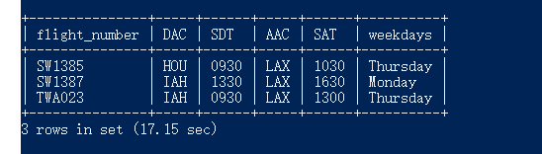

1. SELECT t1.Airline airline, t1.sum_seats as total_empty_seats FROM (SELECT flight.Airline,SUM(leg_instance.Number_of_available_seats) as sum_seats FROM flight,leg_instance WHERE flight.Flight_number = leg_instance.Flight_number AND leg_instance.Date BETWEEN '2019-09-01' AND '2019-09-30' GROUP BY flight.Airline) AS t1 WHERE t1.sum_seats=(SELECT MAX(t1.sum_seats) FROM (SELECT flight.Airline,SUM(leg_instance.Number_of_available_seats) as sum_seats FROM flight,leg_instance WHERE flight.Flight_number = leg_instance.Flight_number AND leg_instance.Date BETWEEN '2019-09-01' AND '2019-09-30' GROUP BY flight.Airline) as t1 WHERE 1);

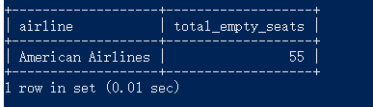

1. SELECT flight.Airline airline, SUM(leg_instance.Number_of_available_seats) total_empty_seats FROM flight,leg_instance WHERE flight.Flight_number = leg_instance.Flight_number AND leg_instance.Date BETWEEN '2019-09-01' AND '2019-09-30' GROUP BY flight.Airline HAVING total_empty_seats<30;

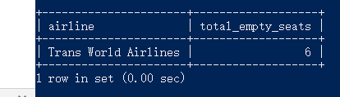

1. SELECT t2.Airline,t1.Airline FROM (SELECT * FROM (SELECT DISTINCT flight.Airline, fl.Arrival_airport_code FROM flight_leg fl, (SELECT Flight_number, Leg_number FROM flight_leg WHERE Departure_airport_code IN (SELECT Airport_code FROM airport WHERE City ='Houston')) t1, flight WHERE t1.Flight_number = fl.Flight_number AND t1.Leg_number <= fl.Leg_number AND t1.Flight_number=flight.Flight_number) t1

WHERE EXISTS (

SELECT * FROM (SELECT DISTINCT flight.Airline, fl.Arrival_airport_code FROM flight_leg fl, (SELECT Flight_number, Leg_number FROM flight_leg WHERE Departure_airport_code IN (SELECT Airport_code FROM airport WHERE City ='Houston')) t1, flight WHERE t1.Flight_number = fl.Flight_number AND t1.Leg_number <= fl.Leg_number AND t1.Flight_number=flight.Flight_number) t3 WHERE t3.Arrival_airport_code = t1.Arrival_airport_code AND t3.Airline <> t1.Airline

)) t1 INNER JOIN (SELECT * FROM (SELECT DISTINCT flight.Airline, fl.Arrival_airport_code FROM flight_leg fl, (SELECT Flight_number, Leg_number FROM flight_leg WHERE Departure_airport_code IN (SELECT Airport_code FROM airport WHERE City ='Houston')) t1, flight WHERE t1.Flight_number = fl.Flight_number AND t1.Leg_number <= fl.Leg_number AND t1.Flight_number=flight.Flight_number) t1

WHERE EXISTS (

SELECT * FROM (SELECT DISTINCT flight.Airline, fl.Arrival_airport_code FROM flight_leg fl, (SELECT Flight_number, Leg_number FROM flight_leg WHERE Departure_airport_code IN (SELECT Airport_code FROM airport WHERE City ='Houston')) t1, flight WHERE t1.Flight_number = fl.Flight_number AND t1.Leg_number <= fl.Leg_number AND t1.Flight_number=flight.Flight_number) t3 WHERE t3.Arrival_airport_code = t1.Arrival_airport_code AND t3.Airline <> t1.Airline

)) t2 ON t1.Arrival_airport_code=t2.Arrival_airport_code AND t1.Airline<>t2.Airline GROUP BY t2.Arrival_airport_code;

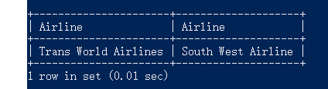

1. SELECT f.Airline airline, f.Weekdays weekdays, f.Flight_number FN, fl.Leg_number LN, fl.Departure_airport_code DAC, DATE_FORMAT(fl.Sheduled_departure_time,"%H%i") SDT, fl.Arrival_airport_code AAC, DATE_FORMAT(fl.Sheduled_arrival_time,"%H%i") SAT FROM flight as f LEFT OUTER JOIN flight_leg AS fl ON f.Flight_number=fl.Flight_number;

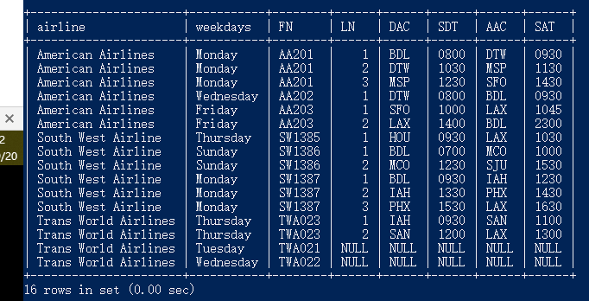

1. DROP VIEW IF EXISTS `4a`;

CREATE VIEW `4a` AS (SELECT fl1.Flight_number, fl1.Departure_airport_code, fl2.Arrival_airport_code FROM (SELECT f.Flight_number, f.Weekdays FROM flight as f WHERE f.Flight_number IN (SELECT fl.Flight_number FROM flight_leg as fl, (SELECT fld.Flight_number, fld.Leg_number FROM flight_leg fld WHERE fld.Departure_airport_code IN (SELECT Airport_code FROM airport WHERE `Name`='George Bush Intercontinental Airport')) as t1, (SELECT fla.Flight_number, fla.Leg_number FROM flight_leg fla WHERE fla.Arrival_airport_code IN (SELECT Airport_code FROM airport WHERE `Name`='Los Angeles International Airport')) as t2 WHERE t1.Flight_number = t2.Flight_number AND t1.Leg_number <= t2.Leg_number AND fl.Flight_number = t1.Flight_number)) as t1, flight_leg as fl1, flight_leg as fl2 WHERE t1.Flight_number = fl1.Flight_number AND fl1.Flight_number = fl2.Flight_number AND fl1.Leg_number = (SELECT MIN(Leg_number) FROM flight_leg WHERE Flight_number = t1.Flight_number) AND fl2.Leg_number = (SELECT MAX(Leg_number) FROM flight_leg WHERE Flight_number = t1.Flight_number));

1. SELECT * FROM information_schema.views WHERE information_schema.views.TABLE_NAME = '4a';

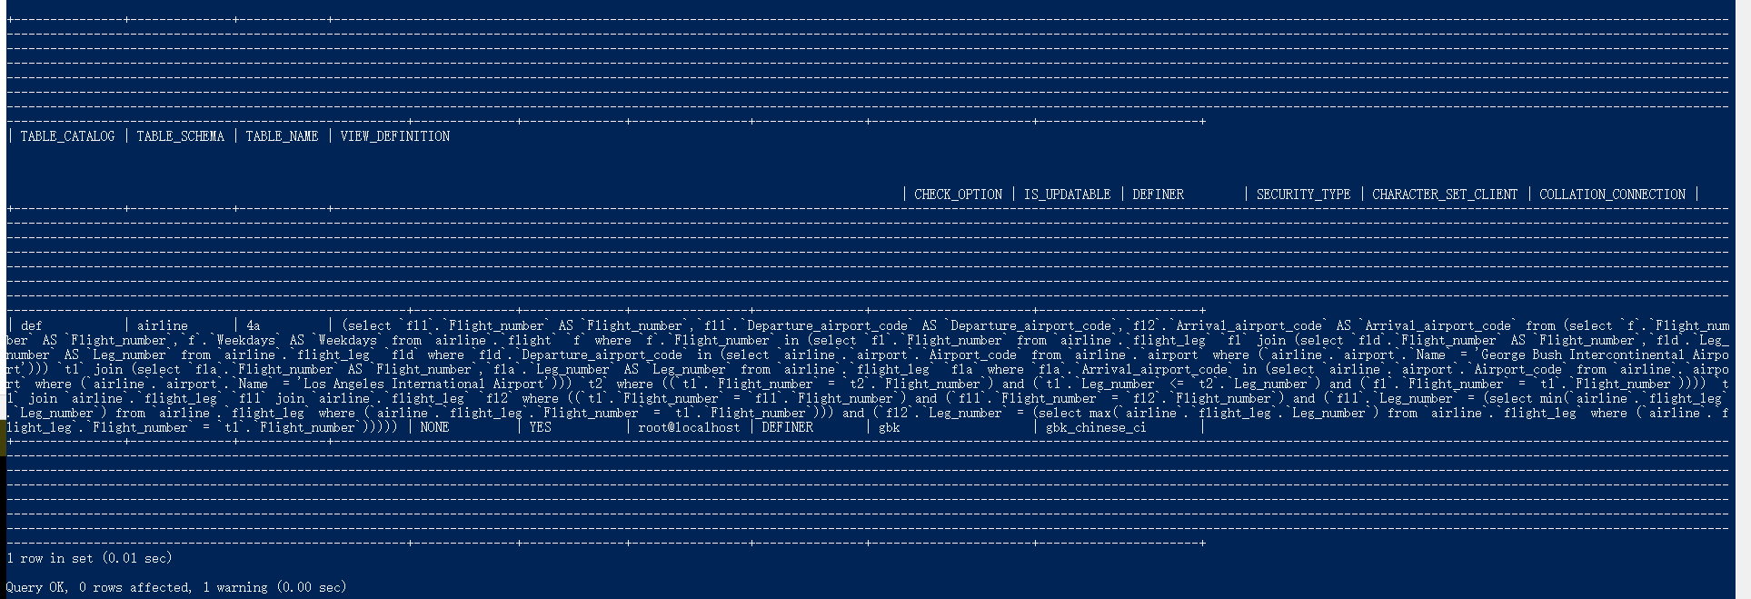

1. DROP VIEW IF EXISTS `4c`;

CREATE VIEW `4c` AS (SELECT t1.Flight_number flight_number, t1.Departure_airport_code DAC, DATE_FORMAT(t1.Sheduled_departure_time,"%H%i") SDT, t2.Arrival_airport_code AAC, DATE_FORMAT(t2.Sheduled_arrival_time,"%H%i") SAT, t1.Weekdays weekdays FROM (SELECT fl.Flight_number, fl.Departure_airport_code, fl.Sheduled_departure_time, fl.Arrival_airport_code, fl.Sheduled_arrival_time, f.Weekdays FROM flight as f, flight_leg as fl, (SELECT fld.Flight_number, fld.Leg_number FROM flight_leg fld WHERE fld.Departure_airport_code IN (SELECT Airport_code FROM airport WHERE City='Houston')) as t1, (SELECT fla.Flight_number, fla.Leg_number FROM flight_leg fla WHERE fla.Arrival_airport_code IN (SELECT Airport_code FROM airport WHERE City='Los Angeles')) as t2 WHERE t1.Flight_number = t2.Flight_number AND t1.Leg_number <= t2.Leg_number AND fl.Flight_number = t1.Flight_number AND f.Flight_number=fl.Flight_number AND fl.Leg_number>=(SELECT Leg_number FROM flight_leg WHERE Flight_number=t1.Flight_number AND Leg_number=t1.Leg_number)) AS t1, (SELECT fl.Flight_number, fl.Leg_number, fl.Departure_airport_code, fl.Sheduled_departure_time, fl.Arrival_airport_code, fl.Sheduled_arrival_time, f.Weekdays FROM flight as f, flight_leg as fl, (SELECT fld.Flight_number, fld.Leg_number FROM flight_leg fld WHERE fld.Departure_airport_code IN (SELECT Airport_code FROM airport WHERE City='Houston')) as t1, (SELECT fla.Flight_number, fla.Leg_number FROM flight_leg fla WHERE fla.Arrival_airport_code IN (SELECT Airport_code FROM airport WHERE City='Los Angeles')) as t2 WHERE t1.Flight_number = t2.Flight_number AND t1.Leg_number <= t2.Leg_number AND fl.Flight_number = t1.Flight_number AND f.Flight_number=fl.Flight_number AND fl.Leg_number>=(SELECT Leg_number FROM flight_leg WHERE Flight_number=t1.Flight_number AND Leg_number=t1.Leg_number)) AS t2 WHERE t1.Flight_number=t2.Flight_number AND t1.Departure_airport_code IN (SELECT Airport_code FROM airport WHERE City='Houston') AND t2.Arrival_airport_code IN (SELECT Airport_code FROM airport WHERE City='Los Angeles'));

SELECT * FROM `4c`;

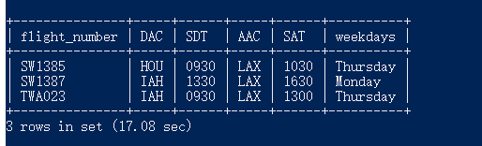

1. DROP PROCEDURE IF EXISTS del_idx;

DELIMITER $

create procedure del_idx(IN p_tablename varchar(200), IN p_idxname VARCHAR(200))

begin

DECLARE str VARCHAR(250);

set @str=concat(' drop index ',p_idxname,' on ',p_tablename);

select count(*) into @cnt from information_schema.statistics where table_name=p_tablename and index_name=p_idxname ;

if @cnt >0 then

PREPARE stmt FROM @str;

EXECUTE stmt ;

end if;

end $

DELIMITER ;

call del_idx('airport','airport_name_unique');

CREATE UNIQUE INDEX airport_name_unique ON airport(`Name`);

SELECT * FROM mysql.`innodb_index_stats` WHERE mysql.`innodb_index_stats`.database_name='airline' AND mysql.`innodb_index_stats`.table_name='airport';

SHOW INDEX FROM airport;

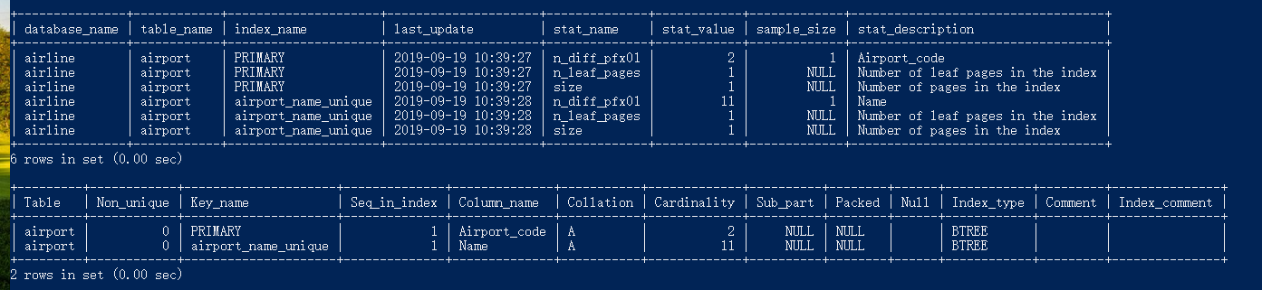

1. CREATE UNIQUE INDEX airline_unique ON flight(Airline);

Result: Failed to create an index with UNIQUE option on ‘Airline’ field of FLIGHT table.



1. INSERT INTO flight_leg VALUES('TWA023', 3, 'LAX', '14:00', 'YVR', '15:00');

