1、

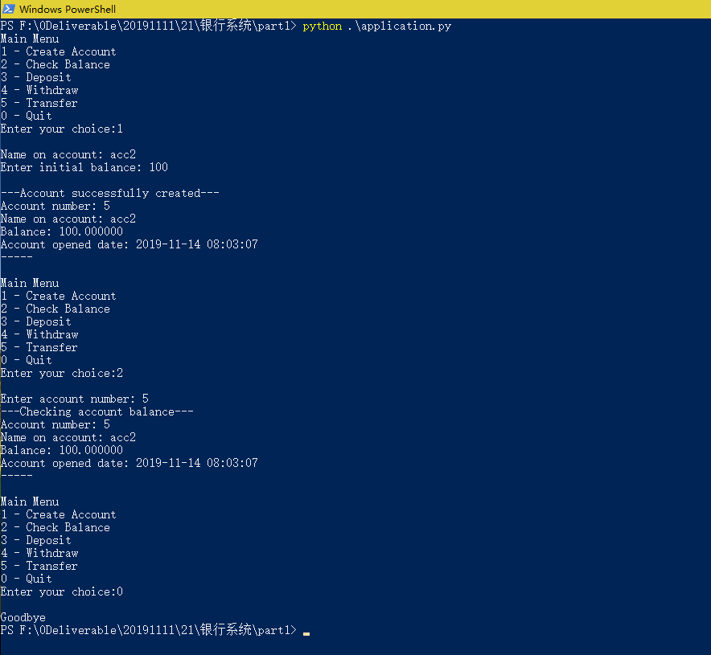

2、

Change account_dao.py:

import time  
from account import Account  
import datetime  
  
from account import Account  
  
  
class AccountDao:  
 def __init__(self, con):  
 self.__con = con  
  
 def insert(self, name_on_account, balance):  
 try:  
 with self.__con.cursor() as cur:  
 sql = "INSERT INTO account(name_on_account, balance) VALUES('%s', '%f')" % (name_on_account, balance)  
 cur.execute(sql)  
 last_id = cur.lastrowid  
 return last_id  
 except Exception as e:  
 self.__con.rollback()  
 return None  
 finally:  
 self.__con.commit()  
 print("current time:" + datetime.datetime.now().strftime('%Y-%m-%d %H:%M:%S'))  
  
 def find_by_id(self, account_no):  
 try:  
 with self.__con.cursor() as cur:  
 sql = "SELECT * FROM account WHERE account_no = '%d'" % account_no  
 cur.execute(sql)  
 rows = cur.fetchall()  
 return Account(rows[0][0], rows[0][1], rows[0][2], rows[0][3])  
 except Exception as e:  
 return None  
 finally:  
 self.__con.commit()  
 print("current time:" + datetime.datetime.now().strftime('%Y-%m-%d %H:%M:%S'))

result:

