1. Screenshots

（1）Deposit and withdraw

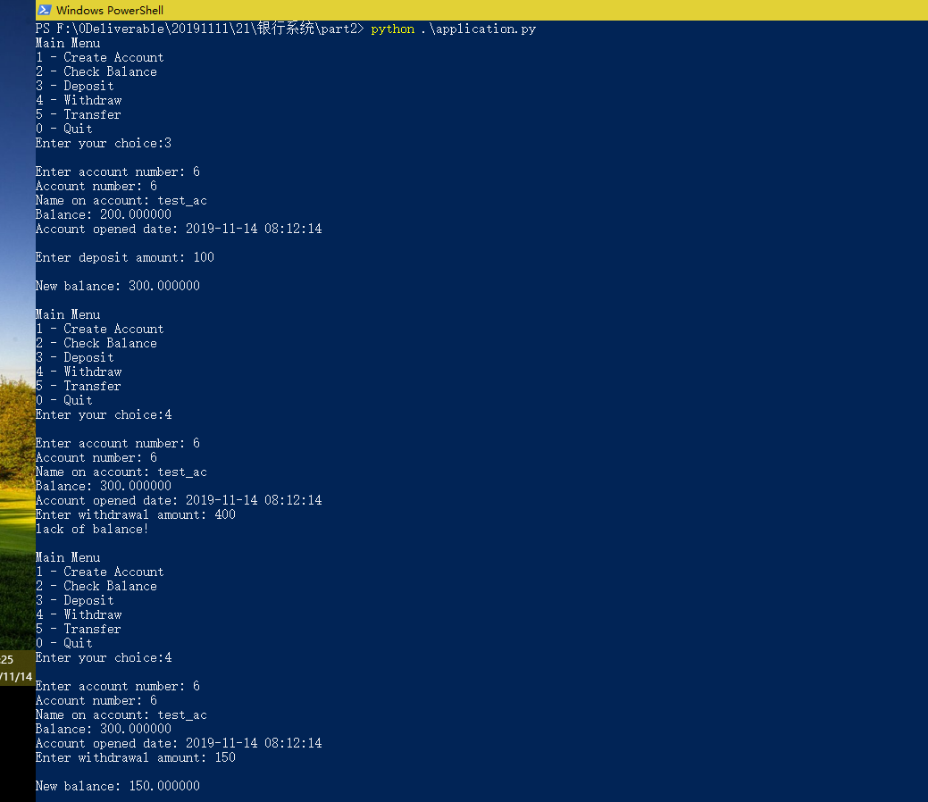

(2) Transfer

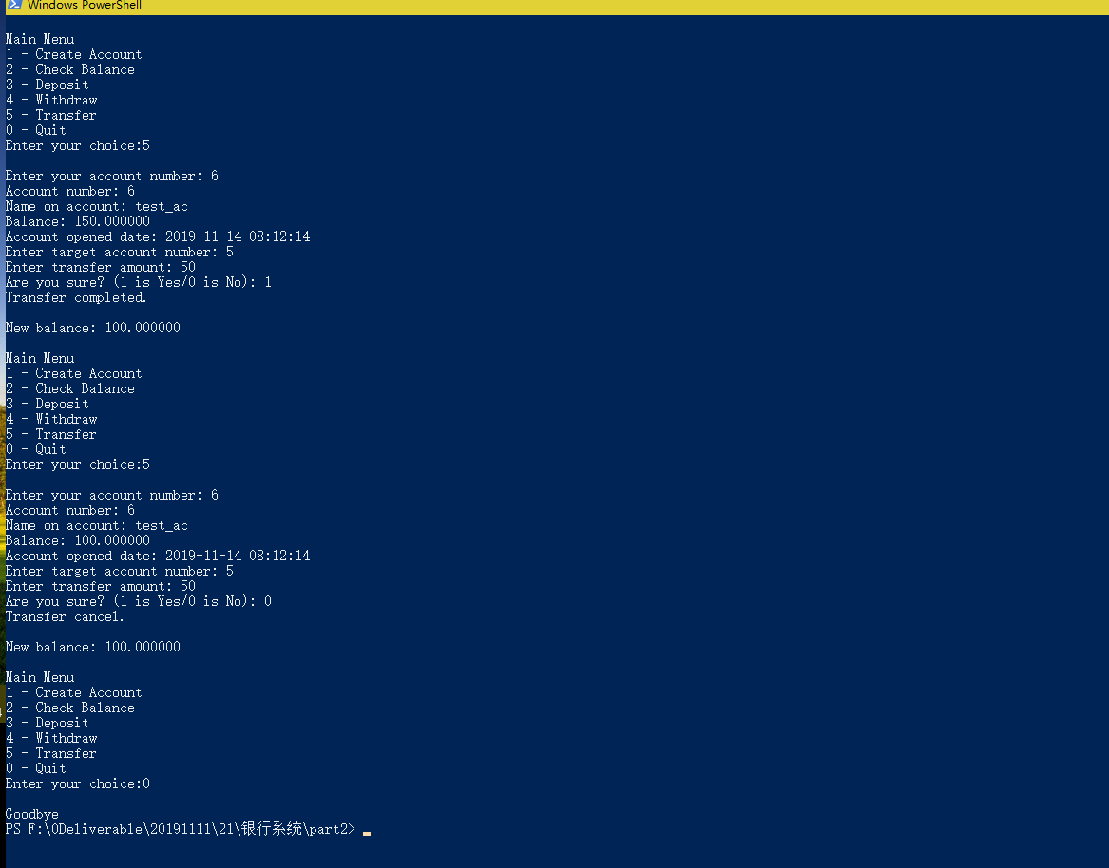

def withdraw(self):  
 no = int(input("Enter account number: "))  
 self.__accountDao.begin()  
 acc = self.__accountDao.find_by_id_lock(no)  
 if acc is not None:  
 self.display_account(acc)  
 wit = int(input("Enter withdrawal amount: "))  
 if wit > acc.get_balance():  
 print("lack of balance!")  
 self.__accountDao.rollback()  
 else:  
 self.__accountDao.reduce_balance(no, wit)  
 self.__accountDao.commit()  
 acc = self.__accountDao.find_by_id(no)  
 if acc is not None:  
 print("\nNew balance: %f" % acc.get_balance())  
 else:  
 print("\nFailed to withdraw")  
 else:  
 print("There is no account with account_no %d" % no)  
 self.__accountDao.rollback()  
 return

query and update operations are both in a same transaction.

2. Atomicity

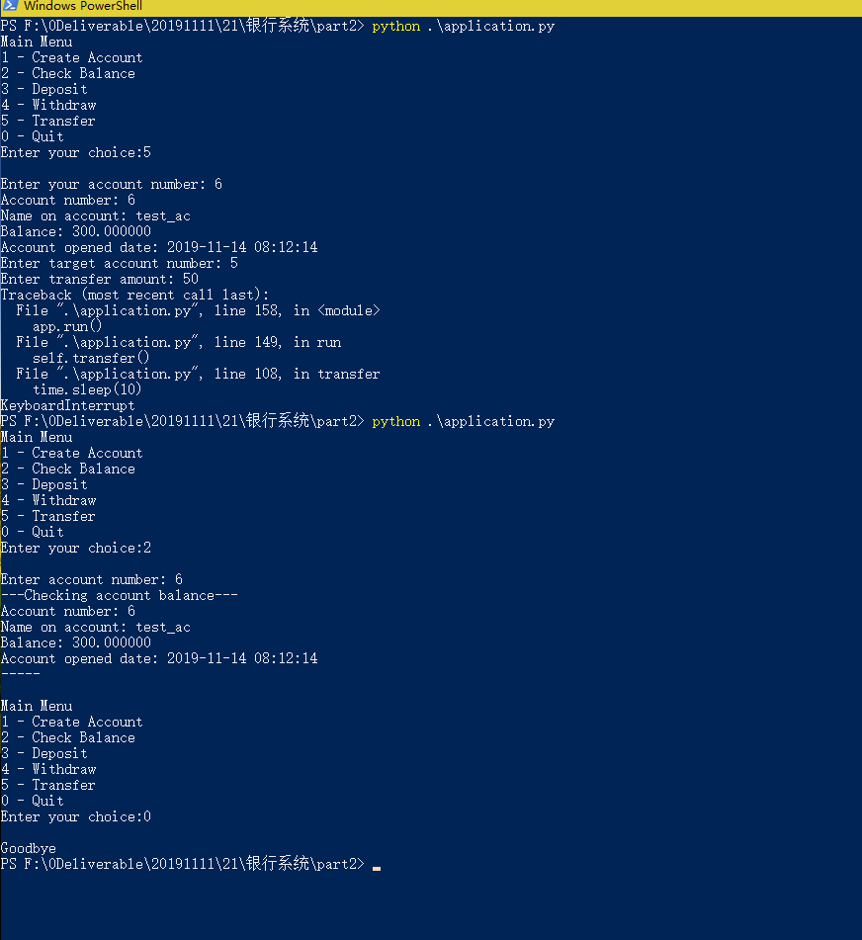

3. Consistency

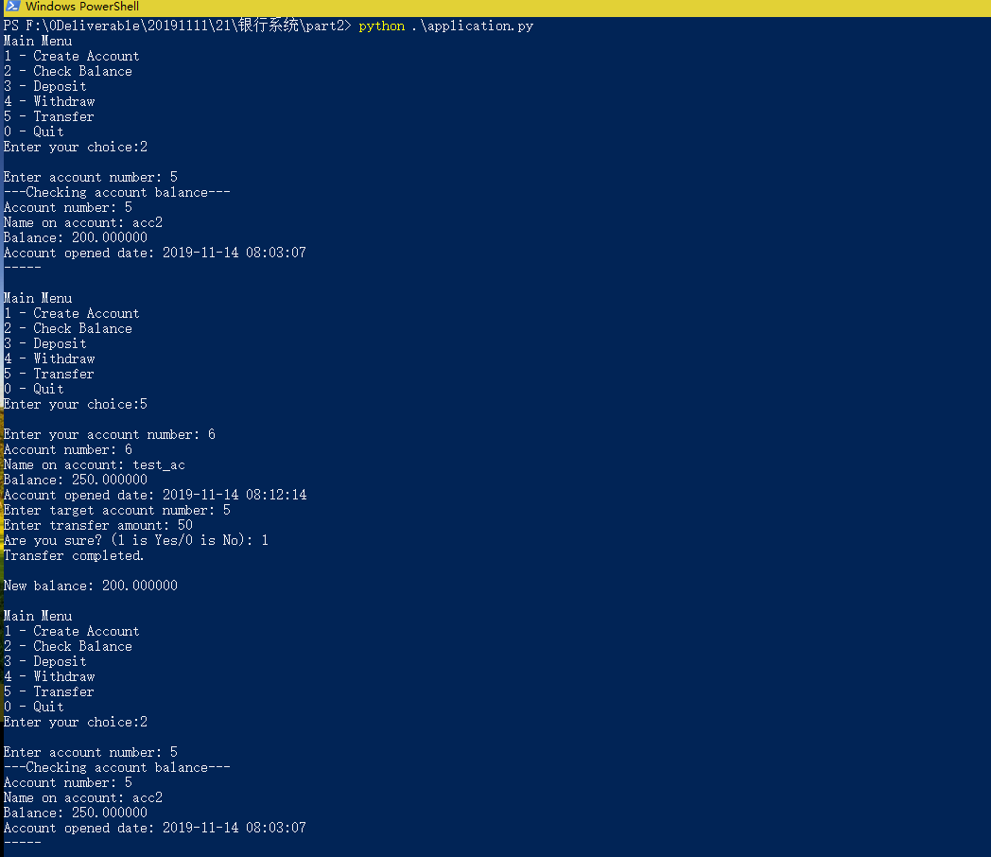

Your balance and target balance have both changed.

4. Isolation

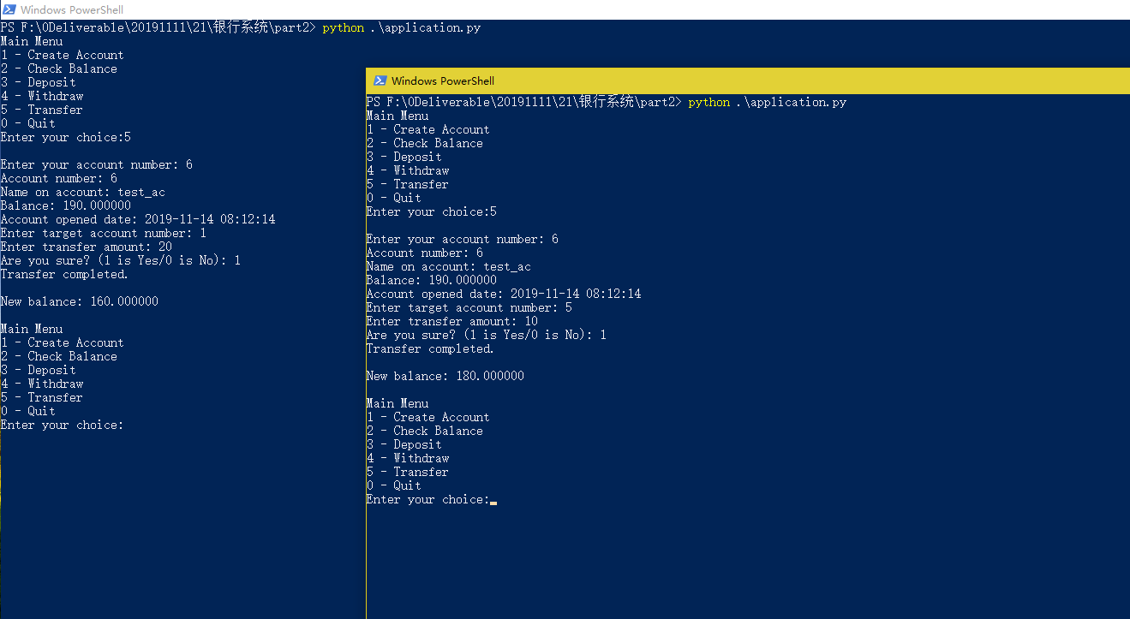

Row lock: The small window is waiting for the big one releasing the lock.