1. See the file 6-1.c
2. adds %xmm0, %xmm1

addq $1, %rdx

1. a latency of 3 cycles.
2. See the file 6-2c.c
3. As the length value increases, the difference between the execution time of inner and inner2 increases, and the performance of inner2 is better than that of inner.

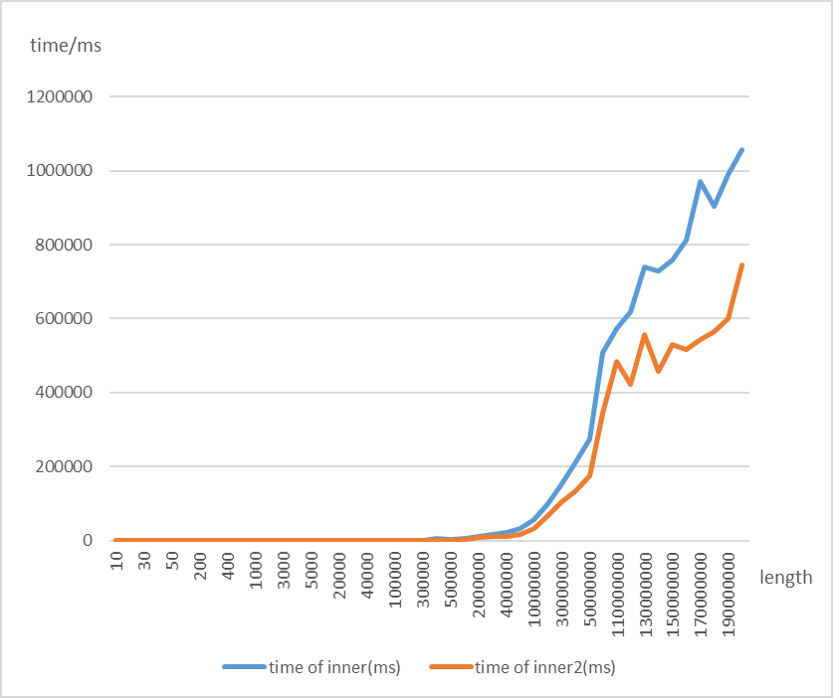

(original data: See the appendix)



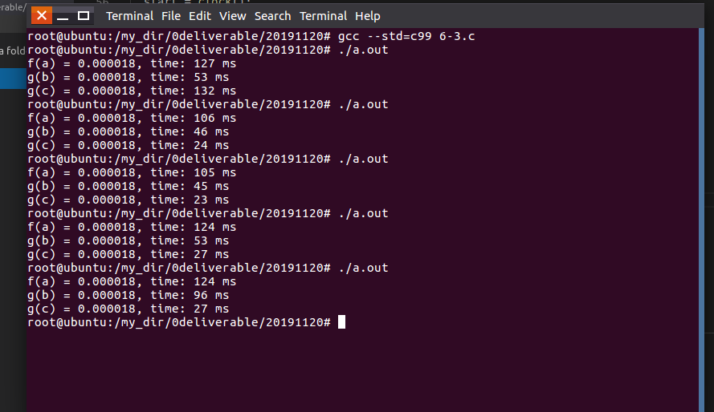

**Appendix:**

**original data of 6-2c:**

|  |  |  |
| --- | --- | --- |
| length | time of inner(ms) | time of inner2(ms) |
| 10 | 1 | 0 |
| 20 | 2 | 1 |
| 30 | 1 | 1 |
| 40 | 2 | 1 |
| 50 | 2 | 0 |
| 100 | 2 | 1 |
| 200 | 3 | 1 |
| 300 | 4 | 1 |
| 400 | 3 | 2 |
| 500 | 4 | 5 |
| 1000 | 7 | 4 |
| 2000 | 10 | 6 |
| 3000 | 15 | 9 |
| 4000 | 87 | 17 |
| 5000 | 75 | 22 |
| 10000 | 51 | 35 |
| 20000 | 88 | 127 |
| 30000 | 140 | 94 |
| 40000 | 175 | 107 |
| 50000 | 246 | 208 |
| 100000 | 609 | 318 |
| 200000 | 897 | 556 |
| 300000 | 1456 | 836 |
| 400000 | 4486 | 1415 |
| 500000 | 2300 | 1383 |
| 1000000 | 5463 | 2855 |
| 2000000 | 10585 | 6969 |
| 3000000 | 15538 | 9556 |
| 4000000 | 21800 | 12152 |
| 5000000 | 31476 | 17295 |
| 10000000 | 56330 | 31693 |
| 20000000 | 98537 | 68698 |
| 30000000 | 153270 | 103939 |
| 40000000 | 213056 | 133455 |
| 50000000 | 273346 | 176121 |
| 100000000 | 507182 | 345610 |
| 110000000 | 572264 | 484273 |
| 120000000 | 618044 | 422214 |
| 130000000 | 738741 | 556804 |
| 140000000 | 729301 | 457149 |
| 150000000 | 757992 | 529818 |
| 160000000 | 811166 | 516175 |
| 170000000 | 971540 | 543718 |
| 180000000 | 903588 | 565574 |
| 190000000 | 991311 | 598760 |
| 200000000 | 1057302 | 744754 |