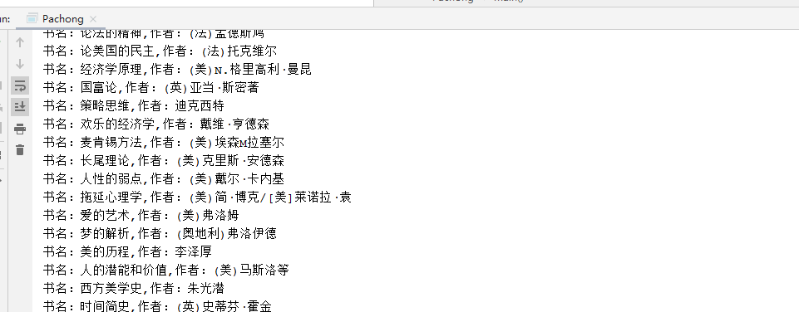

**import** org.jsoup.Jsoup;  
**import** org.jsoup.nodes.Document;  
**import** org.jsoup.nodes.Element;  
**import** org.jsoup.select.Elements;  
  
**import** java.io.IOException;  
**import** java.util.Iterator;  
  
**public class** Pachong {  
 **public static void** main(String[] args) {  
 **try** {  
 Document doc = Jsoup.*connect*(**"http://www.lib.uestc.edu.cn/bysw/list60"**).get();  
  
 Elements div = doc.select(**"div.grid_1_of_3 h4"**);  
 Elements h4 = div.select(**"h4"**);  
 **for** (Iterator<Element> iterator = h4.iterator(); iterator.hasNext(); ) {  
 String[] texts = iterator.next().text().split(**" "**);  
 System.***out***.println(**"书名："** + texts[0] + **",作者："** + texts[1]);  
 }  
 } **catch** (IOException e) {  
 e.printStackTrace();  
 }  
  
 }  
}