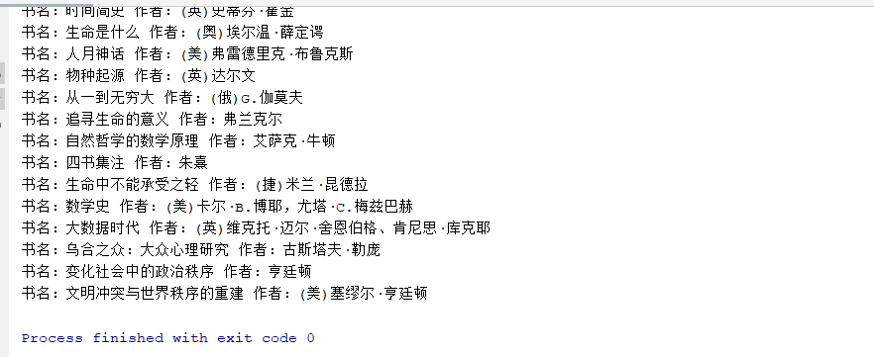

**import** org.jsoup.Jsoup;  
**import** org.jsoup.nodes.Document;  
**import** org.jsoup.nodes.Element;  
**import** org.jsoup.select.Elements;  
  
**import** java.io.IOException;  
**import** java.util.ListIterator;  
  
**public class** Solution {  
 **public void** solve() {  
 Document doc = **null**;  
 **try** {  
 doc = Jsoup.*connect*(**"http://www.lib.uestc.edu.cn/bysw/list60"**).timeout(3000).get();  
  
 Elements divElts = doc.select(**"div.grid_1_of_3 h4"**);  
 Elements h4Elts = divElts.select(**"h4"**);  
 h4Elts.forEach((h4) -> {  
 System.***out***.println(**"书名："** + h4.ownText() + **" 作者："** + h4.getElementsByTag(**"p"**).first().text());  
 });  
 } **catch** (IOException e) {  
 e.printStackTrace();  
 }  
 }  
  
 **public static void** main(String[] args) {  
 **new** Solution().solve();  
 }  
}