上海建桥学院
成

绩
信息技术学院

《数据库应用系统实践》
课程报告
课题名称： 大学生竞赛管理系统

专 业： 计科智能
班 级： 2班
学生姓名： 林晓婷
学 号： 1720056
指导教师： 徐敬红

一、需求分析
1．系统背景
全国各地举办的大学生竞赛活动数目也是逐年增加，报名参加各个竞赛的大学生数量也是逐年地大批增长。面对如此大的数目的参赛方信息的录入，原始的数据采集系统已经远远不能满足要求，如何利用现代信息技术使得举办方拥有快速、高效的参赛者信息反馈能力和高度的效率，已经是竞赛举办方特别关心的问题。通过开发这个高校竞赛信息管理系统，使参赛者信息的录入和管理工作系统化，规范化，自动化，从而达到提高管理效率的目的。满足日常管理的需要，并达到操作过程中的直观，方便，实用，安全等要求；系统采用模块化程序设计方法，这样既便于系统功能的各种组合，又便于未参与开发的技术维护人员补充，维护；系统应具备数据库维护功能，及时根据用户需求进行数据的添加，删除，修改等操作。

- 系统功能结构（需包含功能结构框图和模块说明）

（1）功能结构图

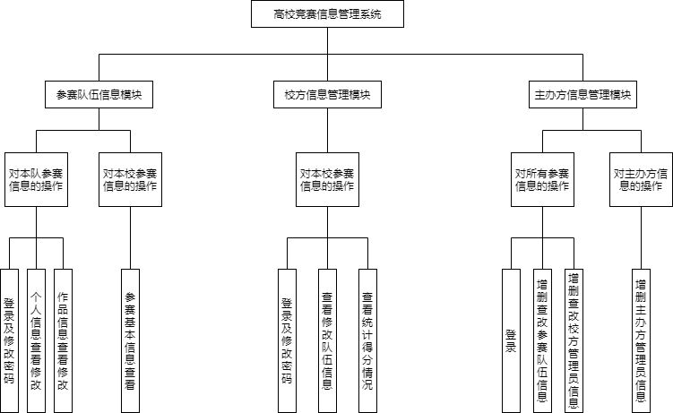

- 模块说明

高校竞赛信息管理系统分为三个模块：参赛队伍信息模块，校方信息管理模块，主办方信息管理模块。
参赛队伍信息模块包括：参赛队伍成员的登录，以及对密码的修改；参赛成员查看本队详细信息，并对其有修改、删除权限；提交竞赛作品；查看该队竞赛作品信息的修改、删除权限；访问查询本校其他参赛队伍基本信息。
校方信息管理模块：校方管理员的登录、以及对密码的修改；对本校参赛信息的查询、统计权限；对参赛队伍信息的查看、修改权限。
主办方信息管理模块：校方管理员的登录;增删查改删除队伍；增删查改校方管理员信息；增删查改主办方管理员信息。

- 系统功能简介

高校竞赛管理系统所涉及的用户包括：参赛学生、校方信息管理员、主办方信息管理员。
参赛学生可以根据主办方管理员注册的登录用户名和密码进行登录，及对密码的修改;到系统内部关于本队的内容进行查看、修改和删除;对竞赛作品提交信息的输入、查看、修改和删除;对该校其他参赛队伍的参赛信息进行访问、查询。
校方信息管理员可以根据主办方管理员注册的登录用户名和密码进行登录，及对密码的修改；根据需要对参赛队伍进行查看、修改和删除操作。
主办方终端信息管理员可以对全部的参赛信息新增、查看、修改和删除；对全部的作品信息进行查看；对所有参赛作品进行打分；新增、删除、查看、修改校方管理员信息；新增、删除、查看、修改主办方管理员信息。

- 概念模型设计

1．基本要素
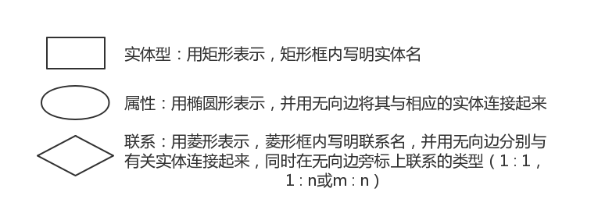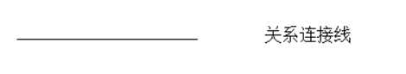

- ER图
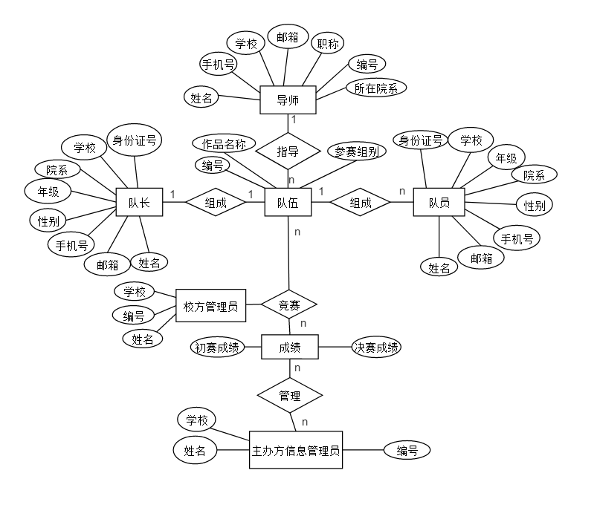
三、逻辑模型设计
1．ER模型向关系模型转换规则
（1）实体类型的转换
将每个实体类型转换成一个关系模式，实体的属性即为关系的属性，实体标识符即为关系的键。
（2）联系类型的转换
1实体间的联系是1:1
可以在两个实体类型转换成两个关系模式中的任意一个关系模式的属性中加入另一个关系模式的键和联系类型的属性。
2如实体间的联系是1:N
则在N端实体类型转换成的关系模式中加入1端实体类型转换成的关系模式的键和联系类型的属性。
3如实体间的联系是M:N
则将联系类型也转换成关系模式，其属性为两端实体类型的键加上联系类型的属性，而键为两端实体键的组合。

2．转换后的关系模型
队伍(队伍编号、参赛组别、作品名称、队长姓名、队员1的名字、队员2的名字、导师姓名、院校名称、所在学校、校方管理员编号)
队长(队长姓名、队长身份证号码、手机号、邮箱、性别、年级、所在院系、所在学校)
队员1(队员1姓名、队员1身份证号码、手机号、邮箱、性别、年级、所在院系、所在学校)
队员2(队员2姓名、队员2身份证号码、手机号、邮箱、性别、年级、所在院系、所在学校)
导师(导师姓名、手机号、邮箱、职称、所在院系、导师编号、所在学校)
校方管理员(校方管理员名字、校方管理员编号、所在学校)
成绩(队伍编号、初赛成绩、决赛成绩、作品名称、主办方终端管理员编号)
主办方信息管理员(主办方终端管理员名字、主办方终端管理员编号、所在学校)

3．关系模型优化（达到3NF）
队伍(队伍编号、参赛组别、作品名称、队长姓名、队员1的名字、队员2的名字、导师姓名、院校名称、、所在学校、校方管理员编号)
队长(队长姓名、队长身份证号码、手机号、邮箱、性别、年级、所在院系、所在学校)
队员1(队员1姓名、队员1身份证号码、手机号、邮箱、性别、年级、所在院系、所在学校)
队员2(队员2姓名、队员2身份证号码、手机号、邮箱、性别、年级、所在院系、所在学校)
导师(导师姓名、手机号、邮箱、职称、所在院系、导师编号、所在学校)
校方管理员(校方管理员名字、校方管理员编号、所在学校)
成绩(队伍编号、初赛成绩、决赛成绩、作品名称、主办方终端管理员编号)
主办方信息管理员(主办方终端管理员名字、主办方终端管理员编号、所在学校)

四、物理设计
1．创建数据库的SQL语句或截图
use master;

drop database if exists competition;
create database competition
on primary
(name =competition_data,
filename='F:\_idea\CompetitionManagementSystem\assets\competition_data.mdf',
size=30mb,
maxsize=unlimited
),
(name=competition_data1,
filename='F:\_idea\CompetitionManagementSystem\assets\competition_data.ndf',
size=30mb,
maxsize=unlimited
)
log on
(name =competition_log,
filename='F:\_idea\CompetitionManagementSystem\assets\competition_data.ldf',
size=15mb,
maxsize=unlimited
)

2．创建所有表的SQL语句或截图（包含完整性约束：实体、域、参考完整性等）
（1）创建队伍表
create table team
(
id varchar(40) primary key,
code varchar(30),
name varchar(50),
group_in varchar(2) CHECK(group_in LIKE '[A-D]'), --参赛组别
school varchar(30),--院校名称
school_admin_id varchar(40),
teacher_id varchar(40),
production_id varchar(40),
foreign key (teacher_id) references teacher(id),
foreign key (production_id) references production(id),
foreign key (school_admin_id) references school_admin(id),
);
（2）创建队员表
create table member
(
id char(40) primary key,
id_card char(40), -- 身份证号
name varchar(50), -- 姓名
phone varchar(20), -- 手机号码
email varchar(40), -- 邮箱
sex char(2) check(sex ='男' or sex = '女'), -- 性别
class varchar(20), --年级
department varchar(50),--所在院系
school varchar(50), --所在学校
password varchar(40) default 'aaaaaa', --密码
team_id varchar(40),-- 队伍
is_leader tinyint check(is_leader = 1 or is_leader=0), --队长?
foreign key (team_id) references team(id),
);

- 创建导师表
create table teacher
(
id varchar(40) primary key,
code varchar(30), --导师编号
name varchar(50), --名字
phone varchar(20), --手机号码
email varchar(40), --邮箱
title varchar(20), --职称
department varchar(50), --所在院系
school varchar(50), --所在学校
);

- 创建校方管理员表
create table school_admin
(
id varchar(40) primary key,
code varchar(30), --编号
name varchar(50), --名字
school varchar(50), --所在学校,
password varchar(40) default 'aaaaaa', --密码
);
- 创建成绩表
create table grade
(
id varchar(40) primary key,
team_id varchar(40),
pgrade float check(pgrade>=0 and pgrade<=100), --初赛成绩
lgrade float check(lgrade>=0 and lgrade<=100), --决赛成绩
hoster_admin_id varchar(40) , --主办方终端管理员编号
foreign key (team_id) references team(id),
foreign key (hoster_admin_id) references hoster_admin(id),
);
- 创建主办方管理者表
create table hoster_admin
(
id varchar(40) primary key,
code varchar(30), --编号
name varchar(30), --名字
school varchar(50), --所在学校,
password varchar(40) default 'aaaaaa', --密码
);
五、数据库实施
1．粘贴所创建的数据库关系图

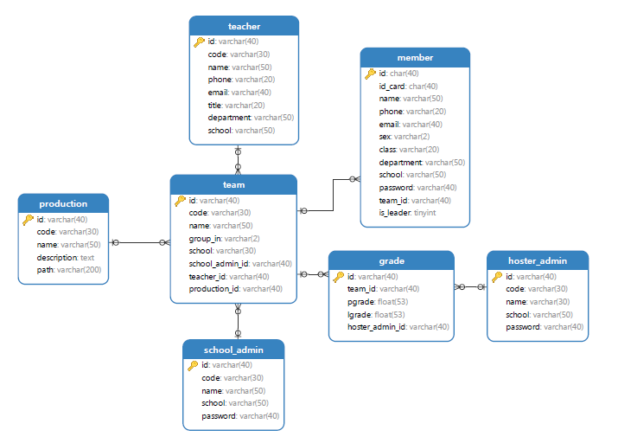
2．数据录入
insert into school_admin(id, code, name, school, password) values ('C12341','C12341','牛行','上海建桥学院','aaaaaa');
insert into school_admin(id, code, name, school, password) values ('C12342','C12342','文宇通','上海复旦大学','aaaaaa');
insert into school_admin(id, code, name, school, password) values ('C12343','C12343','包得知','上海大学','aaaaaa');
insert into school_admin(id, code, name, school, password) values ('C12347','C12347','孙吉祥','上海政法大学','aaaaaa');

insert into hoster_admin(id, code, name, school, password) values ('C12344','C12344','林镇','上海复旦大学','aaaaaa');
insert into hoster_admin(id, code, name, school, password) values ('C12345','C12345','严厉','上海复旦大学','aaaaaa');
insert into hoster_admin(id, code, name, school, password) values ('C12346','C12346','林镇','上海复旦大学','aaaaaa');

insert into teacher(id, code, name, phone, email, title, department, school) values ('12834675','S18723', '张韶涵','12834675','12834675@gench.cn','教授', '信息技术学院','上海建桥学院');
insert into teacher(id, code, name, phone, email, title, department, school) values ('12354456','S12445', '林博学','12354456','12354456@gench.cn','讲师', '信息技术学院','上海复旦大学');
insert into teacher(id, code, name, phone, email, title, department, school) values ('18977667','S214112','袁世泽','18977667','18977667@gench.cn','教授', '信息技术学院','上海大学' );
insert into teacher(id, code, name, phone, email, title, department, school) values ('15657577','S124324','毛当' ,'15657577','15657577@gench.cn','副教授','信息技术学院','上海政法大学');

insert into production(id, code, name, description, path) values('production1','production1','富强',null,'1.png');
insert into production(id, code, name, description, path) values('production2','production2','民主',null,'2.mp3');
insert into production(id, code, name, description, path) values('production3','production3','文明',null,'3.mp4');
insert into production(id, code, name, description, path) values('production4','production4','和谐',null,'4.jpg');
insert into production(id, code, name, description, path) values('production5','production5','自由',null,'5.html');
insert into production(id, code, name, description, path) values('production6','production6','平等',null,'6.jar');

insert into team(id, code, name, group_in, school, school_admin_id, teacher_id, production_id) values('team1','team1','富强队','A','上海建桥学院','C12341','12834675','production1');
insert into team(id, code, name, group_in, school, school_admin_id, teacher_id, production_id) values('team2','team2','民主队','A','上海复旦大学','C12342','12354456','production2');
insert into team(id, code, name, group_in, school, school_admin_id, teacher_id, production_id) values('team3','team3','文明队','A','上海大学', 'C12343','18977667','production3');
insert into team(id, code, name, group_in, school, school_admin_id, teacher_id, production_id) values('team4','team4','和谐队','A','上海政法大学','C12347','15657577','production4');
insert into team(id, code, name, group_in, school, school_admin_id, teacher_id, production_id) values('team5','team5','自由队','A','上海大学', 'C12343','12834675','production5');
insert into team(id, code, name, group_in, school, school_admin_id, teacher_id, production_id) values('team6','team6','平等队','A','上海大学', 'C12343','12354456','production6');

insert into grade(id, team_id, pgrade, lgrade, hoster_admin_id) values('1','team1','88','90','C12344');
insert into grade(id, team_id, pgrade, lgrade, hoster_admin_id) values('2','team2','70','0','C12345');
insert into grade(id, team_id, pgrade, lgrade, hoster_admin_id) values('3','team3','88','94','C12344');
insert into grade(id, team_id, pgrade, lgrade, hoster_admin_id) values('4','team4','85','91','C12346');
insert into grade(id, team_id, pgrade, lgrade, hoster_admin_id) values('5','team5','90','88','C12345');
insert into grade(id, team_id, pgrade, lgrade, hoster_admin_id) values('6','team6','86','85','C12346');

insert into member(id, id_card, name, phone, email, sex, class, department, school, password, team_id, is_leader) values ('2102873','2102873','李强', '13320031','13320031@sina.com','男','大一','信息技术学院','上海建桥学院','aaaaaa','team1', 1);
insert into member(id, id_card, name, phone, email, sex, class, department, school, password, team_id, is_leader) values ('2039843','2039843','王大强','12003334','12003334@qq.com', '男','大二','信息技术学院','上海复旦大学','aaaaaa','team2', 1);
insert into member(id, id_card, name, phone, email, sex, class, department, school, password, team_id, is_leader) values ('3002938','3002938','林小强','1223334', '1223334@sina.com', '女','大一','职业技术学院','上海大学' ,'aaaaaa','team3', 1);
insert into member(id, id_card, name, phone, email, sex, class, department, school, password, team_id, is_leader) values ('1202932','1202932','薛碧柔','1588897', '1588897@qq.com', '女','大二','信息技术学院','上海政法大学','aaaaaa','team4', 1);
insert into member(id, id_card, name, phone, email, sex, class, department, school, password, team_id, is_leader) values ('2346565','2346565','贾大亮','1234543', '1234543@126.com', '男','大二','职业技术学院','上海大学' ,'aaaaaa','team5', 1);
insert into member(id, id_card, name, phone, email, sex, class, department, school, password, team_id, is_leader) values ('1323456','1323456','唐唐', '1988005', '1988005@126.com', '女','大一','职业技术学院','上海大学' ,'aaaaaa','team6', 1);

insert into member(id, id_card, name, phone, email, sex, class, department, school, password, team_id, is_leader) values ('4415232','4415232','王少伟', '1986341', '1986341@sina.com', '男','大二','信息技术学院','上海建桥学院','aaaaaa','team1', 0);
insert into member(id, id_card, name, phone, email, sex, class, department, school, password, team_id, is_leader) values ('2319873','2319873','欧阳云海','12276654','12276654@qq.com', '男','大二','信息技术学院','上海复旦大学','aaaaaa','team2', 0);
insert into member(id, id_card, name, phone, email, sex, class, department, school, password, team_id, is_leader) values ('3238723','3238723','王大明', '1988644', '1988644@qq.com', '男','大二','职业技术学院','上海大学' ,'aaaaaa','team3', 0);
insert into member(id, id_card, name, phone, email, sex, class, department, school, password, team_id, is_leader) values ('2233412','2233412','彭莎', '18898734','18898734@qq.com', '女','大一','信息技术学院','上海政法大学','aaaaaa','team4', 0);
insert into member(id, id_card, name, phone, email, sex, class, department, school, password, team_id, is_leader) values ('4323423','4323423','关东', '19983474','19983474@sina.com','女','大二','职业技术学院','上海大学' ,'aaaaaa','team5', 0);
insert into member(id, id_card, name, phone, email, sex, class, department, school, password, team_id, is_leader) values ('2343543','2343543','唐唐', '1223665', '1223665@126.com', '女','大一','职业技术学院','上海大学' ,'aaaaaa','team6', 0);

insert into member(id, id_card, name, phone, email, sex, class, department, school, password, team_id, is_leader) values ('3413434','3413434','林大大','1344531', '1344531@126.com', '男','大一','信息技术学院','上海建桥学院','aaaaaa','team1', 0);
insert into member(id, id_card, name, phone, email, sex, class, department, school, password, team_id, is_leader) values ('2335423','2335423','张梅里','1982742', '1982742@qq.com', '男','大一','职业技术学院','上海复旦大学','aaaaaa','team2', 0);
insert into member(id, id_card, name, phone, email, sex, class, department, school, password, team_id, is_leader) values ('3543151','3543151','燕南栋','12887613','12887613@qq.com', '男','大一','职业技术学院','上海大学' ,'aaaaaa','team3', 0);
insert into member(id, id_card, name, phone, email, sex, class, department, school, password, team_id, is_leader) values ('2432562','2432562','郭美琪','11344543','11344543@qq.com', '女','大一','信息技术学院','上海政法大学','aaaaaa','team4', 0);
insert into member(id, id_card, name, phone, email, sex, class, department, school, password, team_id, is_leader) values ('2351665','2351665','郑少华','19773242','19773242@126.com','男','大二','职业技术学院','上海大学' ,'aaaaaa','team5', 0);
insert into member(id, id_card, name, phone, email, sex, class, department, school, password, team_id, is_leader) values ('3464456','3464456','张少少','1234996', '1234996@126.com', '女','大一','职业技术学院','上海大学' ,'aaaaaa','team6', 0);

3．数据处理
（1）至少包括2张表的等值连接；
select member.*, t.* from member inner join team t on member.team_id=t.id;
select team.*, t.* from team left join teacher t on team.teacher_id = t.id;
（2）创建视图；
create view my_school_teams as (select * from team where school = '上海复旦大学');
（3）编写包含子查询的SQL语句；
select team.id,team.name from team where team.id in (select grade.team_id from grade group by team_id having avg(pgrade)>80.0)
（4）有修改语句；
update member set id_card=?, name=?, phone=?, email=?, sex=?, class=?, department=?, school=?, password=?, team_id=?, is_leader=? where id=?
- 有删除语句；
delete from member where id=?
delete from production where id=?

（6）有包含聚集函数；
select team.id,team.name from team where team.id in (select grade.team_id from grade group by team_id having avg(pgrade)>80.0)

（7）有记录过滤，条件过滤语句；
select id, id_card, name, phone, email, sex, class, department, school, password, team_id, is_leader from member where id_card = ? and password = ?
（8）有修改表结构的SQL语句；
Alter table member alter column sex char(2) check(sex ='男' or sex = '女')
（9）用T-SQL语句写出一个对数据表处理的人机交互程序；

（10）编写一个触发器；
create trigger tr_add_member on member after insert as
begin
DECLARE @cls varchar
SELECT @cls=class FROM inserted
if @cls not in ('大一','大二','大三','大四','大五')
begin
update member set class = '大一' where id in (select id from inserted)
end
end

六、数据库应用系统实现
1．系统相关界面截图（必须有注册界面，信息的管理界面（增删改查））
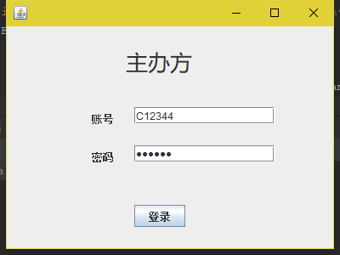
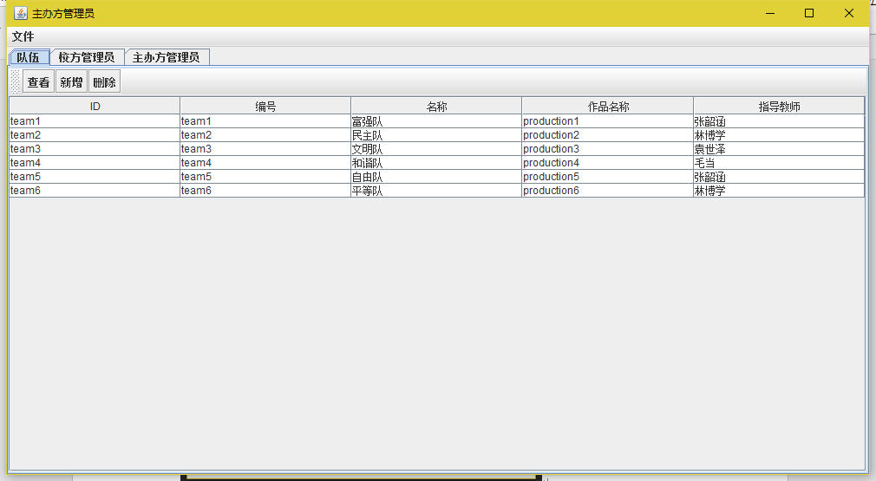
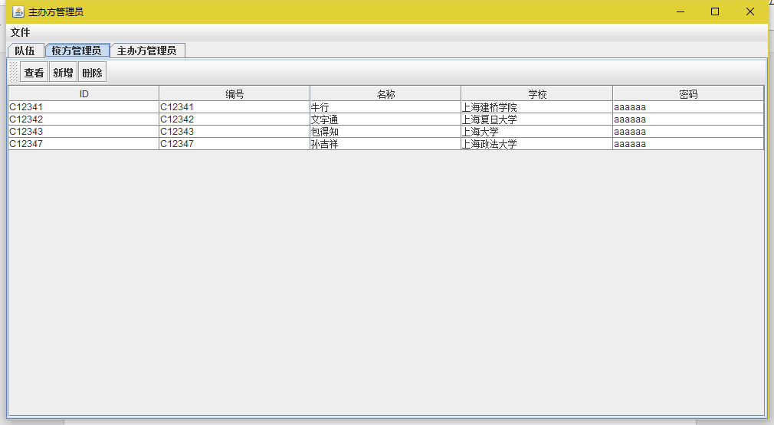
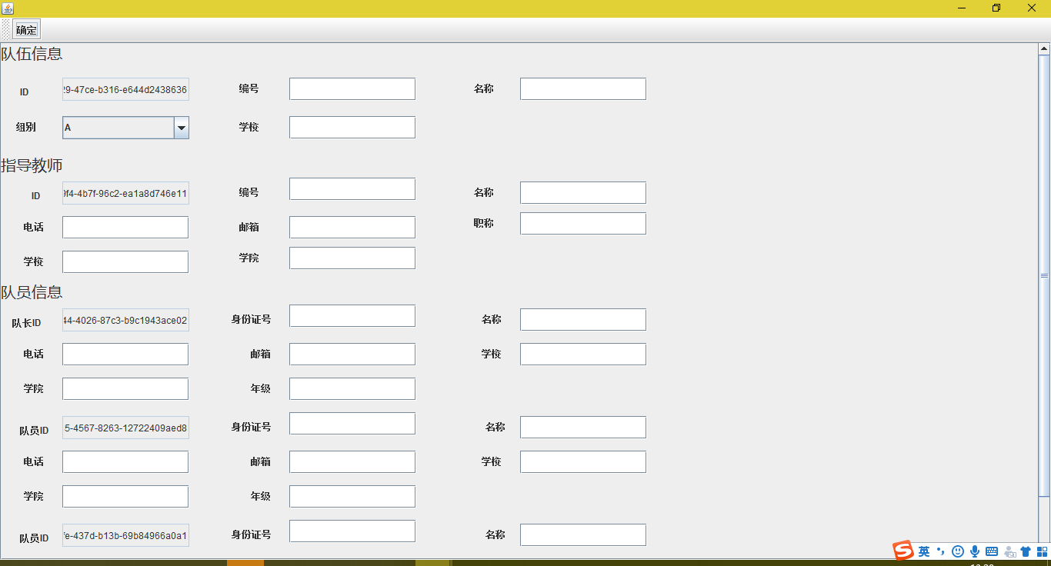
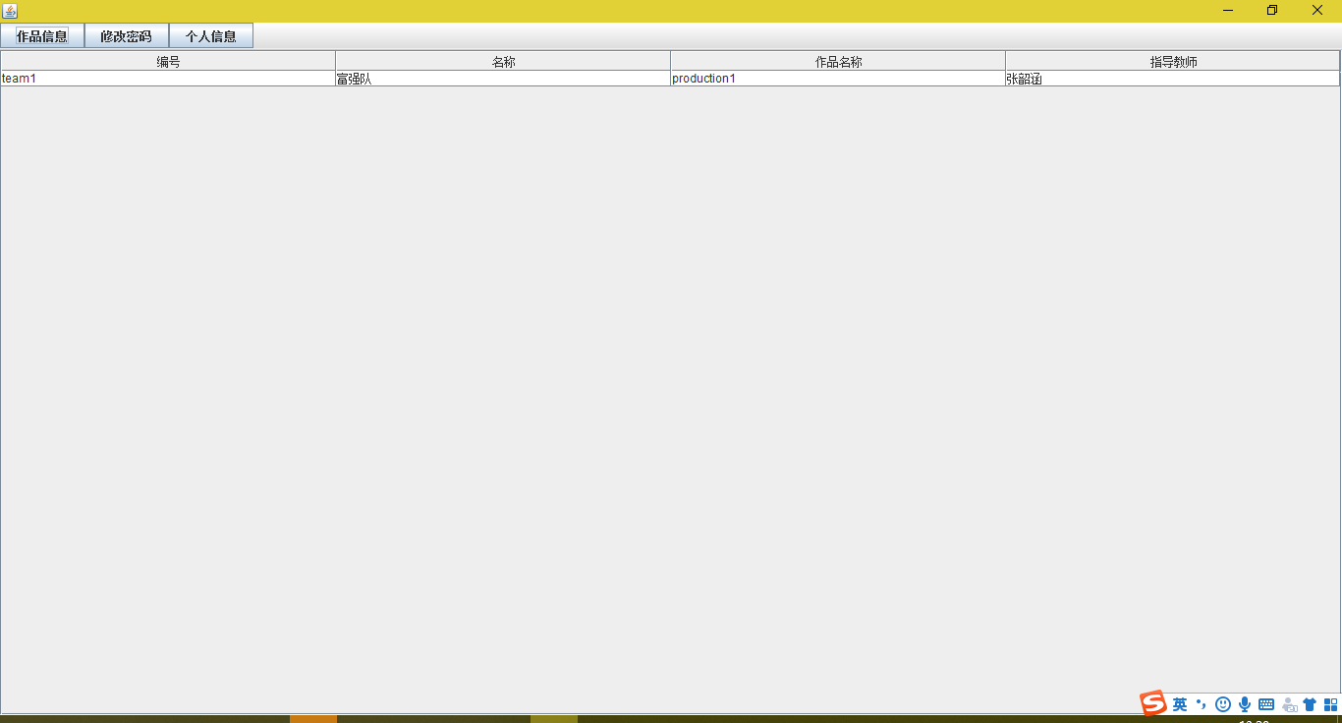
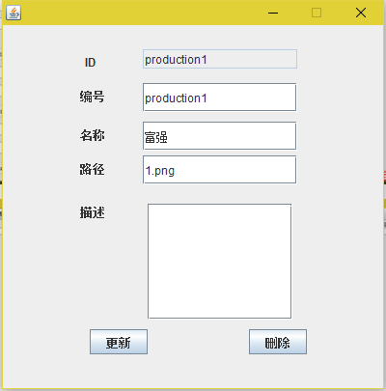
2．和数据库连接的程序语句
public static Connection getConnection() {
if (connection == null) {
try {
ResourceBundle resource = ResourceBundle.getBundle("competition/management/system/config/jdbc");
driver = resource.getString("driver");
url = resource.getString("url");
username = resource.getString("username");
password = resource.getString("password");
Class.forName(driver);
connection = DriverManager.getConnection(url, username, password);
} catch (Exception e) {
e.printStackTrace();
System.exit(1);
}
}
return connection;
}

3．具体实现代码（注意排版）
3.1 JDBCUtil.java
package competition.management.system.util;

import competition.management.system.dao.*;

import java.sql.Connection;
import java.sql.DriverManager;
import java.util.ResourceBundle;

public class JDBCUtil {
private static Connection connection = null;
private static String url;
private static String driver;
private static String username;
private static String password;

private static SchoolAdminDao schoolAdminDao = null;
private static MemberDao memberDao = null;
private static TeamDao teamDao = null;
private static ProductionDao productionDao = null;
private static TeacherDao teacherDao = null;
private static GradeDao gradeDao = null;
private static HosterAdminDao hosterAdminDao = null;

private JDBCUtil() {

}

public static Connection getConnection() {
if (connection == null) {
try {
ResourceBundle resource = ResourceBundle.getBundle("competition/management/system/config/jdbc");
driver = resource.getString("driver");
url = resource.getString("url");
username = resource.getString("username");
password = resource.getString("password");
Class.forName(driver);
connection = DriverManager.getConnection(url, username, password);
} catch (Exception e) {
e.printStackTrace();
System.exit(1);
}
}
return connection;
}

public static SchoolAdminDao getSchoolAdminDao() {
if (schoolAdminDao == null) {
schoolAdminDao = new SchoolAdminDao();
}
return schoolAdminDao;
}

public static MemberDao getMemberDao() {
if (memberDao == null) {
memberDao = new MemberDao();
}
return memberDao;
}

public static TeamDao getTeamDao() {
if (teamDao == null) {
teamDao = new TeamDao();
}
return teamDao;
}

public static TeacherDao getTeacherDao() {
if (teacherDao == null) {
teacherDao = new TeacherDao();
}
return teacherDao;
}

public static ProductionDao getProductionDao() {
if (productionDao == null) {
productionDao = new ProductionDao();
}
return productionDao;
}

public static GradeDao getGradeDao() {
if (gradeDao == null) {
gradeDao = new GradeDao();
}
return gradeDao;
}

public static HosterAdminDao getHosterAdminDao() {
if (hosterAdminDao == null) {
hosterAdminDao = new HosterAdminDao();
}
return hosterAdminDao;
}
}

3.2 MemberDao.java
package competition.management.system.dao;

import competition.management.system.entity.Member;
import competition.management.system.entity.Team;

import java.sql.PreparedStatement;
import java.sql.ResultSet;
import java.sql.SQLException;
import java.util.ArrayList;
import java.util.List;

public class MemberDao extends AbstractDao<Member> {
@Override
public Member findById(String id) throws SQLException {
Member member = null;
String sql = "select id, id_card, name, phone, email, sex, class, department, school, password, team_id, is_leader from member where id = ?";
PreparedStatement ps = connection.prepareStatement(sql);
ps.setString(1, id);
ResultSet rs = ps.executeQuery();
while (rs.next()) {
member = new Member();
member.setId(rs.getString(1));
member.setIdCard(rs.getString(2));
member.setName(rs.getString(3));
member.setPhone(rs.getString(4));
member.setEmail(rs.getString(5));
member.setSex(rs.getString(6));
member.setCls(rs.getString(7));
member.setDepartment(rs.getString(8));
member.setSchool(rs.getString(9));
member.setPassword(rs.getString(10));
Team team = new Team();
team.setId(rs.getString(11));
member.setTeam(team);
member.setLeader(rs.getBoolean(12));
}
return member;
}

@Override
public List<Member> findAll() throws SQLException {
ArrayList<Member> members = new ArrayList<>();
Member member = null;
String sql = "select id, id_card, name, phone, email, sex, class, department, school, password, team_id, is_leader from member";
PreparedStatement ps = connection.prepareStatement(sql);
ResultSet rs = ps.executeQuery();
while (rs.next()) {
member = new Member();
member.setId(rs.getString(1));
member.setIdCard(rs.getString(2));
member.setName(rs.getString(3));
member.setPhone(rs.getString(4));
member.setEmail(rs.getString(5));
member.setSex(rs.getString(6));
member.setCls(rs.getString(7));
member.setDepartment(rs.getString(8));
member.setSchool(rs.getString(9));
member.setPassword(rs.getString(10));
Team team = new Team();
team.setId(rs.getString(11));
member.setTeam(team);
member.setLeader(rs.getBoolean(12));

members.add(member);
}
return members;
}

@Override
public boolean remove(String id) throws SQLException {
String sql = "delete from member where id=?";
PreparedStatement ps = connection.prepareStatement(sql);
ps.setString(1, id);
return ps.executeUpdate() == 1;
}

@Override
public boolean insert(Member entity) throws SQLException {
String sql = "insert into member(id, id_card, name, phone, email, sex, class, department, school, password, team_id, is_leader) values(?,?,?,?,?,?,?,?,?,?,?,?)";
PreparedStatement ps = connection.prepareStatement(sql);
ps.setString(1, entity.getId());
ps.setString(2, entity.getIdCard());
ps.setString(3, entity.getName());
ps.setString(4, entity.getPhone());
ps.setString(5, entity.getEmail());
ps.setString(6, entity.getSex());
ps.setString(7, entity.getCls());
ps.setString(8, entity.getDepartment());
ps.setString(9, entity.getSchool());
ps.setString(10, entity.getPassword());
ps.setString(11, entity.getTeam().getId());
ps.setBoolean(12, entity.getLeader());
return ps.executeUpdate() == 1;
}

@Override
public boolean update(Member entity) throws SQLException {
String sql = "update member set id_card=?, name=?, phone=?, email=?, sex=?, class=?, department=?, school=?, password=?, team_id=?, is_leader=? where id=?";
PreparedStatement ps = connection.prepareStatement(sql);
ps.setString(1, entity.getIdCard());
ps.setString(2, entity.getName());
ps.setString(3, entity.getPhone());
ps.setString(4, entity.getEmail());
ps.setString(5, entity.getSex());
ps.setString(6, entity.getCls());
ps.setString(7, entity.getDepartment());
ps.setString(8, entity.getSchool());
ps.setString(9, entity.getPassword());
ps.setString(10, entity.getTeam().getId());
ps.setBoolean(11, entity.getLeader());
ps.setString(12, entity.getId());
return ps.executeUpdate() == 1;
}

public Member findByUsernameAndPassword(String username, String password) throws SQLException {
Member member = null;
String sql = "select id, id_card, name, phone, email, sex, class, department, school, password, team_id, is_leader from member where id_card = ? and password = ?";
PreparedStatement ps = connection.prepareStatement(sql);
ps.setString(1, username);
ps.setString(2, password);
ResultSet rs = ps.executeQuery();
while (rs.next()) {
member = new Member();
member.setId(rs.getString(1));
member.setIdCard(rs.getString(2));
member.setName(rs.getString(3));
member.setPhone(rs.getString(4));
member.setEmail(rs.getString(5));
member.setSex(rs.getString(6));
member.setCls(rs.getString(7));
member.setDepartment(rs.getString(8));
member.setSchool(rs.getString(9));
member.setPassword(rs.getString(10));
Team team = new Team();
team.setId(rs.getString(11));
member.setTeam(team);
member.setLeader(rs.getBoolean(12));
}
return member;
}

public boolean changePassword(String id, String newPassword) throws SQLException {
String sql = "update member set password=? where id=?";
PreparedStatement ps = connection.prepareStatement(sql);
ps.setString(1, newPassword);
ps.setString(2, id);
return ps.executeUpdate() == 1;
}

public List<Member> findByTeamId(String teamId) throws SQLException{
ArrayList<Member> members = new ArrayList<>();
Member member = null;
String sql = "select id, id_card, name, phone, email, sex, class, department, school, password, team_id, is_leader from member where team_id = ?";
PreparedStatement ps = connection.prepareStatement(sql);
ps.setString(1, teamId);
ResultSet rs = ps.executeQuery();
while (rs.next()) {
member = new Member();
member.setId(rs.getString(1));
member.setIdCard(rs.getString(2));
member.setName(rs.getString(3));
member.setPhone(rs.getString(4));
member.setEmail(rs.getString(5));
member.setSex(rs.getString(6));
member.setCls(rs.getString(7));
member.setDepartment(rs.getString(8));
member.setSchool(rs.getString(9));
member.setPassword(rs.getString(10));
Team team = new Team();
team.setId(rs.getString(11));
member.setTeam(team);
member.setLeader(rs.getBoolean(12));

members.add(member);
}
return members;
}
}

七、总结
（200字左右的小结，包括完成情况和不足之处、心得体会、建议）

参考文献：
(至少列出三本以上的参考文献)

格式要求：
文档版式：A4
正文：宋体，5号字；首行缩进；行距：固定值20磅。

