**KERMODE, THESIS**

TODO

* Look up the rendering of CREASED EDGES in Pixar Renderman. Which renderer should I use?
  + Mental Ray renderer (suggested in FYF) is no longer available as a default in Maya.
* Middle is not actually modular. What is the best way to stage this center to ‘reveal’ the Internet. Discuss with Arvind.
* Look at *The Setup Machine* on anzovin.com (a setup rigger, not only for humanoid skeletons, costs money).

ASSET METHOD

* Sketch design from top, orthogonal sides (paper, pencil). Rule lines between views to ensure proportionality.

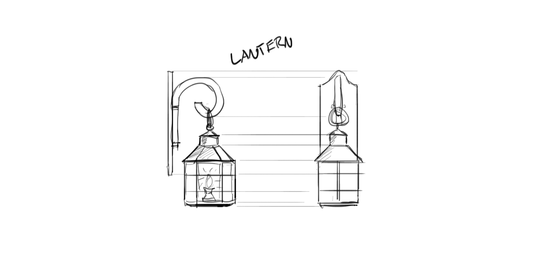

* Import image planes into Maya, and model 3D character.
* Texture asset with Allegorithmic Substance Painter.

ASSETS

**Characters**

* Cube (main character)
  + Expressive eyes
  + Squash and stretch, rigged with flexibility
* Packet Shape (a template for many instances)
  + Workflow to create a packet from the basis of a general shape.
  + Could this just be a UV layer overlaid on a 3D topology? Rippled, stylized sides.
* WiFi Lieutenant
  + Reasonably expressive, eyes.
  + Rigged ‘ribs’ to move and direct.
* Facebook Colonel
  + Flexible rig with ‘arms’ (sides of ‘F’) and expressive eyes.
  + Industrial-like character, so could take shortcuts on eyes.

**Environments**

* Laptop (interior)
  + Looking out on an inverted Facebook page, including shadow of user.
  + Start from template of British animator’s tutorial for space room.
* Router (interior)
  + Needs to be composed of many pieces, possibly multiple scenes.
  + The most technically detailed, to ‘explain.’

**Scenery**

* Transduction Pipe
  + Used in Router (interior), represents a conversion to new data format.
  + Repeated, labeled with different types of transduction.
* WiFi Router (exterior)
  + Seen in a single shot, approaching. Download if possible.
* Laptop (exterior)
  + Seen in a single shot, packet leaving reverse. Download if possible.
* Facebook Gate
  + The packet’s destination; should seem ominous, slightly threatening.

TIMELINE

|  |  |  |
| --- | --- | --- |
| 1 |  | 8th Oct |
| 2 |  | 15th Oct |
| 3 | Lynda tutorials mapped, basic understanding of Maya. | 22nd Oct |
| 4 | Kenny Roy *Finish Your Film* read, funding proposal written. | 29th Oct |
| 5 |  | 5th Nov |
| 6 | Storyboard complete. | 12th Nov |
| 7 |  | 19th Nov |
| 8 | Animatic complete. Transduction Pipe prepared. | 26th Nov |
| 9 | WiFi Router (exterior), Laptop (exterior) prepared. | 3rd Dec |
| 10 | Laptop (interior) and Facebook Colonel prepared. | 10th Dec |

December 10th, Submit Slides

December 10th-15th, Oral Progress Presentation

|  |  |  |
| --- | --- | --- |
| 11 |  | 17th Dec |
| 12 |  | 24th Dec |
| 13 |  | 31st Dec |
| 14 |  | 7th Jan |
| 15 |  | 14th Jan |
| 16 |  | 21st Jan |
| 17 |  | 28th Jan |
| 18 |  | 4th Feb |
| 19 |  | 11th Feb |
| 20 |  | 18th Feb |
| 21 |  | 25th Feb |

March 2nd, Draft Paper

|  |  |  |
| --- | --- | --- |
| 22 |  | 4th Mar |
| 23 |  | 11th Mar |
| 24 |  | 18st Mar |
| 25 |  | 25th Mar |
| 26 |  | 1st Apr |
| 27 |  | 8th Apr |
| 28 |  | 15th Apr |
| 29 |  | 22nd Apr |

April 23rd, Oral Presentation

|  |  |  |
| --- | --- | --- |
| 30 |  | 29th Apr |
| 31 |  | 6th May |

May 7th, Written Final Report

BIBLIOGRAPHY

* *Finish Your Film: Tips and Tricks for Making an Animated Short in Maya*, Kenny Roy. Focal Press, NY and London. 2014.
* *How to Cheat in Maya: Tools and Techniques for Character Animation*, Kenny Roy. Focal Press, NY and London. 2013.
* *Maya 2018 Essential Training*, George Maestri (Lynda)
* *Modeling a Cartoon Character in Maya*, George Maestri (Lynda)
* *Rigging a Cartoon Character in Maya*, George Maestri (Lynda)
* *Animating Cartoon Characters in Maya*, George Maestri (Lynda)
* *Maya: Tips, Tricks and Techniques*, George Maestri (Lynda)
* *Cinematography: Maya*, Aaron F. Ross (Lynda)
* *Maya: Advanced Materials*, Andy Beane (Lynda)
* *Creating Textures and Shaders in Maya*, Eric Keller (Lynda)
* *Photoshop CC 2018 Essential Training*, Julianne Kost (Lynda)
* *InDesign CC 2018 Essential Training*, David Blatner (Lynda)

NOTES (MISC)

The underlying concept of this short is the emphasis of the ‘live’ quality of the data world. The imperative is to give protocols and architectures life so that they intrigue as they ought to for all computer users.

We already understand the Internet’s physical infrastructure (e.g. laptop, router) as ‘real.’ Thus more attention will be paid to the quality of the data itself, *to describe the way that it exists and travels*.

I intend to write a critical response to accompany the short, framing the investigation as an ‘anthropology of the Internet.’ Work with Jeff Himpele to refine this take.