BLM Upgrade Controller Card Program Design

Randy Thurman-Keup
AD / Instrumentation Deptartment

BEAMS-DOC-2433-V4
CVS Code Version v10

Abstract
This document details the structure and behavior of the program that runs in the eZ80 on the Controller Card. The main functionality of this program is to start and stop data acquisition and to maintain data buffers that are accessible from VME at any time without disrupting the aborting capability. These data buffers consist of three circular buffers containing summed data at short, medium, and long integration times, two linear buffers housing profile and flash frames, and a single entry buffer for the most recent display frame.

Introduction
The Controller Card (CC) is an embedded processor (eZ80) board residing in the VME crate of the Beam Loss Monitor (BLM) system [1]. The program’s job is to transfer information between the crate processor and the digitizer cards (DC), timing card (TC), and abort card (AC), in a deadtimeless fashion, i.e. no interruption in the aborting capability of the system. The program operates with a combination of polling and interrupts.
The Controller Card Program (CCP) responds to 5 types of events.
- TCLK
The TC puts relevant TCLK events into its FIFO. The CCP polls the TCLK FIFO status register to determine if there is data in the FIFO. If there is data, it reads it from the FIFO and handles it.
- MDAT
When the TC receives the relevant MDAT frame, it writes the state information to the MDAT FIFO. The CCP polls the MDAT FIFO status register to determine if there is data in the FIFO. If there is data, it reads if from the FIFO and handles it.
- DATA_LATCH (Interrupt)
This is an interrupt generated by the Timing Card when it is time to latch some flavor of Digitizer Card data (fast, slow, or very slow sums). The CCP must then read the status bytes in the Timing Card to determine which data to latch.
- Abort_Service
The abort card generates an interrupt when one of three user selectable states occurs.
  - A digitizer card indicates that a channel is not OK
  - A digitizer channel is over one of the thresholds but the multiplicity requirement is not met for an abort
  - An abort has occurred
The CCP does not respond to the interrupt. Instead it periodically polls the AC to determine the above information.
- Crate Processor
When settings need to be updated, the CP writes the settings to the CC and sets an appropriate register in the CC which then responds by loading the settings into the appropriate cards at the appropriate time.
The CCP might need to do intelligent checking of the state of cards and possibly issue a Reset.

Initialization
At boot time, the CP and CC must handshake to properly bring up the system. This handshaking between CC and CP is documented in Figure 1 below. The initialization procedure includes stopping the CC at the beginning of the procedure. Stopping the CC at boot time is necessary for a number of reasons: first, at crate power up time, the other cards will not have gone through their FPGA programming sequence if the CC immediately starts to access them; second, the waiting gives the CP time to download settings to the CC; and third, if the CC reboots by, e.g. hitting an invalid instruction, it would probably be good to notify the outside world, and save a snapshot of the CC’s debug memory contents for later analysis. The settings that need to be downloaded to the CC are listed in Table 1.
- Timing Card
The timing card must be downloaded with the appropriate TCLK events (see Table 3). In addition to the events listed in Table 3, there are several other TCLK and BSCLK events that the CCP does not respond to but which are responded to by the other cards in the system.
  - TCLK $8F – 1 Hz event for updating the TC clock
  - TCLK $5B – TeV Pbar Injection TBT trigger
  - TCLK $5C – TeV Proton Injection TBT trigger
  - BSCLK $AA – Revolution marker used to generate Make_Meas clock
  - BSCLK $DA – MI TBT trigger
- Digitizer Card
The digitizer card must be setup for the correct memory map. The correct map is enabled by setting bit 7 of address 0xFF to 1. All other settings are part of the CP download.
- Abort Card
The abort card settings are all downloaded as part of the CP download.
After successfully initializing, the CCP continuously polls for events, periodically interrupted by the Data Latch interrupt.

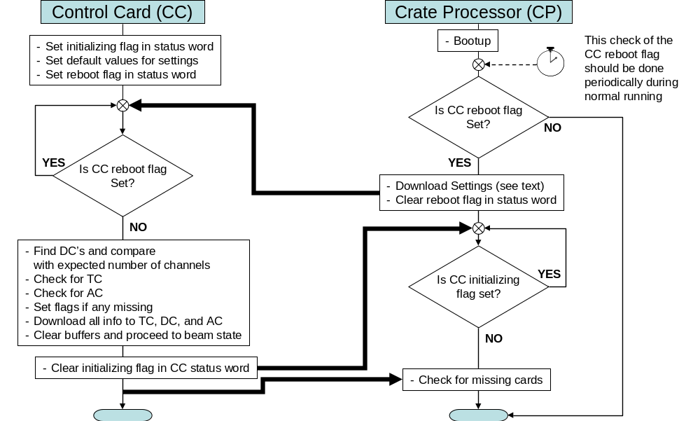
Figure
1: Flowchart of handshaking that occurs at boot time. The alarm clock symbol indicates that the CP should periodically check the reboot bit in the CC and if it finds it set, it should probably notify the outside world somehow. See Section 3 for a description of the flags in the status word.
Table
1: Settings that need to be set on the CC by the CP. The default value is the value that is used by the CCP if not overwritten by the CP and is a compile time setting in the CCP.
Setting | Description | Default Value | Address(Size)
System Time | Unix time in seconds since ??? | 0 | 0x09800014(4)
TC Operation mode | Value to be written to TC control bus CSR. Controls whether TC uses AA marker or internal oscillator. | 4 for TeV  0 for MI | 0x0980010E(2)
Make Measure Div | Amount to divide down the clock by (int. osc.) | 1 for TeV  2 for MI | 0x09800102(2)
Fast Sum Length | # of measurements to accumulate in DC fast sum. | ~64 | 0x09800104(2)
Slow Sum Length | # of measurements to accumulate in DC slow sum. | ~1500 | 0x09800106(2)
Very Slow Sum Length | # of measurements to accumulate in DC very slow sum. (In MI this is the integral and is the same as Fast Sum Length) | ~50000 in TeV  ~64 in MI | 0x09800108(2)
DC Mode Selects | Digitizer channel mode select word (one word / channel). Controls integration mode and whether squelch is enabled among other things. | 0x0002 for TeV  0x000A for MI  (no squelch) | 0x09800200(2)
DC Manual Set Value | The manual setting value if manual setting mode is chosen | 0x0000 | 0x09800202(2)
# of Channels | Expected number of channels | Whatever is present | 0x09800100(2)
Abort Info | Thresholds, Masks, and Multiplicities for all States | Everything 0xFF | 0x09900000
Machine | Which machine is this (1=TeV, 2=MI, 3=Booster) | 2 | 0x0980001C(2)
Initial state | Initial machine state | 0 | 0x0980001E(2)
DC FPGA Control Register | Funny name for something which contains the number of make_meas to skip before doing pedestals divided by 16 ( N_{skip} / 16 ) | 0x1000 | 0x0980010A(2)
IRQ3 Enable Bits | 3 bits that determine what generates an IRQ3 interrupt on the AC | 0x0007 | 0x09800112(2)
Squelch Value | This must be in the appropriate units which is 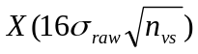where X is the # of sigma to place the squelch | 0x0000 for now since we are not squelching | 0x09800400(120)
Pedestal Length | Must be 16 * Very Slow Sum Length in MI (doesn’t matter in TeV) | 1024 | 0x09800116(2)
Abort Enable | Enables the functioning of the AC | 1 | 0x09800114(2)
Flash, Display, Profile source | This determines the source of the first half of the frame is (0=fast or 1=slow). Bit 0 is for Flash, bit 1 is for Profile, and bit 2 is for Display. | 0x0006  (uses fast for flash, slow for others) | 0x09800006(2)
End of beam delay | Delay (in Fast latch periods) after end-of-beam event before asserting AIP | 18 | 0x09800118(1)
Flash Delay | Delay from flash frame clock event until data is grabbed from buffer | 0 | 0x0980011A(1)
Profile Delay | Delay from profile frame clock event until data is grabbed from buffer | 0 | 0x0980011C(1)
Display Delay | Delay from display frame clock event until data is grabbed from buffer | 0 | 0x0980011E(1)
Input Switch state for peds | Whether or not to open the input switch while taking pedestals | 1 | 0x09800120(2)

Program Components

CC VME Status Register
The status register consists of 16 bits in VME memory. Table 2 shows the bit definitions of the status word.

Table

Bit | Description
15 | Reserved
14 | Reserved
13 | Reserved
12 | Mismatched raw data pointers in TC, DC, or AC
11 | Pedestals Valid; Don’t read pedestals until this is set
10 | Very Slow Buffer has wrapped
9 | Slow Buffer has wrapped
8 | Fast Buffer has wrapped
7 | Wrong number of Digitizer Card channels found
6 | Abort Card not found
5 | Timing Card not found
4 | Crate has triggered an Abort
3 | Some channels are indicating abort
2 | Some channels are not OK
1 | CCP is in the process of initializing
0 | The CC has rebooted; clearing this kicks off the CC

VME Accessible Circular Data Buffers
The data from all the digitizers is stored in VME memory in the form of circular buffers. There are index counters which indicate which frame is the current frame, and flags in the status register to indicate when each buffer has wrapped around. Each data frame header contains a flag byte which indicates a number of things. At end of beam, the last frame contains a 1 in the flag byte. This is nominally to allow the CP to ignore this frame at the beginning of the next beam cycle. The first frame of a cycle has a 2 in the flag byte to allow the CP to correct for a bug in the system whereby the DC waits to start summing, but the TC sends out latches immediately. The result is that the slower sums are incomplete when the first latch is received. The CP can divide by the actual sum length if it knows a frame is the first one of the cycle. The next frames contain a 3 in the flag byte until the input switch is closed. All other frames contain 0 in the flag byte.

State Machine
Figure 2 illustrates the CCP state machine.
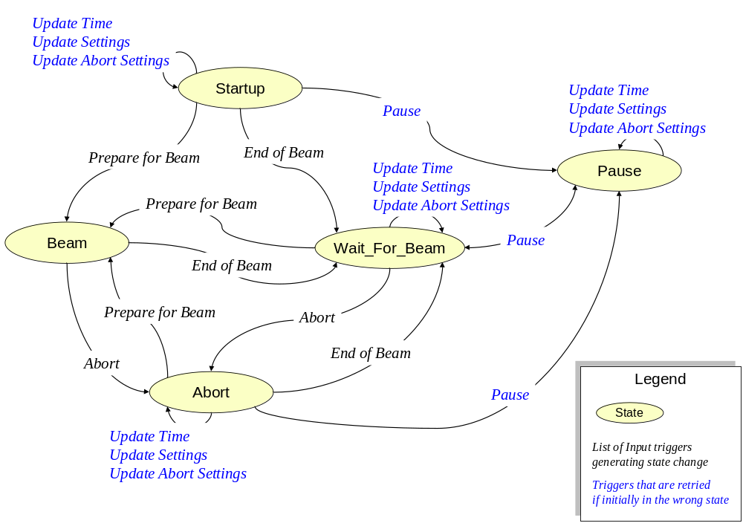
Figure
2: State Machine diagram showing states and state change triggers. The triggers in blue are persistent triggers in that they hang around if they occur during an invalid state. When a valid state is reached, they are replayed.

Figure 3 illustrates a typical beam cycle.
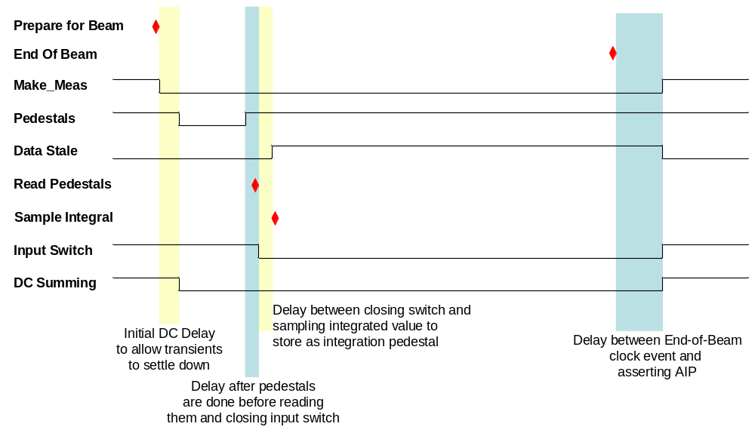
Figure
3: Beam cycle showing the relative timing of various events. The shaded areas are delays between various key events. The integrated value must be sampled after closing the input switch, since there is a glitch upon closing the switch causing the integral to go negative by some amount. The lines are true low.

Abort Information
Abort information is specified as a function of abort state. The CCP receives MDAT frames containing a state which is then mapped to abort state. This mapping is created by the console application user and sent to the CP which then copies the map to the CC as part of update abort settings.

F Sector Handling of Tevatron Aborts
The abort handling in the Tevatron is more complicated than in the Main Injector. Since there is routinely beam traversing the p2 and p3 beam lines in F sector located directly above the Tevatron beamline, there may be false aborts caused by losses from those lines hitting the Tevatron BLMs. To reject these false aborts, the CCP uses a table of MI states and corresponding begin and end TCLK events during which to change the behavior of the aborts. The default behavior is to mask off the aborts at the AC. The actual implementation on the CCP is in the form of the list of begin / end TCLKs indexed by MI MDAT state, and a table of actions indexed by TEV abort state and MI MDAT state. Both the list of TCLKs and the action table are byte arrays. A TCLK entry of 0x00 means do nothing. The 2-D action table is arranged such that the MI MDAT state index increments the fastest. The actions are defined in the following table
Action # | What it does
0x00 | Globally mask off the aborts at the AC
0xFF | Do nothing
0xNN | Switch to TEV abort state 0xNN

As stated above, the default is set to be 0x00 which masks off the crate aborts. The memory maps for these lists are given in Appendix B.

Debugging Information
There is a section in VME accessible memory that contains possibly useful information for debugging and error trapping. There are counts of various quantities like the number of TCLKs, the number of each type of data latch, etc… This list is in Appendix A and in the BLM Users’ Guide [1]. In addition, there is a CP trigger to dump Control Bus memory to a section of VME memory.

External Triggers

TCLK Event
The code responds to TCLK events in the form of polling the TC. A supported TCLK event causes the TC to put the TCLK number in the FIFO. The CCP polls the FIFO by checking the TCLK FIFO status register and reading the TCLK event. Table 3 documents the supported TCLK events.
Table
3: List of CCP supported TCLK events, state inputs resulting from them, and a description of any action taken.
TCLK | State Input | Action
Tevatron
$77 | None | Create a flash frame. The current fast sum and very slow sum buffer frames are appended to the flash frame buffer which contains a maximum of 256 flash frames and is cleared at Reset_DC.
$75 | None | Create a profile frame. The current fast sum and very slow sum buffer frames are appended to the profile frame buffer which contains a maximum of 256 profile frames
$76  $78 | None | Create a display frame. The current fast sum and very slow sum buffer frames are placed in the display frame. Only one display frame is allowed at a time.
$71 | Prepare for Beam | Prepare for beam by issuing a Reset_DC, resetting the circular buffers, and clearing the abort in progress line.
$4B | End of Beam | End of beam. Tell TC to assert Abort In Progress line.
$47 | Abort | Abort. Tell TC to assert Abort In Progress line.
$70 | None | Reset linear buffers for flash and profile frames
Main Injector
$7C | None | Create a flash frame.
$7A | None | Create a profile frame.
$7B | None | Create a display frame.
$79 | Prepare for Beam | Prepare for beam by issuing a Reset_DC, resetting the circular buffers, and clearing the abort in progress line.
$26 | End of Beam | End of beam.
$27 | Abort | Abort

MDAT Frame
An MDAT frame forces a change of abort thresholds if the machine state has changed. The TC receives MDAT frames and places the state number in the FIFO. The CCP polls the FIFO status and reads the MDAT frame from the FIFO. It then switches to the proper thresholds page in the DC, copies the abort mask information corresponding to the MDAT machine state from VME memory to the AC, and tells the TC to generate an update abort settings signal. MDAT frame $12 contains the Tevatron state, and MDAT frame $56 contains the Main Injector state. The state number received by the CC is in the range 0-255 with 0-127 being the TeV state, and 128-255 being 128 + the Main Injector state.

Data Latch Interrupt
Periodically, at each sum period, a corresponding latch is generated by the TC by setting IRQ2 on the control bus. The CC is interrupted and the CCP reads the latch status registers in the TC to determine which sum data to read from the Digitizer Card. It then reads the data and stores it in the circular buffers in VME accessible memory. Finally it clears the corresponding status register which in turn clears IRQ2. Most of the actual memory copies from DC’s to circular buffers are handled by assembly language instructions that are modularized in C language #defines. The assembly code makes use of specialized instructions to do multi-byte copies from one memory location to another, and is optimized to do most address manipulations in registers.

Abort Card Service
The AC is periodically polled by the CCP and if the current status indicates over threshold, or abort, or channel not OK, the CCP status register is modified to reflect the state of the AC.
If the AC is indicating an abort was requested, the snapshot of the last frame of the abort card before the abort is copied to VME memory for access by the CP. The cumulative OR of the snapshots is also copied to VME memory.

Crate Processor
The CCP must poll various VME registers to respond to new data and/or requests from the front end. When the CP wants to initiate one of these events, it loads the proper settings and then writes a non-zero value to the appropriate register. The italicized entries are triggers that are located in the debug section of VME memory.
- Update Time
The Time value must be copied to the TC and the TC must be told to update its time value.
- Update Settings
The DC and TC global settings (e.g. Fast Sum Length) must be copied to the DC and TC boards. This is only done between beam cycles. So in the Tevatron, if there is a necessity to do this during a store, the CCP must be given a fake end-of-beam event (see below) and then restarted after.
- Update Abort Settings
The DC thresholds, and the AC abort settings must be written to the DC and AC boards. Again, this must be done between beam cycles. Additionally, the TC must be told to assert the update settings line in order for the changes to take effect in the AC. In the DC, changes are immediate. Since they are immediate, the CCP switches the DC to threshold page zero which is not a valid state, and then updates the threshold pages and sets the threshold page back to the proper one.
- Read Pedestals
Read the pedestals from the digitizer cards and place them in VME memory.
- Clear Abort Information in Status Word
Tells the CCP to reset the bits in the Status Word that indicate the state of the AC. This also resets the abort snapshot buffer on the AC.
- Clear Abort Snapshot OR
This will clear the OR of abort snapshots on the AC.
- Read / Write Flash Memory
Reading copies the flash memory to the VME memory section reserved for flash downloads/uploads. Writing copies the VME memory section to flash memory. Writing to flash memory involves a protocol and is more elaborate than reading. To initiate a write, the CP must write a 0xA596 to the register.
- Read/Write Control Bus Memory
Read copies 256 bytes of control bus memory to VME memory starting at the specified 16 bit address. The write copies the data byte to the specified 16 bit control bus address. To do this requires writing 0xA596 to the register to avoid accidentally doing this. These are used for debugging purposes and are not part of normal operation.
- Run User Function
This trigger runs a user specified chunk of assembly code that was downloaded to VME memory. It gets copied to normal RAM and the entry point is called. For this to happen, the CP must write 0xA596 to the register (to avoid accidentally running something). This is a debugging feature and not normally used.
- Fake Prepare for Beam
Initiates a prepare for beam state input. Exactly the same as if a prepare_for_beam clock event was received.
- Fake End of Beam
Initiates an end of beam state input. Exactly the same as if an end_of_beam clock event was received.
- Pause the system
When this is received, the system goes into a paused state as soon as it enters a non-beam state. So in the main injector, it would go here after the end of the current cycle (or immediately if currently between cycles). In this state, the control card effectively ignores clock events. This input acts like a toggle button, so successive triggers take the system in and out of the paused state.
- Change Machine State
Change state to the specified state. The specified state is first written to the vme_MachineState register and then this trigger is written with a 0xA596.
- Toggle TCLK polling
Writing 0xA596 here will toggle whether or not the ez80 is processing TCLKs.
- Toggle MDAT polling
Writing 0xA596 here will toggle whether or not the ez80 is processing MDATs.
- Toggle Data Latch Interrupts
Writing 0xA596 here will toggle whether or not the ez80 is processing data latches.
- Toggle Abort Card polling
Writing 0xA596 here will toggle whether or not the ez80 is processing AC information.

Output Control Lines
The control bus Reset State Machine signal can be used to quickly reset the system on the fly in the event that a card gets confused. A Reset is wired to port B pin 2 on the eZ80 which is setup as an output pin. This pin must be pulled low to assert the reset. Currently, the on-the-fly reset of the crate is not used. It would probably be initiated from the CP.

Test Mode
When testing the system hardware, it is advantageous to be able to pulse all the channels in a crate and see that they respond properly. One way of doing this with the BLM system, is to turn the high voltage off for a few minutes, and then turn it back on and record the signal coming from each channel. This is best accomplished by the following procedure on the CP.
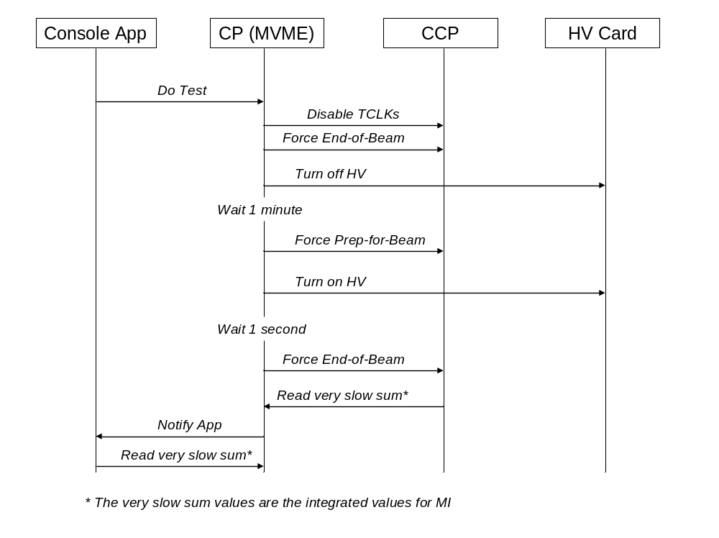

References

- BEAMS-DOC-1410 Beam Loss Monitor Upgrade Users’ Guide. Documents hardware and functionality of the system.
- Data Record
The fundamental unit stored in the various data buffers has the following format:

Byte Offset | Length | Description
0x00 | 1 | Machine state (0-255)
0x01 | 1 | Measurement Divisor
0x02 | 2 | Sum Divisor
0x04 | 1 | Abort Status (currently unused)
0x05 | 1 | Channel Count
0x06 | 1 | Data flag to indicate normal (0), last of cycle (1), new cycle (2), or waiting for stable data (3) frame
0x07 | 1 | Unused
0x08 | 4 | Time stamp: Microseconds since last TCLK 1 Hz Event
0x0C | 4 | Time stamp: seconds since T0 (i.e. 1 January 1970)
0x10 + n*4 | 240 | Sliding Sum data for channel n

The data flag normally cycles through the following progression:
- at start of beam, wait for the digitizer delay, then write a 2 in the first frame collected (for each type of sum)
- write 3 in all the succeeding frames until after the input switch is closed for the specified amount of time
- write 0 in the rest of the frames of the cycle
- at end of beam, write a 1 in the last frame in the circular buffer
In the abort status word, bits 0-3 are the status of the abort from the Immediate, Fast, Slow, and Very Slow measurements, respectively. Bits 4-7 are not used. Loss data are stored as 32-bit long words with data in order from least significant to most significant byte.
Profile, Flash, and Display frames each contain 2 of these data frames. The first one is the user selectable Fast or Slow Sum frame and the second is the Very Slow Sum frame which in the Main Injector contains the integrated value.

- Abort Information Layout
Note that the maps below contain enough entries for 256 states to keep consistency with the abort threshold arrays. Presently the code only handles states 0-63 (zero cannot be changed from its default and is used internally when changing settings).
  - Channel Masks
For each species of abort, there are 8 bytes of channel masks. The channel bits are left shifted in the 8 bytes. So, for instance, if there were 44 (0 to 43) channels in some crate, the channel assignment within the 8 bytes would be as follows (x means unused).
Bytes | 7 | 6 | 5 | 4 | 3 | 2 | 1 | 0
Bits | 7… 0 | 7… 0 | 7… 0 | 7… 0 | 7… 0 | 7… 0 | 7… 0 | 7… 0
Channel | 43…36 | 35…28 | 27…20 | 19…12 | 11…4 | 3…0 x…x | x…x | x…x

So to enable channel 17, one would write a 1 to byte 4, bit 5; and to enable channel 7, one would write a 1 to byte 3, bit 3. This assignment of course depends on how many channels there are in the crate. Let’s assume there are only 20 channels (0-19) in the crate; then one would have the following channel assignment
Bytes | 7 | 6 | 5 | 4 | 3 | 2 | 1 | 0
Bits | 7… 0 | 7… 0 | 7… 0 | 7… 0 | 7… 0 | 7… 0 | 7… 0 | 7… 0
Channel | 19…12 | 11…4 | 3…0 x…x | x…x | x…x | x…x | x…x | x…x

  - MDAT → Abort State Map
The map to go from MDAT state to Abort state is a 256 byte array indexed by MDAT state. The following table illustrates how the information is stored in each word. There is room for 256 entries to cover all possible states, but only 64 are presently used.
VME address | Most Significant Byte | Least Significant Byte
0x098E0000 | Abort state for MDAT state 1 | Abort State for MDAT state 0
0x098E0002 | Abort state for MDAT state 3 | Abort State for MDAT state 2
0x098E0004 | Abort state for MDAT state 5 | Abort State for MDAT state 4
… | … | …

  - TEV F Sector
    - List of MI Start and End TCLK Events
This list is actually 2 lists of 256 bytes each: a list of starting TCLKs, and a list of ending TCLKs, each indexed by MI MDAT state. The format of each list is identical. The following table shows the format for either list. A starting TCLK value of 0x00 indicates there is no action to take for that MI MDAT state. There is room for 256 entries in each list to cover all possible states, but currently only the first 64 are used.
VME address |  | Most Significant Byte | Least Significant Byte
Starting TCLKs | Ending TCLKs | Most Significant Byte | Least Significant Byte
0x098E0100 | 0x098E0200 | TCLK for MDAT state 1 | TCLK for MDAT state 0
0x098E0102 | 0x098E0202 | TCLK for MDAT state 3 | TCLK for MDAT state 2
0x098E0104 | 0x098E0204 | TCLK for MDAT state 5 | TCLK for MDAT state 4
… | … | … | …

    - Table of Actions vs. TEV Abort States / MI MDAT States
This is a 2-D byte array containing the action to take when a MI starting TCLK event occurs. It is indexed by both TEV abort state and MI MDAT state. A value of 0x00 indicates that the AC outputs should just be masked off. A value of 0xFF indicates that nothing should be done. Any other value is interpreted as a TEV abort state to switch to between the starting and ending clock events. The default is 0x00, i.e. mask off the AC outputs. The indices are arranged with MI MDAT state incrementing the fastest. There is enough memory reserved for a 256 x 256 byte array, but currently, it is only 64 x 64. The following table illustrates the layout presently.
VME address | Most Significant Byte | Least Significant Byte
0x098F0000 | Action for MI MDAT state 1 and TEV abort state 0 | Action for MI MDAT state 0 and TEV abort state 0
0x098F0002 | Action for MI MDAT state 3 and TEV abort state 0 | Action for MI MDAT state 2 and TEV abort state 0
0x098F0004 | Action for MI MDAT state 5 and TEV abort state 0 | Action for MI MDAT state 4 and TEV abort state 0
… | … | …
0x098F0040 | Action for MI MDAT state 1 and TEV abort state 1 | Action for MI MDAT state 0 and TEV abort state 1
0x098F0042 | Action for MI MDAT state 3 and TEV abort state 1 | Action for MI MDAT state 2 and TEV abort state 1
0x098F0044 | Action for MI MDAT state 5 and TEV abort state 1 | Action for MI MDAT state 4 and TEV abort state 1
… | … | …

- VME Dual Port Memory Map
VME dual port memory addresses start at 0x09800000. The eZ80 addressing of the dual port memory begins at 0x800000 (24 bit addressing). The following addresses are specified as offsets from the base addresses.
Address | Size | Description
System Status
000000 | 2 | Status Word
000006 | 1 | Bit pattern for selecting Flash/Profile/Display source  Bit 0 = flash, bit 1 = profile, bit 2 = display; 0 = fast, 1 = slow
000008 | 1 | Read flash memory
00000A | 2 | Load flash memory (requires 0xA596 to be written here)
00000C | 2 | Flash memory load status
00000E | 1 | Clear Abort Info Bits in Status Word ( and clear the abort snapshot)
00000F | 1 | Clear Abort Snapshot OR
000010 | 1 | Force Pedestal Read
000012 | 1 | Update Time Setting
000014 | 2 | Time Setting LSW
000016 | 2 | Time Setting MSW
000018 | 1 | Update Settings
00001A | 1 | Update Abort Settings
00001C | 1 | Machine Type
00001E | 1 | MDAT State
00001F | 1 | Abort State
Flash, Profile and Snapshot Indexes
000020 | 2 | Flash Frame Counter
000022 | 2 | Profile Frame Counter
000024 | 2 | Fast Sum Circular Buffer Frame Index 1
000026 | 2 | Fast Sum Circular Buffer Frame Index 2
000028 | 2 | Slow Sum Circular Buffer Frame Index 1
00002A | 2 | Slow Sum Circular Buffer Frame Index 2
00002C | 2 | Very Slow Sum Circular Buffer Frame Index 1
00002E | 2 | Very Slow Sum Circular Buffer Frame Index 2
000030 | 1 | Fast Sum Frame Index Pointer
000032 | 1 | Slow Sum Frame Index Pointer
000034 | 1 | Very Slow Sum Frame Index Pointer
000036 | 2 | TC Raw data pointer
000038 | 2 | DC Raw data pointer
00003A | 2 | AC Raw data pointer
Abort Info
000080 | 8 | Channel Not OK List from Abort Card
Settings
000100 | 1 | Channel Count
000102 | 2 | Make_Meas Divisor
000104 | 2 | Fast Sum Length
000106 | 2 | Slow Sum Length
000108 | 2 | Very Slow Sum Length
00010A | 2 | Digitizer FPGA Control Register ( high byte is number of make_meas to skip before performing pedestal measurements / 16 )
00010C | unused | Digitizer Test DAC
00010E | 1 | Timing Card Control Bus CSR Register
000110 | unused | Timing Card Control Settings (reserved)
000112 | 1 | What generates an IRQ3 interrupt from the Abort Card?
000114 | 1 | Abort Card enable (Bit 0 is global enable, Bit 4 is require 2 consecutive aborts)
000116 | 2 | Pedestal Sum Length
000118 | 1 | End of beam delay before asserting AIP (in fast latch units)
00011A | 1 | Delay after Flash clock event before collecting flash frame (in fast latch units)
00011C | 1 | Delay after Profile clock event before collecting profile frame (in fast latch units)
00011E | 1 | Delay after Display clock event before collecting display frame (in fast latch units)
000120 | 1 | Turn off inputs while doing pedestals
000122 | 1 | Optional extra delay after pedestals before re-enabling DC inputs
000124 | 1 | Delay after re-enabling DC inputs before reading data
000126 | 1 | Delay (slow sum units) after the end TCLK event before re-enabling normal F sector aborts
000200 | 2 | Channel 0 Mode Select
000202 | 2 | Channel 0 MADC Manual Setting
↓
0002EC | 2 | Channel 59 Mode Select
0002EE | 2 | Channel 59 MADC Manual Setting
Pedestal Storage
000300 | 256 | 32-bit pedestals stored in standard data record
Squelch Storage
000400 | 120 | 16-bit squelch values
Abort Snapshot Storage
000500 | 32 | Abort snapshot record from last frame before abort
000520 | 32 | Abort snapshot OR of all abort snapshots since this was last cleared
000540 | 2 | Abort circular buffer pointer at time of abort
000542 | 2 | Fast Sum index at time of abort
000544 | 2 | Slow Sum index at time of abort
000546 | 2 | Very Slow Sum index at time of abort
Integration Pedestal Storage
000600 | 256 | 32-bit Integration pedestals
Debug Information
010000 | 48 | Program name and build date
010030 | 4 | Test Sequence ( 0x44332211 )
010034 | 4 | TCLK count
010038 | 4 | MDAT frame count
01003C | 2 | Last TCLK received
01003E | 2 | Last MDAT state received
010040 | 4 | Data Interrupt count
010044 | 4 | Fast Sum Latch count
010048 | 4 | Slow Sum Latch count
01004C | 4 | Very Slow Sum Latch count
010050 | 4 | Profile request count
010054 | 4 | Flash request count
010058 | 4 | Display request count
01005C | 4 | Abort Interrupt count
010060 | 4 | Channel not OK interrupt count
010064 | 4 | Channel abort interrupt count
010068 | 4 | Crate abort interrupt count
01006C | 4 | Missed Fast Latch count
010070 | 4 | Missed Slow Latch count
010074 | 4 | Missed Very Slow Latch count
010078 | 2 | Program State
01007A | 2 | Number of fast data latches to wait until pedestals are done
01007C | 4 | Last Fast Latch time microsecs
010080 | 4 | Last Fast Latch time seconds
010084 | 4 | Last Slow Latch time microsecs
010088 | 4 | Last Slow Latch time seconds
01008C | 4 | Last Very Slow Latch time microsecs
010090 | 4 | Last Very Slow Latch time seconds
010094 | 4 | Stack Pointer (Updated every time through polling loop)
010098 | 4 | Stack Integrity (0xA4A3A2A1; also updated every loop)
01009C | 16 | Digitizer Map (map of found digitizers; 16th byte is 0)
0100AC | 4 | Timing Card clock error count
0100B0 | 4 | Count of times TCLK queue has more than 1 entry
0100B4 | 4 | Count of times MDAT queue has more than 1 entry
0100B8 | 4 | Number of times a state ≥ 64 was received
0100BC | 2 | Last state machine input
0100BE | 2 | Force prepare for beam event (requires 0xA596 to be written here)
0100C0 | 2 | Force end of beam event (requires 0xA596 to be written here)
0100C2 | 2 | Pause the system (requires 0xA596 to be written here). This happens now if waiting for beam, or after next end of beam event.
0100C4 | 2 | Change the system state (requires 0xA596 to be written here).
0100C6 | 2 | Toggle TCLK polling (requires 0xA596 to be written here)
0100C8 | 2 | Toggle MDAT polling (requires 0xA596 to be written here)
0100CA | 2 | Toggle Data interrupts (requires 0xA596 to be written here)
0100CC | 2 | Toggle Abort polling (requires 0xA596 to be written here)
0100CE | 2 | Enable CPU time measurements (just write a 0x0001 here; 0x0000 turns off CPU time measurements)
0100D0 | 2 | Number of species of CPU time measurements
010100 | 1024 | TCLK counts for each TCLK type (256 types)
010500 | 1024 | MDAT counts for each MDAT state (256 states)
010900 | 2048 | CPU time measurement buffer (each measurement type occupies 32 words)
018000 | 2 | Request a Control Bus memory dump
018002 | 2 | Request a Control Bus write (requires 0xA596 to be written here)
018004 | 2 | Control Bus address to dump / write (dumps 256 bytes / write 1 byte)
018100 | 256 | Data copied from / written to Control Bus (only 1 byte in case of write)
019000 | 2 | Request User Code to be run (requires 0xA596 to be written here)
01A000 | 8192 | Buffer for User Code to be placed
Flash Memory Download
020000 | 128K | Buffer for new flash memory contents
Flash Frames
080000 | 512 | Flash Frame 0
080200 | 512 | Flash Frame 1
↓
09FE00 | 512 | Flash Frame 255
Profile Frames
0A0000 | 512 | Profile Frame 0
0A0200 | 512 | Profile Frame 1
↓
0BFE00 | 512 | Profile Frame 255
Display Frame
0C0000 | 512 | Display Frame
Abort Stuff
0E0000 | 256 | MDAT state to Abort state map
0E0100 | 256 | F sector start TCLKs (indexed by MI MDAT state; a value of 0 means not implemented) This is a 1-D byte array, one byte per MI state.
0E0200 | 256 | F sector end TCLKs (also indexed by MI MDAT state) Also a byte array
0F0000 | 65536 | Array of F sector actions to take, indexed by TEV MDAT state and MI MDAT state. (An action of 0 means mask off the Abort card; a value of 0xFF means don’t do anything, any other value means switch to that TEV abort state) These actions are implemented between the start and end TCLKs given by the lists above. This is a 2-D byte array. The fastest changing index is the MI state, i.e.  unsigned char array[TEV states][MI states]
Abort Machine States
State 0
100000 | 1 | State Number
100002 | 2 | Channel Masks 0 1 for Immediate Abort
100004 | 2 | Channel Masks 2 3 for Immediate Abort
100006 | 2 | Channel Masks 4 5 for Immediate Abort
100008 | 2 | Channel Masks 6 7 for Immediate Abort
10000A | 2 | Channel Masks 0 1 for Fast Abort
10000C | 2 | Channel Masks 2 3 for Fast Abort
10000E | 2 | Channel Masks 4 5 for Fast Abort
100010 | 2 | Channel Masks 6 7 for Fast Abort
100012 | 2 | Channel Masks 0 1 for Slow Abort
100014 | 2 | Channel Masks 2 3 for Slow Abort
100016 | 2 | Channel Masks 4 5 for Slow Abort
100018 | 2 | Channel Masks 6 7 for Slow Abort
10001A | 2 | Channel Masks 0 1 for Very Slow Abort
10001C | 2 | Channel Masks 2 3 for Very Slow Abort
10001E | 2 | Channel Masks 4 5 for Very Slow Abort
100020 | 2 | Channel Masks 6 7 for Very Slow Abort
100022 | 2 | Abort Multiplicity for Immediate and Fast Abort
100024 | 2 | Abort Multiplicity for Slow and Very Slow Abort
100026 | 2 | Crate Abort Mask
100028 | 8 | Unused
100030 | 2 | Channel 0 Immediate Threshold
100032 | 2 | Channel 1 Immediate Threshold
↓
1000A6 | 2 | Channel 59 Immediate Threshold
1000A8 | 8 | Unused
1000B0 | 2 | Channel 0 Fast Threshold LSW
1000B2 | 2 | Channel 0 Fast Threshold MSW
1000B4 | 2 | Channel 1 Fast Threshold LSW
1000B6 | 2 | Channel 1 Fast Threshold MSW
↓
10019C | 2 | Channel 59 Fast Threshold LSW
10019E | 2 | Channel 59 Fast Threshold MSW
1001A0 | 16 | Unused
1001B0 | 2 | Channel 0 Slow Threshold LSW
1001B2 | 2 | Channel 0 Slow Threshold MSW
1001B4 | 2 | Channel 1 Slow Threshold LSW
1001B6 | 2 | Channel 1 Slow Threshold MSW
↓
10029C | 2 | Channel 59 Slow Threshold LSW
10029E | 2 | Channel 59 Slow Threshold MSW
1002A0 | 16 | Unused
1002B0 | 2 | Channel 0 Very Slow Threshold LSW
1002B2 | 2 | Channel 0 Very Slow Threshold MSW
1002B4 | 2 | Channel 1 Very Slow Threshold LSW
1002B6 | 2 | Channel 1 Very Slow Threshold MSW
↓
10039C | 2 | Channel 59 Very Slow Threshold LSW
10039E | 2 | Channel 59 Very Slow Threshold MSW
1003A0 | 80 | Unused
States 1 – 255; each with same offsets as State 0
100400 | 1024 | State 1 Settings
100800 | 1024 | State 2 Settings
↓
13F800 | 1024 | State 255 Settings
In Use Abort Settings for States 0-255
140000 | 256 K | Copy of settings that are in use. These are the settings that are copied to AC and DCs.
Circular Buffers
200000 | 4 Meg | Fast Sum Buffer 16K frames deep
600000 | 1 Meg | Slow Sum Buffer 4K frames deep
700000 | 1 Meg | Very Slow Sum Buffer 4K frames deep

