PUBLIC NOTICE
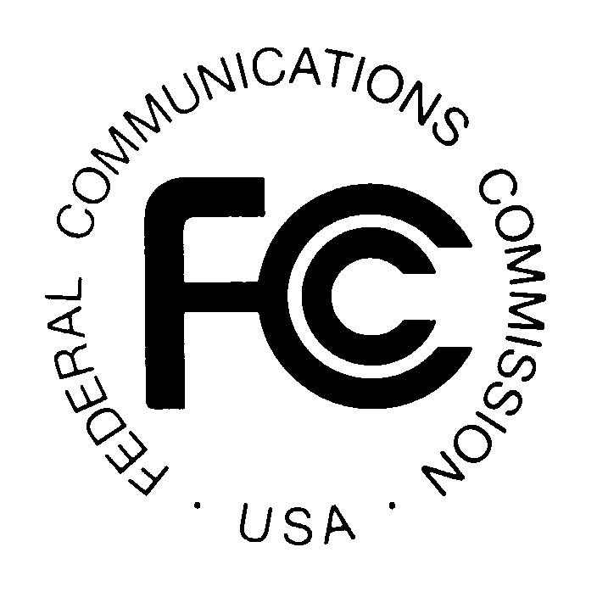
FEDERAL COMMUNICATIONS COMMISSION
445 12TH STREET, S.W.
WASHINGTON, D.C. 20554

News media information 202/418-0500 Fax-On-Demand 202/418-2830 Internet: http://www.fcc.gov ftp.fcc.gov

CABLE SERVICES BUREAU ACTION November 12, 1999

LETTER REGARDING INTERMEDIA PARTNERS OF KENTUCKY, L.P.

InterMedia Partners of Kentucky, L.P. filed a request for special relief which asked for a determination that the Commission’s rules provide the exclusive means for determining whether costs and fees imposed on cable operators can be passed on to subscribers. The Commission has responded to Intermedia’s request in a letter ruling released today by the Deputy Chief, Cable Services Bureau.

Media Contact: Michelle Russo at (202) 418-2358
Cable Services Bureau Contact: Thomas Horan at 418-2486 or Ben Golant at (202) 418-7111
TTY: (202) 418-7172

--FCC--

