PUBLIC NOTICE
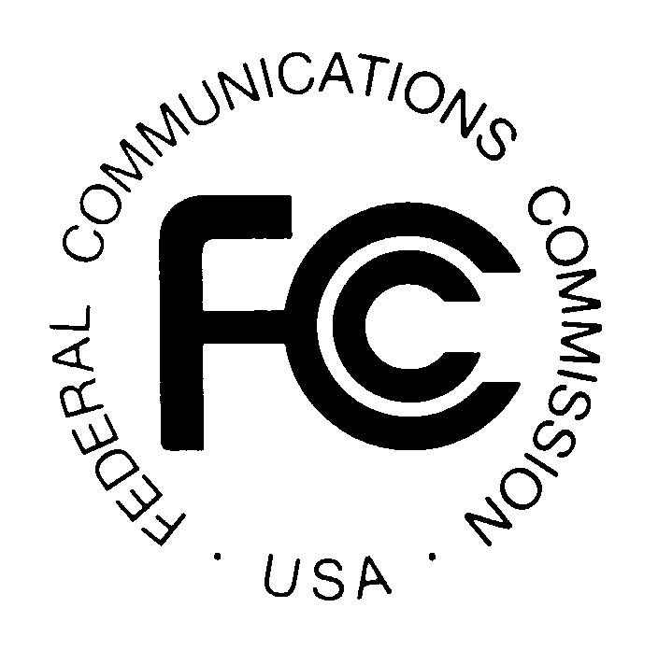
FEDERAL COMMUNICATIONS COMMISSION
445 12TH STREET, S.W.
WASHINGTON, D.C. 20554 DA 99-2495

News media information 202/418-0500 Fax-On-Demand 202/418-2830 Internet: http://www.fcc.gov ftp.fcc.gov

Released: November 9, 1999

WIRELESS TELECOMMUNICATIONS BUREAU
APPROVES WITHDRAWAL OF APPLICATION FOR REVIEW AND
WITHDRAWAL OF PETITION FOR REVOCATION OF LICENSE

On April 5, 1995, the Wireless Telecommunications Bureau granted Alvin B. Asher (Asher) a license for Station WPGQ483, private carrier paging frequency 929.9625 MHz, File No. 9409680421. On May 5, 1995, Westlink Licensee Corporation (Westlink) filed a Petition for Reconsideration (Petition) asking the Bureau to set aside the grant of Asher’s license and dismiss his application as unacceptable for filing. The Bureau denied Westlink’s Petition on June 25, 1996.

On July 25, 1996, Westlink filed (1) an Application for Review of the Bureau’s denial of Westlink’s Petition and (2) a Petition for Revocation of License for Station WPGQ483.

By letter dated November 8, 1999, Arch Communications Group, Inc. (the successor-in-interest to Westlink) requested that the Commission dismiss Westlink’s Application for Review and its Petition for Revocation of License, noting that “[i]ntervening corporate and industry developments have rendered the pleadings moot.” The Policy and Rules Branch of the Commercial Wireless Division has reviewed and hereby approves Arch Communications Group, Inc.’s request to dismiss Westlink Licensee Corporation’s Application for Review and Petition for Revocation of License, both filed July 25, 1996, File No. 9409680421.

Action by the Chief, Policy and Rules Branch, Commercial Wireless Division, Wireless Telecommunications Bureau.

For further information, contact Richard Arsenault at (202) 418-0920, Wireless Telecommunications Bureau, Commercial Wireless Division, Policy and Rules Branch.

