Rudolf BAYER, Michal BREJCHA
CTU in Prague, faculty of electrical engineering

Luminous intensity distribution curve effect on luminaire placement

Abstract. The paper discusses ways to deploy a given number of point light sources in the interior to provide uniform illumination of the working plane. Nowadays this issue is generally solved by a guess of the designer or lighting calculation and simulation software so that the luminaires are positioned in a rectangular evenly spaced grid and after checking calculations have been processed this grid is adjusted. An approximate optimal solution can be found using today popular genetic algorithms. This method can be found in foreign literature especially in conjunction with outdoor lighting system designing such as parking lots, sporting grounds etc. Considering the influence of multiple reflections from room surfaces, the same method can be used for interiors.
The optimal luminaire placement is influenced not only by the geometry of the room, but also by the luminous intensity distribution curves of the luminaires. There are two approaches. Either a grid can be searched for to accomplish the desired uniformity of illumination using a defined number of luminaires with defined luminous intensity curves, or a luminaire grid is defined and luminous intensity curves are changed in order to achieve the desired uniformity of illumination. Therefore another aim of this paper is to evaluate luminous intensity distribution and its effect on the optimal luminaire placement.

Keywords: please insert 3 – 4 keyword or phrases.

Introduction
To prepare the paper for printed publication it is recommended that you use MS Word editor (version 97 and later). The paper should be prepared according to the instructions below, and not as a “camera ready” version. The formatted version of the paper helps in the assessment of the paper length and organization. Please take into account, that this paper will be re-arranged using a different editing package (i.e. Quark Press), and therefore you should not apply special automatic tools proposed by MS Word (for example automatic hyphenation, templates etc).
Firstly, start with the formatting of the page. The paper should be prepared using A4 paper format with the following margins: upper, left and right margins to be set at 1.8 cm and bottom margin to be set at 2.5 cm. The first line comprises of the authors' names (type size 10 with Arial font). Underneath the author’s name, insert the authors' affiliation (type size 8 with Arial font). Insert two blank lines and then add the title of the paper (type size 16 with Arial bold font). Insert a further two lines and write abstracts and key words (type size 7.5 with Arial Italic font). Insert one line and add the section line. There should be two columns with a separation of 5 mm.

Interior lighting

The typical length of the paper should be limited to no more than 5 pages. The whole paper is written using Type size 9 and Arial font with the indentation set at 5 mm. Directly after section headings (type size 9 using Arial bold), place the text in justified style. For figure captions, names of the tables and footnotes use Arial font with type size 8. When symbols need to be inserted into the text, use option “insert/symbol” (for example Δα or ϑ∈∞). Please do not use the equation editor. The equation editor should only be used if a symbol does not exists in the symbol list – for example 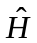. Although the whole text is written using Arial font, for symbols please use the Times New Roman italic – for example J and not J (i.e. the same symbols as in the equations).

Equations
For equations it is recommended to use standard equation editor existing in Word editor (some authors uses Math Type editor, but this can cause some problems with later edition). The equation editor is defined as follows: font Times New Roman italic, matrix bold, for letters font 10, for index 8, for symbol 12. For example, typical equation should be as:

(1) 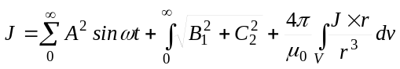

where: J – current density, r – distance, A,B,C – coefficients.

Insert the equation number on the left side, between the text and the equation please leave the distance of 8 points.

Figures
Generally, it is sufficient if the figures are inserted in the document (as an example below - Fig. 1), but for security it is better if the original sources of the figures are also provided, using a typical format such as: TIF, EPS or JPG (i.e. electronic version). Please do not insert the figure directly in the text, but use the “insert text-box” option, and then insert the figure inside of the text box. In this way it is easier later to move or change the dimensions of the figures.
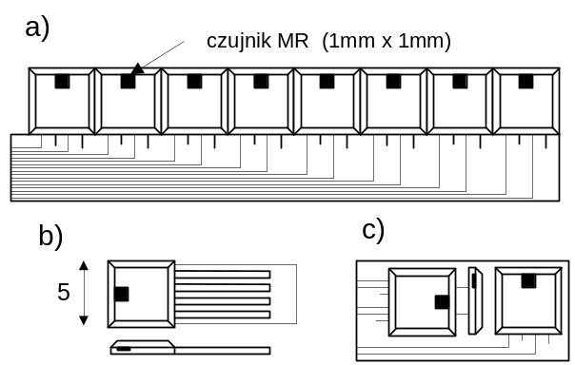

Fig.1. An example of the figure inserted into the text

The best case is, if the figures are of the same width as the column – 8 cm. The letters in the figures should be not smaller than 2 mm. Figure 2 presents an example of a graph.
If there are problems with electronic version of the figures it is recommended to deliver the article with supplemented “hard copies” of the figures. This means that also a “printed version” of the figures should be included for eventual scanning.
It is possible to print figures in the colour version, but in this case the authors are requested to consult this with the editor.
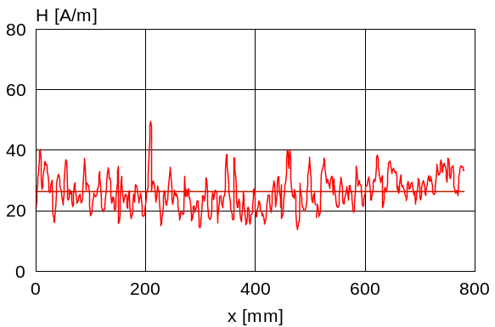

Fig.2. An example of a graph

Tables
Similarly as in the case of the figures the best width of the tables is the width of the column – 8cm. An example of a table is presented below.

Table 1. The parameters of the sensor
Sensor type | Dimensions [mm] | Sensitivity [mv/T]
B50/A | 20×20×200 | 20.2
B80/C | 50×20×200 | 30.5
C20/G | 40×30×800 | 70.4

Acknowledgments to be inserted at the end of the article using type size 9 and Arial italic..

References
References are cited in the text by square brackets [1]. Two or more references at the time may be put in one set of the brackets [2, 3]. The references are numbered in the order in which they are cited. The style of the references is as follows:
REFERENCES
[1] Dostál, F., Sokanský, K., Novák, T.: Long-term measurement of obtrusive light in campus VŠB-TUO, EPE 2009, VŠB-TUO, 60-62(2009), Czech republic, ISBN 978-80-248-1947-1
[2] Johnson B., Pike G.E., Preparation of Papers for
Transactions, IEEE Trans. Magn., 50 (2002), No. 5, 133-137

The references are written using type size 8 with Arial font.

Authors
The address for correspondence, e.g. name with title, address of the institution, e-mail address, should be included at the end of the article,

Authors: prof. ing. Karel Sokanský, CSc., Vysoká škola báňská - Technická univerzita Ostrava Fakulta elektrotechniky a informatiky, 17. Listopadu 15/2172, Czech Republic, e-mail: karel.sokansky@vsb.cz

