Measuring Reflective Properties of Surfaces Using Reflectophotometer

Rudolf Bayer
Department of Electrical Power Engineering
Czech Technical University in Prague
Prague, Czech Republic
bayerrud@fel.cvut.cz

Abstract—Modern computer lighting design programs use for simplification reasons during calculations surfaces of purely diffuse reflection. For more accurate calculations it is necessary to use real reflective properties of surfaces that can be measured by a reflectophotometer. The reflectophotometer of the Department of Electrical Power Engineering, FEE CTU in Prague, allows measuring reflective properties of surface samples 2 by 2 cm. ReflectoSoft, an application designed specially for this reflectophotometer, enables measurements of BRDF in the Klems system of patches. The measured values can than be stored into a XML file containing the BRDF matrix of 145 × 145 elements. The results can be viewed using the software BSDFViewer.
Keywords—reflectophotometer; OPTE-F3K; ReflectoSoft; BSDFViewer

Introduction
The human gets 80 to 90 % of information about the surroundings through the eyes. How objects affect luminous flux constitutes what we call the object's appearance. Most light-active surfaces around us are secondary light sources. Light emitted from primary light sources (sun, artificial light sources), hits a surface, changes its properties, is reflected and thus transmits information about the nature of the object's surface. The photometric properties of material surfaces are especially important in the design and construction of light-active surfaces in terms of reflected light flux spatial distribution , e. g. to reduce brightness in certain directions while maintaining maximum efficiency of the arrangement.

Reflectophotometer OPTE-F3K
Measuring reflective properties of surface materials can be carried out using the reflectometer OPTE-F3K of the Department of Electrical Power Engineering (Fig. 1). This device requires a Bruel & Kjaer Type 1100 luminance contrast meter [1] with an external optical sensor to measure reflective properties of material surfaces. The sensor is fixed in the reflectophotometer, its output connected to the contrast meter and the analog luminance voltage output fed back to the reflectophotometer.

Measuring Principle
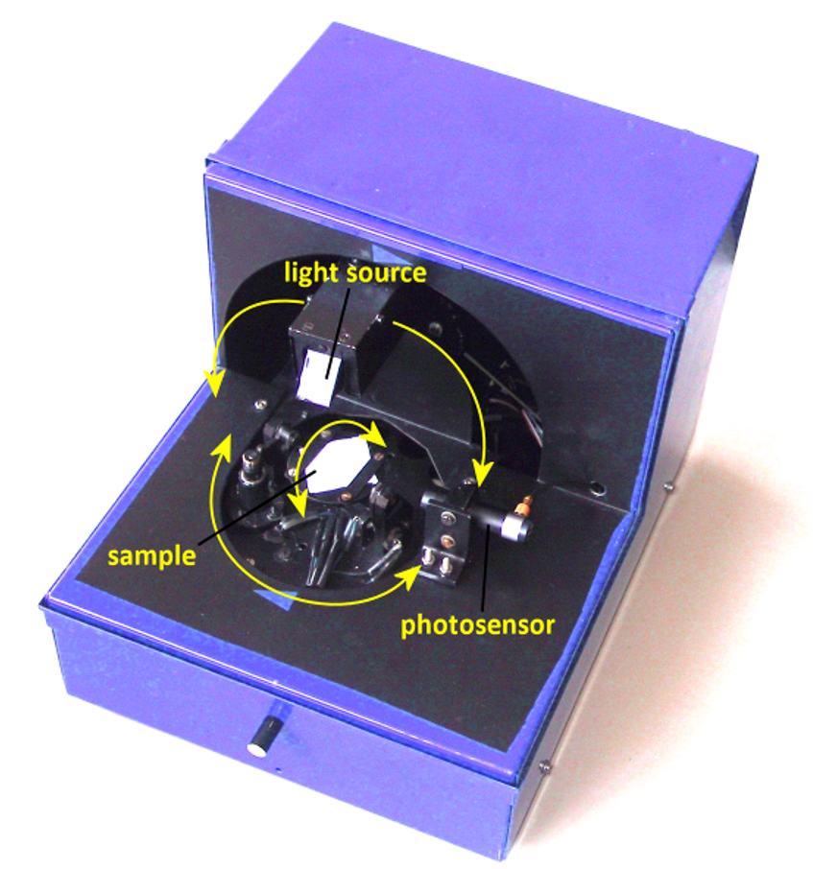Fig. 1: Reflectophotometer OPTE-F3K without sample cover.
To measure luminance spatial distribution of a sample's surface for different incident light ray angles it is necessary to rotate the light source and sample. To make this movement possible, stepper motors are used enabling rotation of the sample around two axes and rotation of the light source around a single axis.
For measuring the spatial distribution of the brightness of the measured sample surface for different incident angles light rays it is necessary to sample and the light source rotate. For this purpose, the reflectometer incorporates stepper motors rotating the sample around two axes and the light source along one axis. Angle arrangements can be found in Fig. 2.
According to Fig. 2 the sample is placed on a pad with its vertical axis N enabling rotation from γ = 0° to γ = 180°. This pad can also be tilted from horizontal position β = 0° to vertical position β = 90°. The reference light source can be rotated from range α = 0° to α = 180°. Angles α, β and γ can be set with an accuracy of 0.5° [2].

Ease of Use

Selecting a Template (Heading 2)
First, confirm that you have the correct template for your paper size. This template has been tailored for output on the A4 paper size. If you are using US letter-sized paper, please close this file and download the file “MSW_USltr_format”.

Maintaining the Integrity of the Specifications
The template is used to format your paper and style the text. All margins, column widths, line spaces, and text fonts are prescribed; please do not alter them. You may note peculiarities. For example, the head margin in this template measures proportionately more than is customary. This measurement and others are deliberate, using specifications that anticipate your paper as one part of the entire proceedings, and not as an independent document. Please do not revise any of the current designations.
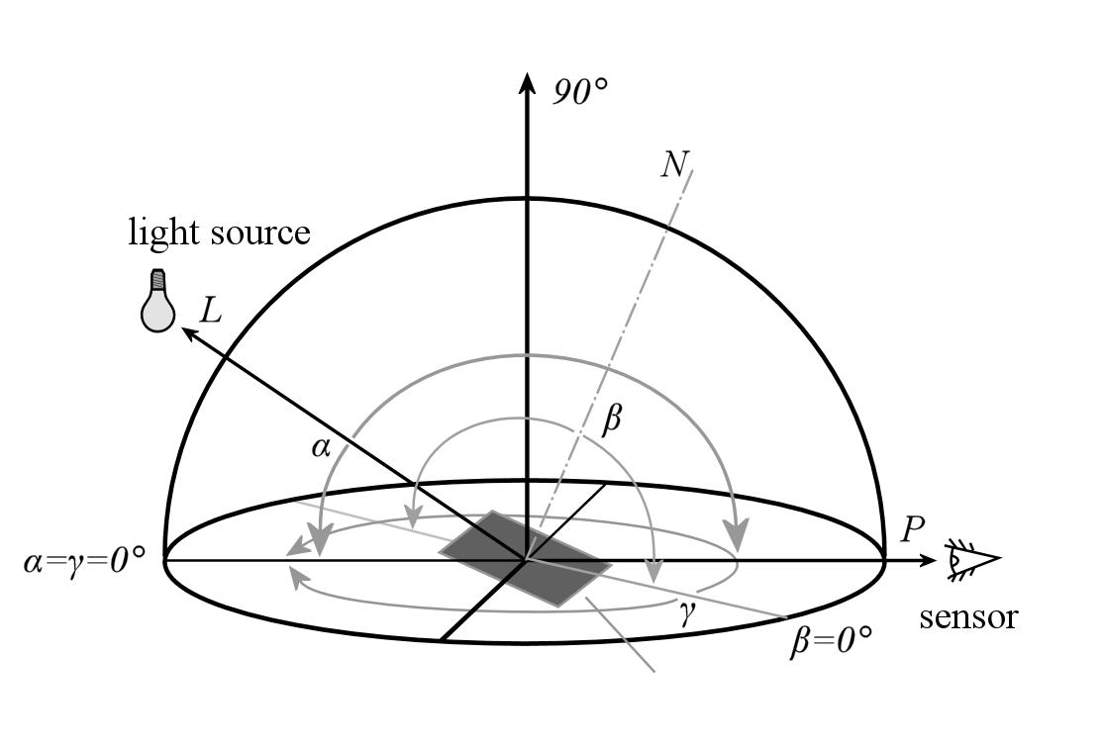Fig. 2: Angle setup of the sample and light source used in OPTE-F3K.

Prepare Your Paper Before Styling
Before you begin to format your paper, first write and save the content as a separate text file. Keep your text and graphic files separate until after the text has been formatted and styled. Do not use hard tabs, and limit use of hard returns to only one return at the end of a paragraph. Do not add any kind of pagination anywhere in the paper. Do not number text heads-the template will do that for you.
Finally, complete content and organizational editing before formatting. Please take note of the following items when proofreading spelling and grammar:

Abbreviations and Acronyms
Define abbreviations and acronyms the first time they are used in the text, even after they have been defined in the abstract. Abbreviations such as IEEE, SI, MKS, CGS, sc, dc, and rms do not have to be defined. Do not use abbreviations in the title or heads unless they are unavoidable.

Units
- Use either SI (MKS) or CGS as primary units. (SI units are encouraged.) English units may be used as secondary units (in parentheses). An exception would be the use of English units as identifiers in trade, such as “3.5-inch disk drive.”
- Avoid combining SI and CGS units, such as current in amperes and magnetic field in oersteds. This often leads to confusion because equations do not balance dimensionally. If you must use mixed units, clearly state the units for each quantity that you use in an equation.
- Do not mix complete spellings and abbreviations of units: “Wb/m2” or “webers per square meter,” not “webers/m2.” Spell units when they appear in text: “...a few henries,” not “...a few H.”
- Use a zero before decimal points: “0.25,” not “.25.” Use “cm3,” not “cc.” (bullet list)
Identify applicable sponsor/s here. If no sponsors, delete this text box (sponsors).

Equations
The equations are an exception to the prescribed specifications of this template. You will need to determine whether or not your equation should be typed using either the Times New Roman or the Symbol font (please no other font). To create multileveled equations, it may be necessary to treat the equation as a graphic and insert it into the text after your paper is styled.
Number equations consecutively. Equation numbers, within parentheses, are to position flush right, as in (1), using a right tab stop. To make your equations more compact, you may use the solidus ( / ), the exp function, or appropriate exponents. Italicize Roman symbols for quantities and variables, but not Greek symbols. Use a long dash rather than a hyphen for a minus sign. Punctuate equations with commas or periods when they are part of a sentence, as in
a  b             
Note that the equation is centered using a center tab stop. Be sure that the symbols in your equation have been defined before or immediately following the equation. Use “(1),” not “Eq. (1)” or “equation (1),” except at the beginning of a sentence: “Equation (1) is ...”

Some Common Mistakes
- The word “data” is plural, not singular.
- The subscript for the permeability of vacuum μ₀, and other common scientific constants, is zero with subscript formatting, not a lowercase letter “o.”
- In American English, commas, semi-/colons, periods, question and exclamation marks are located within quotation marks only when a complete thought or name is cited, such as a title or full quotation. When quotation marks are used, instead of a bold or italic typeface, to highlight a word or phrase, punctuation should appear outside of the quotation marks. A parenthetical phrase or statement at the end of a sentence is punctuated outside of the closing parenthesis (like this). (A parenthetical sentence is punctuated within the parentheses.)
- A graph within a graph is an “inset,” not an “insert.” The word alternatively is preferred to the word “alternately” (unless you really mean something that alternates).
- Do not use the word “essentially” to mean “approximately” or “effectively.”
- In your paper title, if the words “that uses” can accurately replace the word using, capitalize the “u”; if not, keep using lower-cased.
- Be aware of the different meanings of the homophones “affect” and “effect,” “complement” and “compliment,” “discreet” and “discrete,” “principal” and “principle.”
- Do not confuse “imply” and “infer.”
- The prefix “non” is not a word; it should be joined to the word it modifies, usually without a hyphen.
- There is no period after the “et” in the Latin abbreviation “et al.”
- The abbreviation “i.e.” means “that is,” and the abbreviation “e.g.” means “for example.”
An excellent style manual for science writers is [7].

Using the Template
After the text edit has been completed, the paper is ready for the template. Duplicate the template file by using the Save As command, and use the naming convention prescribed by your conference for the name of your paper. In this newly created file, highlight all of the contents and import your prepared text file. You are now ready to style your paper; use the scroll down window on the left of the MS Word Formatting toolbar.

Authors and Affiliations
The template is designed so that author affiliations are not repeated each time for multiple authors of the same affiliation. Please keep your affiliations as succinct as possible (for example, do not differentiate among departments of the same organization). This template was designed for two affiliations.

For author/s of only one affiliation (Heading 3): To change the default, adjust the template as follows.

Selection (Heading 4): Highlight all author and affiliation lines.

Change number of columns: Select the Columns icon from the MS Word Standard toolbar and then select “1 Column” from the selection palette.

Deletion: Delete the author and affiliation lines for the second affiliation.

For author/s of more than two affiliations: To change the default, adjust the template as follows.

Selection: Highlight all author and affiliation lines.

Change number of columns: Select the “Columns” icon from the MS Word Standard toolbar and then select “1 Column” from the selection palette.

Highlight author and affiliation lines of affiliation 1 and copy this selection.

Formatting: Insert one hard return immediately after the last character of the last affiliation line. Then paste down the copy of affiliation 1. Repeat as necessary for each additional affiliation.

Reassign number of columns: Place your cursor to the right of the last character of the last affiliation line of an even numbered affiliation (e.g., if there are five affiliations, place your cursor at end of fourth affiliation). Drag the cursor up to highlight all of the above author and affiliation lines. Go to Column icon and select “2 Columns”. If you have an odd number of affiliations, the final affiliation will be centered on the page; all previous will be in two columns.

Identify the Headings
Headings, or heads, are organizational devices that guide the reader through your paper. There are two types: component heads and text heads.
Component heads identify the different components of your paper and are not topically subordinate to each other. Examples include ACKNOWLEDGMENTS and REFERENCES, and for these, the correct style to use is “Heading 5.” Use “figure caption” for your Figure captions, and “table head” for your table title. Run-in heads, such as “Abstract,” will require you to apply a style (in this case, italic) in addition to the style provided by the drop down menu to differentiate the head from the text.
Text heads organize the topics on a relational, hierarchical basis. For example, the paper title is the primary text head because all subsequent material relates and elaborates on this one topic. If there are two or more sub-topics, the next level head (uppercase Roman numerals) should be used and, conversely, if there are not at least two sub-topics, then no subheads should be introduced. Styles named “Heading 1,” “Heading 2,” “Heading 3,” and “Heading 4” are prescribed.

Figures and Tables

Positioning Figures and Tables: Place figures and tables at the top and bottom of columns. Avoid placing them in the middle of columns. Large figures and tables may span across both columns. Figure captions should be below the figures; table heads should appear above the tables. Insert figures and tables after they are cited in the text. Use the abbreviation “Fig. 1,” even at the beginning of a sentence.
- Table Styles
Table Head | Table Column Head
Table Head | Table column subhead | Subhead | Subhead
copy | More table copyª
- Sample of a Table footnote. (Table footnote)

- Example of a figure caption. (figure caption)
Figure Labels: Use 8 point Times New Roman for Figure labels. Use words rather than symbols or abbreviations when writing Figure axis labels to avoid confusing the reader. As an example, write the quantity “Magnetization,” or “Magnetization, M,” not just “M.” If including units in the label, present them within parentheses. Do not label axes only with units. In the example, write “Magnetization (A/m)” or “Magnetization (A ( m(1),” not just “A/m.” Do not label axes with a ratio of quantities and units. For example, write “Temperature (K),” not “Temperature/K.”

Acknowledgment (Heading 5)
The preferred spelling of the word “acknowledgment” in America is without an “e” after the “g.” Avoid the stilted expression “one of us (R. B. G.) thanks ...”. Instead, try “R. B. G. thanks...”. Put sponsor acknowledgments in the unnumbered footnote on the first page.

References
The template will number citations consecutively within brackets [1]. The sentence punctuation follows the bracket [2]. Refer simply to the reference number, as in [3]—do not use “Ref. [3]” or “reference [3]” except at the beginning of a sentence: “Reference [3] was the first ...”
Number footnotes separately in superscripts. Place the actual footnote at the bottom of the column in which it was cited. Do not put footnotes in the reference list. Use letters for table footnotes.
Unless there are six authors or more give all authors’ names; do not use “et al.”. Papers that have not been published, even if they have been submitted for publication, should be cited as “unpublished” [4]. Papers that have been accepted for publication should be cited as “in press” [5]. Capitalize only the first word in a paper title, except for proper nouns and element symbols.
For papers published in translation journals, please give the English citation first, followed by the original foreign-language citation [6].

- Technical Review: Luminance contrast measurement [online]. Denmark, 1980, 1980(1) [cit. 2016-05-29]. ISSN 0007-2621. Dostupné z: http://www.bksv.com/doc/bn1681.pdf
- MÁLEK, Jan. Odrazné vlastnosti světelně činných materiálů. Praha, 2007. Disertační práce. České vysoké učení v Praze - Fakulta elektrotechnická. Vedoucí práce Prof. Ing. Jiří Habel, DrSc.
- J. Clerk Maxwell, A Treatise on Electricity and Magnetism, 3rd ed., vol. 2. Oxford: Clarendon, 1892, pp.68-73.
- I.S. Jacobs and C.P. Bean, “Fine particles, thin films and exchange anisotropy,” in Magnetism, vol. III, G.T. Rado and H. Suhl, Eds. New York: Academic, 1963, pp. 271-350.
- K. Elissa, “Title of paper if known,” unpublished.
- R. Nicole, “Title of paper with only first word capitalized,” J. Name Stand. Abbrev., in press.
- Y. Yorozu, M. Hirano, K. Oka, and Y. Tagawa, “Electron spectroscopy studies on magneto-optical media and plastic substrate interface,” IEEE Transl. J. Magn. Japan, vol. 2, pp. 740-741, August 1987 [Digests 9th Annual Conf. Magnetics Japan, p. 301, 1982].
- M. Young, The Technical Writer’s Handbook. Mill Valley, CA: University Science, 1989.

