



Energetics and MEtabolomics Report GEnerator (EMeRGe)

Version 1.0

Van Andel Institute Metabolomics Core

Brejnev Muhire, Christine Isaguirre, Lisa DeCamp, Eric Ma, … Ryan Sheldon and Rusty Jones

Pipelines:
idxMOLAR : IDX-MetabOLomics Analystical Results
MOLAR : MetabOLomics Analytical Results
MIDA. : Mass Isotopologue Distribution Analysis
SeaHorseBE : Seahorse bioenergetics data analysis
MetaboCage : Metabolomics cage

07/20/2021

Table of Contents
Table of Contents 2
1. Introduction 4
1.1 Mass Spectrometry Data 4
1.2 Seahorse Data 4
1.3 MetaboCage Data 4
2. EMeRGe flowchart 5
3. Program Setup and interface 6
3.1 Installing and running EMeRGe 6
3.2 MOLAR graphical user interface 6
3.2.1 Main interface 6
3.2.2 General settings tab 7
3.2.3 Study settings tab 8
3.2.4 Tables, Report, and Manual tabs 9
4. Metabolomics pipelines 10
4.1 IDX-MetabOLomics Analystical Results (idxMOLAR) 10
4.1.1 idxMOLAR sample naming 10
4.1.2 idxMOLAR input files 11
4.1.3 idxMOLAR program settings 11
4.1.4 idxMOLAR data processing steps 11
4.1.5 idxMOLAR output 13
4.2 MetabOLomics Analytical Results (MOLAR) 13
4.2.1 MOLAR sample naming 14
4.2.2 MOLAR input files 14
4.2.3 MOLAR program settings 17
4.2.4 MOLAR data processing steps 17
4.2.5 MOLAR outputs 19
4.3 Mass Isotopologue Distribution Analysis (MIDA) 19
4.3.1 MIDA sample naming 21
4.3.2 MIDA input files 21
4.3.3 MIDA program settings 23
4.3.4 MIDA data processing steps 23
4.3.5 MIDA outputs 24
4.4 Output directories and data tables 25
4.5 Reports and figures 27
4.5.1 Natural Isotope Correction Outputs and Figures (idxMOLAR and MIDA) 27
4.5.2 QC Correction Outputs (MOLAR) 29
4.5.3 Statistical Analysis (MetaboAnalyst) Outputs and Figures (all pipelines) 31
5. Bio-energetics and Promethion pipelines 36
5.1 SeahorseBE 36
5.2 MetaboCage 36
6. References 37

Introduction

The Van Andel Institute Metabolomics and Bioenergetics Core developed an R-based computer program, Energetics and MEtabolims Report Generator (EMeRGe), which contains a suite of pipelines that process and analyze mass spectrometry, seahorse and metabolic cage data. Since data generated is in different formats, each pipeline processes the data in a unique way, performs dimensionality reduction for sample or metabolite visualization, statistical analyses for group comparison (ANOVA, t-Test) and pathway analysis between groups pairs. It generates user-friendly report containing all summary figures (heatmaps, PCA plots, volcano plots, and Kegg Pathway maps etc.), data tables, statistical test results. During execution it displays on screen messages detailing each data processing step and this information is saved in log file the end of the run.

Mass Spectrometry Data
Data collected through mass spectrum platforms is initially generated in the form of mass spectral chromatograms – a graph which indicates mass-to-charge signal detected during the instrument run. Compound and instrument specific information such as molecular weight, retention time, and fragmentation pattern is needed to determine which compounds were detected during the analysis. After compounds have been assigned to peaks, the compound response or abundance is determined by integrating the area beneath the chromatographic peak. The process of identifying compounds and integrating peaks is typically referred to as “peak-picking”.

Multiple programs and mass spectral libraries are available to aid in this analysis, but it remains a time-consuming task. Furthermore, licensing or access requirements for the software, and the prerequisite knowledge to accurately assign compounds and consistently integrate peaks, often necessitates that peak-picking is completed by the staff of Metabolomics Core, rather than the core user. Typically, cores return the mass spectrometry data to the user in the form of a raw peak area table, which lists the response of each compound in each sample. Core users with varying degrees of metabolomics knowledge may have difficulty manipulating the data and performing the statistical analyses necessary to interpret the data. In addition, subsequent generation of publication quality figures can be a tedious and error-prone process. To improve data-accessibility EMeRGe program consisting of several R-based data pipelines was developed to aid in processing and interpretation of data generated by the VAI Metabolomics and Bio-energetics Core

Seahorse Data
[Introduce package here]

MetaboCage Data
[Introduce package here]

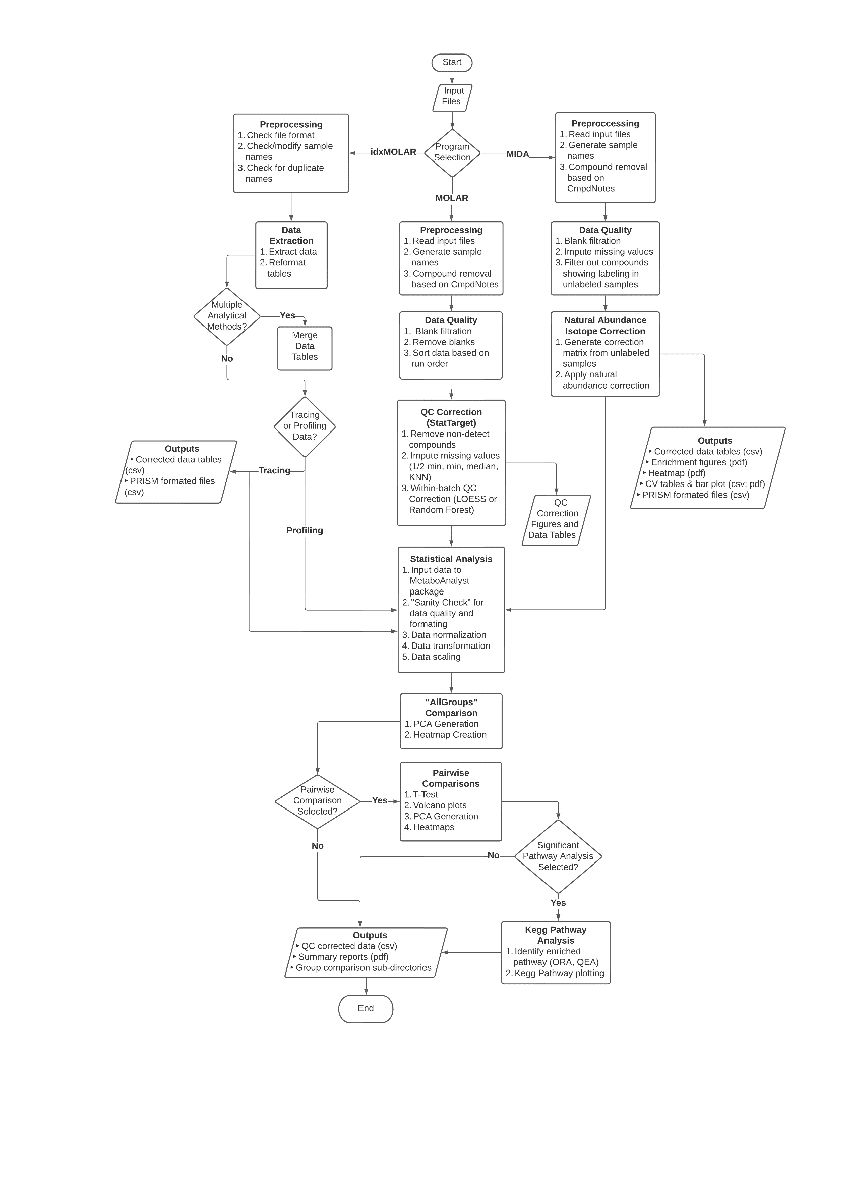
EMeRGe flowchart

Figure 2-1 EMeRGe Flowchart

Program Setup and interface

Installing and running EMeRGe
- Download EMeRGe from GitHub: https://github.com/VAI-Metabolism/EMeRGe. Included scripts:
- app.R, server.R, ui.R : EMeRGe shiny app files (app.R launches the app)
- idxUtils.R : contains shared functions and idxMOLAR specific functions
- molarUtils.R : contains MOLAR specific functions
- midaUtils.R : contains MIDA specific functions
- idxMOLAR.bat : batch file used to launch the EMeRGe ShinyApp on Windows OS
- dependencies.R : used to install required R libraries to run EMeRGe pipelines
- Install the required R packages by running the “dependencies.R”
- Run the “app.R” script in Rstudio , or edit the paths in idxMOLAR.bat batch file and run it.

MOLAR graphical user interface

Main interface

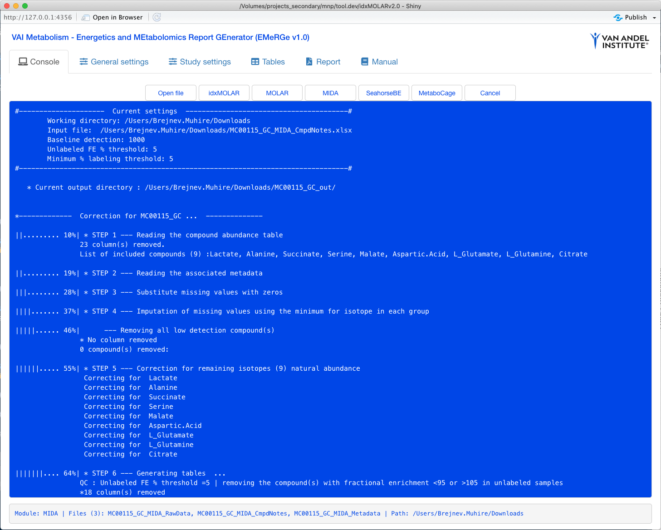
Figure 3-1 Main Interface
The main interface (Figure 3-1) consists of a “console” tab which contains command buttons for loading input files and running all the programs, and a window that displays all computation messages.

General settings tab

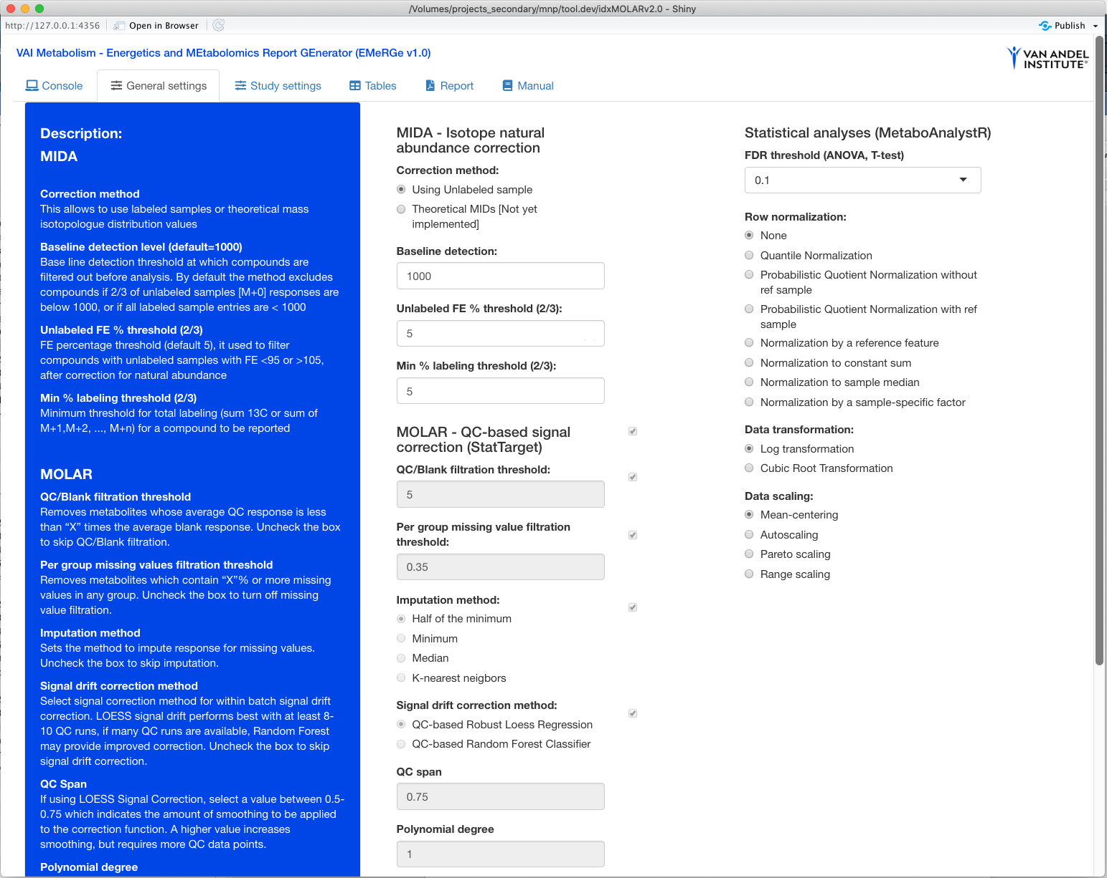
Figure 3-2 General settings tab
The general settings tab (Figure 3-2) allows the user to set parameters used for isotope natural abundance correction, QC-based signal correction and statistics analyses.

Isotope natural abundance correction (MIDA):
- Correction method: allows using labeled samples or theoretical MIDs (Theoretical MIDs not yet implemented)
- Baseline detection level: removes a compound if (2/3) for M+0 in any group is bellow threshold
- Unlabeled FE% threshold (2/3): removes a compound with 2/3 of unlabeled samples in any group having for example FE <95 or >105 after correction for natural abundance.
- Min % labeling threshold (2/3): minimum cut-off for total labeling (total 13C or M+1 + M+2 + ... + M+n). Removes a compound If 2/3 for samples in any group are below threshold

QC-based signal correction with StatTarget (MOLAR):
- QC/Blank filtration threshold*: set threshold to remove samples with low response
- Per group missing value filtration threshold*: remove compounds with low detection rate
- Imputation method*: set imputation method for missing response values
- Signal-drift correction method*: sets method for signal correction (random forest or loess)
- QC span: the smoothing parameter for the correction function
- Polynomial degree: sets the degree for the signal correction model
*Functions can be turned on or off using the checkbox

Statistical Analysis and Reporting (MetaboAnalyst) (idxMOLAR, MOLAR, and MIDA):
- FDR: set the threshold to identify significant difference in metabolite response
- Row normalization: allows selecting a normalization method
- Data transformation method: allows selecting a data transformation method
- Data scaling method: allow selecting a data scaling method

Study settings tab
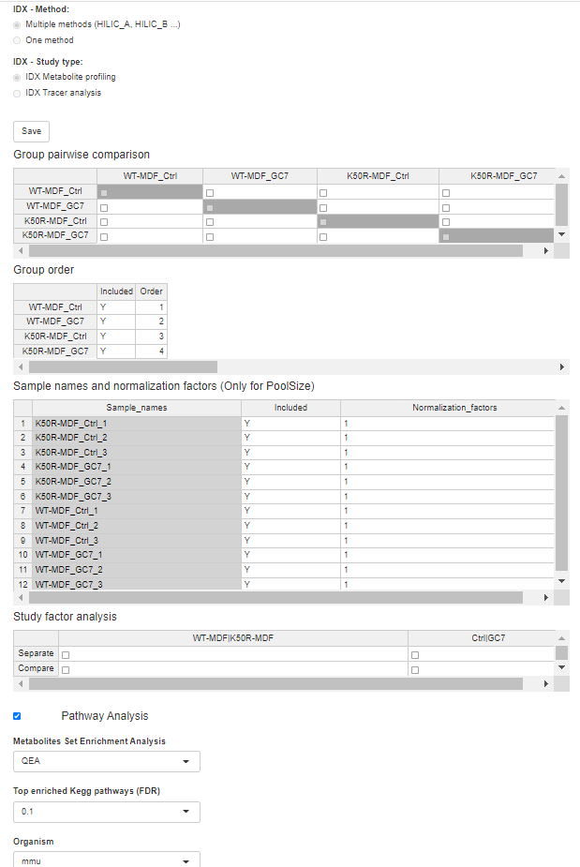
Figure 3-3 Study settings tab
The study settings tab (Figure 3-3) allows setting IDX method (one or multiple) and study type (profiling or tracer). For all programs, allows setting various study settings, including group pairwise comparison, group ordering/removal, using sample normalization factor and study factor and pathway analyses
The study setting tab allows the user to select the analyses of interest:
- Study Type (idxMOLAR specific):
  - Indicates if the input file(s) are data from a single or multiple ID-X analytical methods
  - Selects the type of IDX experiment as “tracing analysis” or “metabolite profiling”
- Group pairwise comparison:
  - The table (matrix with checkboxes) gets displayed once the input is load and allows to select which group pairs to be compared.
- Group order:
  - This table allows to exclude any specific group by changing Y to N (case insensitive) and the “order” column allows changing the ordering of group on final plots.
- Sample names and normalization factors:
  - Enter “N” if one or more samples should be excluded from analysis (for samples which may be an outlier). Each sample group must have a minimum of two biological replicates. Values for removed samples are imputation using average of the other replicates in the group.
  - Normalization factor for one or more samples (e.g. used to account for number of cells)
- Study factor analysis:
  - Once the input file is loaded, a table is generated, allowing the user to select if study factors that should be analyzed separately or comparatively
- Pathway analysis:
  - Pathway enrichment method selects one of the pathway enrichment method:
  - Quantitative Enrichment Analysis (QEA): computed from concentration data from multiple samples (two groups) and uses the Global test algorithm. The enriched metabolite sets can be identified when only a few compounds are significantly changed or when many compounds are only slightly (but consistently) changed. The algorithm uses a generalized linear model to estimate a ‘Q-stat’ for each metabolite set. The Q-stat describes the correlation between compound concentration profiles, X, and phenotype labels, Y. (MSEA; Xia & Wishart, 2010)

  - Metabolite Over-Representation Analysis (ORA): evaluates whether a particular set of metabolites is represented more than expected by chance within a given compound list. It is based on a cumulative hypergeometric distribution (Boyle et al. 2004, & Xia &Wishart, 2010)

  - Top enriched Kegg pathways (FDR): sets the threshold for determining significantly enriched Kegg pathways.
  - Organism: select the studied organism to peak the corresponding Kegg pathway

Tables, Report, and Manual tabs

- The “Tables” tab allows users to view current output tables:
  - MID FE: Mass Isotopologue Distribuition fractional enrichment
  - T.Label FE: total labeling fractional enrichment
  - PoolSize: total pool size
  - MID PoolSize: Mass Isotopologue Distribution pool size
  - T.Label PoolSize: total labeling pool size

- The “Report” tab allows users to view the output report (pdf).
- The “Manual” tab allows users to view this manual (pdf).

Metabolomics pipelines

IDX-MetabOLomics Analystical Results (idxMOLAR)

idxMOLAR performs statistical analyses for data from metabolite profiling and isotope tracing experiments run on the Thermo Orbitrap ID-X platform and pre-processed by Compound Discover software. It streamlines data extraction, filtration, normalization, and scaling, and statistical analyses, visualization and reporting. The final output contains a final user-friendly report (.pdf) grouping all generated figures (heatmaps, PCA plots, volcano plots etc.), data tables (.csv) associated with figures, table for statistical tests performed, tables for visualization PRISM, and a log file detailing the processing. For statistical analyses idxMOLAR, MOLAR and MIDA uses functions adapted from MetaboanalystR package (https://github.com/xia-lab/MetaboAnalystR). Note: pathway analysis will be implemented when we figure out how to export compound Kegg IDs from Compound discover.

idxMOLAR sample naming

Sample naming occurs when setting up the run on the instrument for sample analysis. Properly naming each sample is critical for idxMOLAR to identify the analytical method, sample ID, replicate number, and treatment group.

IDX-Methods: HILIC_A, HILIC_B, LIPID, T3, T3pos, PHneg, Phpos, PHTCA

Sample name format:
{idxMethod}_{ExperimentID}_{SampleID}_{StudyFactor1}_{StudyFactor2}_..._{ReplicateNumber}.raw

Sample name example:
HILIC_B_MC00071_04_PDL1OE_30min_1.raw

Sample ID: “Not required”
Method: “required”
Experiment_ID “required”
HILIC_A_MC00082_S34_8hr_ACLYKO_Acetate_2.raw
LIPID_MC00082_S31_2hr_BDH1KO_Lactate_3.raw

replicate number “required”
Study factors “at least one study factor is required”

Note: Study factor name should NOT contain the underscore “_” or space character.

idxMOLAR input files

idxMOLAR takes as input the output data file directly from Compound Discover in .xlsx format. The file should be named as follows:

File name format: {ExperiemntID}_{idxMethod}.xlsx

File name example: MC00139_HILIC_A.xlsx

If multiple analysis methods were used, the experiment identifier must be the same for each

Example: MC00139_HILIC_A.xlsx, MC00139_HILIC_B.xlsx, MC00139_PHneg.xlsx etc.

The Compound Discover export file can be used as shown in Figure 4-1, with the nested rows hidden or shown. Column A (“Checked”) should report “TRUE” or “FALSE”. “TRUE” indicates that the compound will be included in the downstream statistical analyses. However, output tables for both the checked compounds and all compounds are generated.

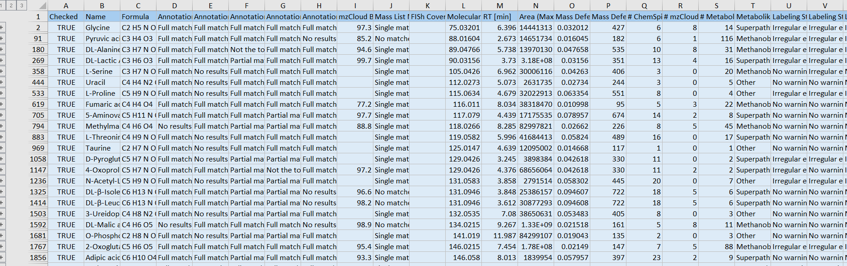
Figure 4-1 idxMOLAR Input data
idxMOLAR input file (Figure 4-1) is in Excel format directly generated form compound Discover, it is directly loaded into idxMOLAR without additional files or formatting.

idxMOLAR program settings

idxMOLAR pipeline setting include those for Statistical analyses (MetaboAnalystR) section of General Settings Tab (see Section 3.2.2) and settings of IDX-method, study type (profiling/tracer), group pair comparison, group ordering, sample exclusion and scaling, study factor analyses all found on the Study Settings Tab (see section 3.2.3).

idxMOLAR data processing steps

Step 1: Pre-processing of the input:
After loading the input file:
- Checks whether idxMOLAR file name format is respected 'MC00099_HILIC_A.xlsx’
    - Checks whether you have multiple files in case study type “MultiMethods” was selected
    - Reading the input files
    - Removing any date stamp (14 digit format) from sample names.
    - Renames duplicated compound names (eg. ADP, ADPb, ADPc).
    - Removes process blanks (MC-PB), double blanks (MC-DB), and QC samples

After clicking the ‘run idxMOLAR’ command button:
    - Checks if input data format matches study type (profiling tracer).
    - If the data has >800,000 lines makes table for only selected compound.

Step 2: Extracting data tables (MID_FE, PoolSize, and TotalLabeling_FE)
- Extracts the tables for all and selected compounds
- Missing data for some samples / compounds is filled with zeros (for MID_FE).
- Uses the maximum value for duplicated samples for a given compound (for PoolSize).

Step 3: Reformatting each individual table
- Reformats the MID_FE, PoolSize, and TotalLabel_FE
- Reformats names, removes the method and project number from the sample names
- Appends a method prefix to compound names (Method abbreviation) for (idxMOLAR):
Abbr: HILIC_A: ‘a’, HILIC B: ‘b’, LIPID: ‘l’, T3pos: ‘ t3’, PHpos: ‘pp’, PHneg: ‘pn’, PHTCA: ‘pt’
- Removes the indicated samples and/or groups
- Imputes new replicates for group with less than 3 replicates
- Scales final values with normalization factors

Step 4: Merging Method 1 and Method 2 data ... (Only when IDX Method=’Multi-Methods’)
- Merges the data similar tables generated for different methods
- In the file name replaces method names 'HILIC_A', 'HILIC_B' with “Comb” indicating combined data from different methods.
- Generates MID_PoolSize and Total_Labeling PoolSize tables

Step 5: Generating tables for PRISM (only for selected compound, for tracer study only):
  - FE_12C_13C: fractional enrichment showing the percentage sum of C12 and C13 for each sample and biological replicate.
  - FE_MID: fractional enrichment (M+0, M+1, . . ., M+n) for each sample and biological replicated
  - Intensity_12C_13C: The intensity obtained by multiplying FE_12_13C by PoolSize
  - Intensity_MID: The intensity obtained by multiplying FE_MID by PoolSize

STEP 6: Statistical Analysis and Reporting (MetaboAnalyst)
- Input pre-processed, filtered data into MetaboAnalyst R script
- “Sanity Check” determines if data is suitable for analysis
- Mechanisms to impute minimum values and filter based on RSD if needed
- Data normalization, transformation, and scaling based on selected settings
- For All Groups, 2D and 3D PCA plots and heatmaps are generated with all associated data displayed in csv tables. ANOVA is preformed and the associated table result is saved.
- For two groups, 2D PCA, heatmaps, volcano plots are generated, T-test, and associated data is provided in csv tables.
- Performs study factor analysis separately or comparatively

Step 7: Report generation:
- All generated figures are compiled in one report
- A log file is detailing the run generated

idxMOLAR output
The output directory name is the input file name plus ‘_out’ suffix for “One Method” e.g. “MC00139_HILIC_A_out”, and ‘_comb_out’ for ‘Multiple Methods’ e.g. “MC00139_comb_out”.

The directory contains all individual report figures (PDF/PNG) and data tables (CSV) containing statistical results ( Figure 4-2).

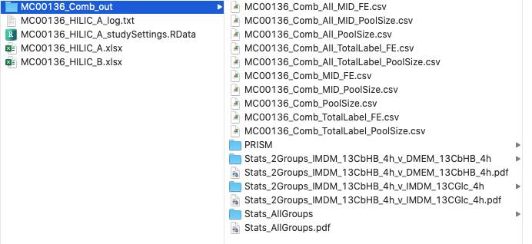
Figure 4-2 idxMOLAR output directory

- The output tables for all compounds and selected compounds (MID_FE, MID_PoolSize, TotalLabel_FE, TotalLabel_PoolSize).
- PRISM folder: contains all PRISM .csv files associated with each compound that was selected.
- Stats_AllGroups: statistical analysis output for all groups comparisons
- Stats_2Groups: directory whose name stats with “Stats_2Groups” (eg. Stats_2Groups_IMDM_13CbHB4h_vs_DMEM_13CbHP_4h) contain results of the listed pairwise comparison.
- PDF report containing figures in each subdirectory (Stats_AllGroups, Stats_2Groups)

MetabOLomics Analytical Results (MOLAR)

MOLAR accepts GC-MS and LC/QQQ-MS Agilent MassHunter Quantitative Analysis software generated data and performs data pre-processing, filtration, QC sample-based signal correction (StatTarget), statistical analyses, data visualization and pathway analysis. Similar to idxMOLAR, MOLAR generates a user-friendly report (.pdf) grouping all generated figures (heatmaps, PCA plots, volcano plots etc.), data tables (.csv) associated with figures, table for the statistical tests performed, and a log file detailing the processing.

MOLAR sample naming

The sample names are generated using the study factor/group information provided in the metadata input file.

Sample name format: { StudyFactor1}_{StudyFactor2}_..._{ReplicateNumber}.raw

Sample name example: WT_HFD_24hr_1.raw, KO_HFD_24hr_1.raw etc.

Note: Study factor name should NOT contain the underscore (“_”) character.

The input data also include Blanks and QC samples named differently from the other samples and contains the following key words followed by injection number (#):
- “MC-DB_#” (metabolomics core double blanks) used for testing machine performance
- “MC-PB_#” (metabolomics core process blanks) used for QC/blank filtration.
- “QC_#” Quality control (QC) samples used for QC/blank filtration and QC-based signal correction

MOLAR input files

The input data consists of three Excel files (.xlsx) containing:
          - Raw data: contains compound response values
          - Metadata table: describes samples,
          - Compound note table (xlsx): lists the names of all compounds to be analyzed their Kegg IDs, and a column indicating whether to include or exclude a compound

The file naming structure is shown in Table 4-1.
File name format: {ExerimentID}_{ProgramName}_{fileType}.xlsx

Table 4-1 MOLAR Input File Naming
File Type | Naming format | Example
Raw Data File | {ExperimentID}_MOLAR_RawData.xlsx | MC00028_MOLAR_RawData.xls
Metadata File | {ExperimentID}_MOLAR_Metadata.xlsx | MC00028_MOLAR_Metadata.xls
Compound Notes File | {ExperimentID}_MOLAR_CmpdNotes.xlsx | MC00028_MOLAR_CmpdNotes.xls

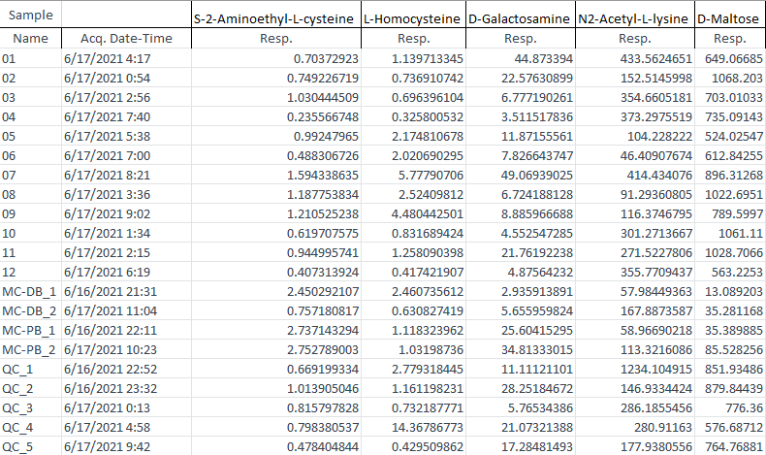
Figure 4-3 MOLAR Raw Data
The Raw Data input file is the MS-Excel file output generated by Agilent MassHunter Quantitative Analysis software (Figure 4-3). Sample names and information are listed in first column (‘Sample’), compound names are listed on the top row. The values indicate the response for each compound in each sample. MassHunter allows the user to output additional information about each sample: the Raw Data file must include the sample acquisition time (Acq. Date-Time) and sample response. Any other sample information should be excluded (If the exported file contains additional information, manually delete from the Raw Data file, or re-export from MassHunter with only the necessary information displayed).

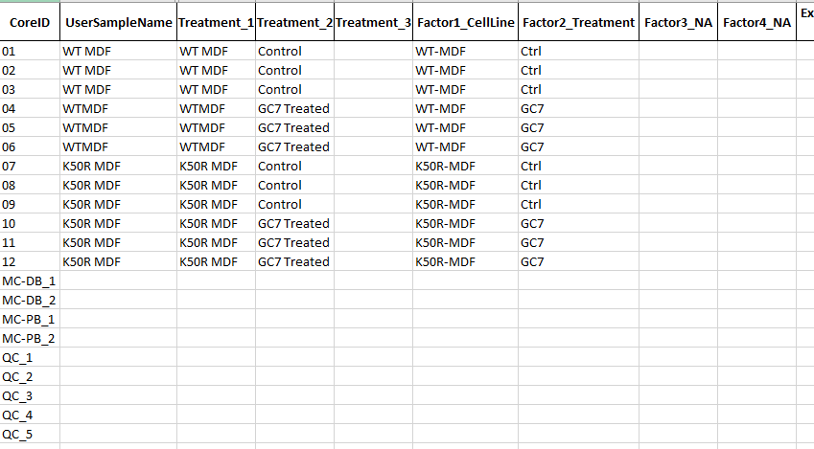
Figure 4-4 MOLAR Metadata
Sample names are listed the first column “CoreID” and must match and be in the same order as Sample names in the Raw Data file. Necessary metadata information is listed across the columns. The “UserSampleName” and “Treatment_#” columns are used to input information directly from the Core user (the person/group who generated the samples), so that they may use it as reference to know the identity of each sample.

The “Factor#_{name}” information is translated the MOLAR-friendly sample names. At least one study factor is required, and study factor name should NOT contain the underscore “_” or space character. The study factor name is taken as treatment name or its abbreviated version (i.e short factor names are preferred).

Four factor columns are available, but more can be added by the user if needed. For any factor columns not used “NA” should be added after the underscore.

The double blanks (MC-DB_#), process blanks (MC-PB_#), and quality control samples (QC_#) do not need any information entered in these columns.

A Metadata template is available to ensure consistent formatting. Multiple other columns for metadata information are provided which may be relevant for experiment information or recording sample handling procedures. These columns are not necessary for MOLAR and may be filled in or left blank in accordance with the experiment’s needs.

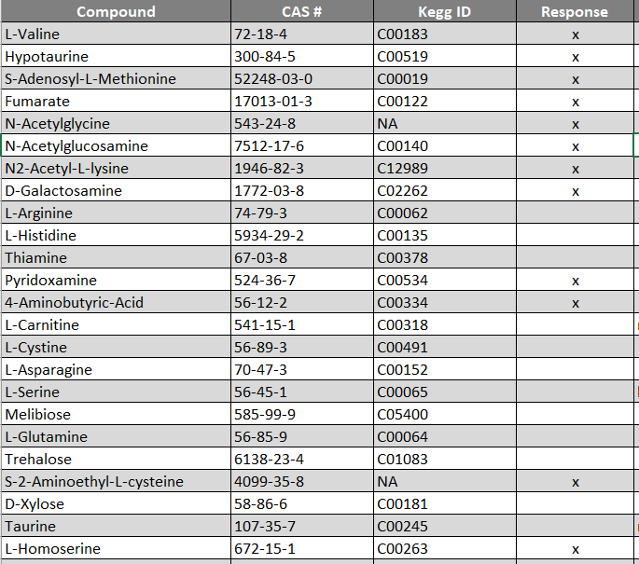
Figure 4-5 MOLAR Compound Notes
Compounds are listed in first columns and should be identical to the names used in the raw data table. The CAS number and KEGG ID must be provided for each compound (or NA). The “Response” column indicates if each compound was detected during mass spectrometry analysis; an “X” in the “Response” column denotes which compounds were not detected and should be excluded from the analysis. A Compound Notes template is available to populate to ensure consistent formatting.

NOTE: For all input tables, NO extra data are is allowed bellow or outside of the table, since extra data will cause an error.

MOLAR program settings

The general settings that apply for MOLAR are “QC-based signal correction (StatTarget) and Statistical analyses (MetaboAnalystR) (see Section 3.2.2) and group pair comparison, group ordering, sample exclusion and scaling, study factor analyses and pathway analyses, all found on the Study Settings (see section 3.2.3).

MOLAR data processing steps

STEP 1: Pre-processing
- Checks if all required files are available (raw data, meta data, compound note)
- Reads raw, compound, and metadata files
- Checks whether initial sample names (CoreIDs) are identical between raw data and metadata
- Generates new sample names by concatenation of study factors in the format: {Factor1}_{Factor2}_..._ReplicateNumber). New names are saved in ‘MetadataE.csv’
- Reformats compound names (replace space with dot, dashes with underscores, digit at the beginning of compound name with “X”.digit).
- Checks whether compound names match between raw data and compound note
- Filters out compounds marked with “X” on the compound note data file
- Checks for duplicated sample or compound names
- Checks whether sample names match between raw data and metadata

STEP 2: Data quality control
- QC/Blank filtration. Removes compounds with a sample response less than “X” times higher than the response in the blank
- Removes process blanks (MC-PB) and double blanks (MC-DB)
- Sort data based on run order using acquisition time from the Raw Data File
- Checking if the starting samples consists of at least three QC samples

STEP 3: QC correction (Stat Target)
- Remove non-detected compounds (remove compound results for a sample group if more than X% of the samples responses are zero/non-detect)
- Impute missing values per group per compound (half of the minimum, minimum, median, or KNN)
- Perform within-batch signal correction using Loess Regression or Random Forest
- Generate QC Correction Summary Figures
- Create QC and Sample run order vs response scatterplots
- Generates PCA for samples before and after correction compared clustering improvement
- Produce pdf displaying the magnitude of RSD difference per sample group per compound
- NB: any of the steps above can be skipped using the corresponding checkbox in the general settings tab.

STEP 4: Statistical Analysis and Reporting (MetaboAnalyst)
- Input pre-processed, filtered data into MetaboAnalyst R script
- “Sanity Check” determines if data is suitable for analysis
- Mechanisms to impute minimum values and filter based on RSD if needed
- Data normalization, transformation, and scaling based on selected settings
- For All Groups, 2D and 3D PCA plots and Heatmaps are generated, ANOVA test is performed and associated table is saved.
- For two groups, 2D PCA plots, Heatmaps are generated, and t-Test and associated data is provided in csv table.
- Performs study factor analysis separately or comparatively
- Performs path way analysis

Step 5: Report generation:
- All generated figures are compiled in one report
- A log file is detailing the run generated

MOLAR outputs

MOLAR produces a PDF summary report containing figures which display the results of the statistical analyses. MOLAR also generates a data folder (named ExperimentIdentifier_out) with all individual report figures (PDF/PNG) and data tables (CSV) containing statistical results.
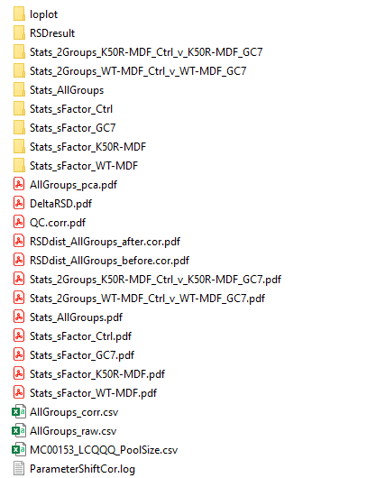
Figure 4-6 MOLAR output directory

- Figures to assess QC Correction effect (loplot, RSDresult, DeltaRSD, QC.corr, RSDdist_AllGroups_after.cor, RSDdist_AllGroups_before.cor)
- Folders for the individual PDFs and supporting tables (csv) for the AllGroups report (Stats_AllGroups), pairwise comparison reports (Stats_2Groups_GroupA_v_GroupB), and comparative or separate factor reports (Stats_sFactor_SelectedFactor)
- CSV files for the raw and corrected data (AllGroups_raw and AllGroups_corr) with their sample and group name, and arranged based on instrument injection order.
- ExperimentIdentifier_PoolSize.csv contains raw data formatted properly for upload to MetaboAnalyst (https://www.metaboanalyst.ca/) so the results of the MOLAR analysis can be compared to the results of the online tool on which it was based.
- Record of the parameters selected in the general settings tab in the ParameterShiftCor.log

Mass Isotopologue Distribution Analysis (MIDA)

MIDA streamlines stable isotope natural abundance correction for metabolite tracing experiments. It accepts raw GC-MS data exported from Quant and pre-process (filtration, transformation, scaling), performing isotope natural abundance correction followed by statistical analyses, pathway analysis and similar to idxMOLAR and MOLAR programs, it generates a user-friendly report (.pdf) grouping all generated figures (heatmaps, PCA plots, volcano plots etc.), data tables (.csv) associated with figures, table for statistical tests performed, and a log file detailing the processing.

Rationale for isotope natural abundance correction:
Isotopes are naturally occurring atoms that have one or more extra neutrons in their nucleus; the added neutron(s) increase the molecular weight of the atom. When an atom with an isotope is found in a metabolite, the mass shift from the additional neutron can be seen in mass spectral analysis.
This phenomenon can be utilized to design metabolite tracing experiments in which a labeled substrate (such as ¹³C glucose) is introduced into a biological system (cell culture, mouse, etc.), and the labelled atoms can be tracked through metabolic pathways. As the labeled atoms move through metabolic processes, the labeled atoms may accumulate in a certain metabolite, causing the metabolite to have a mass of M+1, M+2, M+3…to M+N (where N equals the number of carbons in the metabolite). In this manner, a researcher can understand the flux of metabolites in a system.

When analyzing the results of a tracing experiment, it is crucial to account for the natural abundance of stable isotopes (Midani). Fernandez et al. describes the matrix equation which can be used to account for the natural abundance of ¹³C:
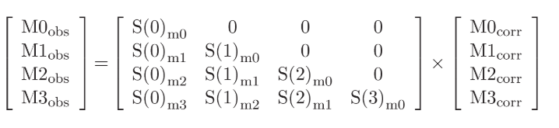
A_{observed}
[CM]
A_{corrected}

$$A_{observed}=\left[CM\right]×A_{corrrected}$$

$$A_{corrected}={\left[CM\right]}^{-1}×A_{observed}$$

Where:
[CM] = matrix of natural abundance correction factors
A_{observed} = vector of observed abundance (uncorrected data)
A_{corrected} = vector of corrected abundance (corrected data)

The correction factors represent the naturally occurring abundance of each isotopologue (M+N). The correction factors can be determined theoretically (based on the number of carbons contained in the compound, and the naturally occurring abundance for ¹³C). However, when performing GC-MS analysis, the samples are typically derivatized to improve chromatographic separation and peak identification. During derivatization, other chemical groups are attached to the compounds of interest, making it difficult to identify the exact chemical formula for the molecule. Furthermore, the impacts of GC-MS noise and uncertainty cannot be quantified and applied as part of the correction factor.

It is preferred to determine the natural abundance experimentally, by analyzing unlabeled samples alongside the labeled samples. In this manner, the difficulty of assigning chemical formulas to compounds can be avoided, and GC-MS variation can be incorporated.

Although relatively straightforward, construction and manipulation of the matrices needed to perform the correction becomes a cumbersome and error-prone process when completed with the large datasets generated by GC-MS analysis. Trefely et al. published a webtool based on R code to automatically perform the correction process (http://fluxfix.science/
; https://github.com/sophietrefely/traceranalysis). However, only one metabolite can be corrected at a time, reducing the potential efficiency of the correction process. Furthermore, the corrected data is presented in a simple matrix format, which requires additional manipulation to generate the figures needed to visualize the results. MIDA was created to streamline natural abundance correction for metabolite tracing experiments.

MIDA sample naming

Similar to MOLAR the sample names are generated using the study factor/group information provided in the metadata input file. Also the metadata table contains a column indicating whether a sample is labelled or unlabeled.

Format: { StudyFactor1}_{StudyFactor2}_..._{ReplicateNumber}.raw

Sample Name Example: WT_HFD_24hr_1.raw, KO_HFD_24hr_1.raw etc.

Note: no single study factor should contain the underscore (“_”) or space character.

The input data also include Blanks and QC samples named differently from the other samples and contains the following key words followed by injection number:
- “MC-DB_#” (metabolomics core double blanks) used for testing machine performance
- “MC-PB_#” (metabolomics core process blanks) used for QC/blank filtration.
- “QC_#” Quality control (QC) samples used for QC/blank filtration and QC-based signal correction

MIDA input files

The input data consists of three Excel files (.xlsx) containing:
          - Raw data: contains compound response values
          - Metadata table: describes samples,
          - Compound note table (xlsx): lists the names of all compounds to be analyzed their Kegg IDs, column indicating whether to include or exclude a compound

The file naming structure is shown in Table 4-2.
File name format: {ExerimentID}_{ProgramName}_{fileType}.xlsx

Table 4-2 MIDA Input File Naming
File Type | Naming format | Example
Raw Data File | {ExperimentID}_MIDA_RawData.xls(x) | MC00028_MIDA_RawData.xls
Metadata File | {ExperimentID}_MIDA_Metadata.xls(x) | MC00028_MIDA_Metadata.xls
Compound Notes File | {ExperimentID}_MIDA_CmpdNotes.xls(x) | MC00028_MIDA_CmpdNotes.xls

Specific input file formatting required for MIDA is described in Figures Figure 4-7, Figure 4-8, and Figure 4-9.

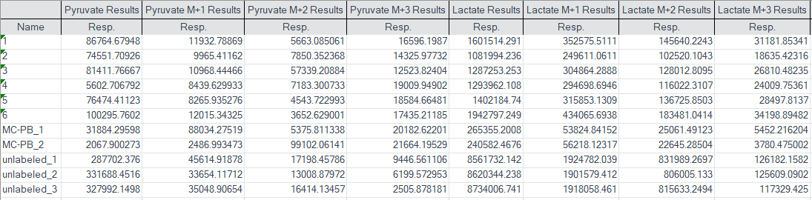
Figure 4-7 MIDA Raw Input File
The Raw Data file must include each isotopologue of a compound labeled as “Compound M+N Results” (Note: for M+0 no isotopologue number is needed). The isotopologues must be listed in ascending order.

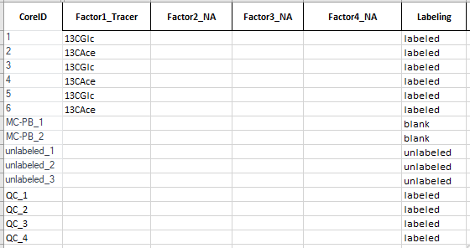
Figure 4-8 MIDA Metadata File
The necessary columns of the Metadata file for MIDA are shown. The CoreID should match the Name in the Raw Data file. Factors 1-4 may be used as needed to describe the sample’s group information. The sample’s “labeled”, “unlabeled”, or “blank” status must be entered in the Labeling column. QCs may be labeled or unlabeled in accordance with the samples. (Unnecessary columns not shown for clarity.)

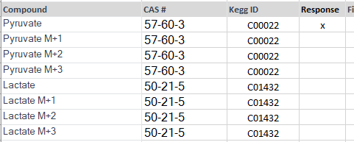
Figure 4-9 MIDA Compound Notes File
The compound notes must include the names of all the compounds, in the order they appear in the Raw Data file. The isotopologues may be included (as shown) or excluded from this file. Regardless, MIDA will filter out compounds which have an “x” marked in the response column for the M+0 isotope only.

MIDA program settings

MIDA setting for Isotope natural abundance correction are set on the General Settings tab (see Section 3.2.2) and group pair comparison, group ordering, sample exclusion and scaling, study factor analyses and pathway analyses, all found on the Study Settings (see section 3.2.3).

MIDA data processing steps

STEP 1: Pre-processing
After loading the input file:
- Check if all required input files are available (raw data, metadata and compound notes)
- Read raw data, compound note and metadata
- Checks whether initial sample names (CoreIDs) are identical between raw data and metadata
- Generates new sample names by concatenation of study factors in the format: {Factor1}_{Factor2}_..._ReplicateNumber). New names are saved in ‘MetadataE.csv’
After clicking the run MIDA command button:
- Reformatting isotopologue names (i.e. part of ‘M+0’ becomes ‘M.0’)
- Reformats compound names (replace space with dot, dashes with underscores, digit at the beginning of compound name with “X”.digit).
- Checks whether the compounds in the compound note file list match those in the data table
- Checks the ordering of isotopes (M+0, M+1, M+2…M+n) from raw data table
- Remove compounds as indicated in the Compound Notes file

STEP 2: Reading the metadata file
- Read metadata and check whether samples names match those in the input table.
- Selects only relevant rows for unlabeled and labeled

STEP 3: Substitute missing values with zeros
STEP 4: Imputation of missing value and filtration based on base-line detection threshold
- Filter out compound if 2/3 of unlabeled samples M+0 are below base-line detection threshold (default=1000) or all labeled sample entries are < 1000
- Impute of missing values (per group, per isotopologue, minimum value must be > 0)
- Remove all compounds which show labeling in more than 2/3 of the unlabeled samples (eg. 2/3 of unlabeled samples M+0 response is greater than Min % labeling threshold (e.g. for 5% threshold. Remove all compound with >105% or <95% total pool size.)

STEP 5: Correction for isotope natural abundance
- Natural abundance correction: for each compound, create the correction matrix, CM, from unlabeled data (for multiple unlabeled samples, the mean of each isotopologue is used). Each labeled sample is corrected using the following formula:

A_{corr} = [CM] ^{-1 x} A_{obs}

[CM]⁻¹: inverse of correction matrix*
A_{obs}: labeled sample MIDs
Acorr : corrected MIDs
*CM is obtained from the average response of each isotoplogue from the unlabeled samples, or from theoretical MIDs for a given compound, as selected in the general settings tab. (NOTE: use of theroretical MIDs not yet implemented.)
- Remove all compounds which show no labeling in more than 2/3 of the labeled compounds (eg. 2/3 of the labeled samples have a labeled pool (sum of M+1 to M+N) size that is less than 5% of the total pool size (M+0 to M+N))

STEP 6: Generating tables (csv)
- Produce output tables for all analyzed compounds (MID_FE, MID_PoolSize, TotalLabel_FE, TotalLabel_PoolSize).
- PRISM .csv files are generated for each compound
  - FE_12C_13C: fractional enrichment showing the percentage sum of C12 and C13 for each sample and biological replicate.
  - FE_MID: fractional enrichment (M+0, M+1, . . ., M+n) for each sample and biological replicated
  - Intensity_12C_13C: The intensity obtained by multiplying FE_12_13C by PoolSize
  - Intensity_MID: The intensity obtained by multiplying FE_MID by PoolSize

STEP 7: Generating figures
- Generate four isotope enrichment figures as pdf files
- Generate heatmap of compounds with fractional enrichment >5 in at least one group
- Output CV.pdf which provides assessment of the coefficient of variation for each compound for group.

STEP 8: Statistical Analysis and Reporting (MetaboAnalyst)
- Input pre-processed, filtered data into MetaboAnalyst R script
- “Sanity Check” determines if data is suitable for analysis
- Mechanisms to impute minimum values and filter based on RSD if needed
- Data normalization, transformation, and scaling based on selected settings
- For All Groups, 2D and 3D PCA plots and Heatmaps are generated with all associated data displayed in csv tables.
- For two groups, 2D PCA plots, t-Test, Heatmaps are generated, and associated data is provided in csv tables.
- Performs pathway analysis
Step 9: Report generation:
- All generated figures are compiled in one report
- A log file is detailing the run generated

MIDA outputs

Outputs from MIDA are saved into an output file {SampleIdentifier_out} located in the same file location as the input files (See Figure 4-10). This file contains data tables (csv) with the natural abundance corrected data table. It also includes fractional and total enrichment figures for each compound. In addition, csv files for each compound formatted for direct use with GraphPad Prism. MIDA also sends the corrected data directly through the statistical and pathway analysis routine implemented for idxMOLAR and MOLAR.

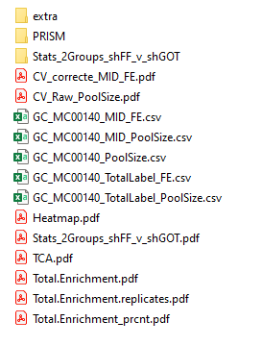
Figure 4-10 MIDA Output directory

- Output tables for all analyzed compounds (MID_FE, MID_PoolSize, PoolSize, TotalLabel_FE, TotalLabel_PoolSize).
- PRISM folder: contains PRISM .csv files for each compound
- Output enrichment figures containing all analyzed compounds (Total.Enrichment, Total.Enrichment.replicates, Total.Enrichment_prcnt, TCA, Heatmap)
- Graphs for visualizing the coefficient of variation for corrected and raw data (CV_corrected_MID_Fe and CV_Raw_PoolSize)
- Individual total enrichment percent PDF figures for each compound in “extra” sub-directory
- MOLAR Outputs (Stats_AllGroups, Stats_2Groups, and corresponding sub-directories).

Output directories and data tables

Producing interpretable, well-formatted data tables is one of the main goals of the EMeRGe pipelines. The data tables can be returned to users to support the validity of the figures, and allow the users to further investigate then data, perform additional statistical tests, and generate their own figures.

Beside the main data tables generated my all pipelines (FE, PoolSize, MID_FE, TotalLabeling_FE, TotalLabeling_PoolSize), within output subdirectories we have several tables described bellow:

Table 4-3 All Groups Sub-Directory

File Name | Description
01_09_T.pool_htmp_FDR_0.1_  metabolite_vs_all_samples_dpi72 | Heatmap data for group averages for metabolites with FDR < 0.1
01_10_T.pool_htmp_all_  metabolites_vs_all_samples_dpi72 | Heatmap data for all groups and all metabolites
01_10_T.pool_htmp_FDR_0.1_  metabolite_vs_all_samples_dpi72 | Heatmap data for all samples for metabolites with FDR < 0.1
01_11_T.pool_htmp_all_  metabolites_vs_all_samples_dpi72 | Heatmap data for all samples for all metabolites
T.pool_anova_all | ANOVA results (only comparisons of >2 groups)
T.pool_anova_posthoc | Posthoc ANOVA results (only comparisons of >2 groups)
T.pool_pca_loadings | PCA loading values for each compound
T.pool_pca_score | PCA score for each sample
tmpTPool | Raw Data formatted properly for upload to MetaboAnalyst

Table 4-4 Pairwise Comparison Sub-Directory
File Name | Description
msea_ora_result | Results for Kegg pathways with significant differences by ORA analysis
msea_qea_result | Results for Kegg pathways with significant differences by QEA analysis
name_map | Lists Kegg IDs, Compound Names, and other identifiers used in Kegg analysis
T.pool_fold_change | Results from fold change analysis
T.pool_t_test_all | T-test results for all metabolites
T.pool_t_test_sig | T-test results for metabolites with a significant difference between groups
T.pool_volcano_all | Volcano plot values for all metabolites
T.pool_volcano_sig | Volcano plot values for metabolites significant difference between groups
tmpTPool_kegg | Corrected Data formatted properly for upload to MetaboAnalyst

Table 4-5 Natural isotope abundance correction tables
File Name | Description
ExpID_X_MID_FE.csv | Percent isotopologue distribution (for each isotope)
ExpID_X_ MID_PoolSize.csv | Pool size for each isotopologue
ExpID_X_ TotalLabel_FE.csv | Sum of FE (M+1%, M+2%, … , M+N%)
ExpID_X_ TotalLabel_PoolSize.csv | Sum of labeled pool size (M+1, M+2, … , M+N)
ExpID_X_ PoolSize.csv | Sum of total pool size (M+0, M+1, M+2, … , M+N)

Table 4-6 PRISM Tables Sub-Directories (idxMOLAR & MIDA)
Sub-Directory | Contents
FE_12C_13C | Percent of each sample that is unlabeled (12C) versus labeled (13C)
FE_MID | Percent of each isotopologue (M+0, M+1, etc.) in each sample
Intensity_12C_13C | Response for each sample that is unlabeled (12C) versus labeled (13C).
Intensity_MID | Response for each isotopologue (M+0, M+1, etc.) in each sample

Reports and figures
Producing clear, understandable output figures is one of the main purposes of the mass spectrometry data pipelines. Important figures are compiled into summary output reports, but individual PDF figures are also generated in sub-directories.

Natural Isotope Correction Outputs and Figures (idxMOLAR and MIDA)
MIDA generates several figures that show the impacts of labeling on each group. Additional coefficient of variation figures are generated to provide insight into data quality.

- Total Enrichment
- Figure 4-11 Percent Enrichment
- Figure 4-12 Percent Enrichment in TCA Cycle Intermediates
- Figure 4-13 Raw Pool Size CV
- Figure 4-14 Corrected Fractional Enrichment CV

The total enrichment figure shows the average response of each isotope for each study group. A second total enrichment figure shows the response for each isotope in each sample. The percent enrichment figure shows group average isotopologue response normalized to 100%. The percent enrichment figure allows for a clear comparison of different labeling patterns in different study groups.

The Percent Enrichment in TCA cycle intermediates plots the percent enrichment graphs into a figure formatted to display the TCA cycle. Only intermediates for which a response was detected are shown. This provides the user an easy way to visualize labeling patterns moving through the TCA cycle.

The coefficient of variation (CV) (also known as relative standard deviation) provides insight to the variability of the samples within a group. The value of the CV for each compound in each sample group is graphed before and after natural isotope abundance correction. This figure highlights if specific metabolites did not have a consistent response during analysis.

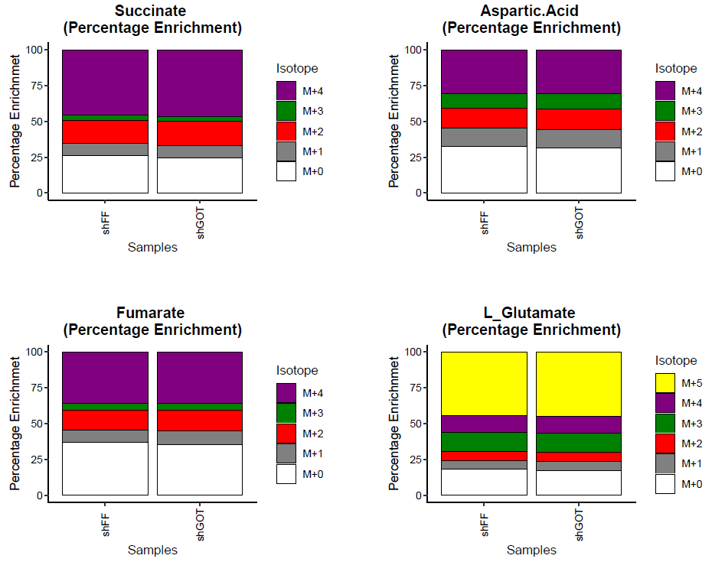
Figure 4-11 Percent Enrichment

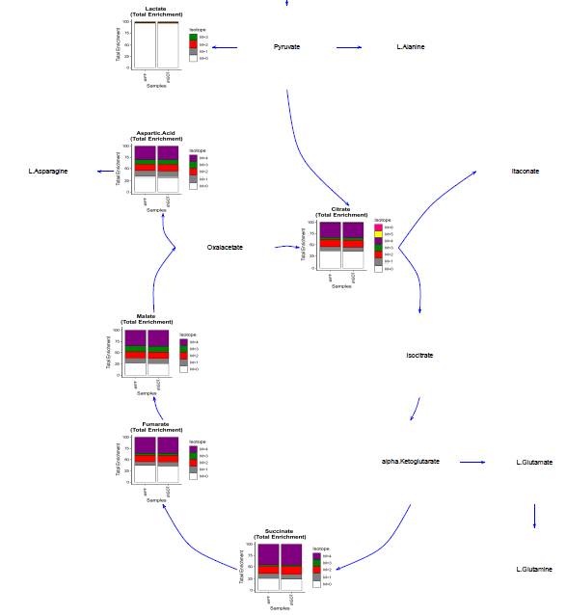
Figure 4-12 Percent Enrichment in TCA Cycle Intermediates

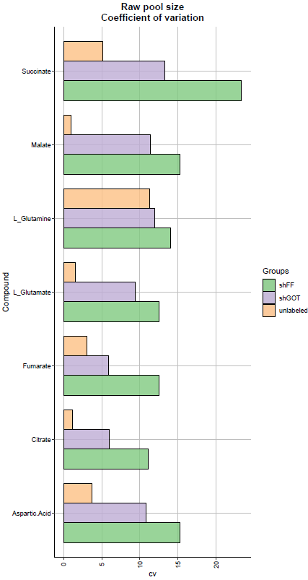
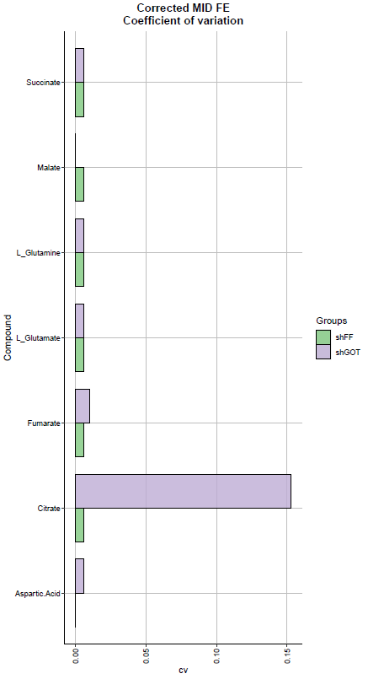
Figure 4-13 Raw Pool Size CV
Figure 4-14 Corrected Fractional Enrichment CV

For idxMOLAR, heatmaps are produced for each compound marked as “TRUE”, containing the M+N response for each sample and each isotopologue (Figure 4-15). These pdfs can be found in the FE_MID sub-directory.
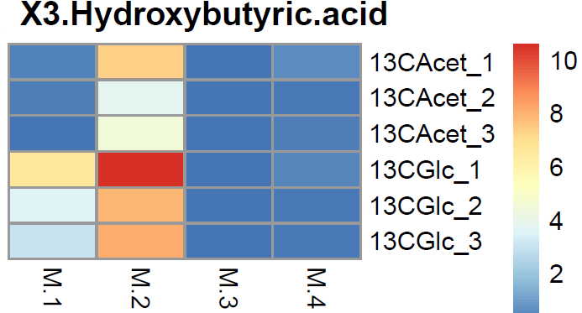
Figure 4-15 Fractional Enrichment Heatmap

QC Correction Outputs (MOLAR)
MOLAR provides sample-based QC correction. Multiple figures are generated to provide an assessment of the impacts of the QC correction to help determine if it improves data quality.

- Figure 4-16 QC CorrectionFigure 4-16 QC (Individual plots found in loplot subdirectory)
- Figure 4-17 All Groups PCA
- Figure 4-18 Delta RSD
- Figure 4-19 Cumulative Distribution of RSD Before and After QC Correction

The QC Correction figures (QC correction figures before and after correction are generated for each metabolite) plot sample response based on injection order. Sample (green symbol) responses falling more in-line with the QC (red symbol) responses indicate an improvement from the QC correction.

The All Groups PCA provides a PCA where each sample in a group is plotted as an individual point. If grouping of samples improves after QC correction, this indicates an overall benefit from applying the correction.

The relative standard deviation (RSD) is calculated for each compound before and after QC correction (results can be found in the RSD result subdirectory). The Delta RSD figure shows the result of subtracting the RSD before QC correction from the RSD after QC correction. If QC correction reduces RSD, (providing a negative value), the QC correction likely improved response.

The Cumulative Distribution of RSD figures indicate the number of compounds with an RSD less than the value indicated on the X-axis. A flatter line towards the top of the figure indicates that more compounds have a low (acceptable) RDS. Plotting the data before and after QC correction provides a visualization of the impact of QC correction for each group.
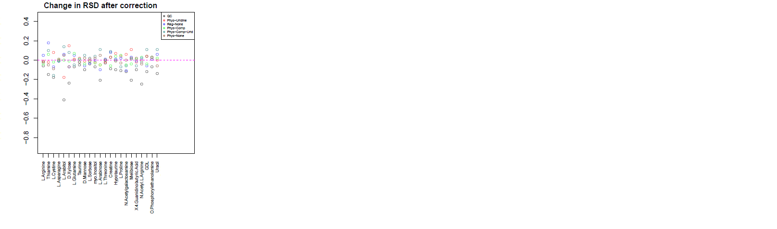
Figure 4-18 Delta RSD
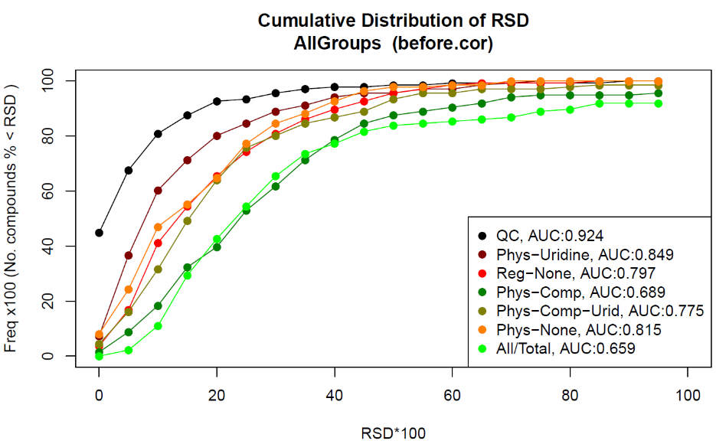
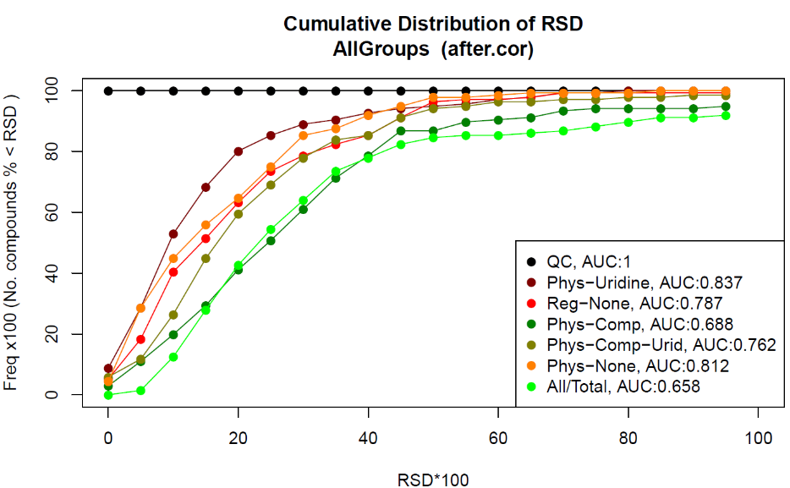
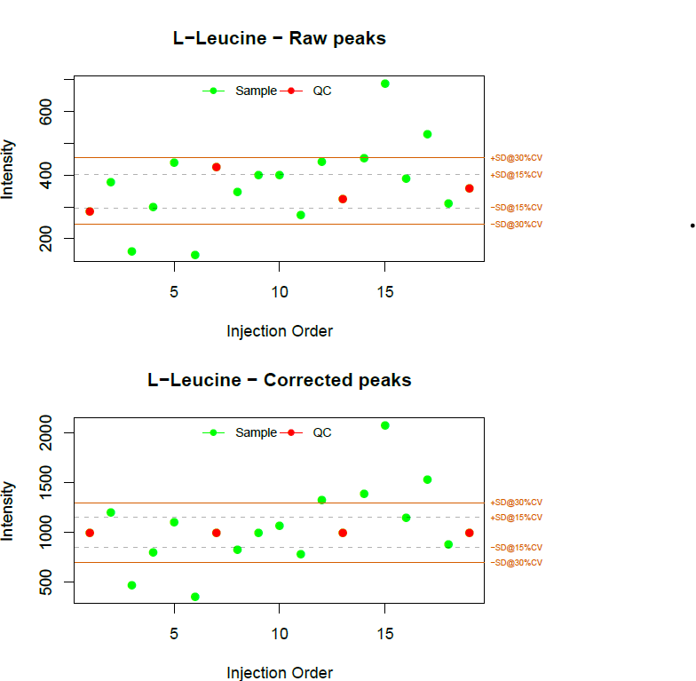
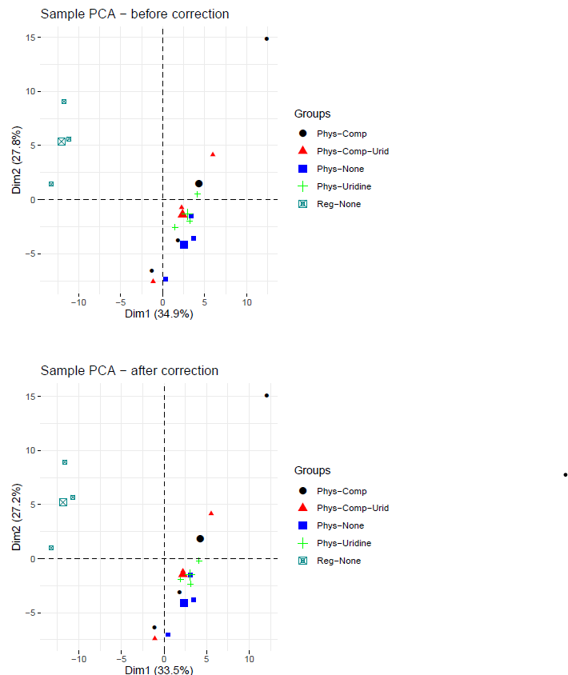
Figure 4-19 Cumulative Distribution of RSD Before and After QC Correction
Figure 4-16 QC Correction
Figure 4-17 All Groups PCA

NOTE: this QC-signal correction approach needs improvement. This method looks at results of overall QC-base signal correction for all metabolites in a sample group, as such on could implement a method that detect specific metabolites that need to be corrected perform correct for those metabolites only

Statistical Analysis (MetaboAnalyst) Outputs and Figures (all pipelines)
Output figures are compiled into a summary report and can be visualized using the “Report” tab or opened with a pdf viewer. Example figures are shown below. Items marked with an asterisk (*) are only generated for pairwise comparisons.

- Figure 4-21 Metabolite Normalization Summary
- Figure 4-20 Sample Normalization Summary
- Figure 4-22 PCA Pair Plot
- Figure 4-23 Scree Plot
- Figure 4-24 Scores Plot
- Figure 4-25 PCA Loading Plot
- Figure 4-26 Volcano Plot*
- Figure 4-27 3D Scores Plot
- Figure 4-28 Significant metabolites heatmap (all samples)
- Figure 4-29 Metabolite Set Enrichment Overview 1*
- Figure 4-30 Metabolite Set Enrichment Overview 2*
- Figure 4-31 Enriched Kegg Pathway*

In addition to the “Significant metabolites heatmap (all samples)”: there also
- Significant metabolites group averages
- All metabolites all sample
- All metatbolites group averages

Individual pdf and png files of each figure are found under the sub-directory folder with the same name as the report.

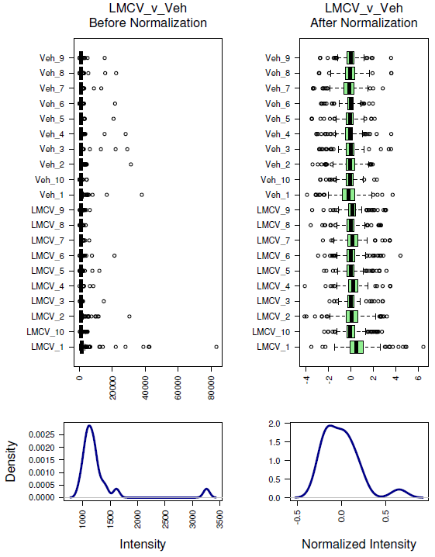
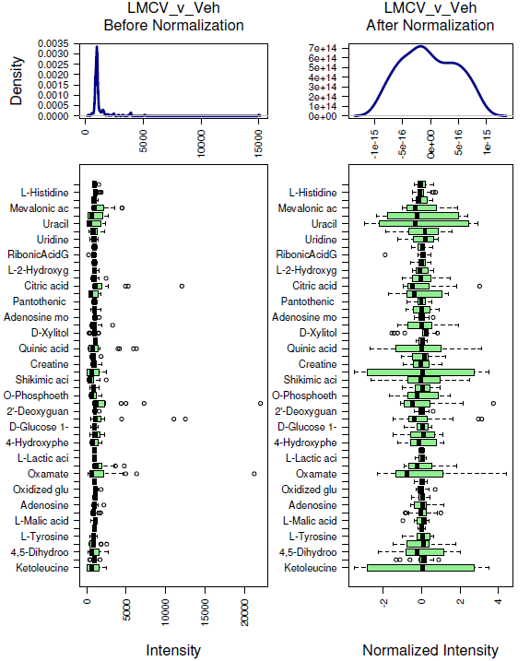
Figure 4-20 Sample Normalization Summary
Figure 4-21 Metabolite Normalization Summary

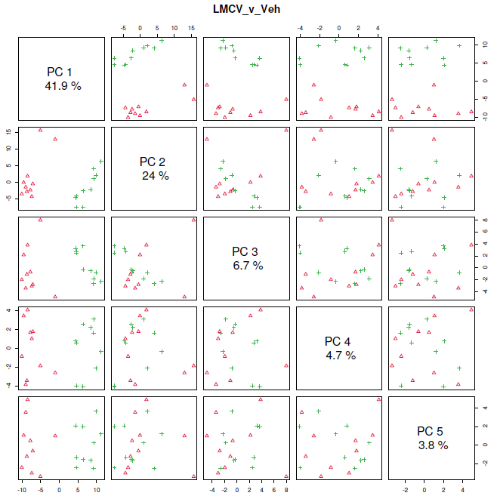
Figure 4-22 PCA Pair Plot
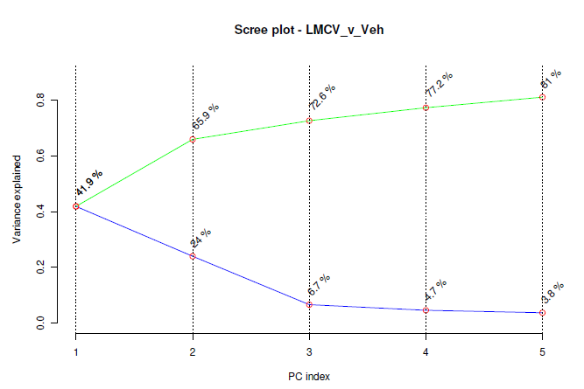
Figure 4-23 Scree Plot

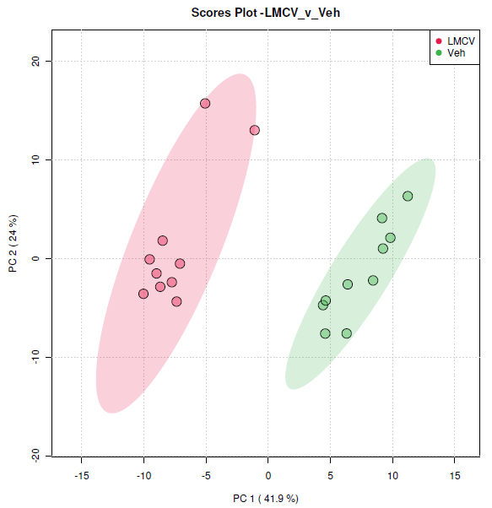
Figure 4-24 Scores Plot
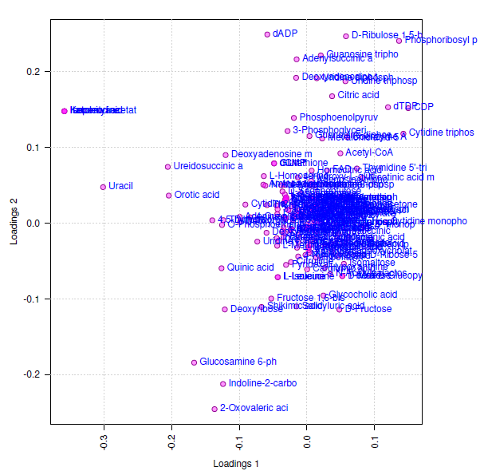
Figure 4-25 PCA Loading Plot

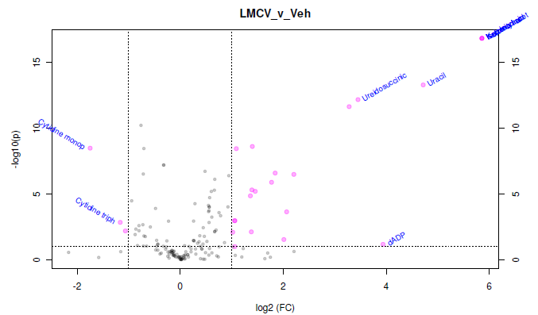
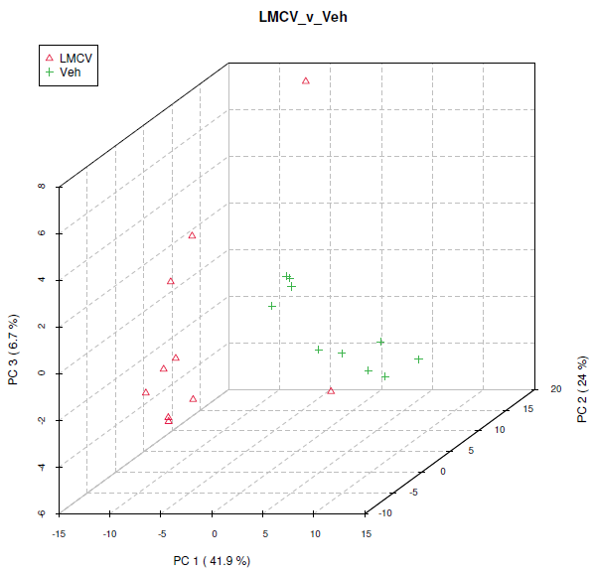
Figure 4-26 Volcano Plot
Figure 4-27 3D Scores Plot

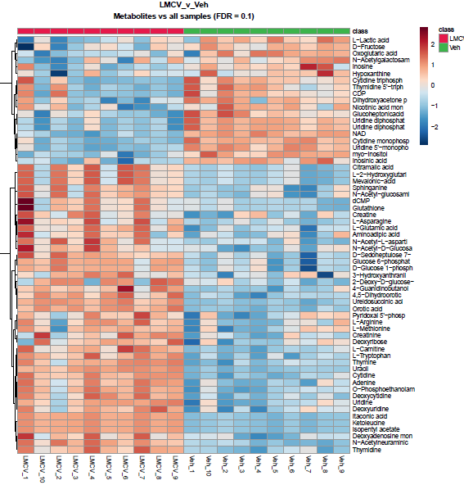
Figure 4-28 Significant metabolites heatmap (all samples)

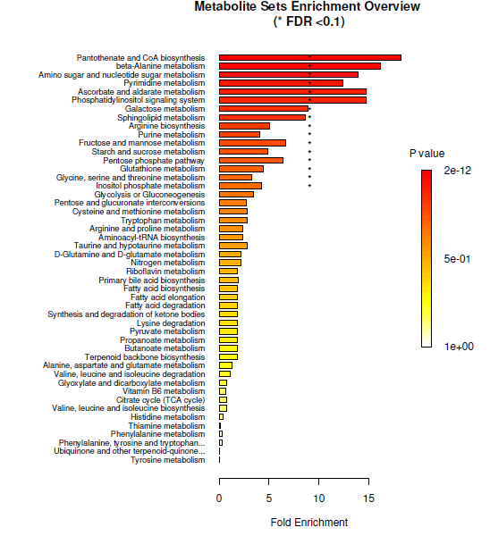
Figure 4-29 Metabolite Set Enrichment Overview 1

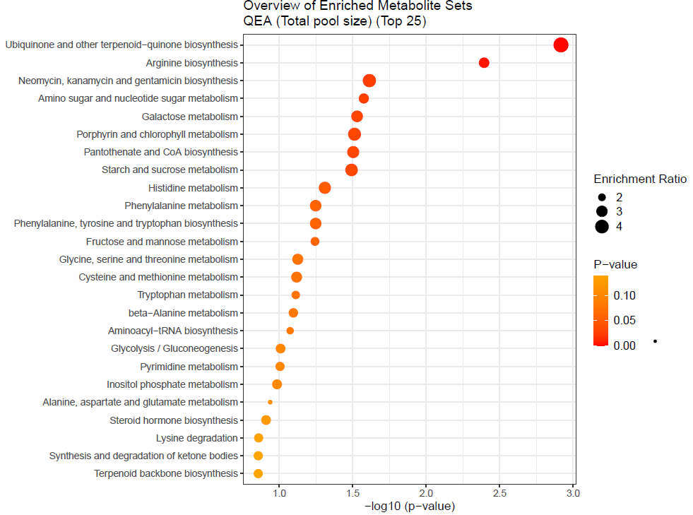
Figure 4-30 Metabolite Set Enrichment Overview 2

ß

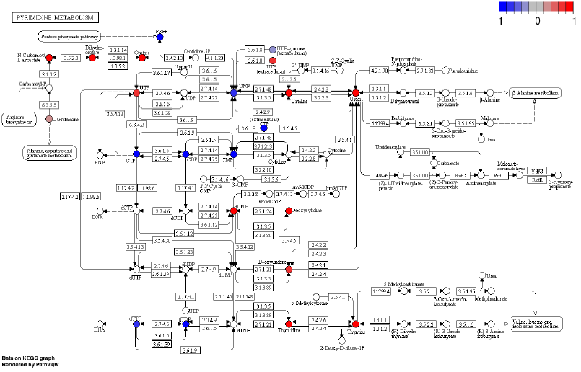
Figure 4-31 Enriched Kegg Pathway

Bio-energetics and Promethion pipelines

SeahorseBE
[Describe Pipeline]

MetaboCage
[Describe Pipeline]

References

Boyle, E.I., Weng,S., Gollub, J., Jin, H., Botstein, D., Cherry, J.M., and Sherlock, G.. (2004). “GO::TermFinder–open Source Software for Accessing Gene Ontology Information and Finding Significantly Enriched Gene Ontology Terms Associated with a List of Genes.” Bioinformatics (Oxford, England) 20 (18): 3710-5.
https://doi.org/10.1093/bioinformatics/bth456.

Chong, J., Wishart, D., Xia, J., (2019). Using MetaboAnalyst 4.0 for Comprehensive and Integrative Metabolomics Data Analysis. Current Protocols in Bioinformatics, Vol 68, e86. doi: 10.1002/cpbi.86

Xia, J., Wishart, D., (2010). MSEA: a web-based tool to identify biologically meaningful patterns in quantitative metabolomic data. Nucleic Acid Research, Vol 38, W71-W11, doi:10.1093/nar/gkq329

Xia, J., Wishart, D., (2010). MetPA: a web-based metabolomics tool for pathway analysis and visualization. Bioinformatic Applications Note, Vol 26 No. 18, 2342-2344, doi:10.1093/bioinformatics/btq418

