**Brekeke PBX**

**CTI for Salesforce Lightning**

**Quick Setup Guide**

**Version 2.7**

**Brekeke Software, Inc.**

Version

Brekeke PBX v2.7 CTI for Salesforce Lightning Quick Setup Guide

Copyright

This document is copyrighted by Brekeke Software, Inc.

Copyright © 2015 Brekeke Software, Inc.

This document may not be copied, reproduced, reprinted, translated, rewritten or readdressed in whole or part without expressed, written consent from Brekeke Software, Inc.

Disclaimer

Brekeke Software, Inc. reserves the right to change any information found in this document without any written notice to the user.

Trademark Acknowledgement

* LINUX is a registered trademark of Linus Torvalds in the United States and other countries.
* Salesforce is a registered trademark of Salesforce.com, inc.
* Windows is a trademark or registered trademark of Microsoft Corporation in the United States and other countries.
* Other logos and product and service names contained in this document are the properties of their respective owners.

1. How to configure Brekeke PBX with Salesforce 3

1.1. Install and Configure the Demo Adapter 3

1.2. Create Lightning application 4

1.3. Setup Call Center Adapter 7

1.4. Log in to Salesforce CRM and check CTI 8

2. Setup for links of recording files 10

2.1. Create a link object at Salesforce CRM. 10

2.2. Check if the links work properly. 13

# Integrate Brekeke PBX Widget with Salesforce

## Create Lightning application

Go to setup and from Quick Find search option find “App Manager”. Add new application by clicking [New Lightning App].

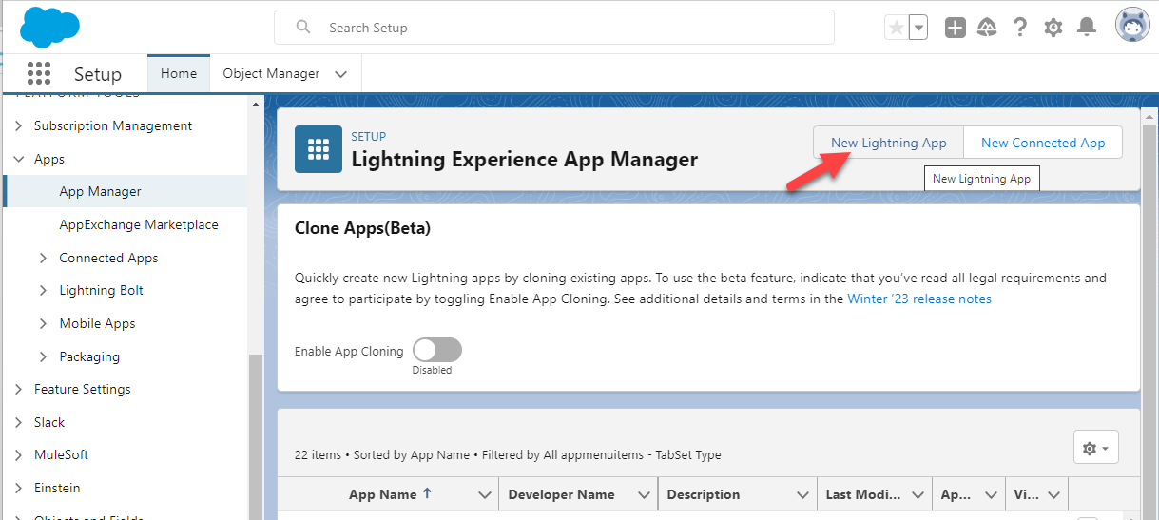

Assign AppName, Developer Name and Description.

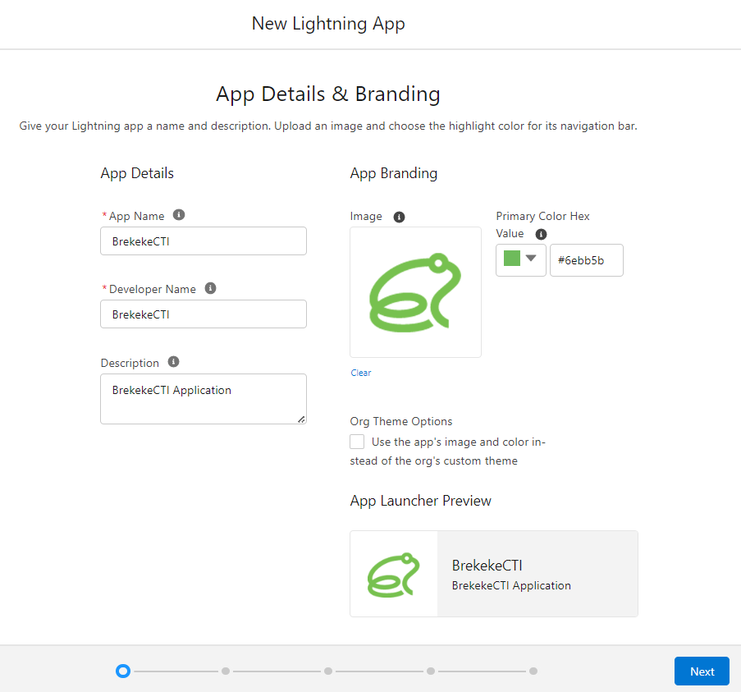

Configure the lightning app

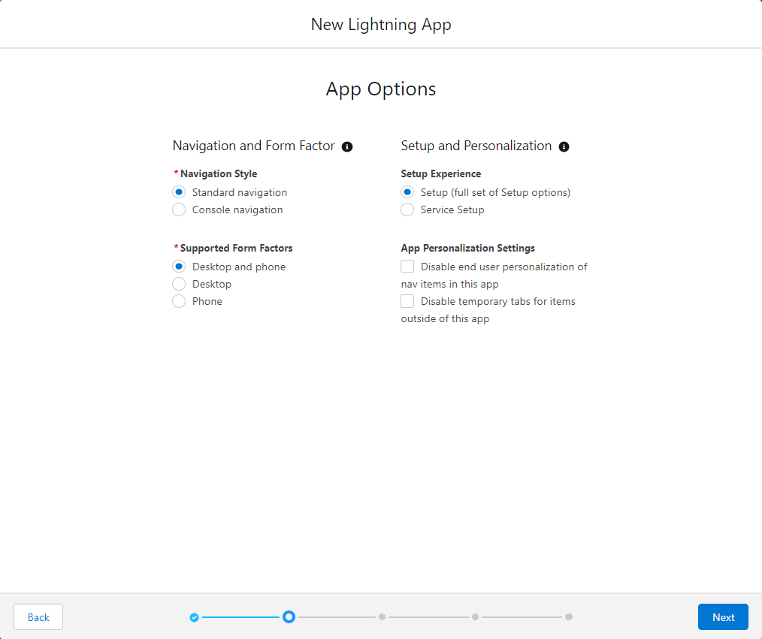

Add Utility Item and select “Open CTI softphone”.

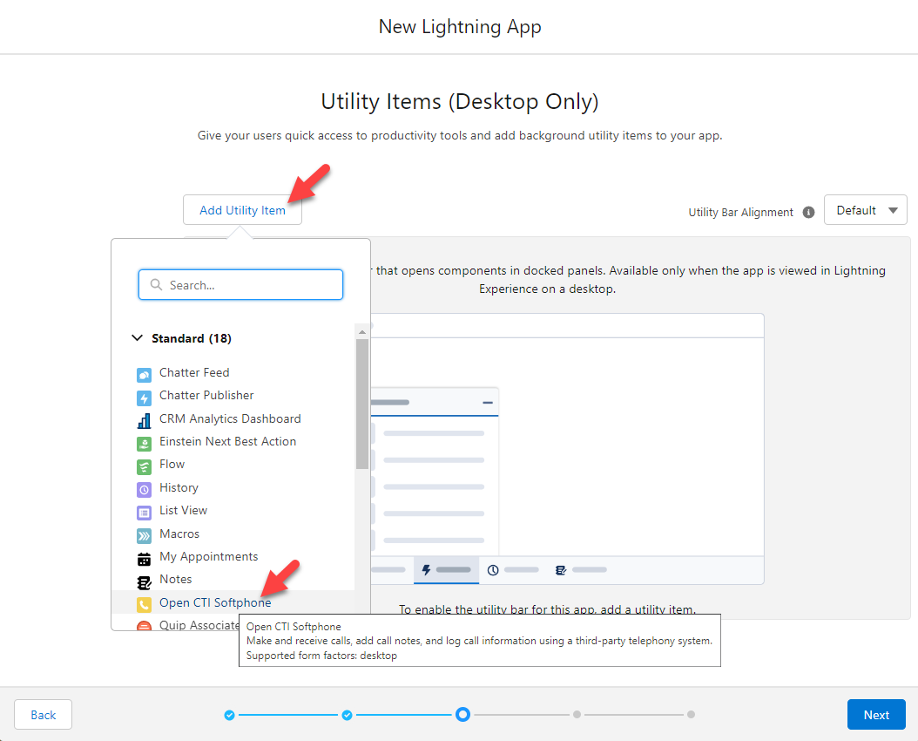

Add required Navigation Items.

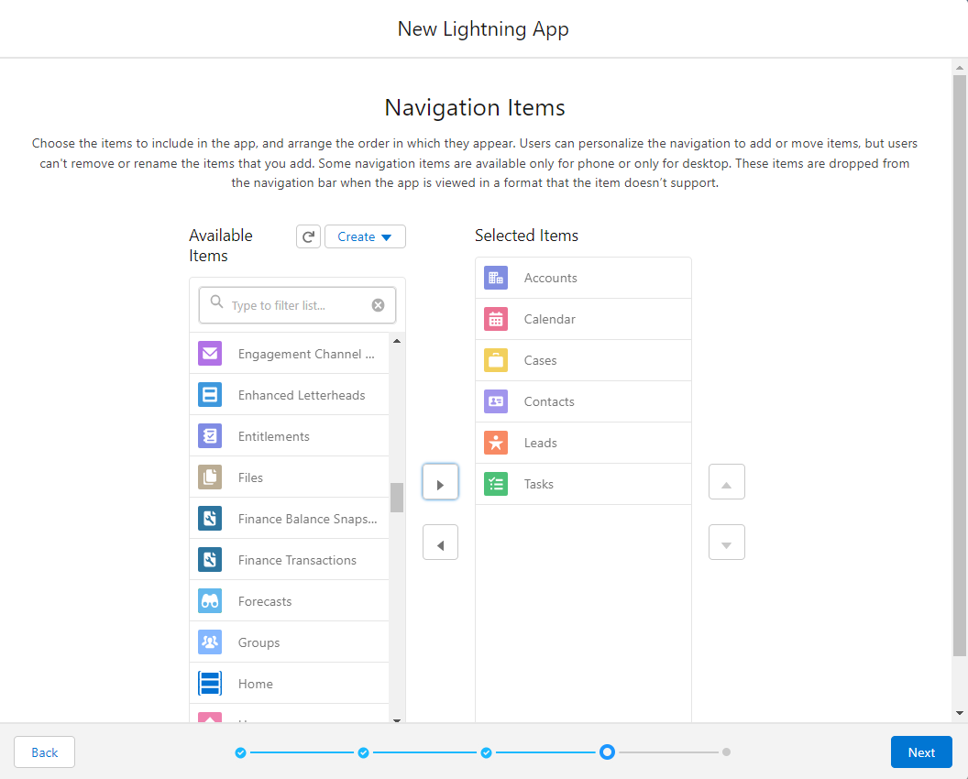

Add user profiles as per organization need.

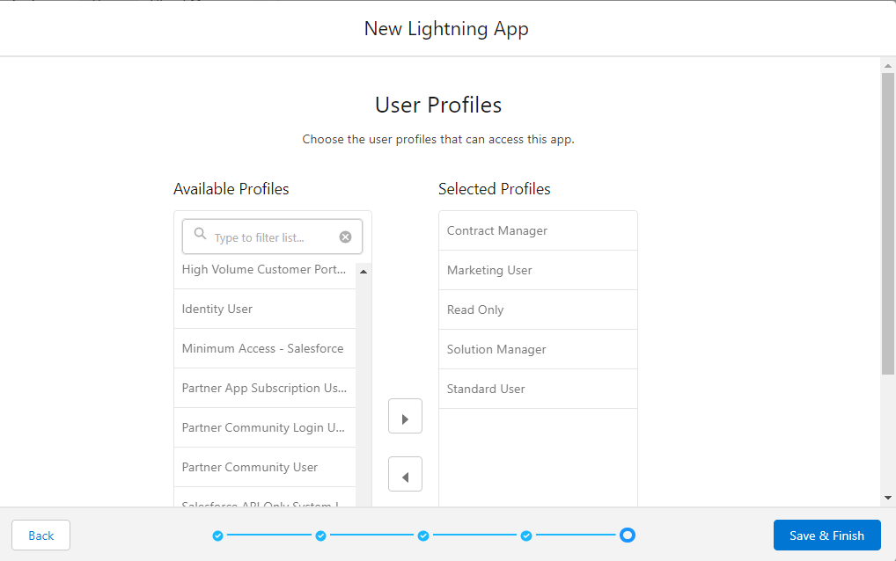

*If system administrator will test the app later, include “System Administrator”.

Application creation is completed.

## Configure Call Center Service

Select [Call Centers] from the quick find menu.

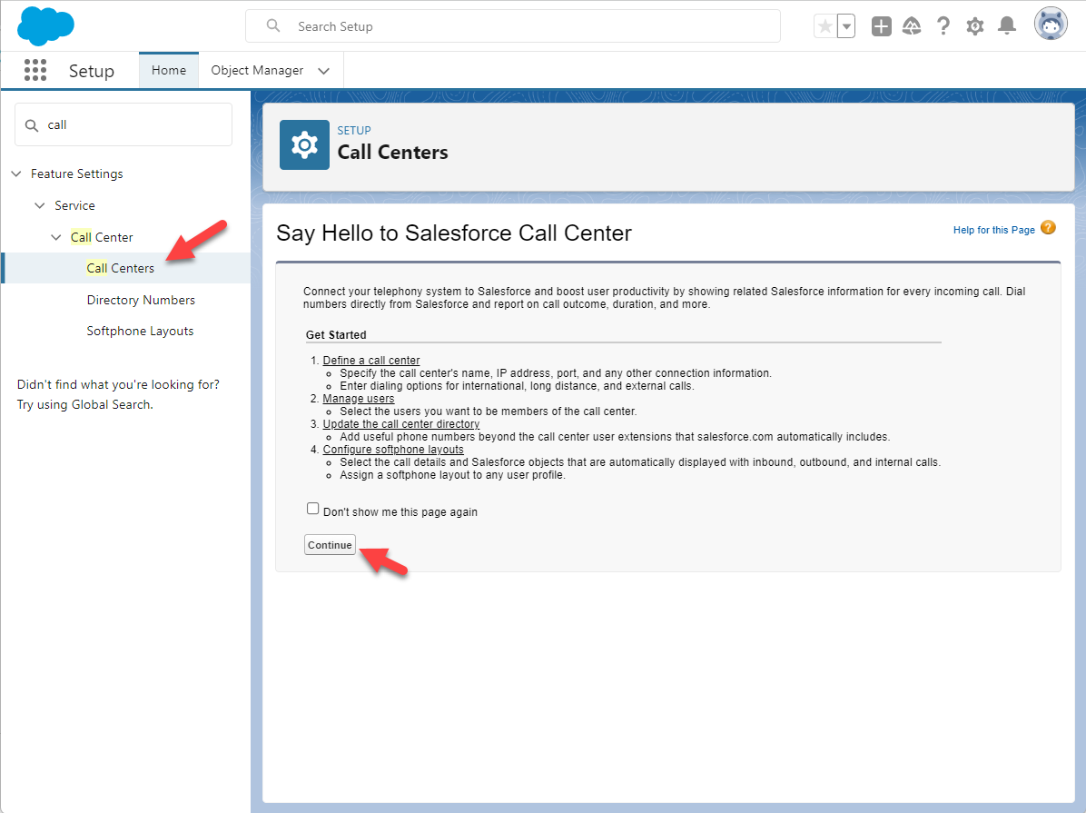

Import the “BrekekeCallcenter.xml” file.

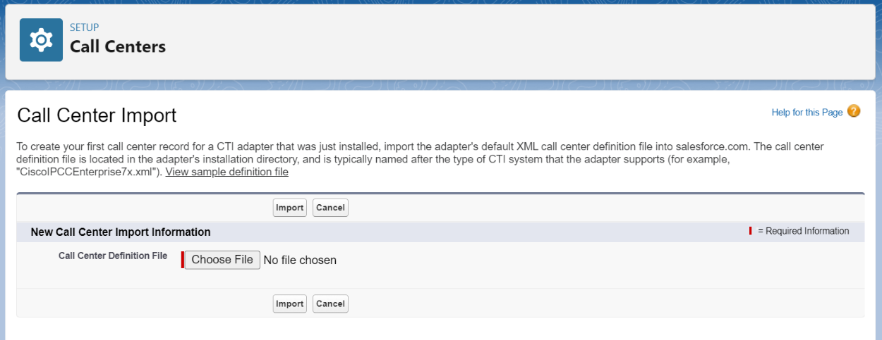

Change the value of [CTI Adapter URL] and [CTI Standby URL] fields for your environment.

## Then click Manage Call Center User to add users.

## Configure Softphone Layout

Go to setup and from Quick Find search option find “Softphone Layout”. Add new Softphone Layout by the “New” button.

Check the [is Default Layout] check box.

Select “Inbound” at the [Select Call Type].

Configure Screen Pop Settings.

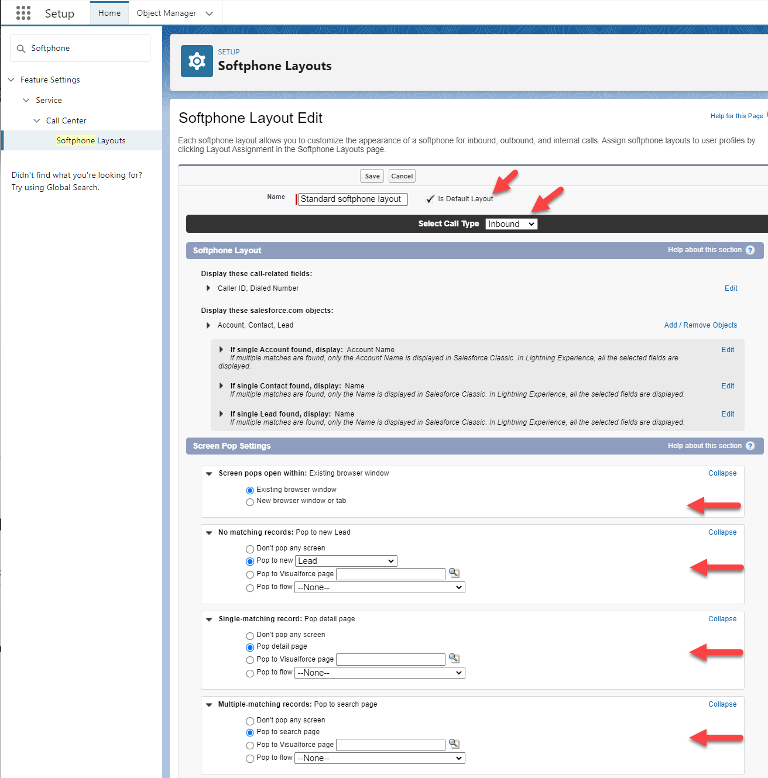

# Log in Salesforce CRM and check CTI

1. Log in salesforce CRM and at [App Launcher], select the application you created.

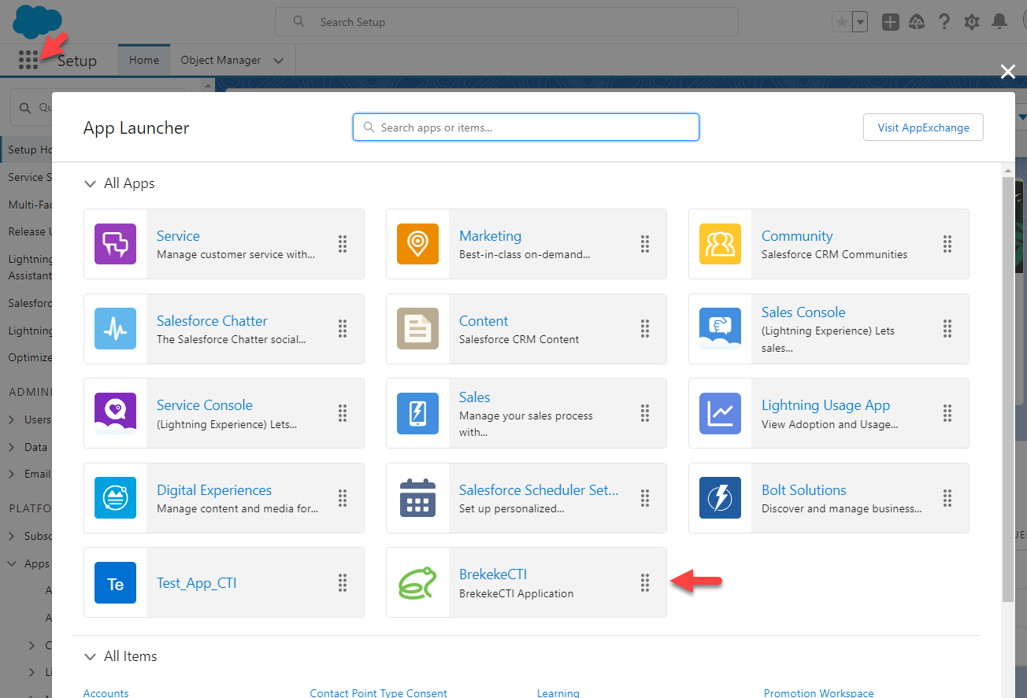

1. In the application, when you click the [Phone] icon located at bottom left, Brekeke Widget login menu is automatically launched.

1. After you log in Brekeke Widget, you can make a call from both of the phone icons in salesforce CRM and a client tool bar.

Reference Salesforce.com "Lightning Open CTI"

(*https://developer.salesforce.com/page/Lightning_Open_CTI*)

# Setup for links of recording files

## Create a link object at Salesforce CRM.

1. Move to [Object and Fields] > [Object Manager].

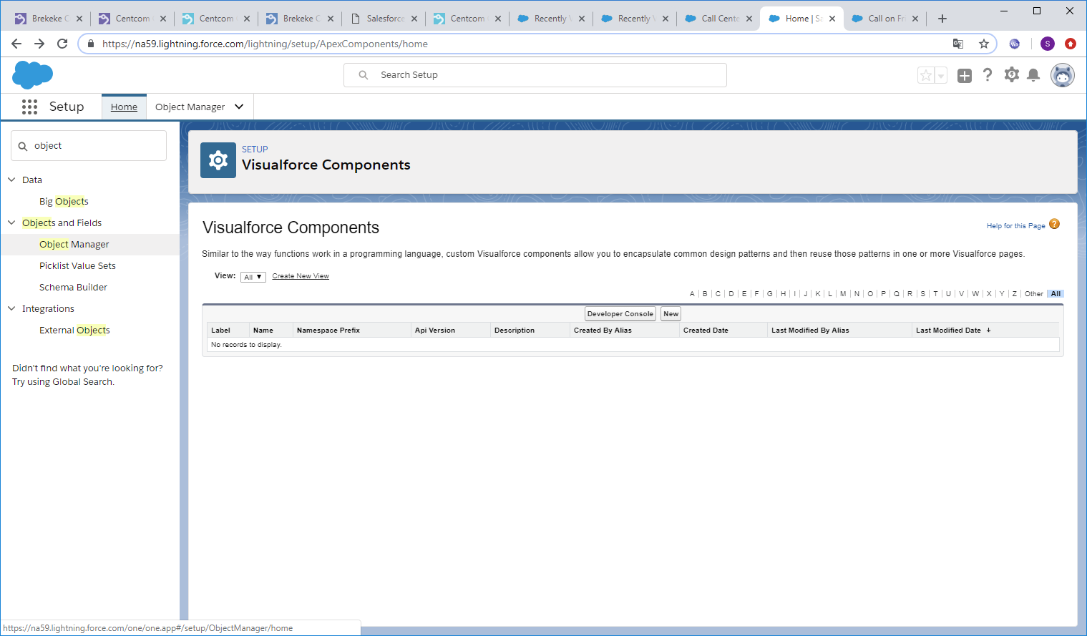

1. In [Object Manager] page, select a [Task] item.

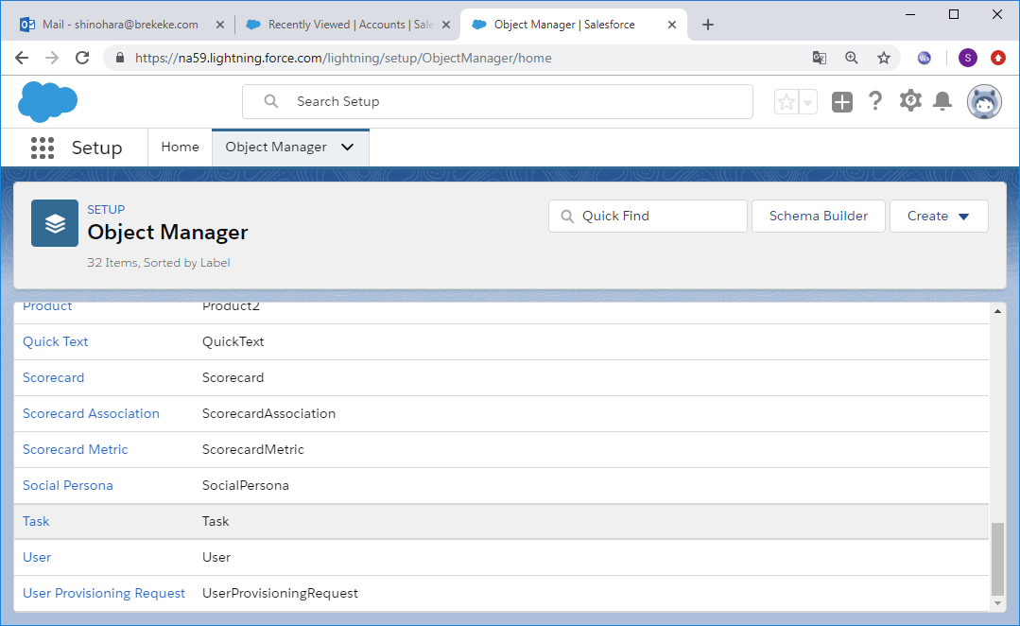

1. Move to [Buttons, Links, and Actions] page, then click a [New button or Link] button.

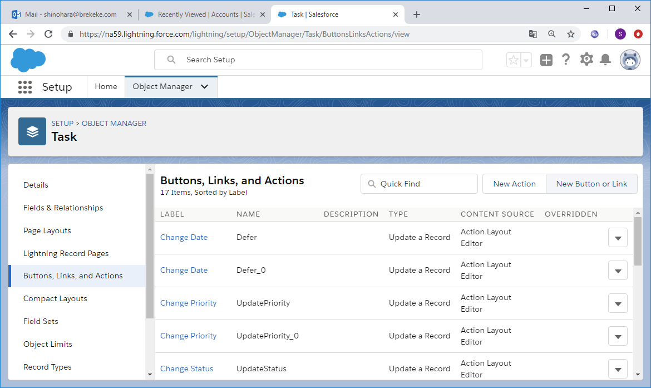

1. Edit the details as follows and save it.

* Label : Any label (Example: *audio link*)
* Name : Any name (Example: *audio link*)
* Display Type : “*Detail Page Link*”
* Behavior : “*Display in new window*”
* Content Sourse : “*URL*”
* Select Field Type :”*Task*”
* URL:

*https://<your_brekeke_pbx_host_address>:<port>/pbx/rec/{!Task.CallObject}*

(Example: *https://mt.brekeke.com:8443/pbx/rec/{!Task.CallObject}*)

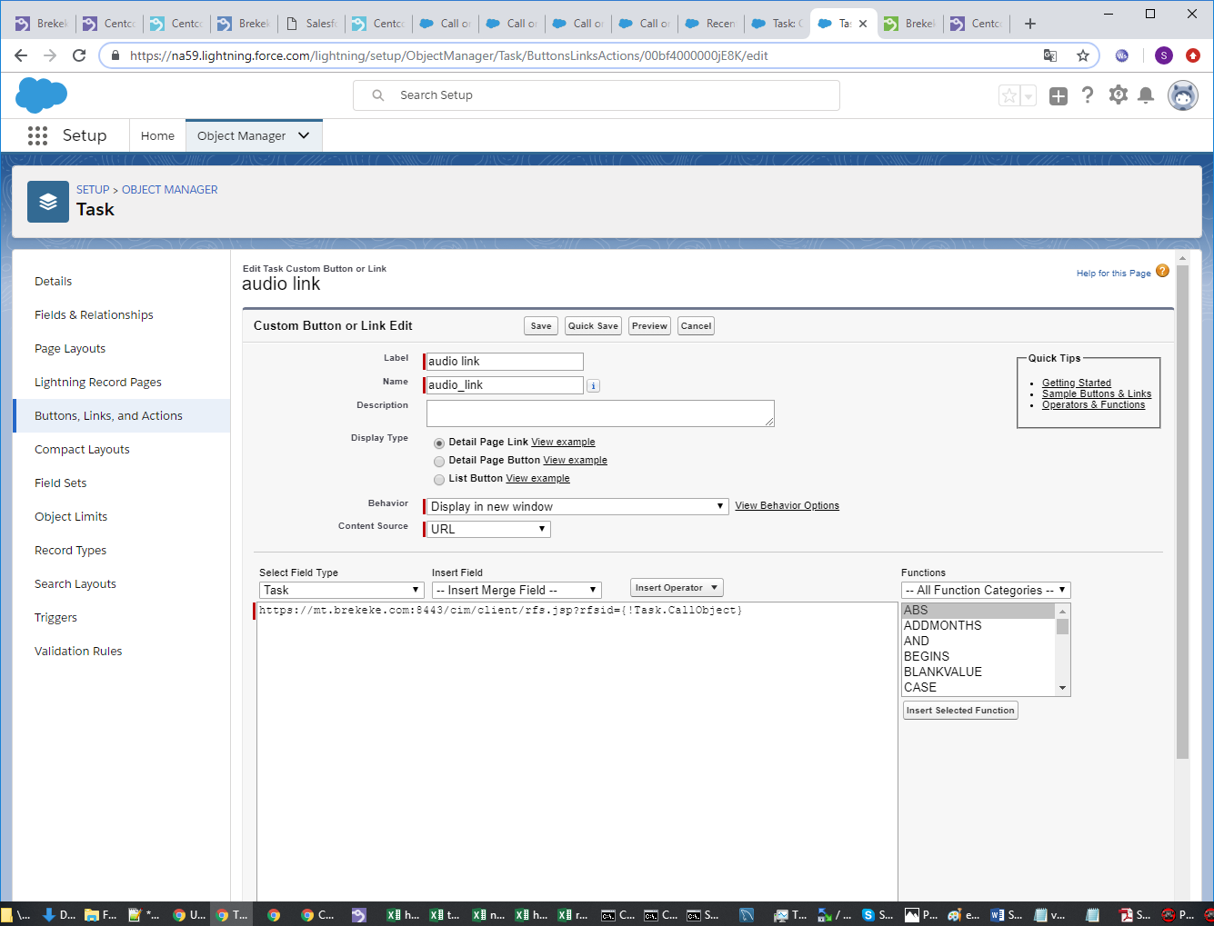

1. Move to the [Page Layouts] menu and select a page layout where you want to add link. Here, click “Task Layout” as example.

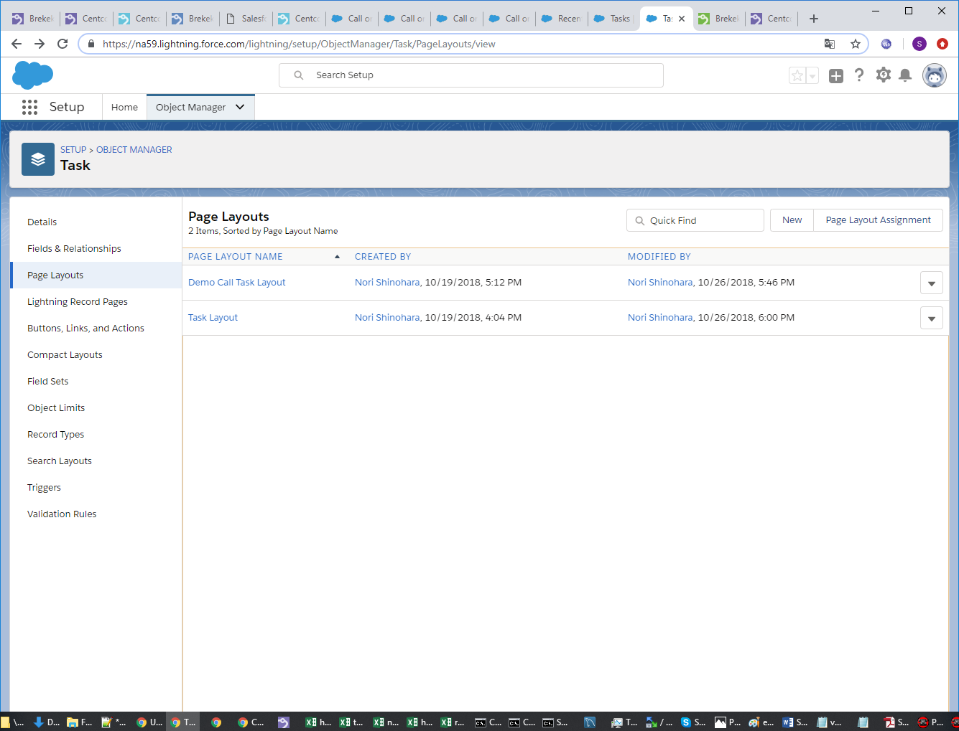

Up to four phones can be assigned under each Brekeke PBX user extension on the [Phones] page in the [Phone n] > [Phone ID] field. These phones can call each other by dialing the number 1 to 4 in [Phone n].

1. Select [Custom Links] menu, then drag the “audio link” object that was created in previous steps and drop it in the [Custom Links] section.

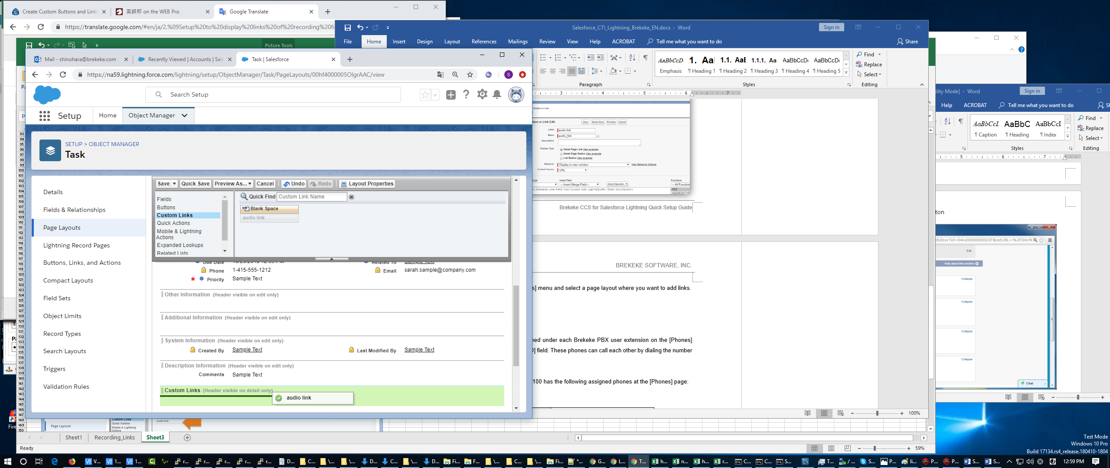

## Check if the links work properly.

1. Log in to Salesforce CRM. Then Move to the [Tasks] page. The “audio link” is shown at [Customer Links] section.

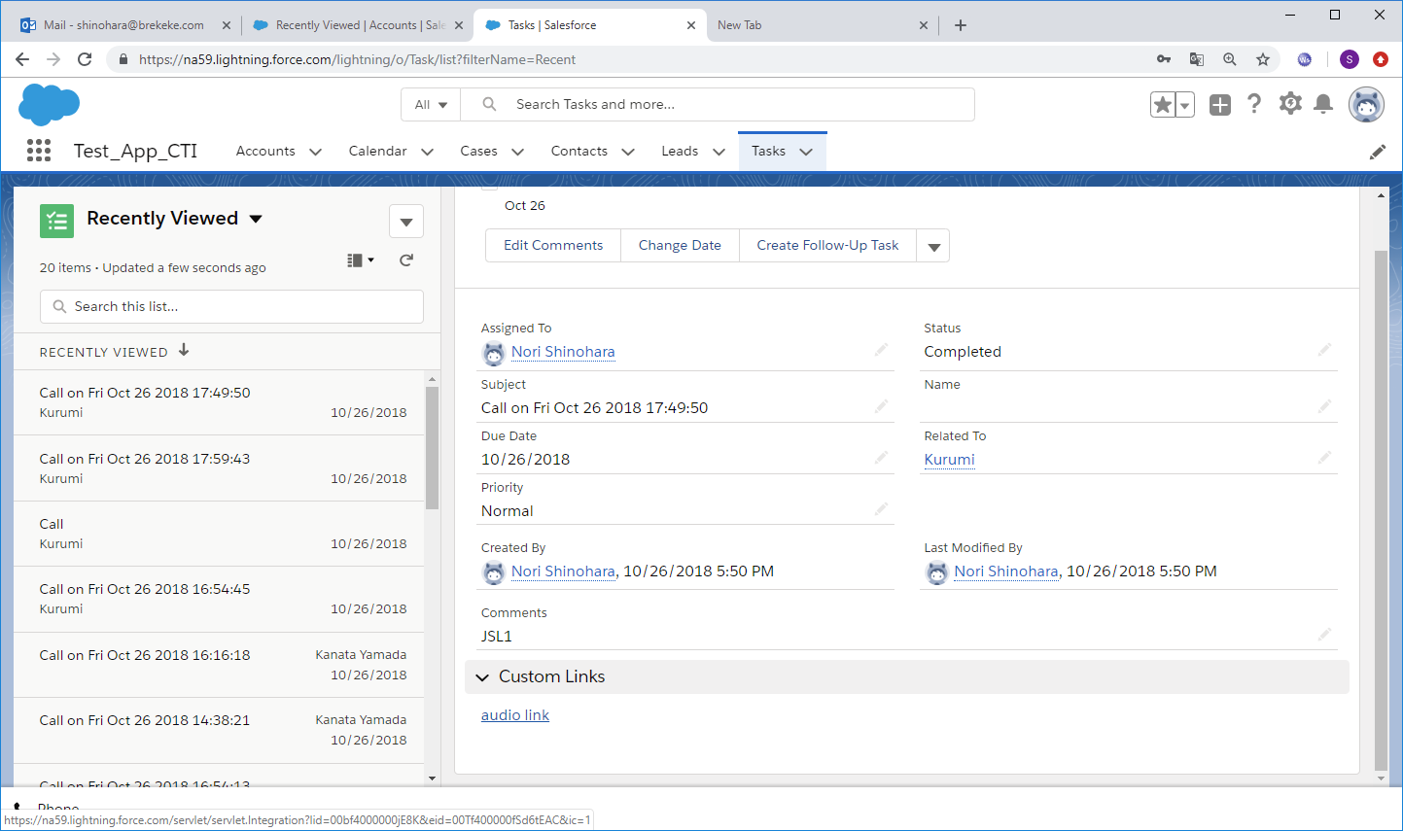

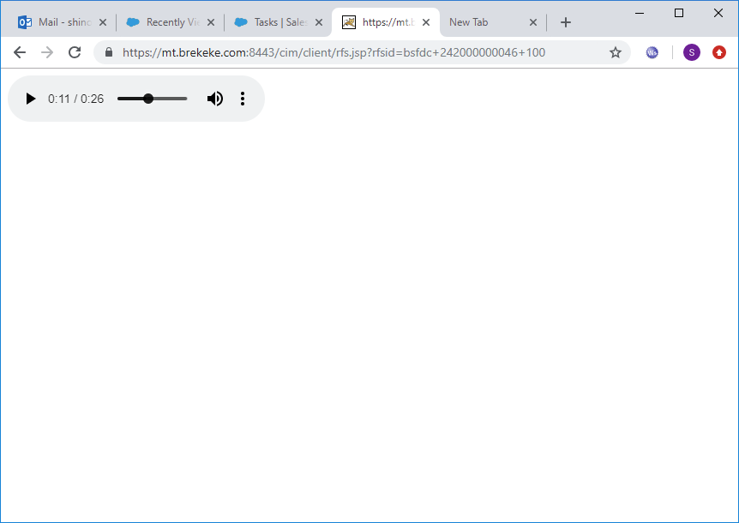

Reference Salesforce.com "Create Custom Buttons and Links"

(https://trailhead.salesforce.com/en/content/learn/modules/lex_customization/lex_customization_buttons_links)