Brendan Khamvong  
GEOG 478

Lab 5

Lab 5 GitHub link:

<https://github.com/brekhamvong/BK-GEOG478-Lab/tree/main/Lab/Lab5>

Tutorial Screenshot(s):

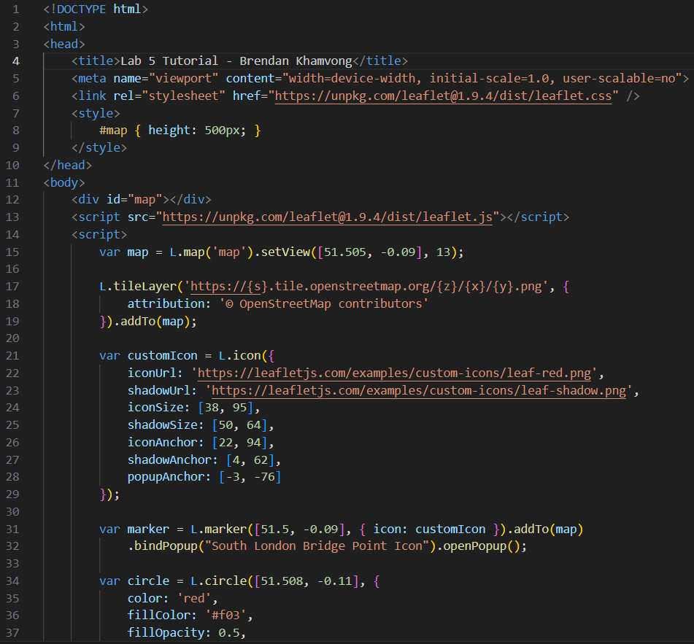

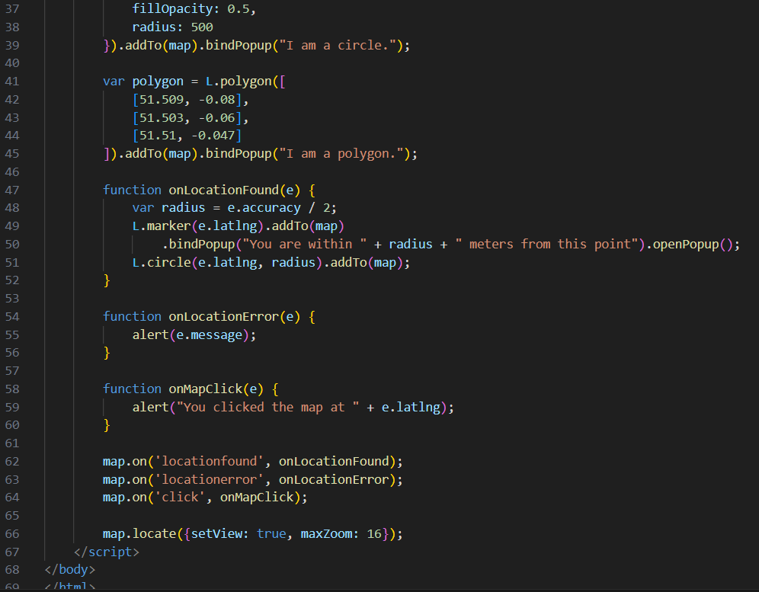

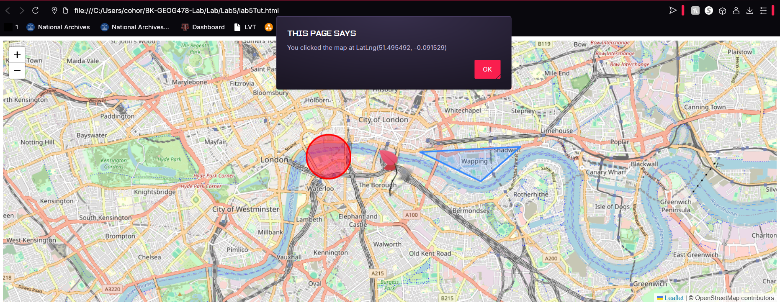

College Station Web Map:

