Brendan Khamvong  
GEOG 478

Lab 6

Lab 6 GitHub link:

<https://github.com/brekhamvong/BK-GEOG478-Lab/tree/main/Lab/Lab6>

Tutorial Screenshot(s): 1 - geoJSON; 2 - Choropleth

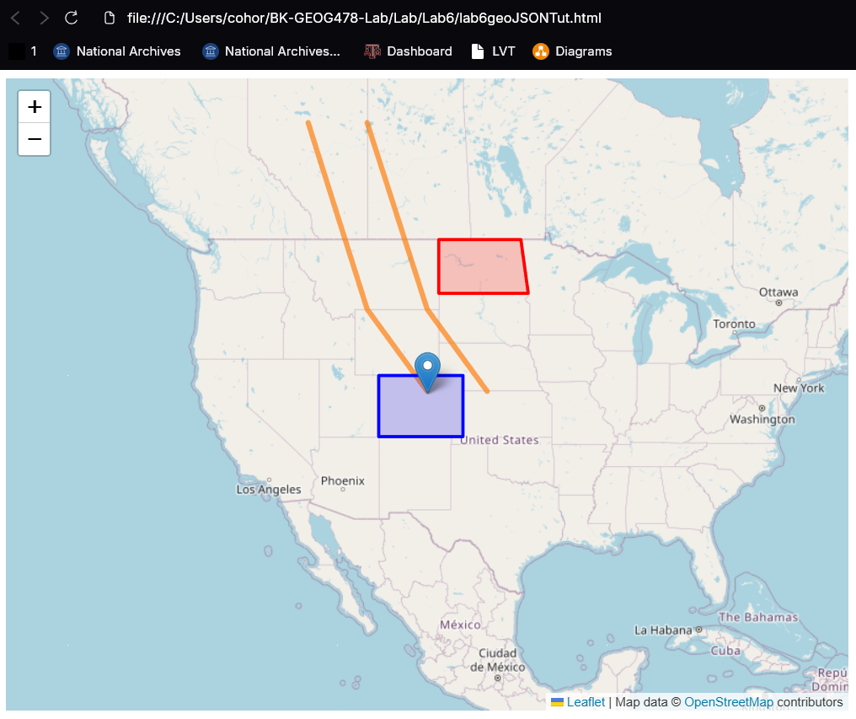

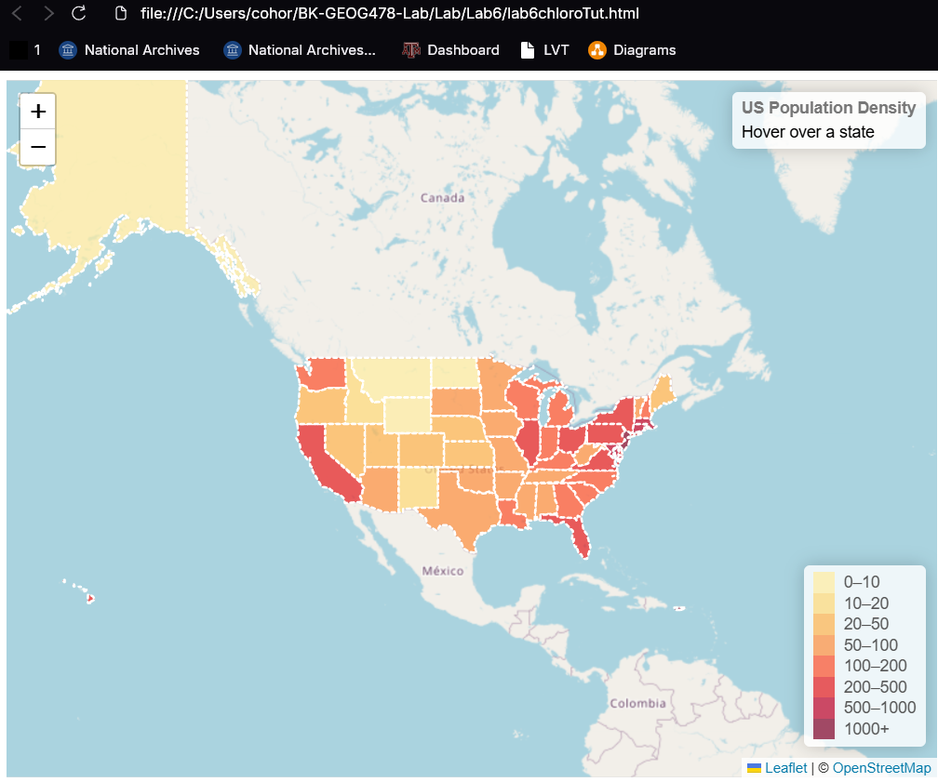

College Station Web Map:

