## **Environmental Science project: Air Quality Monitoring**

Make an environmental monitoring guide for one sensor including this information:

1. Names of group members
2. Parameter being measured
3. Description of the parameter, what it's increase or decrease means and why it's important.
4. What are the standard values for this parameter? (Use EPA or EU guidelines)
5. Take clear pictures of the wiring of your sensor (and attach them at the end)
6. Copy / paste the code you used to program your sensor.
7. +10 points if you make a simulation of your sensor using https://www.tinkercad.com/#/?type=circuits (add a link)
8. What were the values of your parameter at the University of Aruba? Take at least 10 measurements.
9. How did you use the sensor?
10. Describe how your sensor works.
11. **Names of group members**

* Ian Flanegien
* Geraldine Borgers
* Gia Kolfin
* Rikkerd Maes

1. **Parameters being measured**

We were assigned a pressure sensor. A pressure sensor measures Barometric Pressure (Hg), also referred to as air pressure.

1. **Description of the parameter, what it's increase or decrease means and why it is important**

Within the parameter of the Barometric Pressure (Hg) scale you can define typical weather patterns and determine the quality of local atmospheric conditions.

Barometric pressure increases or decreases has significant effects on weather conditions (nice weather = low pressure - rain and storms = high pressure). Air pressure also affects water chemistry, it affects the amount of gas, for example oxygen, that dissolves into water. The higher the air pressure the more oxygen is being dissolved in water. The increase and decrease in important in the prediction of the weather in the short run. In the long run change in the barometric pressure can be used to explain the reason behind the increase in water temperature as Nathan Gillett of the University of Victoria, Canada, and his colleagues have shown that there is also a greenhouse effect on air pressure. Changes in air pressure could have a big effect on climate. Air pressure controls the atmosphere's circulation, and therefore influences how moisture moves. Changes in circulation can alter rainfall, temperature, winds and storminess (Philip Ball, 2003)

1. **The standard values for Barometric pressure.**

The standard value for Barometric pressure at normal ocean level is 29.92Hg.

1. **The wiring of our sensor:**

A circuit board on a table

Description generated with high confidenceA circuit board

Description generated with very high confidenceA circuit board

Description generated with very high confidenceA circuit board

Description generated with high confidence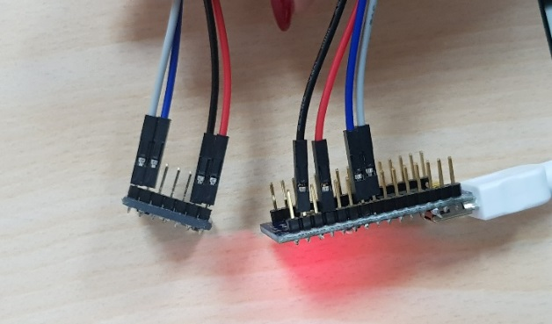A close up of a device

Description generated with very high confidence

1. **The code we used to program our sensor:**

(<https://github.com/brenchies/env1005/blob/master/air02_Altimeter/air02_Altimeter.ino>)

|  |
| --- |
| /**************************************************************************/ |
|  |

|  |
| --- |
| /*! |
|  |

|  |
| --- |
| @file Adafruit_MPL3115A2.cpp |
|  |

|  |
| --- |
| @author K.Townsend (Adafruit Industries) |
|  |

|  |
| --- |
| @license BSD (see license.txt) |
|  |

|  |
| --- |
| Example for the MPL3115A2 barometric pressure sensor |
|  |

|  |
| --- |
| This is a library for the Adafruit MPL3115A2 breakout |
|  |

|  |
| --- |
| ----> https://www.adafruit.com/products/1893 |
|  |

|  |
| --- |
| Adafruit invests time and resources providing this open source code, |
|  |

|  |
| --- |
| please support Adafruit and open-source hardware by purchasing |
|  |

|  |
| --- |
| products from Adafruit! |
|  |

|  |
| --- |
| @section HISTORY |
|  |

|  |
| --- |
| v1.0 - First release |
|  |

|  |
| --- |
| */ |
|  |

|  |
| --- |
| /**************************************************************************/ |
|  |

|  |
| --- |
|  |
|  |

|  |
| --- |
| #include <Wire.h> |
|  |

|  |
| --- |
| #include <Adafruit_MPL3115A2.h> |
|  |

|  |
| --- |
|  |
|  |

|  |
| --- |
| // Power by connecting Vin to 3-5V, GND to GND |
|  |

|  |
| --- |
| // Uses I2C - connect SCL to the SCL pin, SDA to SDA pin |
|  |

|  |
| --- |
| // See the Wire tutorial for pinouts for each Arduino |
|  |

|  |
| --- |
| // http://arduino.cc/en/reference/wire |
|  |

|  |
| --- |
| Adafruit_MPL3115A2 baro = Adafruit_MPL3115A2(); |
|  |

|  |
| --- |
|  |
|  |

|  |
| --- |
| void setup() { |
|  |

|  |
| --- |
| Serial.begin(9600); |
|  |

|  |
| --- |
| Serial.println("Adafruit_MPL3115A2 test!"); |
|  |

|  |
| --- |
| } |
|  |

|  |
| --- |
|  |
|  |

|  |
| --- |
| void loop() { |
|  |

|  |
| --- |
| if (! baro.begin()) { |
|  |

|  |
| --- |
| Serial.println("Couldnt find sensor"); |
|  |

|  |
| --- |
| return; |
|  |

|  |
| --- |
| } |
|  |

|  |
| --- |
|  |
|  |

|  |
| --- |
| float pascals = baro.getPressure(); |
|  |

|  |
| --- |
| // Our weather page presents pressure in Inches (Hg) |
|  |

|  |
| --- |
| // Use http://www.onlineconversion.com/pressure.htm for other units |
|  |

|  |
| --- |
| Serial.print(pascals/3377); Serial.println(" Inches (Hg)"); |
|  |

|  |
| --- |
|  |
|  |

|  |
| --- |
| float altm = baro.getAltitude(); |
|  |

|  |
| --- |
| Serial.print(altm); Serial.println(" meters"); |
|  |

|  |
| --- |
|  |
|  |

|  |
| --- |
| float tempC = baro.getTemperature(); |
|  |

|  |
| --- |
| Serial.print(tempC); Serial.println("*C"); |
|  |

|  |
| --- |
|  |
|  |

|  |
| --- |
| delay(2000); |
|  |

}

1. **A simulation of our sensor:**

Link: <https://www.tinkercad.com/things/j8BJ7QIkubH-temp-sensor-/editel>

This is the module we made using Tinkercad:

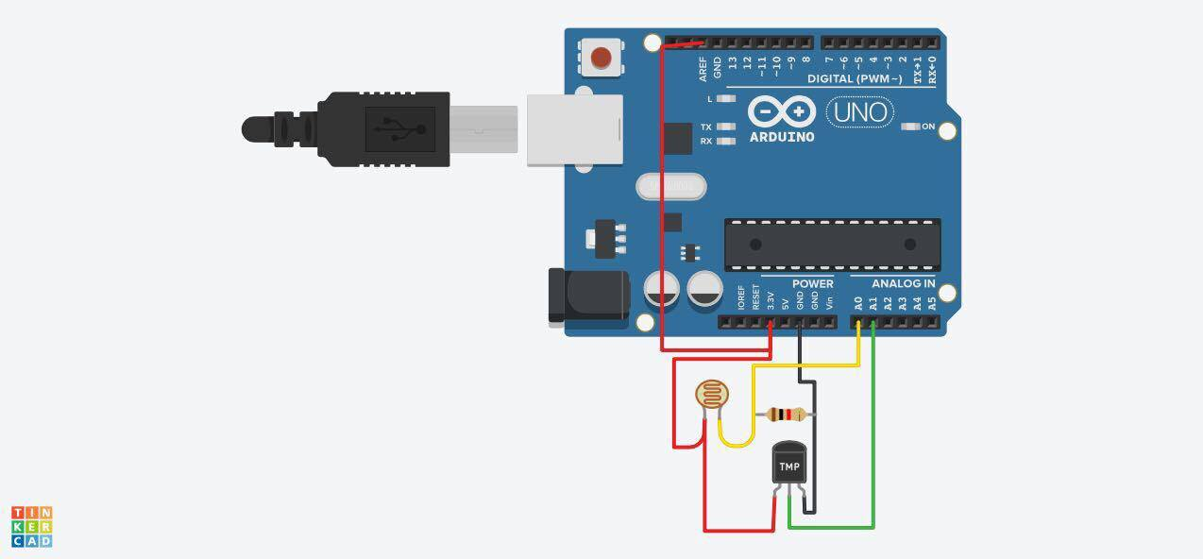

(Although we have the Barometric Pressure sensor / Altimeter, this is a sensor for temperature. Tinkercad had removed certain parts for the Barometric Pressure sensor like the BMP180 which is what we needed to build the Barometric sensor).

1. **Barometric pressure:**

The standard value is 29.92 inHg

At the university the Hg value was an average of 29.97 inHg over 10 measurements

1. **How did we use the sensor?**

We build the sensor in class according to the schedule provided. The sensor has a bus to connect it through USB to a computer/laptop. Arduino needs to be installed on the laptop to communicate with the sensor. In the Arduino software we needed to program the sensor to work with certain parameter like measurement time and barometric pressure units. When that is done you start the sensor and it will give you date that you can record for future usage.

1. **How our sensor works:**

We were assigned a pressure sensor. The pressure sensor we got was the 12C precision altimeter. The sensor employs a microelectromechanical system (MEMS) pressure sensor with a 12C interface (12C interface is designed to allow easy communication between components on the same circuit board). The sensor is a low-power, high accuracy digital output altimeter, barometer (with high accuracy pressure sensor with integrated data calculation and logging capabilities) and thermometer. Our sensor was set up to measure Inch of Mercury or inHg. This measurement is the pressure exerted by a column of mercury of 1 inch (25.4mm) in height at the standard acceleration of gravity.