Name: Alexandra Pierre, Avelyne Pierre, Robert Wester

Course: Environmental Science

Assignment: Air Quality Monitoring

We have used the Carbon Monoxide Parameter. This device is suitable for sensing CO concentrations in the air. It has a highly sensitivity and a fast response time. It can also detect fire and you can use this parameter for measuring air quality indoors and outdoors.

It is important to know the air quality around you as every person needs oxygen to live. If the air we breathe is full of Carbon it is not healthy for us. If the measurement is too high it is not good for our health. Therefore, high measures are dangerous.

The sensor uses 60 seconds to heat up and then 90 seconds to take measurements. In the heating process one should not use those measurements as data. After plugging in the sensor we opened the Ardruino application and went to Tools 🡪 Board 🡪 Port 🡪 Serial Monitor and it started to work.  
Below you can find our pictures, the code we used and the measurements at UA.

Pics:

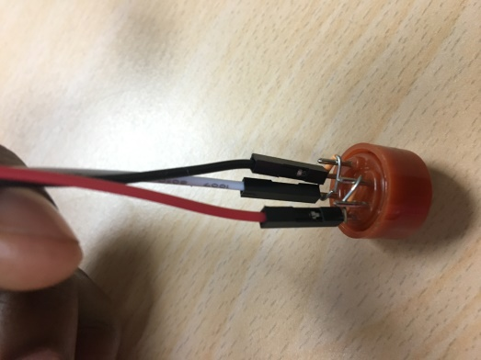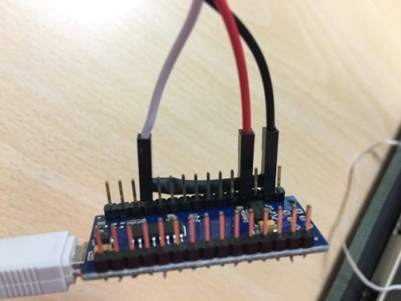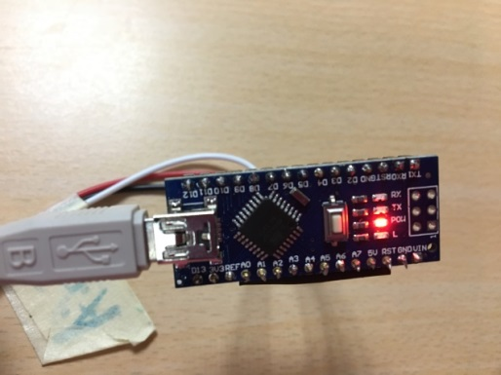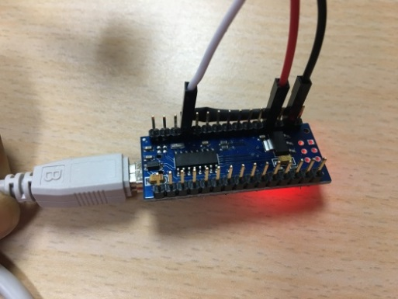

Code:

/* MQ-7 Carbon Monoxide Sensor Circuit with Arduino */

|  |
| --- |
|  |
|  |  |
|  | const int AOUTpin=0;//the AOUT pin of the CO sensor goes into analog pin A0 of the arduino |
|  | const int DOUTpin=8;//the DOUT pin of the CO sensor goes into digital pin D8 of the arduino |
|  | const int ledPin=13;//the anode of the LED connects to digital pin D13 of the arduino |
|  |  |
|  | int limit; |
|  | int value; |
|  |  |
|  | void setup() { |
|  |  |
|  | Serial.begin(115200);//sets the baud rate |
|  |  |
|  | pinMode(DOUTpin, INPUT);//sets the pin as an input to the arduino |
|  | pinMode(ledPin, OUTPUT);//sets the pin as an output of the arduino |
|  |  |
|  | } |
|  |  |
|  | void loop() |
|  | { |
|  |  |
|  | value= analogRead(AOUTpin);//reads the analaog value from the CO sensor's AOUT pin |
|  | limit= digitalRead(DOUTpin);//reads the digital value from the CO sensor's DOUT pin |
|  |  |
|  | Serial.print("CO value: "); |
|  | Serial.println(value);//prints the CO value |
|  | Serial.print("Limit: "); |
|  | Serial.print(limit);//prints the limit reached as either LOW or HIGH (above or underneath) |
|  |  |
|  | delay(100); |
|  |  |
|  | if (limit == HIGH){ |
|  | digitalWrite(ledPin, HIGH);//if limit has been reached, LED turns on as status indicator |
|  | } |
|  | else{ |
|  | digitalWrite(ledPin, LOW);//if threshold not reached, LED remains off |
|  | } |
|  |  |
|  | } |

Measurements at UA:

In the classroom = 664  
Canteen= 583  
Entrance=595  
Bathroom next to class A and B =595  
Outside= 630  
Parking lot=570  
Upstairs= 560  
Bathroom next to the library= 565  
by the IT= 563  
At the back of classroom A and B= 550