**Names of group members:**

Anarosa Simon

Mary Stephanie Dijkhoff

Karina Wadhwani

**Parameter being measured:** Propane

**Description of the parameter:** Propane, which is sometimes known as liquefied petroleum gas is usually compressed and stored as a liquid. Propane comes from natural gas processing and oil refining. It is commonly used for heating, cooking and as fuel engine applications such as generators. In this experiment, a sensor is being used to measure the amount of propane in the atmosphere at a certain location. Increases in propane are important for cleaning such as for substituting propane for other fuels such as gasoline. It reduces the greenhouse gas carbon dioxide and air pollutants like carbon monoxide. Other reasons can be it’s more affordable and it’s available in abundance. Properties of propane include colorless, nontoxic and virtually odorless.

**Standard value for propane:** In Europe, the standard value for propane as fuel caloric values are 11950kcal/kg. On the Internet, it is difficult to find the exact amount of propane in the atmosphere in a certain area/location.

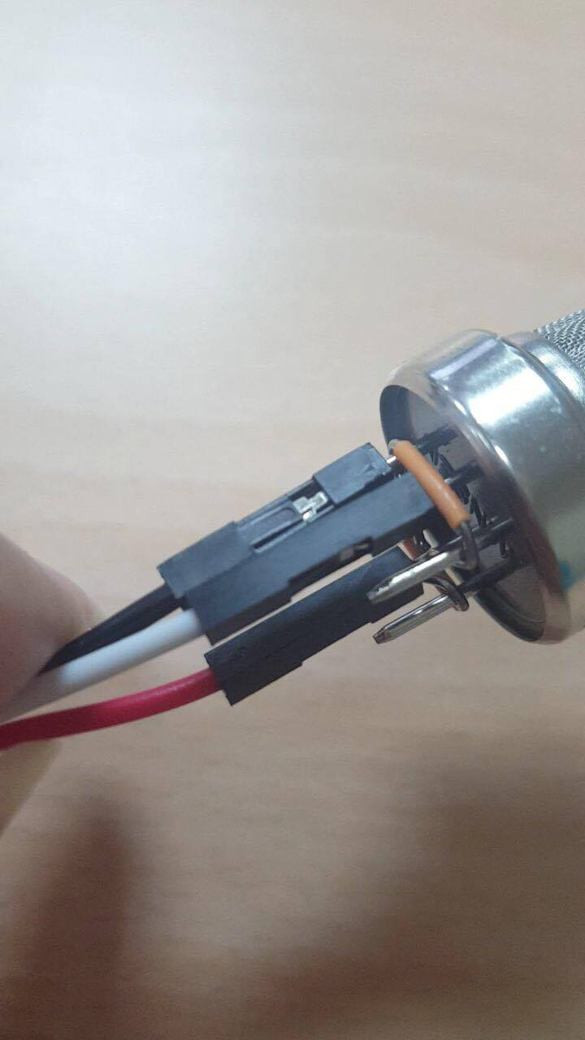**Pictures:**

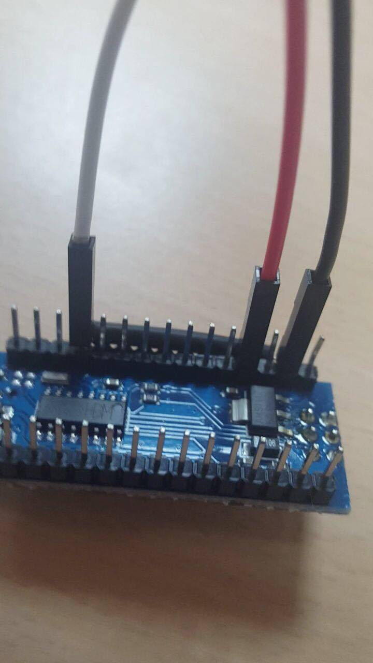

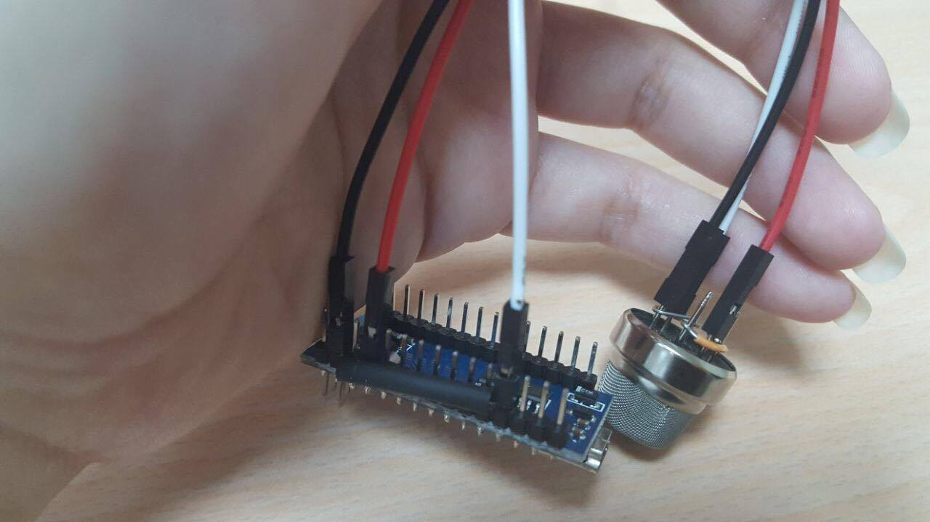

**Code for sensor:**

**int** sensorValue; **int** GasSensorPin = **0**; //Gas Sensor Connection **void** **setup**() { Serial.begin(**9600**); // sets the serial port to 9600 } **void** **loop**() { sensorValue = analogRead(GasSensorPin); // read analog input pin 0 Serial.println(sensorValue, DEC); // prints the value read delay(**1000**); // wait 1000ms for next reading }

**Extra points:**

<https://www.tinkercad.com/things/433h8bt3PhJ-spectacular-stantia/editel?sharecode=fQNf-zNP25lTYT_8EBz5a7i_PM18r5tV7lCGa6sYIsw>

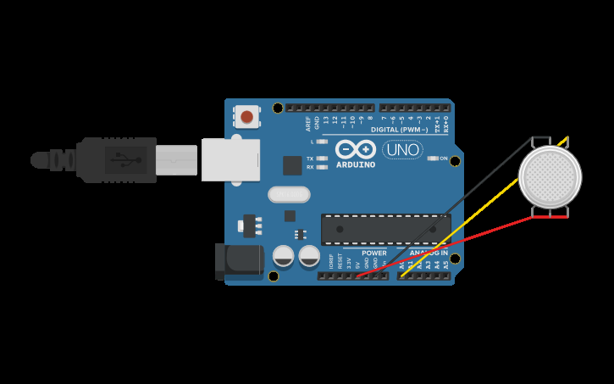

**Values of Propane at the University of Aruba:** The values at the University showed between 1020-1021 volts. This was measured in different areas throughout the University.

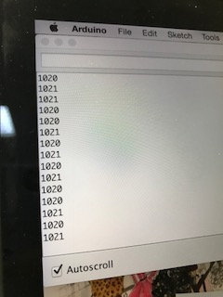

**Usage of sensor:** The sensor detects the amount of propane in the atmosphere. Every area has a different level of propane. This sensor was used around the University of Aruba to measure the amount of propane in the atmosphere. The sensor will also be taken to the ‘Parkieten bos’ (dump) and the levels of propane will be measured. These two measures will be compared with each other to see if the level has risen or fallen.

**Description of how the sensor works:** This sensor is connected to the computer using a USB and the Arduino application. The sensor detects the propane gas in the air and the measurements are transferred and appear on the computer screen in volts. It shows the exact measurement of this gas in the atmosphere at that certain moment, at that time.