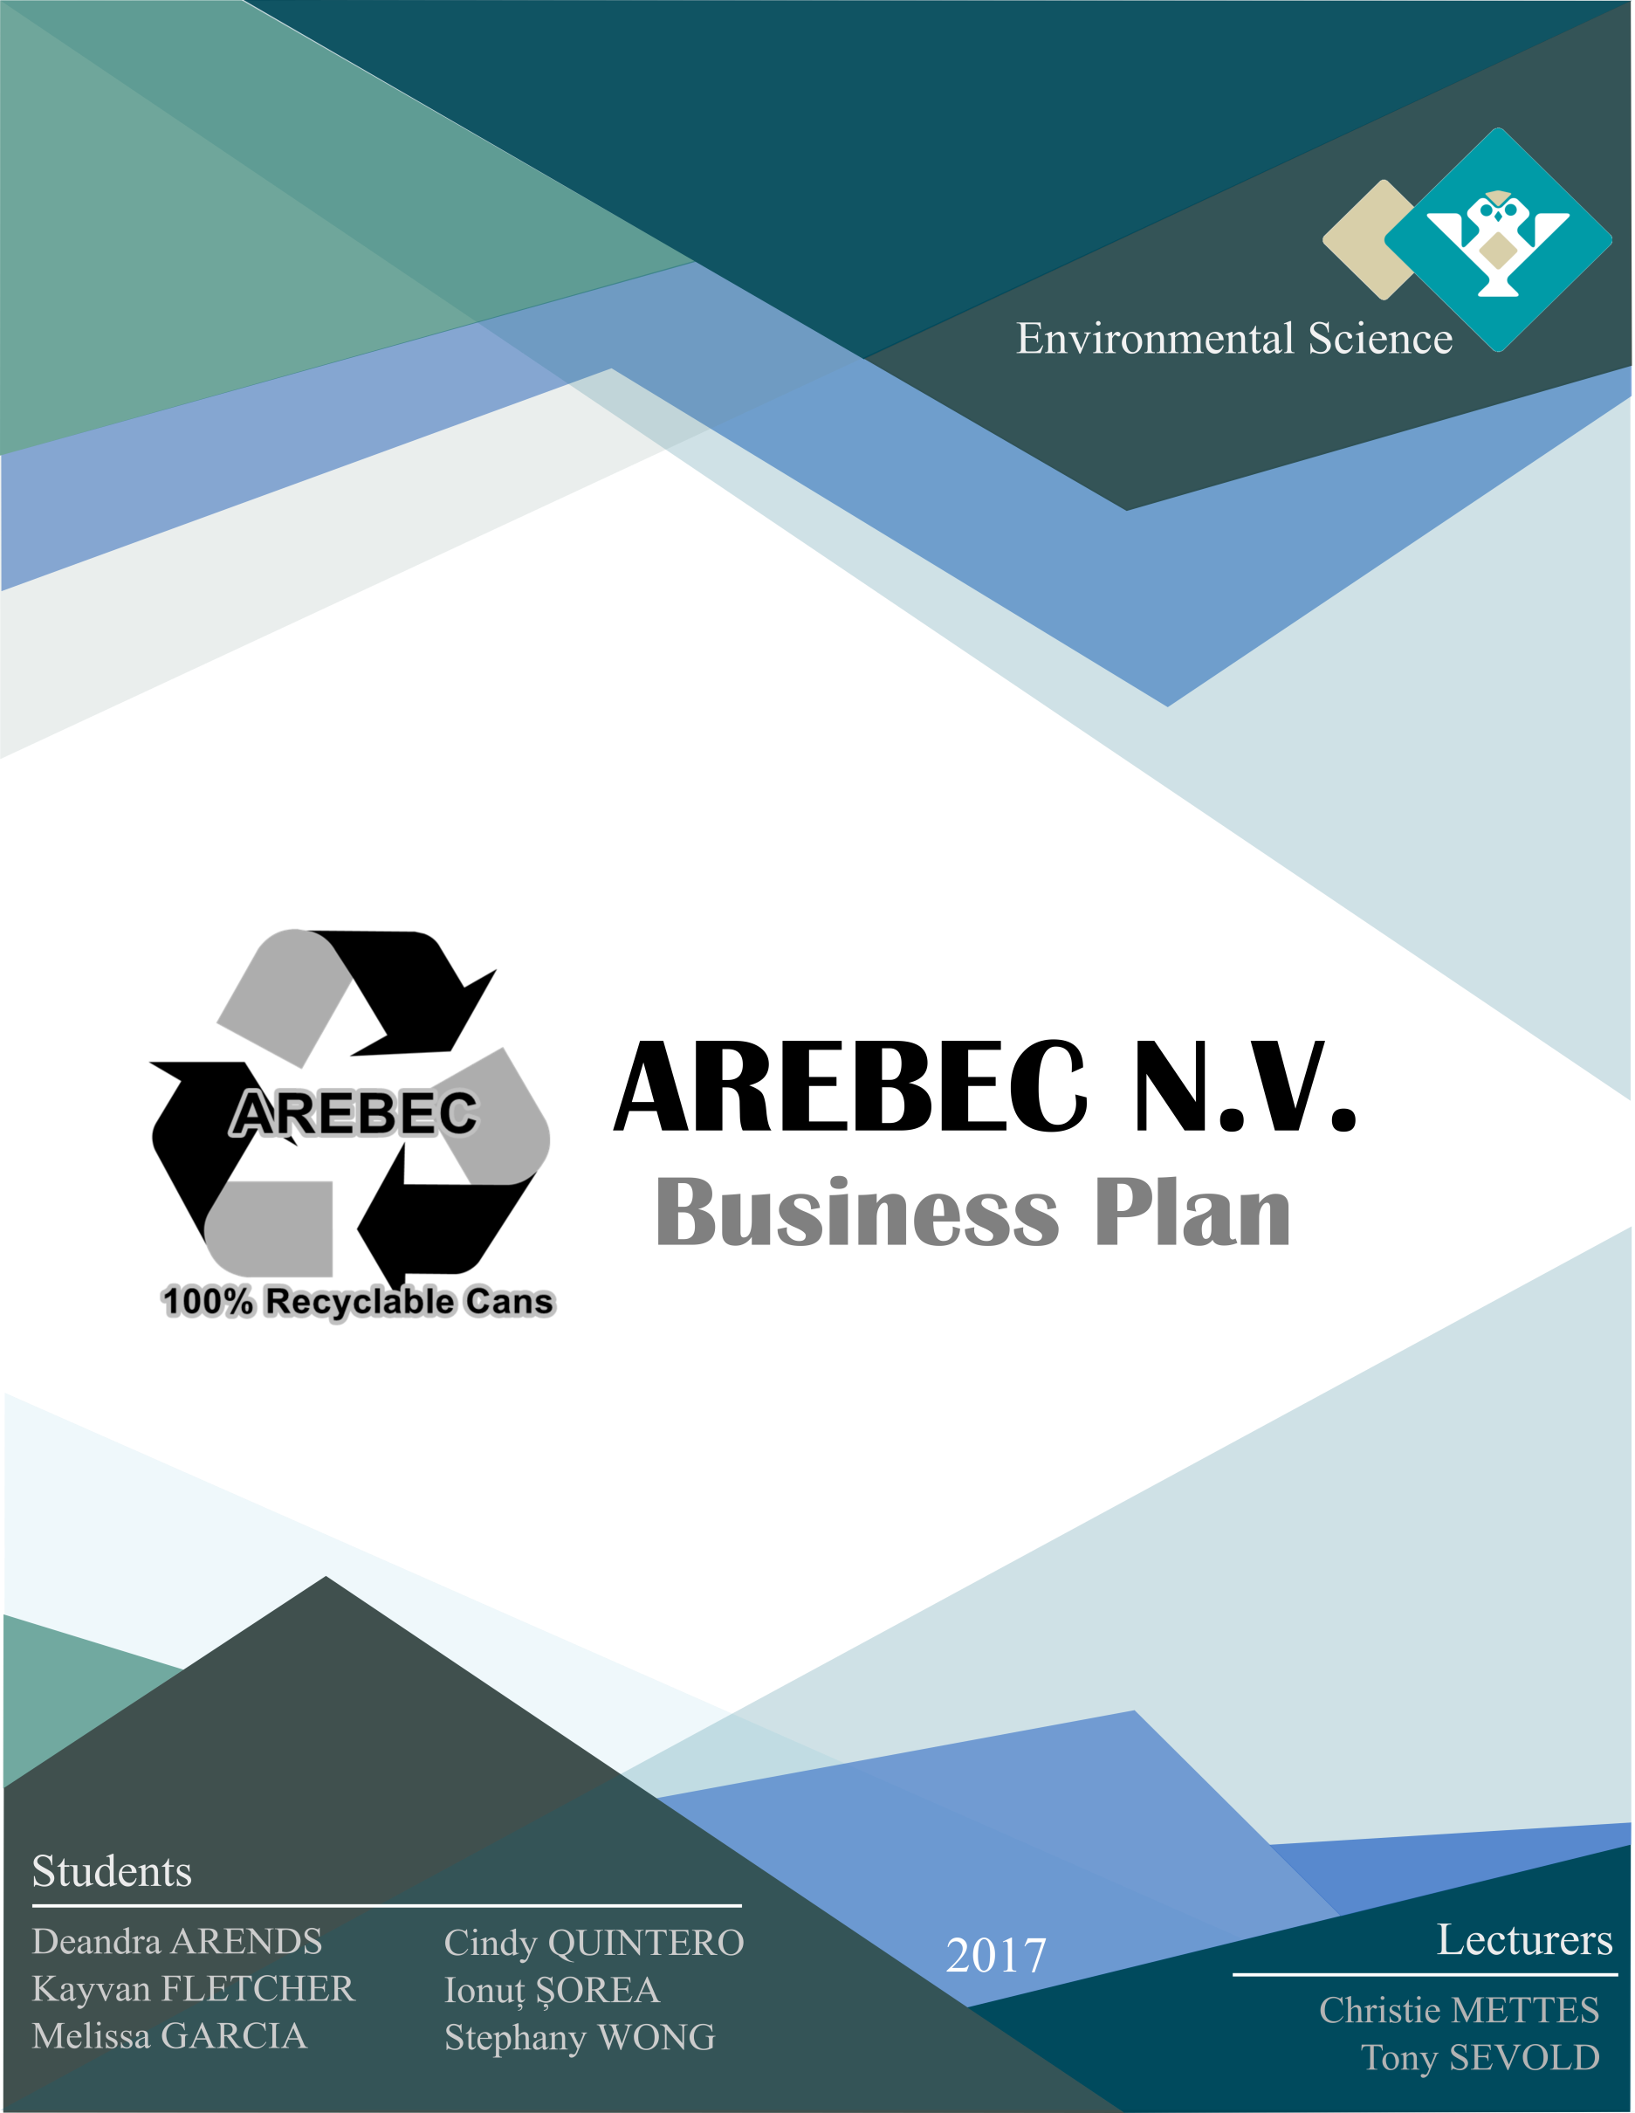

# Abstract

The purpose of this paper is to illustrate and explain the business model of our firm, AREBEC. AREBEC provides recycling companies with aluminum Used Beverage Cans. Our goals are to aid in creating and maintaining a sustainable environment for everyone. In the current paper, we explain the business plan of the company, which is divided in different segments. These are standard segments that are important when initiating a business. They include the following: customer segment, channels, customer relationship, key resources, key activities, value proposition, revenue streams, cost structure and key partnerships. Lastly, we conclude that this business plan is profitable in the short-run, because we will generate a revenue of 23,100 USD monthly and in the long-run 277,200 USD yearly. We will reach our BREAK-EVEN-POINT in **3 years** and make profit in **5 years.** Moreover, we will be able to aid prevent pollution, manage waste sufficiently and strengthen our market position and eventually, expand our business and services in the recycling industry.

KEYWORDS: *business plan, recycling, aluminum used beverage cans, environment*

**Table of Contents**

Abstract 2

Introduction 4

AREBEC Business Model 5

1.      Customer Segment 5

2.      Channels 5

3.      Customer Relationship 6

4.      Key Resources 6

5.      Key Activities 7

6.      Value Proposition 7

7.      Revenue Streams 8

8.      Cost Structure 9

9.      Key Partnerships 10

Conclusion 11

List of references 12

APPENDIX – Illustrations 13

# Introduction

AREBEC is a firm that supplies aluminium Used Beverage Cans (UBC) to companies abroad for recycling purposes. Our service is a key element in the recycling and waste management process.

AREBEC’s stands for ‘Aruba Recyclable Beverage Cans’. We are a firm which consists of six dynamic, environmental friendly individuals, whose goal are to minimize the amount of

UBC begin dispose of in our environment and in the world. We believe that recycling is important, even though, it requires a lot of energy, time and capital. For this reason, is why we decided to form a firm that can aid in this recycling process, and eventually begin to recycle UBC ourselves.

The recycling of aluminium is both economically and environmentally effective, as it requires a lot less energy to recycle than it does to mine, extract and smelt aluminium ore. Recycling 1 ton of aluminium saves 4 tons of bauxite (aluminium ore) and 700kg of petroleum coke and pitch, as well as keeping 35kg of aluminium fluoride out of the air (W. Cunningham & M. Cunningham, 2013, p.341). Therefore, Recycling aluminium UBC lowers the demand for raw resources. According to a report issued by the Secretariat of the Pacific Regional Environment Programme (SPREP), aluminium exposed to fires at dumps can release poisonous gases. If aluminium recovery were doubled worldwide, more than a million tons of air pollutants would be eliminated every year (W. Cunningham & M. Cunningham, 2013, p.341). In addition, cans dumped in the environment can harbour mosquito breeding (SPREP report, n.d.). Thus, companies like AREBEC are important, because it facilitates the recycling process of aluminium UBC, and minimize the environmental and health threats imposed by aluminium UBC waste.

# AREBEC Business Model

1.      Customer Segment  **https://lh5.googleusercontent.com/65BhuWjnDfvmpQF2r7BY3EBuVD_LngsMgwrgnKjH8lO8spdS7rvwBIwQY-hvlDEanT7KtYzRLBraaKtzOoKPRJa6QyCXGQXFFEpcRU2W5TovCEoBjMaL1bTqgbqf5Yf3QCt0Ff2D**

AREBEC’s customers are Wo Sang Metal Shop Co. Ltd., situated in Foshan, China (Wo Sang Metal Shop Co. Ltd. Official Website, n.d.) and Gottlieb, Inc. situated in Pittsburgh, Pennsylvania, US (Gottlieb Inc. Official Website, n.d.). These companies both import various types of metal and aluminum scraps in order to reduce, reuse and recycle (three R's) materials. Their focus is on cleaning up the environment and creating a sustainable future. Moreover, they are open-minded and care about the environment. We create value to customers, by providing them with reliable shipping and quality Usable Beverage Cans (UBCs), which in turn assist them in the ‘three Rs’ strategy (Cunningham W., Cunningham M., 2013, p.334).

2.      Channels **https://lh5.googleusercontent.com/cm1u0BsCiDKalTXwAfJH-buWaHJpUZZ8ekRAdPClo4Q_BZYNve0F49ojcQWp3h2ij5FWtcZWXB316c-O37UvpHcQj0dxupO_La-eqgDqxDVhg84KOlm-AiJkGfWWfRP6JDxkm5ZShttps://lh5.googleusercontent.com/2lZtQlMj0r6vP0GLPu7wpaqQyrXrljOXMqKtYxXvDptdyuYOfPuATnm8V8CKHhsk9Xvxm0frhWf9GwpxL-JEKdov01_LkB9toultY4Jy2gAZN8Ry8V0HYzBCO6DusYzSNfy6_tEYhttps://lh5.googleusercontent.com/De02-8vmxLveflnfdXjub1SUiXXlhlZ4Q-U4zplouNdyzryGxeosIno1bcJh-jYXz2kxf5ggpD40Et9IrHnfswv5yISw2RNck5wl8OlNH-g750jVcZBy-4JDtohw2IByrXUClC7bhttps://lh4.googleusercontent.com/udpLa_eyapuXGZCvMiRvj4-P26eaqbgpdXzdAbLE-7IVGILgdRWE5AcETV-7MBmNLQTaNzwAkF_mqauAoGxZ0oVtavMtuTDergdGzfECx44AhE6uyTPBkti3LuZuIUg1LI_80hDK**

Our primary channels of communication with customers is done by using our sales force, lectures of awareness, Facebook page, email, call center and website. Our competitive advantage over our competitors is that, our marketing is administered by the owners of the firm. This method generates higher margins, maximizes customer value propositions and company revenue. Whereas, other companies use partner channels, which generate lower profit margins (E-commerce Digest Website, n.d.). As a promotion tool, we will use the ‘personal selling’ strategy to strengthen our personal interactions with our UBC supplier, Ecogas (Kotler, P., Bowen, J.T., and Makens, J.C., 2017, p.381).

3.      Customer Relationship  

Our goal is to maintain a long-term relationship with a local recycling company ‘Ecogas Free Zone N.V.’, and our current customers abroad, by understanding their wants, needs and desires. Our customers are our primary income and we plan to manifest this goal by collecting UBC from Ecogas, which will enable them to be more environmentally friendly, and strengthen their marketing position. Furthermore, we will provide our customers abroad with efficient and effective customer service. Moreover, we will promote clear communication. Our (long-term) goals are to establish a contract with the local hotels, cruise lines, schools, and Tropical Bottling Company N.V., in order to bring us one step closer towards creating a sustainable environment.

4.      Key Resources 

AREBEC’s prime resource is our facility, located at Rooi Prikishi 16 B, ORANJESTAD, Aruba. It has a surface area of 400 square meters and, hence it is a perfect space for our newly established operation. Our physical assets are the machine can cleaner, used to clean the UBC and the pressing machine, used to compress the UBC after they are cleaned (Environmental Expert Website, n.d.). This process produces our raw materials (aluminum and steel). The firm's six owners, four employees, and potential interns are considered to be the human resources. We as owners, handle the marketing, finance and management assets. Employees responsibilities vary from management supervision, providing daily sales report, separating, cleaning, storing, and loading the UBC into containers.

## https://lh5.googleusercontent.com/FQEJQ6gOYTtEvAOHAVOC7TvC2oLNkBfrnuaWVszvVcZ-ev97daDP6m0PzYCeyoI44ht7352cKf9AW5wl1MnKURCd0TcFJR7BvucGIP67GeQ8U4i9Kk-Qi-KF4OcLLZl7cVNH7gtu5.      Key Activities

Our key activities are collecting-cleaning and compressing the UBC. The UBC are delivered to us by our partner Ecogas (free of charge). We then prepare the end product for the shipping process, which is handled by random shipping companies that provide us with empty shipping container(s) to the port. After the container(s) arrive at the port, our logistic company (Bon Bini Cargo Services N.V.) collects and delivers it to us. Last, we load the container and the logistics firm takes it back to the port, where it is shipped to its destination.

As part of our future expansion, we will also use the company’s pick-up truck to collect cans from the hotels, cruise ships, schools and Tropical Bottling Company N.V.

6.      Value Proposition 

Our value proposition has a mix of benefits for our customers and the firm itself. We provide recycling companies abroad with the much-demanded aluminum UBC. What differentiates us from other companies in Aruba is our ability to assist in the process of recycling aluminum UBC more effectively and efficiently. In addition, we ensure risk-reduction and pose the necessary workforce and space required to control waste management. Furthermore, the service we provide aids to reuse raw materials, prevents a lack of landfill space, municipal solid waste and pollution (Cunningham W., Cunningham M., 2013, p.333-339). Our firm also prevents the ‘Parkietenbos’ dump from releasing hazardous substances into the air, water and soil, as a result of burning the cans (Cunningham W., Cunningham M., 2013, p.334). We strive towards creating a cleaner island.

7.      Revenue Streams  **https://lh6.googleusercontent.com/teuKyn-3vmqHF7T-VF-o27Asyj4GSK9b163pVkkBPJhftyUjH3E0xhzZvgBoKxC8GNOEHe9Tv-MdMeqqjoXp6AHVAfE4X93DgVtsujSedzFlgzd1Y-Ivpq_LQanoC35PovwNcOvv**

The revenue streams are generated from our main customers abroad. After receiving the UBC from Ecogas, we separate them manually (using our labor force), because the cost of a machine that could do this is temporary not in the firm’s budget. For this reason, is why our cans will be sold for 700 USD per ton (0.35 USD per pound x 2000 pound = 700 USD), which is equivalent to the current market price (CMC Recycling Website, n.d.). We will produce a total of 36 containers per year, which we will be shipping **3 containers per month**, 1 to China and the other 2 to US. The containers have a total weight of 33 tons (each weighing 11 ton). This will generate a revenue of approximately 277,200 USD (498,960 AWG) per year (36 containers x 11ton x 700 USD). Our revenue per month will be (700 USD x 33 ton) 23,100 USD (45,360 AWG).

In the **third year** we will break-even. We expect to obtain profitin **5 years**. China’s shipping duration will be from 36 to 52 days, while shipping the container to Pittsburg will take 8 to 9 days (Freightos Website, n.d.). Thus, the payment will vary based upon the time the companies receive the containers. Customers are entitled to make payments through Electronic Funds Transfer (EFT) immediately after the shipment has been received.

8.      Cost Structure 

AREBEC Balance Sheet 2017

|  |  |  |  |  |
| --- | --- | --- | --- | --- |
| **Liabilities** |  |  | **Assets** |  |
| **Current Liabilities** |  |  | **Current Assets** |  |
| Salary + Wages | AWG 5,422.30 |  | Cash | AWG 1,800.00 |
| Bank Loan | AWG 100,000.00 |  | Inventories | AWG 16,000.00 |
|  |  |  | Other | AWG 900.00 |
|  |  |  | Account Receivables | AWG 45,360.00 |
|  |  |  | Utilities | AWG 2,932.67 |
|  |  |  |  |  |
|  |  |  | Start-up Costs | AWG 46,674.97 |
| Total Liabilities | AWG 105,422.30 |  |  |  |
|  |  |  | **Total Current Assets** | AWG 113,667.64 |
| **Owner's Equity** |  |  |  |  |
| Ionut | AWG 2,000.00 |  | **Fixed Assets** |  |
| Kayvan | AWG 3,000.00 |  | Rent Facility | AWG 1,800.00 |
| Melissa | AWG 5,000.00 |  | Electricity Consumption Machine | AWG 661.93 |
| Cindy | AWG 4,000.00 |  | Water Consumption | AWG 1,210.73 |
| Deandra | AWG 2,500.00 |  | Gasoline Generator | AWG 100.00 |
| Stephany | AWG 5,000.00 |  | Gasoline Comp Truck | AWG 600.00 |
|  |  |  | Shipping Cost China | AWG 5,306.00 |
|  |  |  | Shipping Cost US | AWG 3,576.00 |
|  |  |  |  |  |
| Total Owner's Equity | AWG 21,500.00 |  | **Total Fixed Assets** | AWG 13,254.66 |
| **Total Liabilities** | AWG 126,922.30 |  | **Total Assets** | AWG 126,922.30 |

**Table 1** – AREBEC balance sheet 2017

After analyzing the assets of our company, we have calculated all our cost, which is listed in the above table. The amount of money that the owners invested in the firm is 21,500 AWG. Our total expenses are 126,922.30 AWG. Our start-up costs are 46,674.97 AWG.

Our total shipping cost per month is (5,306+3,576 AWG) 8,883 AWG. We will receive a monthly amount of 45,360 AWG as revenue from our customers abroad. Based on this calculations, we conclude that we will reach our **break-even point in 3 years** and gain **profit in 5 years**.

9.      Key Partnerships 

Ecogas Free Zone N.V. (our supplier), Wo Sang Metal Shop Co. Ltd., and Gottlieb, Inc. are our key partnership companies.

 Ecogas aids the Aruban community with waste management, which is ideal to our firm’s operation. We have established an agreement with them to supply us with the aluminum UBC, free of charge. This will enable us to process and send the cans to our customers abroad.

Wo Sang Metal Shop Co. Ltd., has been trading non-ferrous metal scraps since 1956. Previously, they focused on serving Hong Kong customers, however, they expanded and established their own branch and metal scrap yard in Nanhai, Foshan, which simplified their processing methods. Shortly after, they began purchasing a variety of aluminum and metal scraps from local companies (Wo Sang Metal Shop Co. Ltd. Official Website, n.d.).

 “Gottlieb’s Inc. specializes in manufacturing high quality aluminum, with on time deliveries. They have been in the business for over 50 years and are known purchasing raw materials used to contribute to their end products” (Gottlieb Inc. Official Website, n.d.).

# Conclusion

After reviewing our business plan, we concluded that AREBEC will reach its break-even point in 3 years and will profit from its relationships established with its customers (Wong Sang Metal Shop Co. Ltd. and Gottlieb, Inc) abroad in 5 years, since there is a high demand for aluminum UBC on the market. Furthermore, the business for aluminum cans will continue to growth and be profitable, as long as more people are made aware of the three R’s strategy. In the long-run, if we obtain more investors, we would be able to expand our local network and establish a contract with hotels, cruise lines, schools and Tropical Bottling Company N.V. This will allow us to create more revenue and build long lasting partnerships. All in all, we believe that AREBEC is beneficial to the Aruban community, because it eliminates a great amount of hazardous waste that would have been disposed in the ‘Parkietenbos’. By preventing this, we are minimizing the amount of damaging gasses being released into the environment, which will in turn eliminate pollution.

Our customer service separates us from our competitors, because we offer great partnerships, consistently, and a strong value proposition. We are the key element in the recycle process and as the years go by, our market position will strengthen, aid more in taking care of the island and eventually establishing a factory that recycles UBC and other aluminum and metal scraps.

# List of references

CMC Recycling Website. (n.d.). Retrieved from https://www.cmcrecyclinghouston.com/current-pricing/.

Cunningham, William P., Cunningham, Mary Ann (2013) Principles of Environmental Science: inquiry and applications (seventh edition), McGraw Hill

E-commerce Digest Website. (n.d.). Retrieved from http://www.ecommerce-digest.com/customer-channels.html.

Environmental Expert Website. (n.d.). Retrieved from https://www.environmental-expert.com/products/harmony-model-bcb2003-extractpack-vertical-baler-72462.

Freightos Website. (n.d.). Retrieved from https://www.freightos.com/portfolio-items/freight-rate-calculator-free-tool/.

Gottlieb Inc. Official Website. (n.d.). Retrieved from http://www.aluminumdeox.com/about.asp.

Government of Aruba Website. (n.d.). Retrieved from http://www.government.aw/information-public-services/wages-minimum-wages_42917/.

Phone Interview Carentra, Melissa Hernandez (22.11 – 23.11.2017)

Kotler, P., Bowen, J.T., and Makens, J.C., (2017), Marketing for Hospitality and Tourism, 7th edition, Prentice Hall

Wo Sang Metal Shop Co. Ltd. Official Website. (n.d.). Retrieved from http://www.wsmetal.com.hk/ourstory.

* All the initial investments and production costs are sourced by:

http://www.ebay.com/bhp/vertical-baler

http://www.pricehacker.aw/restore/

http://www.arubachamber.com/business-in-aruba/establishing-a-business-in-aruba

https://harmony1.com/wp-content/uploads/2016/11/Harmony_ProductLit-BCB2003_Web-112016.pdf

https://www.elmar.aw/your-electricity-statement/calculate-usage

http://energyusecalculator.com/electricity_incandescent.htm

http://energyusecalculator.com/electricity_centralac.htm

https://www.webaruba.com/your-water-bill/calculate-your-water-usage

Phone Interview Carentra, Melissa Hernandez (22.11 – 23.11.2017)

https://www.freightos.com/portfolio-items/freight-rate-calculator-free-tool/

Email conversation Bon Bini Cargo Services (23.11.2017)

http://www.government.aw/information-public-services/wages-minimum-wages_42917/

https://www.arubabank.com/loans/personal-loan-calculator

# APPENDIX – Illustrations

