**Digital Soil Temperature Monitor Guide**



**DS 18b20 sensor**

Faculty: FHTMS

Course: Environmental Science

Assignment: Parkietenbos Landfill Data

Professors: Christie Mettes

Tony Sevold

Group Members: Kayvan Fletcher

Melissa Garcia Hernandez

Alain Gede

Naomi Croes

Date: November 5, 2017

**Measuring Temperature with DS18B20 Sensor**

Results obtained from the soil temperatures at Parkietenbos Landfill and University of Aruba, using the DS18B20 digital-to-digital temperature sensor concluded the following:

**Figure 1:** *soils obtained at Parkietenbos Landfill and the University of Aruba.*

The chart above indicates an overview of the soil temperatures obtained at Parkietenbos landfill and University of Aruba on October 30 and October 22, 2017. The values were taken at different times in the day, and the measurements for each location were calculated to obtain the averages. The average temperature at Parkietenbos for location 1 are 35.93 °C and location 2 is 36.67 °C. The average temperature at University of Aruba (UA) for location 1 are 37.81 °C and location 2 is 28.62 °C.

Calculation: **Each** **Temperature °C** = **Average Temperature**

**Amount of Temp.**

Parkietenbos Location 1

Calculation:(**35.88+35.88+35.94+35.94+35.94+35.94+35.94+35.94+35.94+35.94+35.94+35.94+35.94**) **= 467.1**

**13 temperatures** **13**

**= 35.93 °C**

Parkietenbos Location 2

Calculation: **(37.38+36.75+36.19+36.19+36.44+36.63+36.69+36.69+36.75+36.75+36.75+36.75+36.75) = 476.71**

**13 temperatures 13**

**= 36.67 °C**

University of Aruba Location 1

Calculation: **(37.81+37.81+37.81+37.81+37.81+37.81+37.81+37.81+37.81+37.81+37.81+37.81+37.81) = 491.53**

**13 temperatures 13**

**=** **37.81 °C**

University of Aruba Location 2

Calculation: **(37.38+36.75+36.19+36.19+36.44+36.63+36.69+36.69+36.75+36.75+36.75+36.75+36.75) = 372.06**

**13 temperatures 13**

**= 28.62 °C**

**Observations**

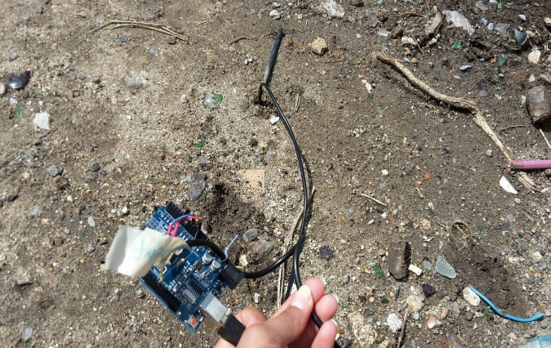 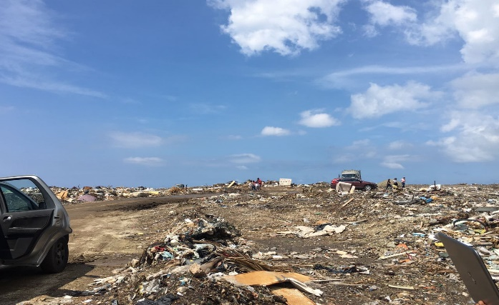

*Figure 2****:*** *Location 1 Soil**Figure 3: Location 1 surrounding*

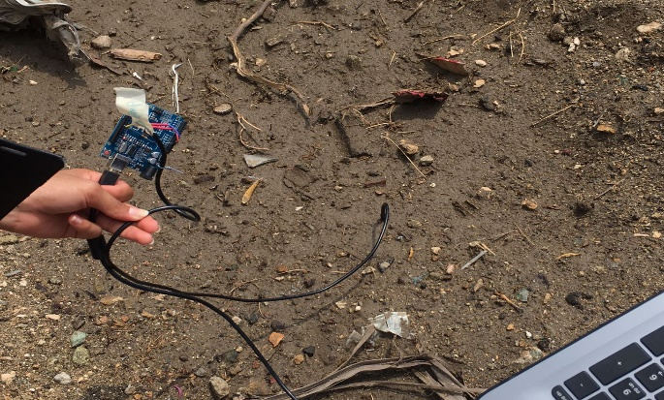 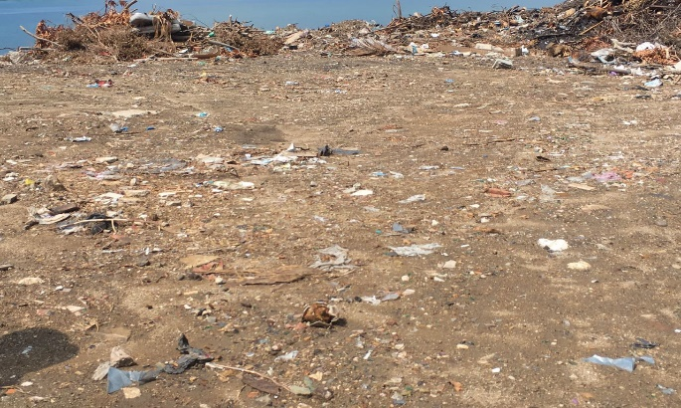

*Figure 4: Location 2 Soil Figure 5: Location 2 surrounding close to the cliff*

Above are a few illustrations of the locations and its surroundings at Parkietenbos.

The soils measured at the location are dry hard soil filled with small rocks, gravel and broken glass (figure 2), and a sticky muddy soil surrounded by garbage (figure 4). Both measurements were taken on October 30, 2017 under the sun. However, it quickly became droopy on the site, thus, leading to rainfall. It was also noted that there had been an abundance of rainfall the day before. Never-the-less, the observations were keenly noted.

The muddy soil presented a temperature of 36.75 °C, which came up serval times on the sensor, however, after calculating the average measurements, the average sum was 36.67 °C. The dry soil on the other hand, measurements of 35.94 °C came up multiple times in the reading, but after calculated, it became 35.93 °C. From the two measurements, it could be concluded that the muddy soil temperature is lower than the dry soil and that the muddy soil will take longer to heat up, despite, the weather.

After comparing the measurements obtained from the UA and those at Parkietenbos, we concluded that the dark brown moist (healthy) soil at 28.62 °C has a lower measurement than that at Parkietenbos, because the UA’s soil is not contaminated, and it did not experience rainfall prior to or on the date the reading was taken. It is evident that rainfall has a serious effect on soil temperatures. Furthermore, dry soil at the UA generated an average temperature of 37.81 °C and when compared to those at Parkietenbos, it is indeed lower, due to the rainfall. In other cases, if there had not been rainfall, the dump would have probably generated a higher measurement, because it is exposed to more sunlight and has no shade.

**Findings**

**Numbers Indication:**

The numbers show that the soil in the study area, Parkietenbos, is polluted to an extent by which it cannot be used for any future agricultural activity. However, the measurements taken at the UA show opportunity for agricultural activity, due to the components of the soil. Ideal soils for agriculture are balanced in contributions from mineral components (sand: 0.05–2 mm, silt: 0.002–0.05 mm, clay: <0.002 mm). The balanced contributions of these components allow water retention and drainage, oxygen in the root zone, nutrients to facilitate crop growth; and they provide physical support for plants.

All plants have maximum, optimum and minimum temperature limits. This is different for each type of plant. The optimum temperature for most plants does not exceed 32 °C, as indicated in the results of the UA research. This indicates that the soil calculation of the dark brown soil measurement at the University of Aruba is able to be used for future agricultural purposes if desired, and those at Parkietenbos cannot.

**Comparison of measured soil temperatures in the context of the international standards/normal levels:**

Below is an overview of average soil temperatures measured at different locations with more or less the same depth (5cm).

University of Aruba measurements:

* 28.62 °C (dark brown, moist soil with silt, clay and fine gravel)
* 37.81 °C (light brown, cracked dried soil with silt and a few gravels)

Temperatures were taken on October 22, 2017 between 11:37 am and 11:44 am.

**Average temperature of soil calculation: (Max °C + Min °C)/2**

Average temperature of dark brown soil: (28.62 °C + 28.26 °C)/2= 28.62 °C

Average temperature of light brown soil: (37.81 °C + 37.81 °C)/2= 37.81 °C

Parkietenbos (Dump) measurements:

* 35.93 °C (dry hard soil filled with small rocks, gravel & broken glass)
* 36.67 °C (sticky muddy soil surrounded by garbage)

Temperatures were taken on October 30, 2017 between 11:47 am and 11:51 am.

Average temperature of dry hard soil: (35.94 °C + 35.88 °C)/2= 35.91 °C

Average temperature of sticky muddy soil: (37.38 °C + 36.19 °C)/2= 36.79 °C

**International standards:**

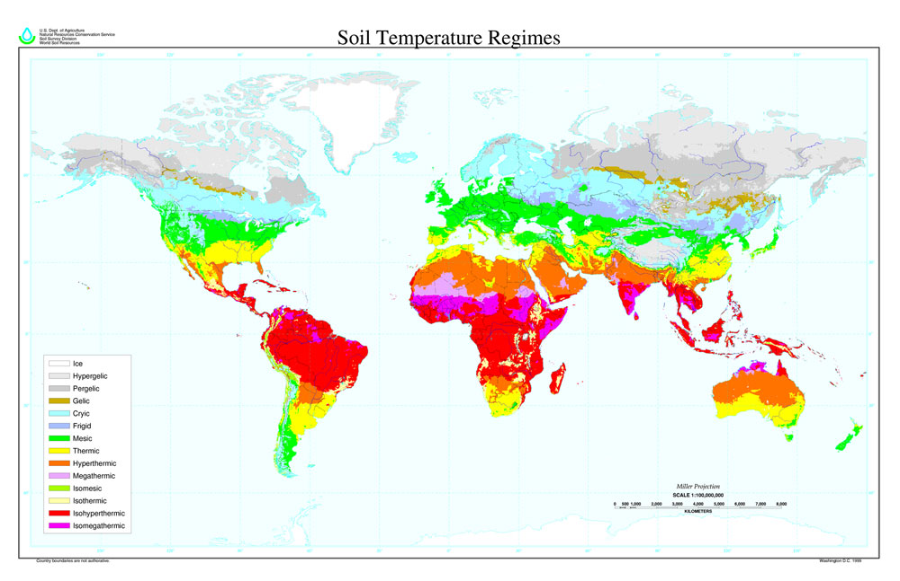

Figure 6

(<http://passel.unl.edu/pages/informationmodule.php?idinformationmodule=1130447033&topicorder=12&maxto=12&minto=1>)

Based on the picture shown above a conclusion can be made that Aruba belongs to the isohyperthermic soil temperature regime. The Mean Annual Soil Temperature (MAST) of a isohyperthermic regime is 22 °C or higher and has a difference between mean summer and mean winter soil temperatures of less than 5 °C at 50 cm below the surface (<http://www.soilinfo.psu.edu/index.cgi?soil_clim&information&general&taxonomy_defs&soil_temp_regimes&iso>). There is some support for the addition of two new Soil Temperature Regimes (STR) for areas where the mean annual soil temperature (MAST) is greater than or equal to 28 °C. These would be called the megathermic and the isomegathermic soil temperature regimes. The isomegathermic regime would be restricted to soils with a difference between the mean summer and mean winter soil temperatures of less than 5 °C (<https://www.nrcs.usda.gov/Internet/FSE_DOCUMENTS/nrcs142p2_051089.pdf>). In the case where there are two additional STR than Aruba would belong to the isomegathermic regime namely because the temperatures measured are equal or greater than 28 °C.

**Comparison:**

Kenya, Africa will be used for a more detailed comparison in terms of a normal level of soil temperature (an extensive research in this field has been done in Kenya). Kenya (as shown in the picture above) also belongs to a isohyperthermic STR and arguably a isomegathermic regime, therefore providing an accurate comparison to Aruba’s soil temperatures.

The Tana River Primate Reserve’s daily average temperature was computed using two different methods. The data was recorded on December 16, 2009 with a depth of 0.25m.

**Average Method** **Daily Average (°C)**

Max + Min/2 34.55

Average of 20 Minute Samples 34.51

(<https://collections.lib.utah.edu/details?id=195771>, page 28)

Most of the average soil temperatures that were taken at different locations on Aruba were higher than the ones at the Tana River Primate Reserve. These results could be due to the difference in the year and month the temperatures were measured, and the environment in which the measurements took place and the amount of time and depth of the measurements.

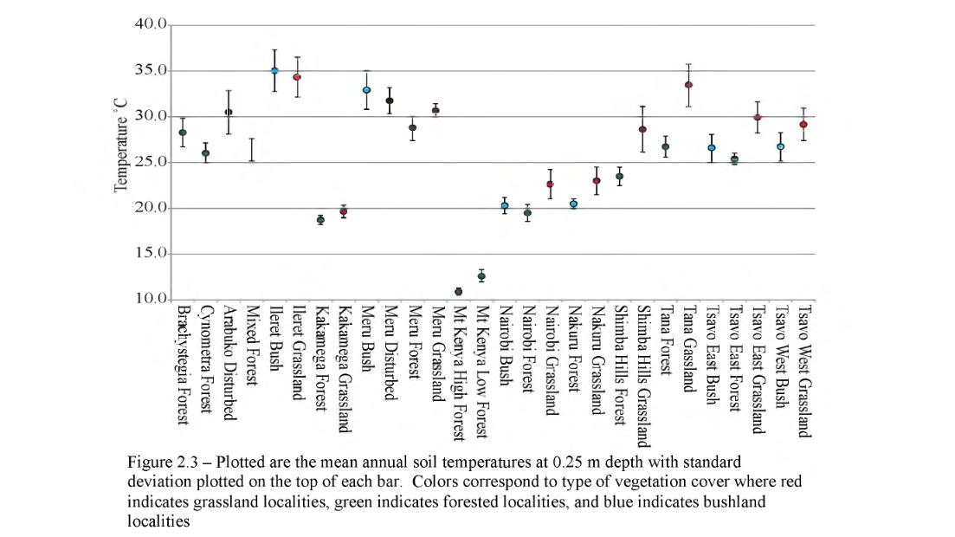

Figure2.3

The link (<https://collections.lib.utah.edu/details?id=195771>, page 38)provides an overview of the MAST at 25cm at different locations in Kenya. Most of the temperatures measured (11) are between 25 °C and 30 °C. As stated in the “comparison conclusion”, most of the temperatures measured on Aruba are higher than the ones at different locations in Kenya. Measurements taken in Kenya are similar to the comparisons observed between Aruba and Tana River Primate Reserve. However, at Kenya the MAST was measured, whereas, in Aruba there were no measurements taken for the MAST.

Tocal’s monthly soil temperature data at 10 cm °C was used as a guideline to estimate the average soil temperatures.



Figure 7: (For a more accurate comparison the other data were left out)

Aruba’s average soil temperatures (measured in October) are higher than the ones at Tocal, Australia. The differences between Aruba and Tocal’s soil temperature measurements are the following:

* Tocal belongs to a thermic STR rather than a isohyperthermic regime
* The depth
* The year; climate changes constant, therefore, it would be difficult to compare measurements
* The time; temperatures taken in the morning and at night differ

A great influence to the differences in soil temperatures is the year in which the measurements were taken (in these cases more than 6 years, this was mostly due to a lack in recent data/research regarding soil temperature). It is evident that through the years the earth’s temperature has been increasing, thus, making a comparison between recent and past measurements are less accurate.

To conclude, although, Aruba and Kenya have the same type of soil temperature regime, the temperatures differ. Aruba has higher temperatures, because it has little rainfall and the weather is hotter in certain parts of the island than some. In this case, Parkietenbos is hotter than the UA, due to a lack of trees and buildings to shade the soil from the sun. In addition, soil temperatures are much higher in Aruba compared to Tocal’s data, because of the different texture of soil.