**Environmental Science.**

Kimberly Balcera

Justin Cijntje

Najib Gomez

Kervens Mallebranche

Shaquille Simmons

Roodnely Ulysse

**Field Work Report.**

Parkietenbos landfill. 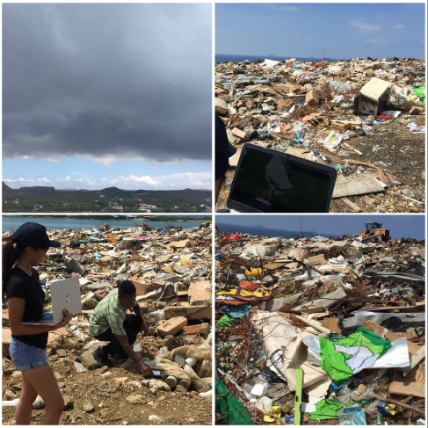

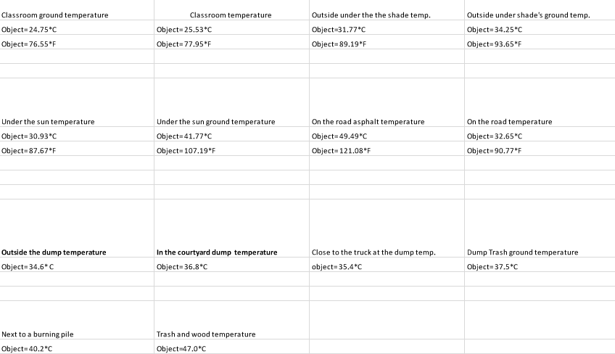

*Average measurement at the University of Aruba;*

Classroom ground temp.: 24.75°C

Classroom temp.: 25.53°C

Outside under the shade temp.: 31.77°C

Outside under the shade’s ground temp: 34.25°C

Under the sun temp.: 30.93°C

Under the sound ground temp.: 41.77°C

On the road asphalt temp.: 49.49°C

On the road temp.: 32.65°C +

271.14°C

271.14 : 8 = 33.89°C

*Average measurement at Parkietenbos;*

Outside the dump temp.: 34.60°C

In the courtyard dump temp.: 36.80°C

Close to the truck at the dump temp.: 35.40°C

Dump trash ground temp.: 37.50°C

Next to a burning pile temp.: 40.20°C

Trash and wood temp.: 47.00°C +

231.50°C

231.50 : 6 = 38.58°C

Observations:

* By the front of the dump it was seen that it is kept clean with different types of trucks coming and going.
* When going uphill with a car, you will see a building on the left side with machines inside of it.
* When walking on the inside of the dump, you would see that the piles of waste are assorted in way. For example, a pile of burnt logs was assorted together.
* There was a dog walking around the dump, dirty yet not malnourished like many stray dogs you see. You could see that the dog would scavenge for food scrap for its survival. Also, it stayed away from people.
* Before we went into the actual trash dump it was sunny, but after we went in dark clouds began to loom over us and began to rain, causing us all to leave the dump earlier than planned.
* When on the dump hill, you can get a higher view of what’s beyond the dump. For example, houses, trees, building etc.

From the data gathered during our trip to the dump it can be noticed that the temperature in the dump is noticeably higher than other locations like the University of Aruba,

The average temperature at the university was 33.89°C on a sunny day while at the dump the average temperature on a cloudy and rainy day was 38.58°C. Trash laying in the landfill measuring as high as 47.0°C. These numbers are a result of a heat-producing process that may be biological or chemical. The higher temperatures also cause an increase in the odor coming from the dump because the combination of heat and humidity allows bacteria to grow faster and smells to travel further. The higher temperatures are also a cause for the fires happening in the dump. Due to the extensive range of substances and materials present in a landfill, landfill fires pose a particular health risk, as they can release hazardous fumes when these materials and substances ignite. It is known for many people who live in the Parkietenbos area to have respiratory issues.

The result gathered from the field work demonstrate a temperature difference between the ground and the actual trash laying around. From all our measurements it is evident that the visible trash had a higher temperature than the ground.

When comparing the results received at the UA with the results received at the dump we can find that they are similaire. For example: Objects can be compared to the physical objects at the dump site (trash). At the UA a temperature of 41.77 were recorded for objects lying in the sun and at the dumpsite temperatures of 41.5-47C were recorded.

Second example: outside ground temperature were recorded at 37.25C at the UA and at ~36.8C at the dump. As one can conclude that the temperature overall at the dump is higher overall compared to UA.